 | 

CARE/JRA3: First Quarterly Report 2006
30/04/2006

Title: High Intensity Pulsed Proton Injectors (HIPPI)
Coordinator: M. Vretenar (CERN), Deputy: A. Lombardi

Participating Laboratories and Institutes:

Institute  (participant number) | Acronym | Country | Coordinator | Scientific Contact | Associated to
CCLRC Rutherford Appleton Laboratory (20) | CCLRC | UK | P. Norton | C. Prior
Commissariat à l’Energie Atomique (1) | CEA | F | R. Aleksan | A. Mosnier
CERN (17) | CERN | CH | G. Guignard | M. Vretenar
Forschungszentrum Jülich (7) | FZJ | D | R. Tölle | R. Tölle
Gesellschaft für Schwerionenforschung, Darmstadt (4) | GSI | D | N. Angert | L. Groening
Institut für Angewandte Physik - Frankfurt University (5) | IAP-FU | D | U. Ratzinger | U. Ratzinger
INFN-Milano (10) | INFN-Mi | I | S. Guiducci | C. Pagani | INFN
CNRS Institut de Physique Nucléaire d’Orsay (3) | CNRS-IN2P3-Orsay | F | T. Garvey | T. Junquera | CNRS
CNRS Laboratoire de Physique Subatomique et de Cosmologie (3) | CNRS-LPSC | F | T. Garvey | J.M. De Conto | CNRS
INFN-Naples | INFN-Na | I | S. Guiducci | V.G. Vaccaro | INFN

Main Objectives: Research and Development of the technology for high intensity pulsed proton linear accelerators up to an energy of 200 MeV.

Cost:
Total Expected Budget | EU Funding
12 M€ (FC) + 2.7 M€ (AC)  Total 14.7 M€ | 3.6 M€

1 Management Activity 3
1.1 Meetings 3
1.2 External Scientific Advisory Committee 3
2 Dissemination Activity 6
2.1 List of talks 6
2.2 List of papers 6
3 Additional staff hiring 6
4 Status of the Work 8
4.1 Work Package 1 : Management and Communication 8
4.2 Work Package 2: Normal Conducting Accelerating Structures……………………...9
4.3 Work Package 3: Superconducting Accelerating Structures 19
4.4 Work Package 4: Beam Chopping 25
4.5 Work Package 5: Beam Dynamics 28
Appendix 1: Gantt chart at end of April 2006…………………………………………..32

- Management Activity

  - Meetings
    - List of meetings
All meetings organized by HIPPI in the year 2006 have been planned (Work Package meetings, general meeting). The participation from HIPPI to the other events in 2006 (International Conferences and workshops, workshops of other collaborations or activities) has been defined. The events concerning HIPPI during the year 2006 are shown in Table 1.1.1a. Only the joint meeting of WP2 and WP5 took place in the period covered by this QR, and details are given in Table 1.1.1b, with the address of the workshop web-site.
    - General meeting
The HIPPI general meeting for 2006 will be hosted by FZJ at the Jülich Laboratory, in the period September 27-29. It will maintain the same structure of previous meetings (2.5 days, with a preliminary report from the ESAC at the end of the meeting), however this year more space will be devoted to general presentations in comparison to the highlights talks, in order to simplify the work of the ESAC.

  - External Scientific Advisory Committee

Contacts (exchange of e-mails) with the members of the ESAC have continued after the HIPPI Meeting in Abingdon (September 2005) and some measures have been taken following the ESAC recommendations, in particular:
  - Links between work packages 3 and 5 have been tightened, with these work packages holding together their workshops at Jülich on April 27-28.
  - A study of DTL post-coupler stabilisation has been started inside WP2.
Table 1.1.1a: Overview of meeting, workshop and event (co)organized by the Activity or with Activity contributions
 | Jan | Feb | March | Apr | May | Jun | Jul | Aug | Sep | Oct | Nov | Dec
CARE & HIPPI
CSC Meeting |  |  |  | 11 Paris |  |  |  |  | 13-14 CERN
WP2 Meeting |  |  |  |  | 18-19 Grenoble
WP3 Meeting |  |  |  | 27-28 Juelich
WP4 Meeting |  |  |  |  | 4-5 CERN
WP5 Meeting |  |  |  | 27-28 Juelich
HIPPI Annual Meeting |  |  |  |  |  |  |  |  | 27-29 Juelich
CARE Meeting |  |  |  |  |  |  |  |  |  |  | ??  Frascati
Collaboration meetings
IPHI-SPL meetings |  |  |  |  |  | 15-16 Saclay
ISTC meetings |  |  | 27-30 Novossib. | 5-7 CERN |  |  |  |  |  |  |  | 1st week Sarov
Conferences, workshops
HB 2006 Workshop |  |  |  |  |  | 29.5-2.6 Tsukuba
EPAC 2006 |  |  |  |  |  | 26-30 Edinbourgh
LINAC 2006 |  |  |  |  |  |  |  | 20-25 Knoxville
RuPAC 2006 |  |  |  |  |  |  |  |  | 10-14 Novosib.

Table 1.1.1b: List of meeting, workshop and event (co)organized by the Activity
Date | Title/subject | Location | Main organizer | Number of participants | Comments and Web site
April 27-28 | Joint workshop HIPPI WP3 and WP5 | Jülich | FZJ | 17 | http://www.fz-juelich.de/ikp/hippi/spring2006/index.html

2 DISSEMINATION ACTIVITY
  - List of talks

No relevant talks were presented during the first quarter of 2006.
  - List of papers
Three CARE notes have been issued during the first quarter of 2006, they are listed in Table 2.2. Two of them represent a deliverable, for working packages 3 and 4 respectively. For the upcoming conferences, EPAC06 (June06, Edinburgh) and LINAC06 (August 06, Knoxville), some 15 abstract have been received. They will be filed as publication once the conference takes place and the complete paper is available.

Table 2.2: List of document issued by the NA or JRA

# | CARE document type and number | Title | Authors and Labs | Date
1 | CARE-Note-2006-001-HIPPI | Design of a triple-spoke cavity for 352 MHz and beta=0.48 | E. Zaplatin1, R. Maier1, M. Pap1, R. Toelle1 , FZJ, Jülich, Germany | 01/2006
2 | CARE-Note-2006-003-HIPPI | Report on tuner design | Paolo Pierini, Nicola Panzeri, Angelo Bosotti, Paolo Michelato, Carlo Pagani, Rocco Paparella  INFN Sezione di Milano - LASA | 03/2006
3 | CARE-Note-2006-004-HIPPI | The beam absorbers of  the 3 MeV H⁻ Test Facility at CERN | L.Bruno, A.Lombardi, M.Magistris, M.Silari  CERN, Geneva, Switzerland | 04/2006

  - Web site
The HIPPI web site (http://mgt-hippi.web.cern.ch/mgt-hippi/) contains the most recent information on the JRA activity. A more user-friendly list of publications in HTML format with direct links to the EDMS repository has been recently implemented

3 ADDITIONAL STAFF HIRING
One fellow has been hired at CERN for HIPPI-related work from March 1st.

Table 3: Temporary staff hiring
# | Lab | Job Type | Duration | Work subject | Status
1 | CERN | Fellow (PostDoc) | 1 year | Radio Frequency design (supervisor: F. Gerigk) | Started March 1st, 2006

- STATUS OF THE WORK

  - Work Package 1 : Management and Communication
The completion of the 2005 annual report has required the usual attention during the first months of 2006. A particular care has been devoted to the follow-up of the few milestones delayed from 2005.
The CARE Steering Committee meeting took place in Paris in April, with a presentation by the Coordinators on the status of HIPPI.
The Work Package meetings have been prepared, while the location and date of the HIPPI Annual Meeting have been finally fixed.
From the scientific point of view, the HIPPI Coordinators have checked that the recommendations of the ESAC are correctly implemented by the different laboratories. In particular, a particular care was devoted to improving the collaboration between Work Package 3 and 5, as recommended by the ESAC. Experts in both fields met several times during the first months of 2006, and came to the definition of optimised layouts for spoke and elliptical cavity based layouts for the 90-180 MeV linac range. The results of this work have been presented at the meeting of WP3 and WP5, jointly organised at Jülich on April 27 and 28. The study of post-coupler stabilisation has been started at CERN by a PhD student, following another ESAC recommendation.
  - Work Package 2: Normal Conducting Accelerating Structures

    - Drift Tube Linac

4.2.1.1 Activities at Rutherford Laboratory (RAL) (WBS 2.1.4)

An important part of the activity at RAL was made on the chopper line, and it is described on the WP4 section.
A second part of the work done at RAL is in conjunction with the RAL Front End Test Stand (FETS).

Bunching cavities

A comprehensive analysis and comparison of the available options for the bunching cavities has been done. Two structures have been extensively analysed: the DTL-like type cavity and the CCL-like type cavity. Both the advantages and disadvantages of the two structures have been studied with the following conclusions:

- Using a DTL-like type cavity has the advantage of compactness and a reduced chopper line length with consequences on the emittance growth. The DTL structure allows quadrupoles to be partially buried inside the drift tube, but on the other hand it has a low shunt impedance so it’s less efficient from the power consumption point of view;
- Using a CCL-like bunching cavity would reduce the power requirements by a factor of 2, but it would increase the length of chopper line, due to the fact that the quadrupoles cannot be accommodated inside the drift-tubes as in the DTL case.

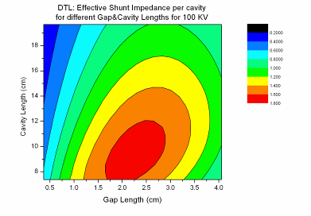
Figure 4.2.1.

Hybrid quadrupoles

The requirement for compact adjustable quadrupoles comes from the space restriction in the FETS chopper line. Two hybrid solutions have been proposed: the tandem combination of PMQ and EMQ and the concentric combination of PMQ and laminar conductor (Lambertson) EMQ types. This second option has been analysed using tools like SuperFish and Vector Fields to check the quality of the field generated by the two quadrupoles together and the adjustability range.

Figure 4.2.2: Field lines generated by the PMQ.

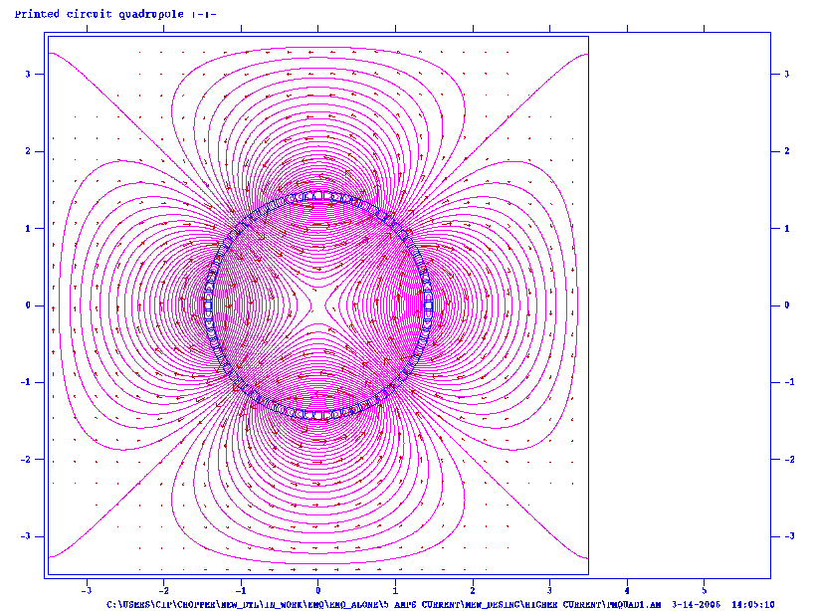

Figure 4.2.3: Field lines generated by the printed-circuit quadrupole

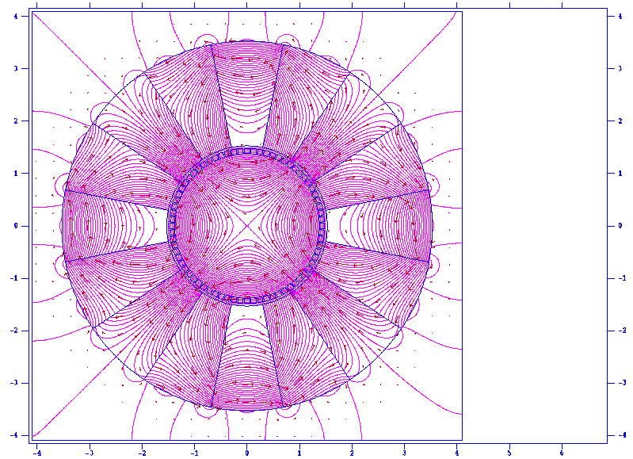

Figure 4.2.4: Field lines generated by the hybrid quadrupole.

4.2.1.2 DTL general design at CERN (WBS 2.1.1 to 2.1.4)

The DTL design developed inside HIPPI was used for the mechanical design of a Tank1 prototype for the Linac4 project, done by the VNIIEF laboratory of Sarov (Russia). The complete prototype is shown in Fig. 1, while a cutout is shown in Fig. 2. At a meeting at CERN beginning of April, the general mechanical design has been approved, and an agreement was defined for the completion of the prototype, considering that the provisions for construction inside the project do not allow for the completion of the prototype. In a first stage, only one complete drift tube will be built. The other 26 drift tubes will be aluminum dummies, which will allow low level RF measurements, field adjustments and tuning of the post-couplers. The prototype equipped with the aluminum drift tubes should be sent to CERN in spring 2007. In a second stage, when additional funding will be available, the aluminum drift tubes will be replaced with real ones.

The final mechanical design of the RF coupler for this prototype, one of the HIPPI deliverables, has been agreed with LPSC Grenoble that will build the device.

An extensive series of 3D RF simulations has been performed on the behavior of post-couplers, a critical component that the ESAC committee recommended to analyse in more detail. The main mode bands in a DTL tank have been identified, and has been defined the correct post-coupler length to allow closing of the stop-band. Simulation of a perturbed case allowed checking that the stability of the tank increases by about a factor 10 when the stop-band is closed. The simulations confirm that the design with one post-coupler per three drift-tubes allows stabilization of the tank.

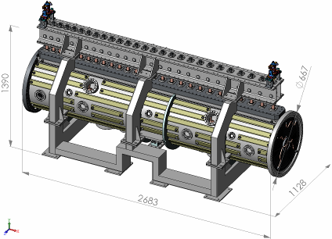

Figure 4.2.5: DTL Tank 1 prototype on its support

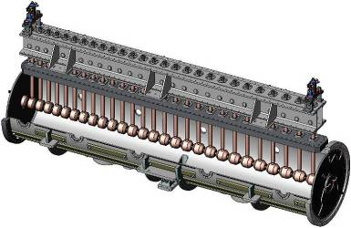

Figure 4.2.6: cutaway view of DTL Tank 1 prototype

4.2.1.2 DTL and coupling port design at CEA Saclay and LPSC (part of WBS 2.1.3)

The 1 MW coupling port is under construction. As foreseen, the upper part of the system (from the RF port flange to the DTL tank) will be built by the VNIIEF Sarov team from the LPSC data and will be part of the tank. The time schedule is to get the coupling port ready for copper plating by September 2006. The main part of the port manufacturing will be done in-house at the LPSC mechanical shop. The expected gain will be around 15 kEuros. The copper plating will be done at CERN. The objective is to have the coupling port ready for the tank reception, during the first quarter of 2007, to make the first tests. A preliminary test session is not realistic due to the necessity to have a resonant cavity with the same size than the DTL tank itself.

Figure 4.2.7: General overview of the coupling port.

    - H-mode DTL (IAP Frankfurt)

4.2.2.1 Beam dynamics design (WBS 2.2.4)

The beam dynamics design for the GSI Proton Injector has been completed and a detailed report can be found in the HIPPI Note 2005-016-HIPPI. The attention is now focused on the transport channel from the Linac to the SIS Synchrotron: the aim is to provide a quite cold beam with an energy spread in the order of 1‰. Preliminary results are encouraging and show the feasibility to deliver the beam inside the specific parameters.
The LORASR code was update in order to perform loss and error studies. The new space charge routine, based on 3D FFT lets calculate up to millions of particles within few hours: it is now possible to calculate the transmission rate with a good approximation.

4.2.2.2 RF cold model design & construction (WBS 2.2.2)

The cold model has been completed and, at the moment it is under copper plating at GSI: the end cells are already performed and the electrodes for the structure have been realised.

The measured frequency was 340 MHz, in good agreement with our simulations, and no leak was observed in the welding points of the stems (see picture 4.2.8): this confirms the mechanical feasibility of such a new structure

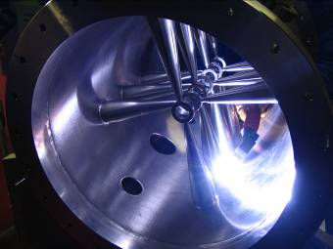

Figure 4.2.8: The welding of the stems inside the CH outer tank.

After copper plating, the cavity will be fed by a 2 KW amplifier to test its RF properties, distribution of electric field and the goodness of the cooling design.

The real prototype is, at the moment under design: several options are taken into account including the possibility to feed several structure with only one klystron. It is foreseen to present preliminary results at the LINAC 06 Conference in August

    - Side Coupled Linac (LPSC and CERN) (WBS 2.3.1 and 2.3.2)

The activity on the Side Coupled Linac has been restarted going back to the original choice of structure, following the advice of the ESAC, and comparing alternative candidates to the acceleration in this energy range, like the Annular Coupled Structure (ACS) and the On-axis Coupled Structure (OCS). The results of this comparison studies should be available in summer 2006. Other possible improvements that are under study are a low average power version of the SCL, to be adopted for Linac4 in case a superconducting section is definitely foreseen for this energy range for the SPL project. Moreover, the analysis of stability of a long chain of coupled cells has restarted, as well as the design of the bridge coupler, a critical component in SCL modules.
The BINP Laboratory in Novosibirsk (Russia) is constructing a brazed full-scale 2-cell model of SCL that should be ready during the summer. It is intended to go through low-level RF measurements first in Russia and then at CERN.

The cold model prototype (aluminium) is under construction at LPSC, at the 0.7 scale (resonant frequency around 1 GHz). Like the coupling port, it will be built in-house and made of 11 accelerating cells i.e. 22 elementary slices. A first slice pre-prototype will be built first, to control the validity of the design.
Figure 4.2.9: SCL cavity drawings.
    - Cell Coupled DTL (CERN) (WBS 2.4.1 to 2.4.3)

The low-level RF measurements on the CCDTL pre-prototype are now completed. The resonant frequency is now 352.19 MHz, with an unloaded Q-value of 22’700, only about 65% of the theoretical Q-value of 34’700 (from Superfish, corrected for 1% coupling). Investigations are going on in order to understand the reason for the low Q-value (about 80% reduction was expected). The measured coupling between cells is 0.88%, in perfect agreement with the simulations, and the wave-guide RF coupler has been easily matched to 50 Ω impedance. A bead-pull measurement of electric field on axis has been performed (Fig. 4.2.10), indicating that field asymmetries are well below 1% (the difference between field in inner and outer gaps is due to the particular geometry of this prototype).

Figure 4.2.10: Field distribution on axis of the CCDTL pre-prototype

After the RF tests, the pre-prototype has been equipped with the cooling pipes (Fig. 4.2.11). The vacuum pumping system has been connected, and at the moment the pre-prototype is waiting for the vacuum leak testing. The high-power test area has been reserved from mid-June for the high-power RF tests that will complete the activity on this pre-prototype.

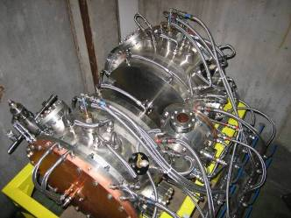

Figure 4.2.11: CCDTL pre-prototype equipped with complete cooling circuits.
The machining and copper plating of the following CCDTL prototype has been completed in the Russian VNIITF Laboratory (Snezinsk, Ural region). The prototype has been delivered in January to BINP (Novosibirsk), which is in charge of completing it with the drift tubes and of low-level RF tests and tuning. The assembly of the prototype in Novossibirsk has been particularly simple, indicating that the construction tolerances were well kept and that the particular support developed by VNIITF is well suited to this structure. Fig. 4.2.12 shows this prototype, as it was during a visit to Novossibirsk at end of March. Fig. 4.2.13 shows the inside of one of the half-tanks.

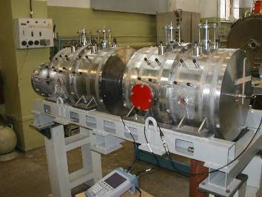

Figure 4.2.12: The CCDTL prototype.

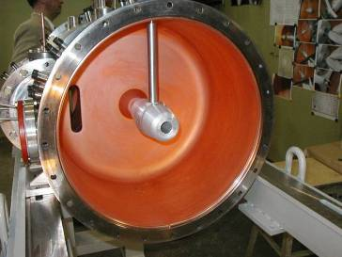

Figure 4.2.13: Inside view of one of the CCDTL prototype half-cells, equipped with an aluminium drift tube.

Table 4.2a : Status of the Sub tasks in WP2 which are supposed to have started according to the MS project breakdown in Annex 1

WBS # | Title | Original begin date (Annex 3) | Original end date (Annex 3) | Estimated Status | Revised end date
2.1 | Drift Tube linac
2.1.1 | DTL Design | July 2004 | June 2007 | On time
2.1.5 | DTL Coupler prototype construction | July 2005 | June 2007 | On time
2.1.4 | DTL beam dynamics design | January 2004 | June 2008 | On time
2.2 | H mode DTL
2.2.2 | RF cold model design & construction | January 2004 | January 2005 | 95% | April 2006
2.2.3 | RF model construction | December 2004 | June 2005 | 50% | December 2006
2.3 | Side Coupled Linac
2.3.2 | RF model mechanical design | July 2004 | December 2004 | 50% | June 2006
2.3.3 | RF model construction | January 2005 | December 2005 |  | Delayed
2.3.4 | RF model testing | January 2006 | June 2006 |  | Delayed
2.3.5 | SCL module design | January 2006 | June 2007 | On time
2.4 | Cell Coupled DTL
2.4.2 | Pre-prototype high power RF tests | July 2004 | March 2005 | delayed | July 2006
2.4.3 | Prototype mechanical design | January 2005 | December 2005 | 100%
2.4.4 | Revision of design | October 2005 | October 2006 | 30%
2.4.5 | Prototype high-power RF tests | August 2006 | June 2007 | Delayed | December 2007

Table 4.2b: Status with respect to the interim reports and deliverables due in 2006 according to the MS project breakdown

WBS # | Title | Due date in Annex 1 | Status | Revised delivery date
2.4.3 | CCDTL Prototype ready | June 2006 | On time | August 2006
2.2.7 | CH-DTL Prototype ready | December 2006 | On time
2.4.4 | CCDTL Design report | December 2006 | On time
Milestones delayed from 2005
2.4.1 | CCDTL Pre-prototype intermediate report | June 2005 | In preparation | August 2006

  - Work Package 3: Superconducting Accelerating Structures
The annual HIPPI-WP3 meeting took place at Jülich (Germany) on April 27 and 28. The programme (http://www.fz-juelich.de/ikp/hippi/spring2006/AgendaWP3.pdf) included a total of 8 presentations, one of them specifically for the joint session with WP5. A copy of the slides is available on the workshop web site:
http://www.fz-juelich.de/ikp/hippi/spring2006/talks.html

INFN-Milano
Mechanical design of tuner (subtask 3.1.2) and Integration of piezo design (subtask 3.1.3)
These tasks for the design of a fast/slow coaxial tuner have been completed, with the emission of the construction drawings and the delivery of the intermediate report on the tuner design (CARE-Note-2006-003-HIPPI).
Tuner construction (subtask 3.1.4)
A Call for Tender for the supply of 2 He tanks and tuning systems has been sent to three European companies, and the formal order for procurement is being prepared by our administration. The expected delivery date is foreseen within 6 months from the acceptance of the order by the company. The tuner/He tank parts will be available for initial mechanical characterization before the end of the year. A few components requiring long procurement times have been already acquired (e.g. Ti hydroformed bellows for the He Tank).

CEA-Saclay
Construction of cavity B (subtask 3.1.6)
The niobium material (sheets, disks and tubes) is supplied. Two of the 10 disks necessary for the cavity cells fabrication show scratches, but we think they could be used all the same.
The “cavity B” is now ordered to ACCEL company and should be ready for November 2006, meaning a delay of 5 months with respect to the schedule of this deliverable. Main part of this delay is due to the supply of AISI-613LN bellows for the Helium tank (see the bellow welded on the coupler port flange in the next picture) and to questions about the mechanical behavior of these bellows after the final heat treatment of the cavity (650°C – 24 hours).
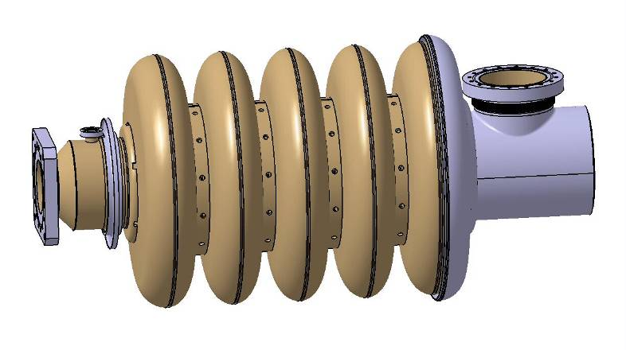
Figure 4.3.1: Sketch of “Cavity B”

In parallel with the design and fabrication of the cavity, we prepared the mechanical set-up for cavity field flatness adjustment. This set-up will be installed in September/October 2006, the goal being to have ready and operational at cavity delivery.
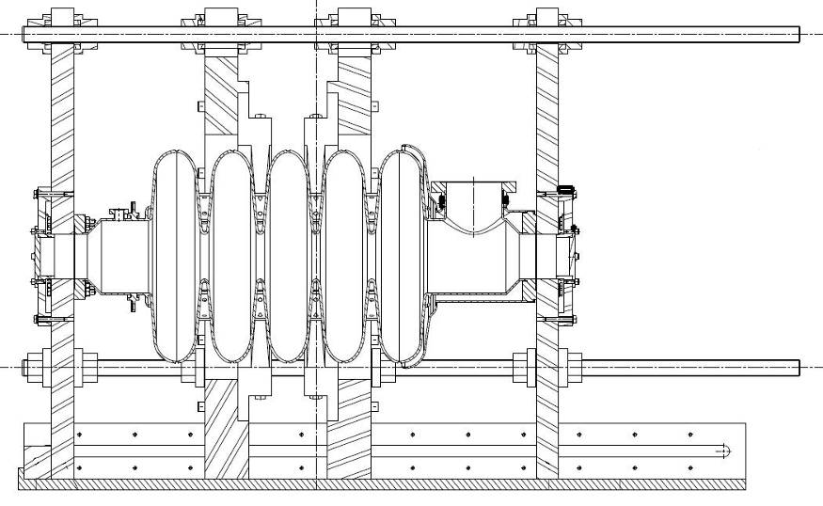
Figure 4.3.2: Set-up for cavity field flatness adjustment

Power coupler design and engineering (subtask 3.1.7)
Mechanical drawings of the cold part of the coupler are well advanced. The outer conductor is cooled by a gaseous helium counter flow in 3 parallel channels able to extract a maximum of 100 W. The inner conductor is water cooled on its whole length as is the RF window. An extra water cooling channel is located on the outer diameter of the ceramic disk. The integration of the coupler in CRYHOLAB is completed: the mechanical design of the flange and bellow connecting the outer conductor to the vacuum vessel is constrained by requirements on the assembly phase, pressure compensation and necessary clearance for the coupler diagnostics.
An adjustable chassis is located below the coupler port to support the doorknob. In order to minimize the stress on the window during final assembly, this chassis is aligned in advance using a dummy part which replaces the doorknob and the inner conductor of the warm coaxial part.

RF source order and preparation (subtask 3.1.8)
The 1MW klystron (VKP-7952C) has been ordered to CPI (Communications & Power Industries) in August 2005 and should be delivered at the end of 2006. All the interfaces (HV connectors, pumping system, cooling circuits, auxiliary power supply) are now fully defined. Study of the klystron is completed and fabrication has begun on time.
The fabrication of the 1MW peak circulator is now finished, but with two months delay due to problems encountered in the supply of ferrites. Low power measurements (VSWR measurements at all the phases and matching conditions) should be done at the end of April ’06. If the results are satisfying this material will be delivered to Saclay and will be stored until being implemented on the power test stand.

Modulator preparation for the 700 MHz test stand (subtask 3.1.10)
Modifications of the existing HV pulsed generator are continuing.
The 110kV power supply has been ordered to Transfo-Industries last February. They completed the study in April, and fabrication in now in progress. The power supply should be delivered next September, in accordance with the schedule of the modulator.

All the components of the power test stand are in fabrication and are on time. The main risk of delay with respect to the schedule is due to the moving of all our cryogenic and RF installations to a new hall.

FZJ
Evaluation of 700 MHz resonator (subtask 3.2.2)
All deliverables are delivered. No further activity due to lack of personnel.

RF design of 352 MHz multigaps resonator (subtask 3.2.6)
The RF design of the 352 MHz resonator was frozen. It was decided to build the resonator without He cover for use in a bath cryostat. Two different scenarios for cavity stiffening have been worked out: (i) rings welded onto the cylindrical surface and ribs welded onto the end caps and (ii) rings welded onto the cylindrical surface and copper sputtering of the end caps. Both scenarios are being investigated for suitability. The best one will be chosen for the HIPPI resonator.

Final mechanical design of resonator (subtask 3.2.7)
Drawings of the mechanical design of all resonator parts are finished (Fig. 8).

Integration of coupler. Tuning options (subtask 3.2.8)
Coupler is contributed by IPN-Orsay. Integration of the coupler is in progress.

Preparations for electron beam welding (subtask 3.2.9 – new sub task)
The forming process for relevant parts of the cavity (e.g. end caps) has started using copper sheets. Ordered RRR Nb sheets arrived in the lab. Forming of the niobium for spokes and end caps is in progress. The necessary new electron beam welding machine (not paid by CARE money) has successfully been commissioned.

IPN-Orsay
Evaluation of 352 MHz 2-gap prototypes (subtask 3.2.3)
The Stainless Steel helium vessel has been added to the beta 0.15 spoke cavity body in December 2005. The first test is foreseen next month in vertical cryostat (preparation week 18 and test @ 4 K week 19).

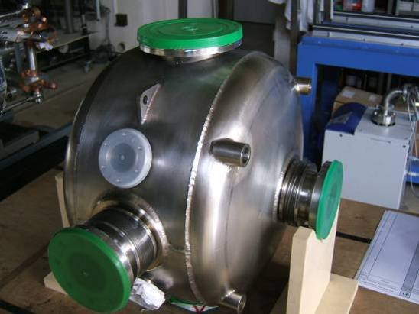
Coupler port

Figure 4.3.3

Design of Coupler Prototype (subtask 3.2.4)
The call for tenders for 2 couplers ended in week 15. The French company SCT was chosen to build these couplers. The fabrication should last 5 months from May to October (August excluded).
First measurements, at low power, are foreseen at the end of the year to validate the RF design (i.e. measurement of S₁₁ parameter).

RF design of 352 MHz multi-gap resonator (subtask 3.2.6)
In the frame of the design study concerning the multi-gap spoke cavity proposed by the Jülich group, some cross-check calculations have been performed at IPN Orsay. In addition to the linkage from CAD code CATIA to mechanical code CAST3M, the new linkage from CATIA to the electromagnetic code SOPRANO has been successfully done. This work allows performing the RF simulations on the multi-gap Spoke resonator. Moreover, SOPRANO has been also linked to CAST3M in order to perform the Lorentz forces detuning of the cavity in pulsed mode. The results have been compared with the results obtained by FZ Jülich with ANSYS and MICROWAVE STUDIO codes. A good agreement is observed. From the calculations made by IPNO, the Lorentz forces factor, which means the frequency shift over the square of the accelerating field, is about 4Hz/(MV/m)², when FZ Jülich has estimated this value 3-5 Hz/(MV/m)².
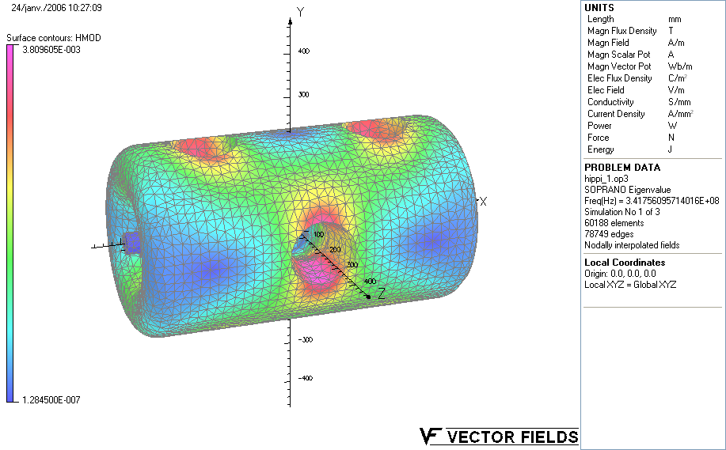
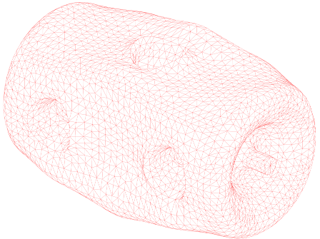

Magnetic field distribution (Soprano) Deformation due to Lorentz forces (Cast3m)

Figure 4.3.4

IAP-FU

Conceptual studies of a tuning system (subtask 3.3.1)
The superconducting CH-prototype cavity has been tested several times since the last report. The total voltage including the transit time factor is 3.7 MV. This corresponds to an effective accelerating gradient of 3.5 MV/m with respect to the total cavity length and of 4.5 MV/m with respect to the length of 9.5βλ. The electric peak field is about 25 MV/m and the magnetic peak field is about 26 mT. Above field levels of about 20 MV/m strong field emission has been observed. Depending on the dosiometric X-ray measurements it will be decided whether a surface preparation will be performed.
During the last test the sensitivity of the frequency due to external pressure differences has been measured. The sensitivity is 250 Hz/mbar. Additionally, Lorentz Force Detuning could be determined. The result was -13Hz/(MV/m)².
For the conception of the tuner, the influence of an external force applied to the end drift tubes of the cavity has been studied. The main effect is the change in capacity for the first and last gap of the structure which results in a maximal frequency shift of -110 kHz/kN and an increase of gap voltage by 9%. The deformation of the end caps has been calculated and the external force limited to a value of about 5 kN in order to avoid fracture due to deviatory mechanical stresses exceeding 150 MPa. For the simulation of the frequency response due to hydrostatic change in pressure the deformation of the whole structure has to be taken into account. The deformation of the end caps is not sufficient for the description as has been shown quantitatively.
The work on the cryomodule is continued to incorporate the cavity for the first cold test in horizontal position. A reconstruction of the cold mass and the tuning system is necessary for that purpose and the aim of obtaining experimental evidence for the conception of the final tuner.
WBS | Title | Participants | Original begin date | Original end date | Estimated Status | Revised end date
3.1 | Elliptical cavities
3.1.2 | Tuner design | INFN | 07 / 2004 | 12 / 2005 | 100%
3.1.3 | Integration of piezo design | INFN | 07 / 2004 | 12 / 2005 | 100%
3.1.4 | Tuner construction | INFN | 01 / 2006 | 06/2006 | 10% | 12/2006
3.1.6 | Construction cavity B | CEA | 11 / 2005 | 06/2006 | 5% | 11/06
3.1.7 | Power coupler design & engineering | CEA-LPSC | 01 / 2005 | 04/2006 | 75%
3.1.9 | RF coupler construction | CEA-LPSC | 05 / 2006 | 05/2007
3.1.8 | RF source order and preparation | CEA | 07 / 2004 | 12/2006 | 65%
3.1.10 | Modulator preparation for test stand | CEA | 01 / 2005 | 12/2006 | 60%
3.1.11 | RF source testing | CEA | 01 / 2007 | 04 / 2007
3.1.12 | High power pulsed tests | CEA | 05/2007 | 06/2007
3.1.13 | Cavity A assembly with tuner | INFN | 06/2006 | 03/2007
3.1.14 | Vert. test & final welding of cavity B | CEA | 07/2006 | 03/2007
3.2 | Spoke cavities
3.2.2 | Evaluation of 700 MHz prototype | FZJ | 09 / 2004 | 09 / 2005 | 100 %
3.2.4 | Design of coupler prototype | IPNO | 01 / 2004 | 12 / 2005 | 100%
3.2.5 | Construction of coupler prototype | IPNO | 01 / 2006 | 06 / 2006 | 5% | 11/2006
3.2.8 | Final design of 352 MHz multigap res. | FZJ-IPNO | 07 / 2005 | 06 / 2006 | 90 %
3.2.9 | Test of coupler prototype | FZJ-IPNO | 07/2006 | 07/2007
3.2.10 | Manufacturing of 352 MHz multigap res | FZJ-IPNO | 04/2006 | 09/2007 | 20%
3.3 | CH resonators
3.3.1 | Design of tuning system | IAP-FU | 01 / 2004 | 06 / 2006 | 70 %
3.3.2 | Construction of tuning system | IAP-FU | 01/2006 | 12/2006
3.3.1 | Measurements of tuning system | IAP-FU | 01/2007 | 06/2007
Table 4.3a : Status of the Sub tasks in WP3 which are supposed to have started according to the MS project breakdown in Annex 1

Table 4.3b: Status with respect to the interim reports and deliverables due in 2006 according to the MS project breakdown
WBS # | Title | Due date in Annex 1 | Status | Revised delivery date
3.1.6 | Cavity B ready (deliverable) | June 2006 | Delayed | Dec. 2006
3.3.1 | Report on CH tuners (milestone) | June 2005 | Delayed | March 2006

  - Work Package 4: Beam Chopping

Web-site: http://lombarda.home.cern.ch/lombarda/WP4/WP4main.htm

During this first quarter of the year 2006 the work of WP4 is progressing steadily but rather slowly. The reasons are, for CERN, the delays in the vacuum tests due to the overload of the vacuum group and for RAL the lack of staff.

The working package annual meeting will take place on the 4-5 May at CERN. 10 participants are expected. The topics for this workshop will be the calculations and measurements of the field coverage factor as well as the status of the key components and the possibility to test the chopper elsewhere than CERN.

CERN:

The advancement of the CERN chopper structure A has followed a somewhat different track than the one foreseen in the planning originally proposed, in order to cope with the delays generated by the overload of the CERN mechanical workshop. At present most of the parts are ready or ordered and the tests of the prototype without beam could start in June 06. .
- Chopper structure (subtask 4.1.4): The chopper is fully assembles since December 05. The chopper is waiting for vacuum tests. Two vacuum tests are foreseen: one to measure the out-gassing and one to measure the heat transfer between the ceramic and the metal plate. Should the first vacuum test not be successful for the expected vacuum of 10⁻⁸ torr, a bake-out at 150 degrees will be performed before the electrical tests. The second vacuum test will give information on the cooling needed to cope with electrical heating and beam losses. A measure of the field coverage actor has been performed. The results are satisfying and the assumed field coverage factor of 80% seems to be confirmed. Besides, new meander lines, ordered from the firm Kyocera are due to arrive before the summer.
- Chopper driver (subtask 4.1.3): a driver based on solid-state MOSFET has been assembled. It can deliver 250 volts with a rise time of less than 2 nsec. Decision has been taken at the beginning of the year of not going ahead and building 3 more modules that would drive the chopper to the nominal voltage but rather to acquire a commercially available module from the firm FID Technology in Russia. The first of four modules is scheduled to arrive at CERN in June06.
- Dump (subtask 4.2.1): machining of the dump is almost finished and it should arrive at CERN by mid-may. Afterwards brazing will start. The delivery seems to be on schedule
- The layout of the optical elements of the chopper line is final. The beam dynamics tool is ready and cross-checked against other codes. Beam dynamics studies are now devoted to devising strategies to measure the chopper with beam.
- A delay in the production of the IPHI RFQ, the radio frequency quadrupole due to accelerate to 3 MeV the H- beam in the CERN test stand , could delay the final tests with beam of the Chopper structure A. In order to avoid this problem a solution has been studied which foresees bringing the chopper line in Saclay for tests with the available 3 MeV beam. A working group (6 people, 3 from Saclay, 3 from CERN) has analyzed the implications and has concluded that the measurements are possible with acceptable mechanical modifications to the set-up and it would be possible to fully characterize the chopper A in Saclay.

RAL:

In RAL highest priority has been given to the development of new designs for the FETS (Front End Test Stand) MEBT using the GPT code. The CERN MEBT input beam parameters (IPHI RFQ) have been used and the CERN MEBT design has to 'benchmark' the GPT code. This activity should result in a definite design of the 3 MeV line after the RFQ.

A comparison of the 'coverage factors' for the RAL and CERN structures using the CST EM studio code has been don and problems involved in shrinking the RAL electrode design to fit inside the CERN MEBT quadrupoles have been addressed.

The 8 kV MOSFET switch for the 'Slow' pulse generator (SPG) has been modified and tested, in the breadboard system.

Work on modelling the re-buncher cavities and on hybrid quadrupole designs is in progress.

.

Table 4.4a: Status of the Sub tasks in WP5 which are supposed to have started according to the MS project breakdown in Annex 1

WBS # | Title | Original begin date (Annex 1) | Original end date (annex1) | Estimated Status | Revised end date
4.1 | Chopper structure A (CERN)
4.1.1 | Pre-prototype construction | January 2004 | June 2004 | Finished | June2005
4.1.2 | Pre-prototype testing | July 2004 | November 2004 | Combined with task 4.1.5 | December 2005
4.1.3 | Driver construction & testing | January 2004 | December 2005 | Finished
4.1.4 | Full scale prototype design | January 2005 | June 2005 | Finished
4.1.5 | Full scale prototype construction | January 2005 | December 2005 | Finished
4.1.6 | Prototype testing w/o beam | January 2006 |  | 20%
4.2 | Chopper line (CERN)
4.2.1 | Dump design | January 2004 | June 2004 | Finished
4.2.2 | Dump construction | January 2005 | June 2005 | 80% | June06
4.3 | Chopper structure B (RAL)
4.3.1 | Pre-prototype design and test | January 2004 | June 2005 | Finished
4.3.2 | Prototype design | January 2005 | December 2005 | 40 %

Table 4.4b: Status with respect to the interim reports and deliverables due in 2006 according to the MS project breakdown

WBS # | Title | Due date in Annex 1 | Status | Revised delivery date
4.1.1 | Chopper A design report | June 2005 | delayed | December 2005
4.1.2 | Intermediate test report | March 2005 | Waiting for task 4.1.5 | August 2006
4.2.2 | Dump design report | June 2005 | Delivered | April 06
4.3.1 | Chopper B design report | June 2006
4.1.2 | Chopper A prototype ready | August 2006

  - Work Package 5: Beam Dynamics
The 2005 WP5-collaboration meeting took place in Jülich, Germany, on April 27 and 28. The programme and the slides of the presentations are available on the FZJ web site: http://www.fz-juelich.de/ikp/hippi/spring2006/AgendaWP5.pdf and the list of talks http://www.fz-juelich.de/ikp/hippi/spring2006/talks . The status of the different activities is summarised in the following sections.

Work at IAP, Frankfurt, Germany

Code development (subtask 5.1.2):

A new version of the LORASR space charge routine based on a 3D FFT is now routinely used for simulations up to 10⁶ simulation particles for verification, and 10⁵ simulation particles for design. In order to make use of this new capability a breeding technique was developed and successfully tested that allows enhancing the small seed of particles (few 10³) of the RFQ output distribution to seeds of 10⁵ or 10⁷ particles while maintaining the important phase space information.

Code comparison and benchmarking (subtask 5.1.7):

The LORASR code was included to the benchmark, and currently definition of quad lengths is in progress. Preparing the Alvarez drift tube input files for the code benchmarking is pending.

Beam dynamics studies and simulations at LPSC Grenoble

Error studies for DTL structures are in progress, in contact with the CERN group.

Work of CERN-group

1) Simulation codes: beam dynamics studies for the high energy part of LINAC4 have been carried out on the basis of the sc spokes cavity. Simulations with Tracewin (50.000 particles) have shown emittance growth between 3-5%, depending on the cavity voltage for designs where the longitudinal-transverse emittance coupling is avoided. The reference normail-conducting SCL design is found equivalent, from a beam dynamics point of view, with the spokes cavity design.

Work at GSI

1) Diagnostics: Further tests of rest gas fluorescence yield have been carried out to optimize the non-destructive diagnostics by the "beam induced fluorescence method", also in the high energy beam line at 750 MeV/u. Longitudinal bunch profile measurements have been tested for resolution optimization. The online transmission control is in the testing phase.
2) Beam Dynamics: In preparation of the UNILAC experiments in May 2006 the required diagnostics has been tested and optimized. For low current the emittance is found nearly conserved, whereas for high current operation about doubling of emittances is found in tank 1, which is relatively well confirmed by the Dynamion simulations.
3) Code Benchmarking: Further progress is achieved in tracking in the UNILAC Alvarez by extending to elongated rather than the idealized spherical bunches. After eliminating some misinterpretations the transverse emittances are now in better agreement. The longitudinal emittances are also in good agreement, except for Dynamion, up to tank 3, where a significant mismatch makes the emittances diverge. The role of a suitable buncher to cure the mismatch between tanks 1 and 2 has been studied.
(Results see http://www-linux.gsi.de/~franchi/HIPPI/code_benchmarking_tracking.html)

Work at FZJ, Juelich

1) Beam dynamics studies on sc linacs with slot structure cavities: beam dynamics studies have shown that in the energy range of 3-21 MeV the slot-finger structure is preferable, with a real estate gradient of 1.7 MV/m. Efforts have been made to lower the ratio peak: accelerating field. In the range 90-180 MeV the different structures have been found to show no differences from a beam dynamics point of view.
2) Diagnostics work is in progress.

Work at CEA

Design optimization from a beam dynamics point of view has been studied. The advantage of "smooth" designs is found, where frequency jumps and too many matching sections are avoided. On this level the design of the cavity (spoke or elliptical) is found to have little impact on beam dynamics.

Table 4.5a : Status of the Sub tasks in WP5 which are supposed to have started according to the MS project breakdown in Annex 1

WBS # | Title | Original begin date (Annex 3) | Original end date (Annex 3) | Estimated Status | Revised end date
5.1 | Code development
5.1.1 | Preparation, Dev. of 3D space charge routines, Testing | January 2004 | June 2007 | 70 %
5.1.2 | LORASR development | January 2004 | December 2005 | Completed, report in prep.
5.1.3 | Neutralization and ECR source model. | January 2004 | December 2005 | 70 % | June 2007
5.1.4 | Improvement, modeling high current | January 2004 | June 2006 | 90 %
5.1.5 | Codes preparation for 3 MeV test stand | January 2004 | December 2006 | 80 %
5.1.6 | Codes preparation for SC linacs | January 2004 | December 2006 | 70 %
5.1.7 | Code comparison and benchmarking | January 2005 | September 2008 | 90%
5.2.1 | Experiment at UNILAC: preparation & simulations | January 2004 | June 2006 | 70 % | December 2006
5.2.2,3 | Measurement campaigns | June and Oct. 2006
5.3 | Diagnostics and collimation
5.3.1 | Profile measurement prototype design and construction (GSI) | July 2004 | February 2005 | Done
5.3.2 | Profile measurement testing (GSI) | March 2005 | June 2006 | 60 %
5.3.3 |  | October 2004 | June 2005 | Done
5.3.4 | Non-interceptive bunch measurement construction (GSI) | January 2005 | December 2006 | 70%
5.3.9 | Halo monitor tests and improvement (CERN) | January 2004 | June 2005 | 20 % | March 2007
5.3.7 | Beam profile monitor design (FZJ) | January 2005 | June 07 | 40 %
5.3.6 | On-line transmission control (GSI) | October 2005 | September 2007 | 20%
5.3.6 | Collimators design (CERN) | January 2005 | December 2006 | Replaced by dump

Table 4.5b: Status with respect to the interim reports and deliverables due in 2005 according to the MS project breakdown

WBS # | Title | Due date in Annex 1 | Status | Revised delivery date
5.1.5 | Code preparation for 3 MeV test stand Intermediate report | June 2006
5.3.2 | Profile measurement by fluorescence final report | July 2006
5.2 | Simulations and experiment at UNILAC final report | December 2006
5.3.4 | Non-interceptive bunch measurement final report | December 2006
5.3.8 | Collimators design prototype ready | December 2006
5.3.8 | Collimators design final report | December 2006

Appendix 1: Gantt chart at end of April 2006

