CARE/JRA3: 2nd Quarterly Report 2004

Title: High Intensity Pulsed Proton Injectors (HIPPI)
Coordinator: R. Garoby (CERN), Deputy: M. Vretenar



Participating Laboratories and Institutes:

Institute  (participant number) | Acronym | Country | Coordinator | Scientific Contact | Associated to
CCLRC Rutherford Appleton Laboratory (20) | CCLRC | UK | P. Norton | C. Prior
Commissariat à l’Energie Atomique (1) | CEA | F | R. Aleksan | A. Mosnier
CERN (17) | CERN | CH | G. Guignard | R. Garoby
Forschungszentrum Jülich (7) | FZJ | D | R. Tölle | R. Tölle
Gesellschaft für Schwerionenforschung, Darmstadt (4) | GSI | D | N. Angert | L. Groening
Institut für Angewandte Physik - Frankfurt University (5) | IAP-FU | D | U. Ratzinger | U. Ratzinger
INFN-Milano (10) | INFN-Mi | I | S. Guiducci | C. Pagani | INFN
CNRS Institut de Physique Nucléaire d’Orsay (3) | CNRS-IN2P3-Orsay | F | T. Garvey | T. Junquera | CNRS
CNRS Laboratoire de Physique Subatomique et de Cosmologie (3) | CNRS-LPSC | F | T. Garvey | J.M. De Conto | CNRS

Main Objectives: Research and Development of the technology for high intensity pulsed proton linear accelerators up to an energy of 200 MeV.

Cost:
Total Expected Budget | EU Funding
12 M€ (FC) + 2.7 M€ (AC)  Total 14.7 M€ | 3.6 M€

OUTLINE

1 Management Activity 3
1.1 Meetings 3
1.2 External Scientific Advisory Committee 6
2 Dissemination Activity 6
2.1 List of talks 6
2.2 List of papers 7
2.3 Web site 8
3 Additional staff hiring 9
4 Status of the Work 10
4.1 Work Package 1 : Management and Communication 11
4.2 Work Package 2: Normal Conducting Accelerating Structures 12
4.3 Work Package 3: Superconducting Accelerating Structures 17
4.4 Work Package 4: Beam Chopping 25
4.5 Work Package 5: Beam Dynamics 28

- Management Activity

The most remarkable events during that period have been:
- The precise definition of the objectives of the DTL-Alvarez work in HIPPI to properly complement the recently approved ISTC project #2888. This was a key objective of the workshop organized by the Work Package 2 last May in Grenoble.
- The organization of the first yearly meeting next September in Frankfurt.
  - Meetings
    - List of meetings

The practical means of interaction inside the HIPPI steering committee (Coordinators of Work Packages, HIPPI coordinator and deputy coordinator) have been routinely applied during the last three months. Each WP coordinator sends a short activity report every month. A phone conference takes then place and a summary report is edited afterwards by the JRA coordinator who sends it to the CARE coordinator. Detailled information is available on the HIPPI web-site (http://mgt-hippi.web.cern.ch/mgt-hippi/).

Numerous events concerning HIPPI are taking place in 2004 (see Table 1.1.1a). The last three months have been very active technically, with all work packages holding their first workshops. Details about these recent meetings are given in Table 1.1.1b, as well as links to web-sites where the files of the talks are accessible.
Table 1.1.1a: Overview of meeting, workshop and event (co)organized by HIPPI or with HIPPI contributions in 2004
NA/JRA Activity | January | February | March | April | May | June | July | August | September | October | November | December
CARE steering meeting |  | 23  Paris |  |  |  | 24-25  Warsaw |  |  |  |  | 5  Hamburg
Meeting/Workshop WP2 |  |  |  |  | 3-4  Grenoble
Meeting/Workshop WP3 |  |  |  |  |  | 6-7  Saclay
Meeting/Workshop WP4 |  |  |  |  | 10-11  Geneva
Meeting/Workshop WP5 |  |  |  |  |  | 4  Darmstadt
Joint meeting /workshop with other CARE activity |  |  |  |  | 25-27  Geneva
CARE / HIPPI yearly meeting |  |  |  |  |  |  |  |  | 29/9-1/10  Frankfurt |  | 2-5  Hamburg
Joint meeting with other collaborations
IPHI – SPL |  |  |  | 26-27  Saclay
ISTC |  |  | 8-10 Geneva  29-2/4  Moscow |  | 13-14  Geneva
Conferences & workshops with activity contrib.
EPAC’04 |  |  |  |  |  |  | 5 - 9 Lucerne
LINAC’04 |  |  |  |  |  |  |  | 22-28  Villars

Table 1.1.1b: List of meeting, workshop and event (co)organized by HIPPI between April and June 2004

Date | Title/subject | Location | Main organizer | Number of participants | Comments and Web site
May 3-4 | WP2 workshop | Grenoble | LPSC | 12 | http://hippiwp2.in2p3.fr/liste%20meeting%20minute.htm
May 10-11 | WP4 workshop | Geneva | CERN | 10 | http://lombarda.home.cern.ch/lombarda/WP4/WP4-Chopper/programme.htm
May 13-14 | ISTC | Geneva | CERN | 15 | https://edms.cern.ch/document/474241/1
May 25-27 | Physics with a multi-MW proton source | Geneva | BENE | 120 | http://physicsatmwatt.web.cern.ch/physicsatmwatt/
June 4 | WP5 workshop | Darmstadt | GSI | 18 | http://www-w2k.gsi.de/Ihofmann/HIPPI%20WP5/WP%205%20main%20page.html
June 6-7 | WP3 workshop | Saclay | CEA | ? | In preparation

    - General meeting (“HIPPI04”)
The first general meeting will take place at the University of Frankfurt, from the 29th of September till the 1rst of October. The goal of the meeting is to summarize all the work that has taken place in the frame of HIPPI since its beginning (January 2004) and to describe the plans for the future. It is meant to favor exchanges between HIPPI participants, across Work Packages, and to inform the members of the External Scientific Advisory Committee. Each Work Package will be treated during a half-day session organized by the WP coordinator concerned. The last half-day will be used by the ESAC to prepare a preliminary assessment and present it.
This event has been officially announced as “HIPPI04”, and the copy of the announcement and practical information are available on a web-site (http://hippi04.web.cern.ch/hippi04/index.htm).
  - External Scientific Advisory Committee
    - Composition
The following persons have been selected and have agreed to be members of the ESAC of HIPPI:
- Andrea. Pisent INFN Legnaro (Italy)
- James E. Stovall SNS Oak Ridge (USA)
- Yoshiharu Yamazaki JAERI Tokai (Japan)
    - Report of the ESAC
The ESAC will produce a preliminary assessment at the end of the HIPPI04 meeting (October 1, 2004). The final version of the report is expected to be available for the general CARE meeting at the beginning of November.
- Dissemination Activity
A list of 13 HIPPI-related publications is accessible on the HIPPI web-site (http://mgt-hippi.web.cern.ch/mgt-hippi/). Four of them have been the subjects of posters at the recent EPAC’04 conference. Seven are approved abstracts for the future LINAC’04 conference in August. The authors being not yet fully used to the procedure for declaring HIPPI publications, the list is not yet complete. A reminder has been sent to improve the situation.

2.1 List of talks
The talks given during the events listed in Table 1.1.1b are accessible through the links in the last columns.

  - List of papers
The documents published since the beginning of HIPPI are listed in Table 2.2. Three EPAC’04 papers have been recently announced and are not yet numbered Abstracts of papers to be published at the LINAC’04 conference (August 2004, Lubeck) are accessible on the HIPPI web-site.

Table 2.2: List of document issued by HIPPI
# | CARE document type and number | Title | Authors and Labs | Date
1 | CARE-Pub-04-001 | Beam Halo in high intensity hadron accelerators caused by statistical gradient errors | F. Gerigk (CCLRC – RAL) | January 2004
2 | CARE-Conf-04-002-HIPPI | A new 180 MeV H- Linac for upgrades of ISIS | F. Gerigk (CCLRC – RAL) | July 2004
3 | CARE-Conf-04-003-HIPPI | Space charge problem in low energy superconducting accelerator | N. Vasyukhin, Y. Senichev (FZJ) | July 2004
4 | CARE-Conf-04-004-HIPPI | Triple spoke cavities in FZJ | E. Zaplatin et al. (FZJ) | July 2004
5 | CARE-Conf-04-007-HIPPI | The CERN-SPL chopper concept and final layout | F. Caspers et al. (CERN) | July 2004
6 | CARE-Conf-04-009-HIPPI | Fast space charge algorithm for an ellipsoidal bunch | G. Franchetti and A. Orzhekovskaya (GSI) | July 2004
7 | CARE-Conf-04-008-HIPPI | A fast beam chopper for next generation high power proton drivers | M.A. Clarke-Gayther (CCLRC-RAL) | July 2004
8 | CARE/HIPPI Document-04-001 | Conceptual design and radiological issues of a dump for the 3 MeV test facility | L. Bruno, M. Magistris, M. Silari (CERN) | March 2004

  - Web site

The HIPPI web-site (http://mgt-hippi.web.cern.ch/mgt-hippi/) is regularly kept up-to date. It provides general information like job opportunities, events, list of publications and activity reports.

It gives access to the web-sites of the technical Work Packages (WP 2 to 5) which are maintained by their respective coordinators. WP 3 (Superconducting cavities) is the only one that is not available yet, largely because of network security measures in the laboratory of the coordinator (CEA-Saclay). It is expected to be solved soon with the LPSC hosting the site.

- Additional Staff Hiring

Three positions have been officially announced on the HIPPI web-site. Two are filled at CERN and one is still open for GSI (Table 3).

More positions are mentioned in the reports of the Work Packages by the other participating laboratories.
Table 3: Temporary staff hiring
# | Lab | Job Type | Duration | Work subject | Status
1 | CERN | Post Doc | 3 years | RF and RF structures (supervisor: M. Vretenar) | Hired. Start on October 1, 2004
2 | CERN | Scientific Associate | 3 years | Beam Dynamics (supervisor: A. Lombardi) | Hired. Started on July 1, 2004
3 | GSI | Staff | 3 years | Beam Dynamics (supervisor: W. Barth / I. Hofmann) | Searching

- Status of the Work

The information available about expenditures is shown in Table 4. Each participating laboratory using still its own accounting system which does not easily allow extracting the relevant data, the table is very incomplete. The situation will improve after implementation of a standard accounting and reporting method.

Table 4: Status of the expenditures per participant and activity at the end of June 2004
participants | Integrated cost for permanent staff in 2004 |  | Integrated cost for temporary staff in 2004 |  | Integrated cost for equipment in 2004 |  | Integrated cost for consumable in 2004 |  | Integrated cost for travel in 2004
 | engaged | spent | engaged | spent | engaged | spent | engaged | spent | engaged | spent
CCLRC |  | 10.05 man.months |  |  | 0 | 0 |  |  | 1484 | 1484
CEA |  | 5.86  man.months |  |  | 0 | 0 | 39229 |  | 2000 | 2000
CERN |  |  | 9  man.months | ? | 0 | 0 | ? | ? | ? | ?
FZJ |  | ? | ? | ? | ? | ? | ? | ? | ? | ?
GSI |  | ? | ? | ? | ? | ? | ? | ? | ? | ?
IAP-FU |  | 14444 |  |  | 0 | 0 | 0 | 0 | 673 | 673
INFN-Milano |  | ? | ? | ? | ? | ? | ? | ? | ? | ?
CNRS-IN2P3-Orsay |  | 1  man.month | 0 | 0 | 0 | 0 | 0 | 0 | 2380 | 2380
CNRS-IN2P3-Grenoble |  | ~ 4

4.1 Work Package 1 : Management and Communication

The participating laboratories have acknowledged reception of 75 % of the E.U. allocation for the first 18 months. Efforts are being made to organize accounting in a convenient way both for the laboratories and the activity coordinator who has to integrate the information (see Table 4).

One quarterly and three intermediate activity reports have been published since the beginning of the year (http://mgt-hippi.web.cern.ch/mgt-hippi/activity_reports/activity_reports.html).

The ESAC members have been nominated and the yearly HIPPI event is now organised (http://hippi04.web.cern.ch/hippi04/index.htm).

Important issues linked to the management of HIPPI have concerned the excessive cost of the 700 MHz klystron needed for the high power test place at Saclay (subtask 3.1.8) and the negotiation to adapt the contributions of the CNRS-LPSC and CEA to complement the ISTC project #2888 (Alvarez DTL development). Because of the financial problem created by the excessive cost of the 700 MHz klystron, the CEA will probably reduce its contribution to the Alvarez DTL development and renounce taking responsibility for the magnetic measurement system needed to characterize the permanent magnet quadrupoles from ITEP (Moscow). The possibility is investigated to deal with that activity at CERN. (More details are given in sections 4.2 and 4.3).

  - Work Package 2: Normal Conducting Accelerating Structures

The first workshop took place in Grenoble on May 3 and 4, as foreseen in the previous quarterly report and on time for the milestone of the subtask 2.1.2. The files of the talks and the minutes are available on the web site (http://hippiwp2.in2p3.fr/) hosted by the LPSC.

Except for the permanent magnet test bench, no drift has been identified versus the original planning and budget.

Alvarez DTL design and prototyping (CEA Saclay, LPSC Grenoble)

In the frame of the ISTC project #2888, the Russian team ITEP(Moscow)/VNIITF(Sarov) will design and build a prototype Alvarez DTL tank for acceleration between 3 and ~10 MeV (https://edms.cern.ch/document/474241/1). However the available resources are not sufficient to realize a fully functional prototype, able to accelerate beam. It cannot be equipped with quadrupoles in all drift tubes, a 1 MW RF coupler cannot be developed and there is no more any magnetic measurement test bench in ITEP to precisely characterize the quadrupoles.

Since this kind of situation was expected, it had been foreseen to adapt the CEA and LPSC contributions to bridge the gaps, once the limitations of the Russian project would be known (subtask 2.1.2). This was done during the WP2 workshop in May, where the following plan has been envisaged:
- setting-up of a magnetic measurement system for alignment and characterization of the DTL quadrupoles by the CEA Saclay,
- design and realization of a 1 MW RF coupler jointly by the CEA and the LPSC (RF design by CEA Saclay, mechanical and thermal design by CEA Saclay and LPSC, realization mainly by the LPSC workshop).

However, considering the tight (2 years) schedule of the ISTC project and the rising cost of the 700 MHz test place, the CEA is now unable to take care of the magnetic measurements. The possibility to have the measurements made at CERN is under investigation. Therefore, the LPSC and CEA will only take care of the high power RF coupler. The distribution of the tasks and the precise schedule have to be consolidated for the end of September.

No expenses have been made so far on this topic.

DTL beam dynamics in RAL

The activity is progressing as expected.

In the new 180 MeV linac design for ISIS, it has been shown that a match across the triple frequency jump (234.8, 704.4 MHz) is achievable. Improvements may be considered, but in the present scenario, the emittance growth does not exceed 20 %. From the radiofrequency point of view, this transitions leads to a substantial increase in phase and jitter, but the final values remain acceptable for ISIS.

A beam dynamics simulation is now available from 2.5 to 180 MeV, spanning the whole linac, but excluding the RFQ and the chopper line.

The future work will be devoted to the improvement of the frequency transition and optimization of the linac layout, including the chopper line aspects.

Part of the time has been devoted to the EPAC04 and LINAC04 conferences contributions.

No expenses have been made on this topic.

An HIPPI position will soon be open.

H-mode DTL (IAP-FU)

The beam dynamics design on the CH DTL front-end has been further developed: different matching schemes between RFQ and the first CH-DTL tank have been investigated. On the one hand the system flexibility with respect to changes in the beam properties behind the RFQ (i.e. beam current, phase space distributions) has to be provided; on the other hand a short, compact MEBT (few elements) with small emittance growth is desirable. Both criteria demand careful beam dynamics investigations. This is why the beam dynamics design of the CH-DTL frontend (MEBT and CH tank 1) is still under development. An intermediate design status will be presented at the 2004 LINAC Conference (subtask 2.2.4). The final goal of the beam dynamics design is to fix the layout of the first CH tank and to decide whether it will house internal quadrupole lenses or not. In parallel, Microwave Studio™ simulations were performed to simulate a CH cavity with integrated quadrupole lenses (subtask 2.2.1). Mechanical construction concepts for the CH resonator have been worked out. In parallel, the mechanical stress (and deformation) of a sample consisting of a drift tube and the carrying stem has been simulated with the code ANSYS™ and experimentally checked (subtask 2.2.2). These prototype investigations will result in a design study of a CH cavity, which will be performed by an industrial manufacturer. An offer has been already received by IAP-FU and the study will be ordered soon.

SCL (CERN, LPSC)

The activities are progressing as foreseen. After a preliminary study of the design (CERN) and some analytical investigations (LPSC), deeper studies have been undertaken to optimize the coupling using two different codes for the 3D RF design of the cavities (Microwave Studio™ at CERN and HFSS™ at LPSC) (subtask 2.3.1). A multicell semi-analytical model, based on the MAPLE mathematical software is under development to study the influence of construction errors on the cavity behavior (subtask 2.3.2). The goal is to define the best coupling factor between cells and the manufacturing tolerances. In the future this model will also be used to simulate the tuning and correction procedures.

The ISTC project #2875 involving BINP (Novosibirsk) is also contributing to these tasks (https://edms.cern.ch/document/489417/2).

No expenses have been made on this topic.

The major issue is still the grant for a PhD student (decision in summer 2004). Demands have been made to the “Région Rhône-Alpes”, CNRS and the Department of Research. This grant is not based on HIPPI money. In order not to loose time, a master-degree student works on the subject for 6 months, with support from the LPSC engineers.

CCDTL (CERN)

After the repair of the weldings, the CCDTL pre-prototype in construction at CERN has successfully passed a complete vacuum test, indicating that the problems have been solved and that the work can proceed. A new planning for the prototype has been prepared with the team involved in its completion. The CERN surface treatment laboratory can only start the Copper plating in October (for a foreseen duration of one month), due to holidays and to other works already planned (new end for subtask 2.4.1). The RF tuning will take place in November-December, installation in the test stand in January-February, and high power tests are scheduled for March-April 2005 (subtask 2.4.2). The design of the second prototype, to be built in Russia as part of the ISTC project #2875, is progressing.

Table 4.2a : Status of the lowest Sub tasks level in the WP which are supposed to have started according to the MS project breakdown in Annex 1

WBS # | Title | Original begin date (Annex 1) | Original end date (annex1) | Estimated Status | Revised end date
2.1 | Drift Tube linac
2.1.1 | DTL Design | July 2004 | June 2007 | 15 % | On time
2.1.2 | Decision on prototyping | April 26, 2004 | April 26, 2004 | 50 % | September 2004
2.1.3 | Prototype component development | May, 2004 | June 2007 | 5% | On time
2.1.4 | DTL beam dynamics design | January, 2004 | June, 2008 | 10 % | On time
2.2 | H mode DTL
2.2.1 | RF model CH tank 1, RF design | January, 2004 | August, 2004 | 75 % | On time
2.2.2 | RF cold model design & construction | July, 2004 | January, 2005 | Starting | On time
2.2.3 | RF model construction | December, 2004 | June 2005 |  | On time
2.2.4 | Beam dynamics design CH tank 1 | January, 2004 | June, 2004 | 75 % | Delayed till ?
2.3 | Side Coupled Linac
2.3.1 | RF model, RF design | January, 2004 | December, 2004 | 50 % | On time
2.3.2 | RF model mechanical design | January, 2005 |  |  | On time
2.4 | Cell Coupled DTL
2.4.1 | Pre-prototype construction | January, 2004 | June, 2004 | 90 % | October 2004
2.4.2 | Pre-prototype high power RF tests | July, 2004 | March, 2005 | Start delayed till March 2005 | April 2005
2.4.3 | Prototype mechanical design | January, 2005 |  |  | ?

Table 4.2b: Status with respect to the interim reports and deliverables to be done in 2004 according to the MS project breakdown

WBS # | Title | Due date in Annex 1 | Status | Revised delivery date
2.2.4 | Beam Dynamics Design CH tank1 : Design report | June, 2004 | Intermediate report to be published at LINAC’04 | August 2004 & ?
2.4.2 | Pre-prototyping high power RF tests | March 2005 | Start delayed till March 2005 | April 2005

  - Work Package 3: Superconducting Accelerating Structures

The first meeting of the work package took place in Saclay on June 7-8. All participating laboratories were represented.

A web-site for the Work Package is in preparation and will soon be active. Due to difficulties of integration in the CEA network, it will be hosted in a CNRS server run by the LPSC-in Grenoble.

INFN-Milan (Elliptical Cavities)

-1) Test of 5-cells beta 0.5 - 704 MHz cavity (subtask 3.1.1)

The first cavity was tested at Jefferson Laboratory in March, 2003. The preparation procedure was: BCP 1:1:2 150 microns, 10 h baking @ 600 °C, tuning, BCP 1:1:2 100 microns, 2x2h HPR and vertical drying in clean room. Tests showed multipactor at 2MV/m (easy to process) and at 7 MV/m (needing 15 min of RF processing). The cavity reached 14 MV/m with Q = 5 109 (and field emission). The Lorentz force coefficient was quite high, 46 Hz/(MV/m)², due to weak constraint.

The second cavity was shipped to Saclay last April. Preparation and test were performed at Saclay in June.

-2) Active Cold Tuning System (subtask 3.1.2)

The development of a coaxial tuner is partially overlapping JRA1-WP8. Mainly, it consists in adaptation of the design of this coaxial tuner for TESLA cavities to larger 700 MHz cavities. This activity will really start once the hiring procedure of a mechanical engineer will be completed. Meanwhile, the characterization of piezoelectric sensor/actuators is under way (subtask 3.1.3). This is a joint development with TESLA & CARE/SRF (SRF WP8). This step is necessary to properly design the tuning system. The natural position of the piezo-actuator is in the link between tuner and Helium tank, and the design of this system is the main commitment of the group right now.

CEA-Saclay (Elliptical Cavities)

-1) Test of 5-cells beta 0.5 704 MHz cavity (from INFN-Mi) (subtask 3.1.1)

The chemical treatment, HPR and drying were performed at Saclay in June, 2004. During the test at low temperature (1.7K), the cavity quenched many times at an intermediate gradient (around 7 MV/m). After some processing, the cavity reached 16 MV/m with a Q = 5 10⁹ limited by field emission (electron detected at 14 MV/m).

-2) Design of a 5-cells elliptical cavity (subtask 3.1.5)

This work began as scheduled in July, 2004. The goal is to design the RF structure for next October in order to begin the mechanical study and drawings before the end of the year.

-3) 1MW power test stand (subtask 3.1.8)

A first proposal for a 704 MHz klystron (1.2 MW peak and 150 kW average) has been received from Thales Electron Devices by the CEA-Saclay. The quoted price is 1.19 MEuros and the delivery time is 18 months after the order. An oral proposal for a modulator 120kV, based on a material TITAN PSD already developed for Los Alamos, increases the total cost of the pulsed power source by about 1 MEuros. The consequence is that the total price of the 704 MHz high power test stand exceeds the estimate provided in the initial CARE contract by 900 kEuros. Efforts are being made to reduce the price from industry by joining these requests with future CERN needs (4 MW, 450 kW average for a RF pulse of 2 ms at 50 Hz). A new request has been sent on the 8th of June and no answer has been received yet.

Meanwhile, a quote for a 1.2 MW pulsed klystron has been asked to an American company (CPI). A proposal should be received for the beginning of September.

In any case a special and lengthy ordering procedure will have to be applied because of the high cost of these equipments. It is planned to be initiated in October 2004.

-4) Preparation of the spoke cavity from Juelich

see Juelich activities.

IPN-Orsay (Spoke Cavities)

-1) Evaluation of 352 MHz 2 gap Spoke Resonator (subtask 3.2.3)

A Superconducting 352 MHz 2 gap Spoke Resonator (beta 0.15) was ordered in industry in December 2003. The delivery time is confirmed for October 2004 (possible start for subtask 3.2.3). The tests in vertical cryostat at Orsay are foreseen for the end of this year (subtask 3.2.3).

-2) Tests at 2 K of the beta 0.35 Spoke Cavity

A beta 0.35 spoke cavity was tested last May. It showed very good performance (indeed a record) reaching the accelerating gradient of 16.2 MV/m with Q₀ > 10⁹.

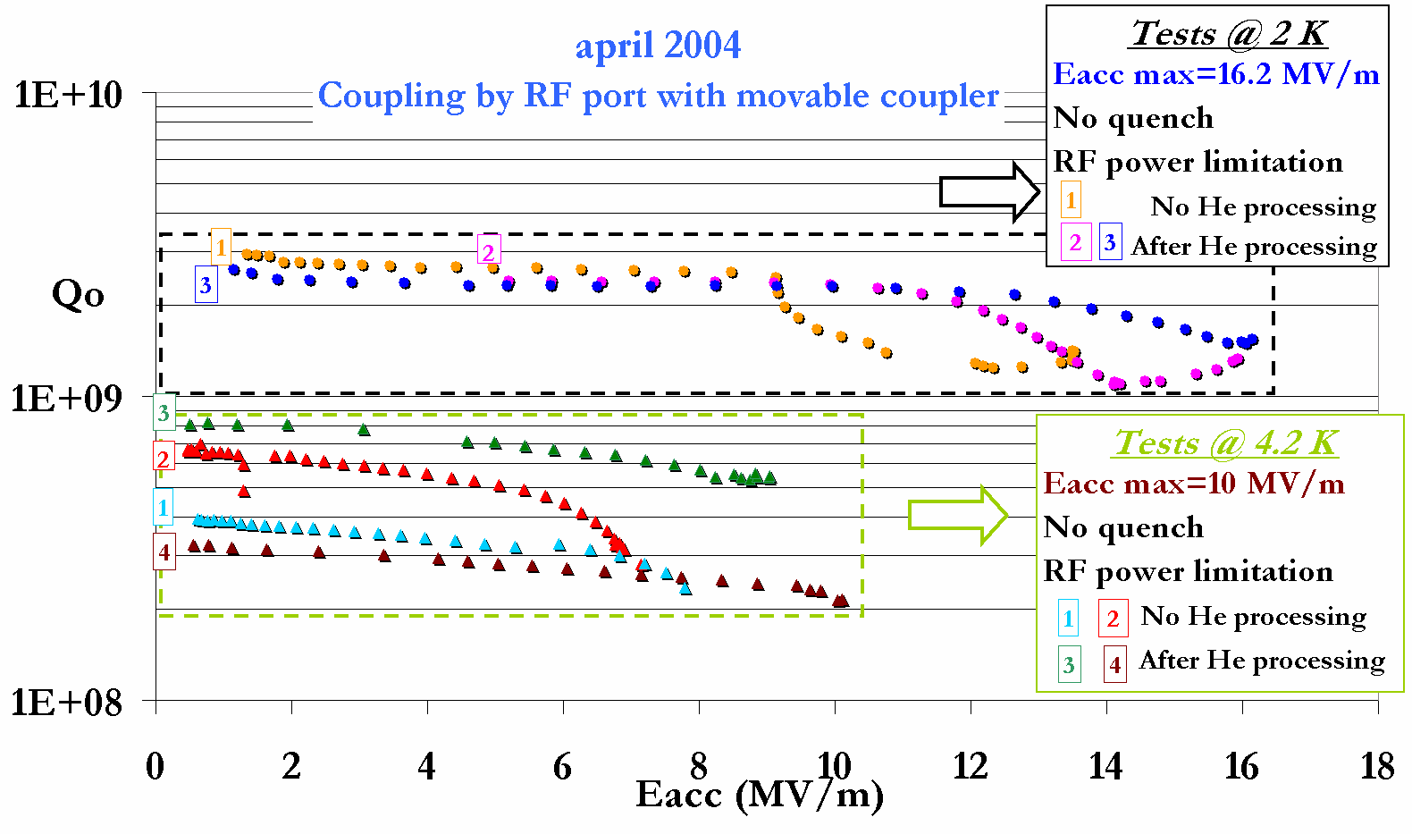

Experimental study of extra losses in the coupler antenna has confirmed the HFSS simulations. The position of the coupler port for the beta 0.15 prototype is confirmed (angle of 90° rather than 45°).

-3) Design of a 352 MHz Power Coupler Prototype 20 KW (CW) (subtask 3.2.4)
A RF comparative study of the ceramic window design (disc or cylinder) has been performed. In parallel, mechanical drawings and preliminary conceptual study of a test setup in a horizontal cryostat, are under way. Main components (i.e. ceramic window) will be ordered before the end of 2004. Assembly and preliminary low power tests are foreseen for the first quarter 2005 (first part of subtask 3.2.5). If expected funding is obtained in 2005, a 352 MHz power amplifier (5 - 10 - 20 KW) will be available for power tests. Then, the high power tests could take place in the second half of 2005 (second part of subtask 3.2.5).

-4) Design of a Multi gap Spoke Resonator (with FZ Jülich) (subtasks 3.2.6-7)

The first Collaboration Meeting took place in Jülich on February 3-4 and the second one after the HIPPI-WP3 meeting in Saclay on June 8. The initial task is the elaboration of a more precise specification list including the main parameters (beta value, beam current amplitude and timing). The preliminary calculations for Coupling and Tuning aspects will be performed in the September 2004-April 2005 period (subtasks 3.2.7). The milestone for the Design Report in May 2005 is confirmed.

FZ-Jülich (Spoke Cavities)

-1) Evaluation of 700 MHz Spoke Resonator (subtask 3.2.2)

The test stand is ready. The in-house electron beam welding machine was successfully recommissioned. Final welds on the 700 MHz resonator are planned for end of July 2004. Companies and Research Facilities have been contacted for chemical processing of the resonator. The colleagues in CEA-Saclay have offered their support for chemical treatment and for High Pressure Rinsing. Chemical processing is planned after the summer holidays. The evaluation report is confirmed for March – April 2005.

-2) Design of 352 MHz triple spoke resonator (together with IPN Orsay) (subtask 3.2.6)

The conceptual layout is finished. The resonator will be built with a second wall for the Liquid He containment to allow testing in the Orsay cryogenic test facility. Main work focuses on specification of the coupler, the integration of coupler and tuner and on interaction with engineers doing the mechanical design (subtask 3.2.8). Niobium sheets will be ordered by the end of July / beginning of August. First Copper tests for forming the end caps are currently being carried out. Limited workshop resources forced us to no longer try to build a full size Copper prototype. We decided to restrict the Copper work to the absolutely necessary workshop machine setup procedures. The Design Report is confirmed for May 2005.

IAP-Frankfurt (CH-structure)

-1) Development of superconducting CH-structure (subtask 3.3)

Present H-mode structures are all operated at room temperature. Many future accelerator projects require continuous (CW) operation. But the achievable gradients of room temperature CW operated H-mode cavities are limited due to power losses and cooling problems. The use of the KONUS beam dynamics allows realizing long lens free sections and makes superconducting multi-cell cavities for low and medium beta beams possible. The superconducting CH-cavity can be realized in the frequency range between 150 and 800 MHz, the beam energy can be chosen between 5 A·MeV and 150 A·MeV which corresponds to a β range from 0.1 to 0.5. The CH-structure can be used for proton as well as for ion beams. But it seems to be especially attractive for future high current proton linacs like XADS, HIPPI or deuteron linacs like IFMIF.

-2) Laboratory for testing superconducting structures

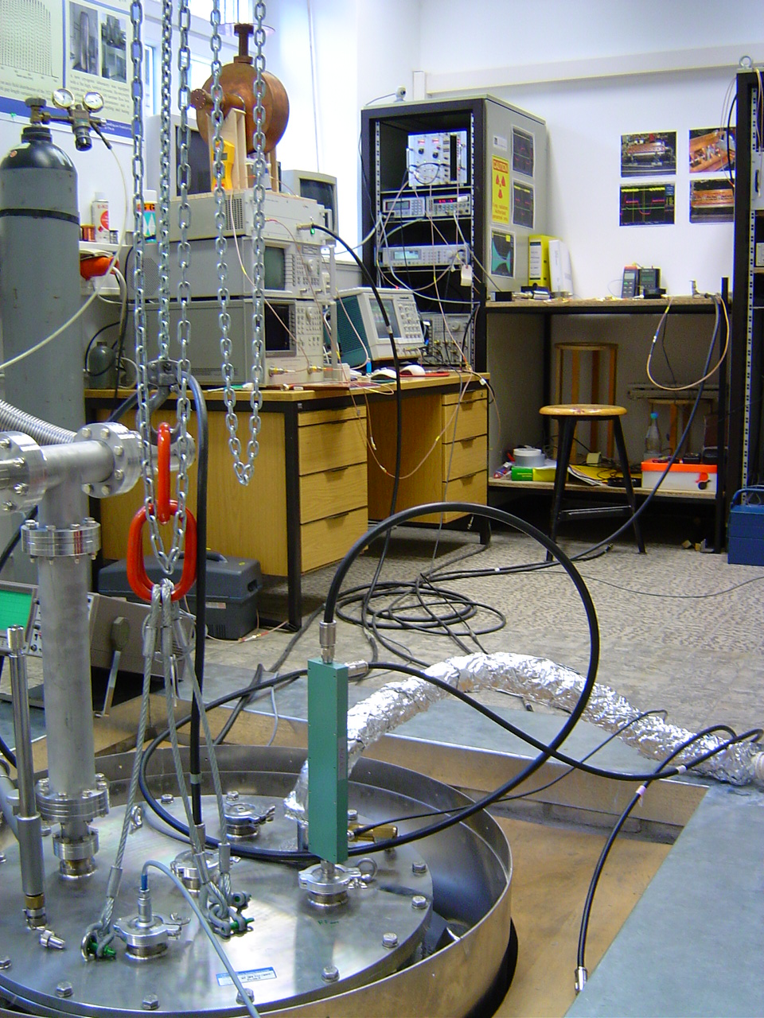
To test the cavity, a new laboratory has been established in Frankfurt. It is now fully equipped with a 3 m long vertical cryostat, two 250 l dewars, a helium recovery system, a class 100 laminar flow box, a magnetic shielding, RF input and output loop with amplifier, RF phase and amplitude control and power meter. A 176 MHz half wave resonator from ACCEL is currently under vacuum, cold-test conditions and phase locked.

View of the new cryo laboratory in Frankfurt with the cryostat in the foreground and the RF and phase systems in the background.

-3) Status of the superconducting CH-structures

A 1:1 copper model is already realised. The prototype 352 MHz cavity is being produced from 2-3 mm thick bulk niobium sheets with a RRR of about 250 by ACCEL in Bergisch Gladbach. The end-caps of the tank and of the girders are produced by spinning whereas all other parts are formed by deep drawing, then EB welded. The production and fabrication is nearly finished. The cavity is expected to be prepared (HPR, CT and HPP) and delivered end of August 2004. The power will be electrically coupled into the cavity by a coaxial coupler which goes through the girder to reach the required external coupling strength.

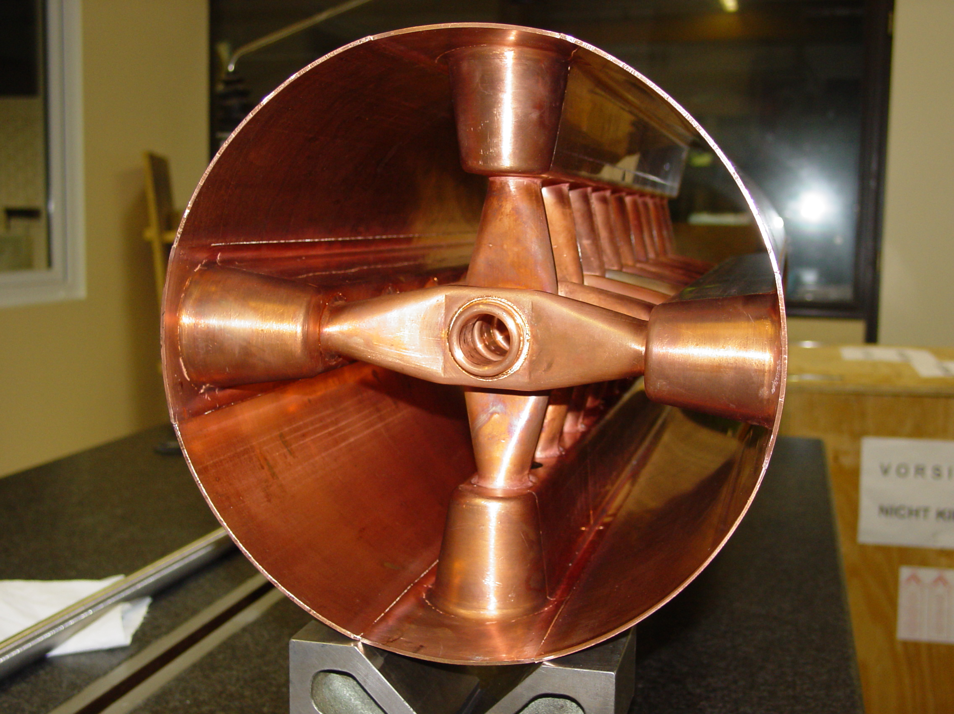

View in the electron beam welded 1:1 copper model of the sc CH-cavity

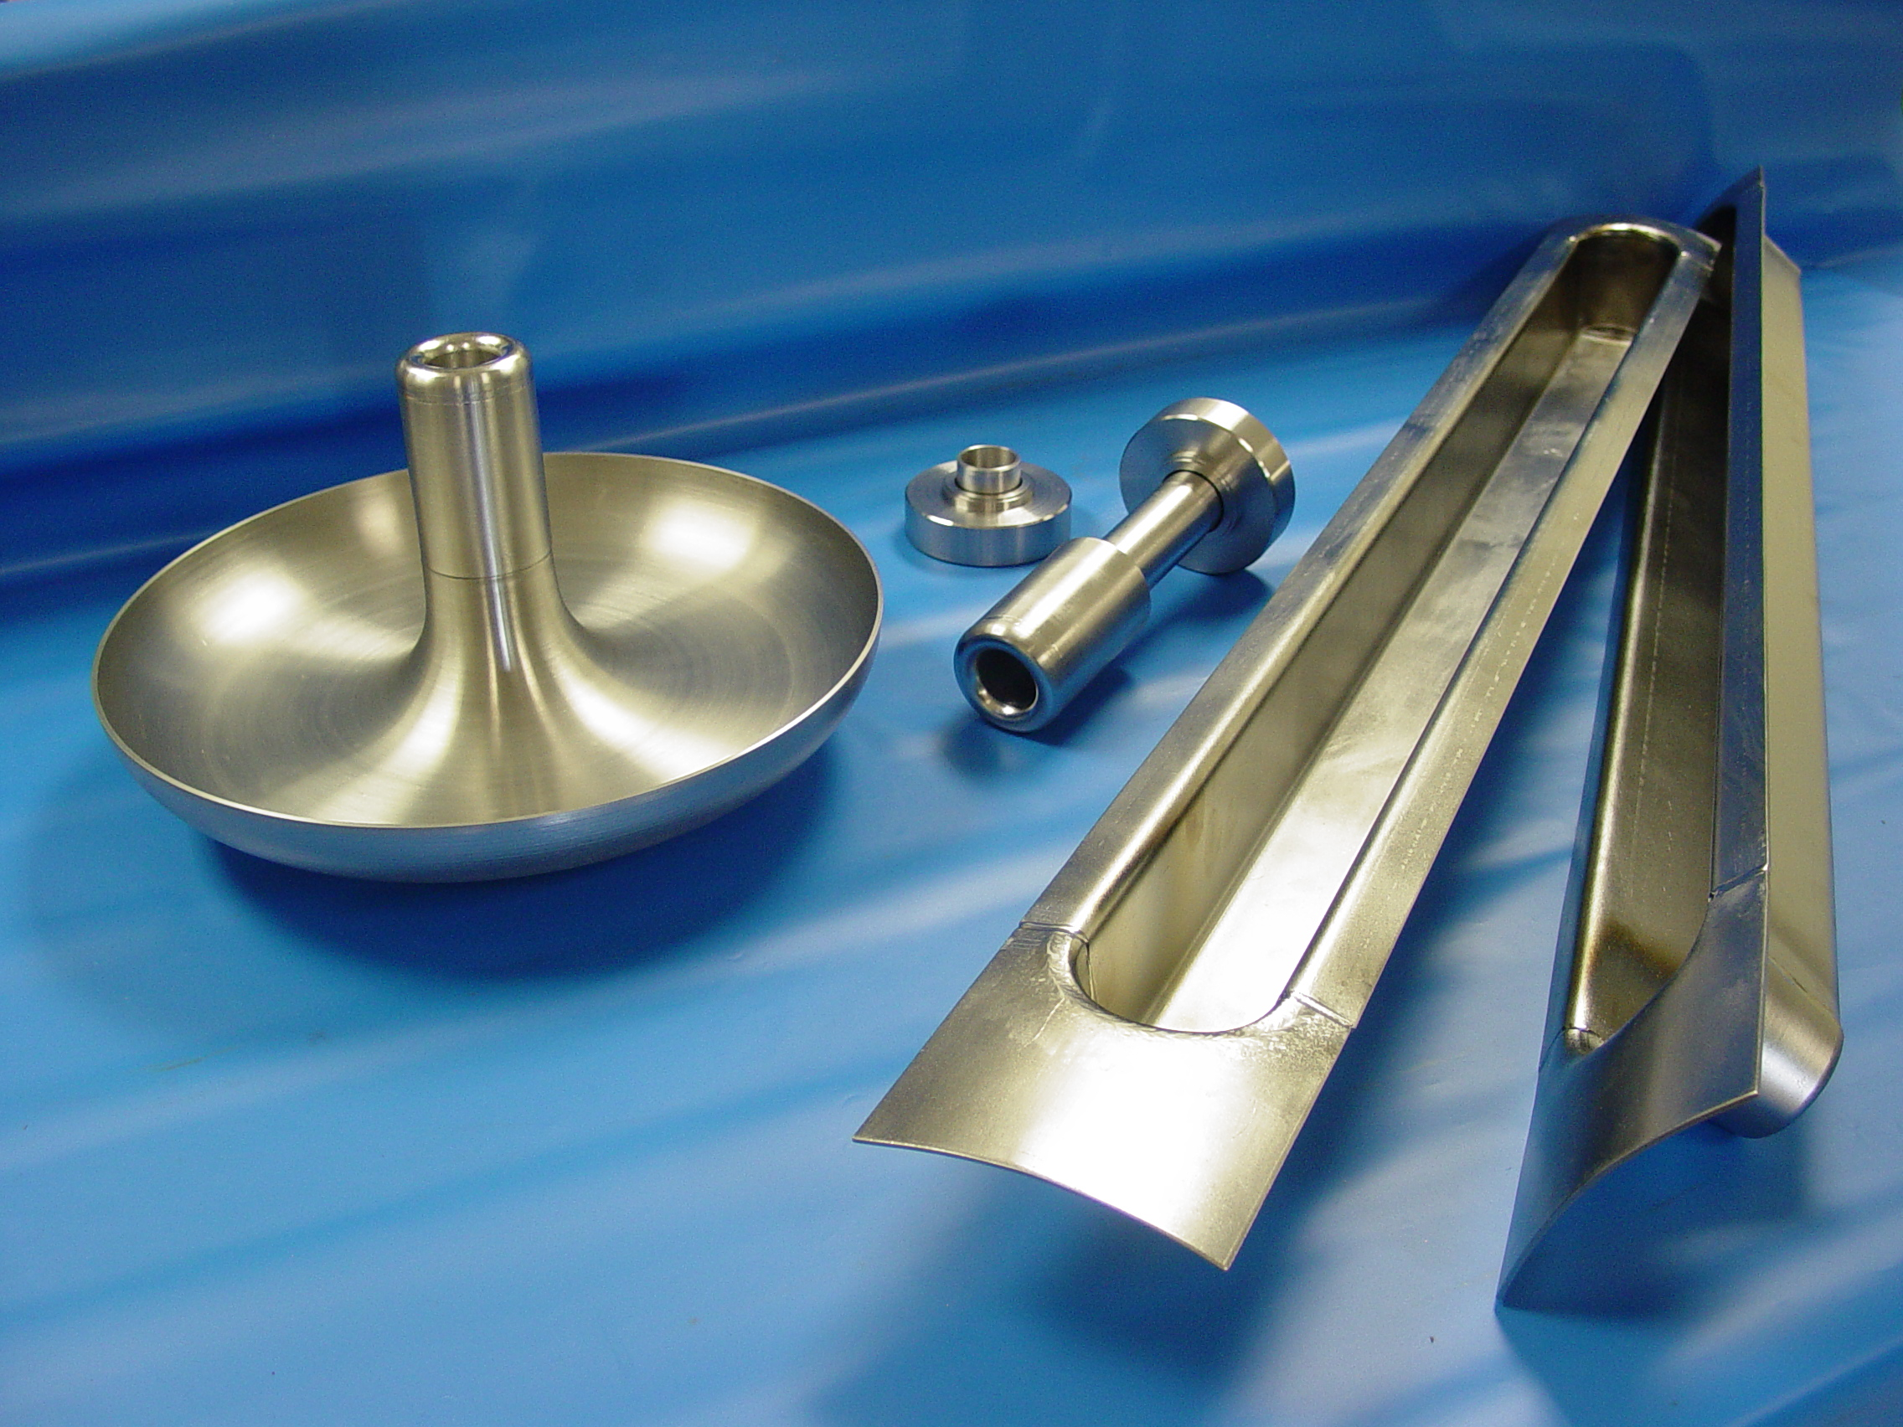

View of some parts of the Nb CH-cavity (endcap, girders and the first drift tube)

-4) Study of the tuning system (subtask 3.3.1)
Extended Microwave Studio™ simulations have been performed to investigate different tuning methods for CH-cavities. One tuning method is the static one, with small tuning cylinders which can be welded into the girders between the stems after the cavity production. For a certain height, the tuner decreases the frequency because of the increased capacitance. These cylinders can also be used to optimize the field distribution. Another tuning method is to stretch and to squeeze the cavity end cells by a mechanical tuner. The calculated frequency shift was about 190 kHz/mm. To determine the maximal possible mechanical stroke of the tuner, simulations with ANSYS™ are planned at GSI. In addition the Lorentz forces coefficients, the mechanical eigenmodes and the mechanical stress resp. frequency shift during cool-down will be investigated. These steps will be undertaken up the end of 2004. Afterwards the technical drawings of a mechanical tuner for the CH-cavity in a horizontal cryostat are scheduled.

Manpower

Permanent staff | 2004 – 1st quarter | 2004 – 2nd quarter
Institute | persons.month (FTE) | persons.month (FTE)
CEA-Saclay ⁽³⁾ | Engineer: 1.1  Technician: 0 | Engineer: 3.3  Technician: 0.6
FZJ ⁽¹⁾ | Eng.&Tech.: 1.5 | Eng.&Tech.: 1.5
IAP-FU | * | *
IN2P3 | Engineer: 1.0 | Engineer: 1.0
INFN | Eng.&Tech.: 1.0 | *

Temporary staff | 2004 – 1st quarter | 2004 – 2nd quarter
Institute | persons.month (FTE) | persons.month (FTE)
CEA-Saclay | None | None
FZJ ⁽¹⁾ | None | None | planned for 2005
IAP-FU | * | *
IN2P3 | None | None | planned for 2005
INFN | None | None ⁽²⁾
* missing information

⁽¹⁾ preliminary statement, facts only at the end of the fiscal year

⁽²⁾ no hiring has been possible up to now ; possibly getting a contract starting in the next weeks

⁽³⁾ only numbers given for the 1st quarter are consolidated
Budget

Budget | hardware, consumables, ... | travels
Institute | (kEuros) | (kEuros)
CEA-Saclay | 39 | 2
FZJ ⁽²⁾ | None | in calculation
IAP-FU | * | *
IN2P3 ⁽¹⁾ | None | 2.38
INFN ⁽³⁾ | None | *

(1) Allocated EU budget for the first 18 month was installed at the IPN-Orsay very recently (end of June 2004)

(2) Money arrival could be confirmed on 11-05-2004; details of the financial calculations under the regulations of FP6 are being investigated.

(3) Contract money acknowledged by INFN: end 03/2004 and money for consumables and travel allocated end of 04/2004

Table 4.3a : Status of the lowest Sub tasks level in the WP which are supposed to have started according to the MS project breakdown in Annex 1

WBS # | Title | Original begin date (Annex 1) | Original end date (annex1) | Estimated Status | Revised end date
3.1 | Elliptical cavities
3.1.1 | Cavity A (INFN-Mi) vertical tests | January 2004 | December 2004 | 50 % | On time
3.1.2 | Mechanical design of tuner, leverage system, motor (INFN-Mi) | July 2004 | December 2004 | Delayed: pending hirement of mechanical engineer at INFN-Mi | On time ?
3.1.3 | Integration of piezo design (INFN-Mi) | August 2004 | December 2004 | Started | On time
3.1.4 | Tuner construction (INFN-Mi) | January 2005 |  |  | On time
3.1.5 | Design cavity B (CEA) | June 2004 | December 2004 | 10 % | On time
3.1.6 | Construction cavity B | January 2005 |  |  | On time
3.1.7 | Power coupler design & engineering | January 2005
3.1.8 | RF source order and preparation | August 2004 |  |  | On time
3.2 | Spoke cavities
3.2.1 | Test stand preparation at FZJ | April 2004 | August 2004 | Completed | On time
3.2.2 | Evaluation of 700 MHz resonator (FZJ) in vertical cryostat | September 2004 | April 2005 |  | On time
3.2.3 | Evaluation of 352 MHz 2 gap resonator (IPN-O) in vertical cryostat | June 2004 | December 2004 | Start delayed | On time
3.2.4 | Design of coupler prototype (IPN-O) | January 2004 | April 2005 | 40 % | On time
3.2.5 | Test of coupler prototype (IPN-O) | May 2005 | September 2005 |  | On time
3.2.6 | Design of 352 MHz multi-gap resonator | January 2004 | April 2005 | 40 % | On time
3.2.7 | Design of coupler and tuner | January 2004 | April 2005 | 40 % | On time
3.2.8 | Engineering of resonator, coupler and tuner | May 2005 |  |  | On time
3.3 | CH resonator (IAP-FU)
3.3.1 | Study of tuning system | January 2004 | June 2005 | 33 % | On time

Table 4.3b: Status with respect to the interim reports and deliverables to be done in 2004 according to the MS project breakdown

WBS # | Title | Due date in Annex 1 | Status | Revised delivery date
3.1.1 | Cavity A vertical tests | December 2004 | 50 % | On time
3.1.2 | Mechanical design of tuner, leverage system, motor | December 2004 | Delayed: pending hirement of mechanical engineer at INFN-Mi | On time ?
3.1.3 | Integration of piezo design | December 2004 | Started | On time
3.1.5 | Design cavity B | December 2004 | 10 % | On time
3.1.8 | RF source order and preparation |  |  | On time
3.2.1 | Test stand preparation at FZJ | August 2004 | Completed | On time
3.2.2 | Evaluation of 700 MHz resonator in vertical cryostat | April 2005 |  | On time
3.2.3 | Evaluation of 352 MHz 2 gap resonator in vertical cryostat | December 2004 | Start delayed | On time
3.2.4 | Design of coupler prototype | April 2005 | 40 % | On time
3.2.6 | Design of 352 MHz multi-gap resonator | April 2005 | 40 % | On time
3.2.7 | Design of coupler and tuner | April 2005 | 40 % | On time
3.3.1 | Study of tuning system |  | 33 % | On time

  - Work Package 4: Beam Chopping

WEB SITE : http://lombarda.home.cern.ch/lombarda/WP4/WP4main.htm

The WP4 yearly meeting for 2004 took place at CERN on May 10 and 11. A total of 10 people (2 from RAL, 8 from CERN) participated full-time. Discussions were focused on the following issues: chopper structure, chopper drivers, dump, beam dynamics and also chopper tests with and without beam. The highlights of the workshop were that the chopper structure developed at RAL has evolved considerably and can now be fitted in a quadrupole as the CERN structure. The beam dynamics in the two proposed chopper lines has been compared with two codes (at RAL and at CERN) giving similar results. Finally, discussion started on the possibility of testing the RAL chopper in the 3MeV chopper line developed at CERN.

This first meeting has been very positive, giving the opportunity to informally exchange information and to set the basis for a stronger collaboration in the future.

CERN:

-1) chopper structure (subtask 4.1.1): a technical solution for the ceramic plate has been successfully tested at CERN (work presented at EPAC04 - see point 4). The completion of the drawing for execution of the chopper system is delayed due to overload of the CERN drawing office. The drawings should be ready by September and construction finished 6 weeks later. Testing (subtask 4.1.2) will then begin in November 2004.

-2) chopper driver (subtask 4.1.3): optimisation of the driver amplifiers is continuing towards the target values. Progress is slowed down by the unavailability of the CERN staff member having started the project. It results in a 6 months delay for the availability of the completed driver (June 2005).

-3) dump (subtask 4.2.1): the conceptual design is finished. The next step is the preliminary study of the detailed technical solutions and integration with the support and vacuum. This next step is currently blocked by the fact that the drawing office is overloaded and can’t complete the designs. It is nevertheless expected that the deadline for end of construction can be maintained (June 2005).

-4) A paper and poster on “The CERN-SPL chopper concept and final layout”, was presented at the recent EPAC 2004 conference at Lucerne (July 5-9)

RAL:

-1) The prototype fast transition time, short duration pulse generator has been delivered to RAL, and has been the subject of extensive acceptance testing (part of subtask 4.3.1). These tests have shown that the pulse generator meets all key specifications except the requirement for pulse droop. The problem has been discussed with the manufacturer, and has involved an extensive search for a specialized ferrite component. Samples of these components have now been tested, and a bulk order has been placed with the supplier. These components have been recently delivered to RAL, and some definitive tests are planned. If the results of these tests are successful, the original 18 pulse generator cards will be retro-fitted with these ferrite components. In addition, the next 18 cards (currently on order) will be equipped with the upgraded ferrite parts.

-2) The prototype slower transition time, high voltage pulse generator modules are being developed at RAL (part of subtask 4.3.1). The electronics design has been developed and checked using a 'SPICE' based circuit simulator (MicroCap 7™). These fan cooled high voltage modules must fit in a confined space, and so the design is challenging. A 3D CAD layout drawing in (Turbocad 10™), and a set of detailed 2D drawings for manufacture, have been recently completed. Specialised high voltage components have been identified, and orders have been placed with suppliers. Initially, one positive, one negative polarity module, and a high voltage 'dummy' load will be constructed and tested.

-3) Three presentations were prepared and presented at a 'Fast Beam Chopper' mini-workshop held at CERN, on 10th and 11th of May 2004.

-4) A paper and poster on 'A fast beam chopper for next generation high power proton drivers', was presented at the recent EPAC 2004 conference at Lucerne (July 5-9).

Hirement

The fellowship advertised on the CARE web site has been filled. The contract has started on July 1, 2004 at CERN in the ABP group.

Table 4.4a : Status of the lowest Sub tasks level in the WP which are supposed to have started according to the MS project breakdown in Annex 1

WBS # | Title | Original begin date (Annex 1) | Original end date (annex1) | Estimated Status | Revised end date
4.1 | Chopper structure A (CERN)
4.1.1 | Pre-prototype construction | January 2004 | June 2004 | Start delayed to September 2004 | October 2004
4.1.2 | Pre-prototype testing | July 2004 | November 2004 | Start delayed to November 2004 | March 2005
4.1.3 | Driver construction & testing | January 2004 | December 2004 | 30 % | June 2005
4.1.4 | Full scale prototype design | January 2005 |  |  | On time
4.2 | Chopper line (CERN)
4.2.1 | Dump design | January 2004 | June 2004 | 50 % | December 2004
4.2.2 | Dump construction | July 2004 | June 2005 | Start delayed
4.3 | Chopper structure B (RAL)
4.3.1 | Pre-prototype design and test | January 2004 | June 2005 | 30 % | On time
4.3.2 | Prototype design | January 2005 |  |  | On time

Table 4.4b: Status with respect to the interim reports and deliverables to be done in 2004 according to the MS project breakdown

WBS # | Title | Due date in Annex 1 | Status | Revised delivery date
4.1.1 | Pre-prototype construction | June 2004 | Start delayed to September 2004 | October 2004
4.1.2 | Pre-prototype testing | November 2004 | Start delayed to November 2004 | March 2005
4.1.3 | Driver construction & testing | December 2004 | 30 % | June 2005
4.2.1 | Dump design | June 2004 | 50 % | December 2004

  - Work Package 5: Beam Dynamics

The first WP5-collaboration meeting to coordinate code benchmarking & comparison with experiment took place in Darmstadt on June 4. Detailled information is available on the web-site of the work package

(http://www-w2k.gsi.de/Ihofmann/HIPPI%20WP5/WP%205%20main%20page.html).

-1) Joint development of existing and new codes (subtask 5.1.1)

At the occasion of the first coordination workshop on June 4th, space charge solver comparison between the different codes has been initiated. A web-page for benchmarking is now set up. At GSI, an exact Poisson solver solution is being developed. It allows comparison of the output of linac code space charge routines with exact solutions and the analysis of "tune" resolution versus particle number etc. A paper has been published at the EPAC’04 conference (G. Franchetti and A. Orzhekovskaya, GSI, "Fast space charge algorithm for an ellipsoidal bunch").

The visit at CERN of E. Froidefond (CNRS-LPSC) is planned for July. Saclay codes will be used. A new engineer partly working for WP5 will be hired for the beginning of October at theCNRS-LPSC.

-2) LORASR code development (IAP-FU) (subtask 5.1.2)

The development of the LORASR-code in IAP-FU is presently driven by current applications, e.g. the design of the GSI Proton Linac, as well as by the WP5 code benchmarking task (Alvarez calculation implementation).

The main activities related to common code development are: (a) development of a complete new graphical input version. (b) increasing the particle number in the simulations (c) faster PIC implementation.

The main activities related to the Alvarez DTL test simulations for code benchmarking are: Calculation of “Alvarez-type” gap field distributions for “norm gaps” by Microwave Studio™ simulations and parameterization of the approximated Ez(ri,z) distributions along different radial positions. Adaptation of the LORASR gap transformation subroutine to the Alvarez DTL.

-3) Code preparation for 3 MeV test stand (CERN) (subtask 5.1.5)

Simulation of the 3 MeV line: the code with all the elements of the line is ready and validated, the diagnostic of the line has been added. A first simulation of the commissioning of the line has been completed: it gives guidelines on setting the buncher phase to appropriate value by beam measurements, energy and energy spread measurements and emittance measurements via quadrupole scan.

-4) Code preparation for SC linacs (FZJ) (subtask 5.1.6)

Preparations for participation in the benchmarking according to the results of the WP5 meeting in Darmstadt are currently in progress.

-5) Experiments at UNILAC: preparation and simulation (GSI) (subtask 5.2)

A new experiment was proposed during the WP5 meeting on June 4. Simulations have started. The official request for GSI beam-time is under preparation.

A Postdoc position is opened and accessible on the HIPPI web-site.

-6) Profile measurement prototype design and construction (GSI) (subtask 5.3.1)

First studies have been performed concerning fluorescence detection from the residual gas. The method was tested with a proof-of-principle experimental set-up detecting one transverse plane only at an external beam dump behind the UNILAC facility. This activity is continuing with the installation of an improved system behind the last module of the UNILAC for both transverse planes, and the development of the data acquisition and presentation systems which are needed for the planned prototype.

-7) Halo measurement device design and construction (CERN) (subtask 5.3.4)
All the components are in house. The vacuum chamber for the final assembly is not ready yet. The detector will be assembled by the end of the year.

-8) Beam profile monitor design (FZJ) (subtask 5.3.5)

Beam profile monitor for space charge dominated beams. Preparations for detector assembly have started.

Table 4.5a : Status of the lowest Sub tasks level in the WP which are supposed to have started according to the MS project breakdown in Annex 1

WBS # | Title | Original begin date (Annex 1) | Original end date (annex1) | Estimated Status | Revised end date
5.1 | Code development
5.1.1 | Preparation, Dev. of 3D space charge routines, Testing | January 2004 | June 2006 | 20 % | On time
5.1.2 | LORASR development | January 2004 | December 2005 | 25 % | On time
5.1.3 | Transport in 3D map implementation | January 2004 | December 2005 |  | On time
5.1.4 | Improvement, modeling high current | January 2004 | June 2006 |  | On time
5.1.5 | Codes preparation for 3 MeV test stand | January 2004 | December 2006 | 15 % | On time
5.1.6 | Codes preparation for SC linacs | January 2004 | December 2006 | 15 % | On time
5.2 | Experiment at UNILAC: preparation & simulations | January 2004 | June 2006 | 20 % | On time
5.3 | Diagnostics and collimation
5.3.1 | Profile measurement prototype design and construction (GSI) | July 2004 | February 2005 |  | On time
5.3.2 | Profile measurement testing (GSI) | March 2005 | June 2006 |  | On time
5.3.3 | Non-interceptive bunch measurement design (GSI) | October 2004 |  |  | On time
5.3.4 | Halo measurement device design & construction (CERN) | January 2004 | June 2005 | 35 % done | On time
5.3.5 | Beam profile monitor design (FZJ) | January 2005 |  |  | On time
5.3.6 | Collimators design (CERN) | January 2005 | December 2006 |  | On time

Table 4.5b: Status with respect to the interim reports and deliverables to be done in 2004 according to the MS project breakdown

WBS # | Title | Due date in Annex 1 | Status | Revised delivery date
5.3.1 | Profile measurement prototype design and construction (GSI) | February 2005 | Started | On time

Appendix 1: Detailed implementation plan (Gantt chart) for the first 18 months as described in the Technical Annex

