 | 

CARE/JRA3: Second Quarterly Report 2005
31/08/2005

Title: High Intensity Pulsed Proton Injectors (HIPPI)
Coordinator: M. Vretenar (CERN), Deputy: A. Lombardi (CERN)

Participating Laboratories and Institutes:

Institute  (participant number) | Acronym | Country | Coordinator | Scientific Contact | Associated to
CCLRC Rutherford Appleton Laboratory (20) | CCLRC | UK | P. Norton | C. Prior
Commissariat à l’Energie Atomique (1) | CEA | F | R. Aleksan | A. Mosnier
CERN (17) | CERN | CH | G. Guignard | R. Garoby
Forschungszentrum Jülich (7) | FZJ | D | R. Tölle | R. Tölle
Gesellschaft für Schwerionenforschung, Darmstadt (4) | GSI | D | N. Angert | L. Groening
Institut für Angewandte Physik - Frankfurt University (5) | IAP-FU | D | U. Ratzinger | U. Ratzinger
INFN-Milano (10) | INFN-Mi | I | S. Guiducci | C. Pagani | INFN
CNRS Institut de Physique Nucléaire d’Orsay (3) | CNRS-IN2P3-Orsay | F | T. Garvey | T. Junquera | CNRS
CNRS Laboratoire de Physique Subatomique et de Cosmologie (3) | CNRS-LPSC | F | T. Garvey | J.M. De Conto | CNRS

Main Objectives: Research and Development of the technology for high intensity pulsed proton linear accelerators up to an energy of 200 MeV.

Cost:
Total Expected Budget | EU Funding
12 M€ (FC) + 2.7 M€ (AC)  Total 14.7 M€ | 3.6 M€

1 Management Activity 3
2 DISSEMINATION ACTIVITY 6
2.1 List of talks 6
2.2 List of papers 6
2.3 Web site 7
3 ADDITIONAL STAFF HIRING 8
4 STATUS OF THE WORK 9
4.1 Work Package 1 : Management and Communication 9
4.2 Work Package 2: Normal Conducting Accelerating Structures 10
4.3 Work Package 3: Superconducting Accelerating Structures 21
4.4 Work Package 4: Beam Chopping…………………………………………………36
4.5 Work Package 5: Beam Dynamics 40
Appendix 1: Gantt chart at end of August 2005...................................................................45

- Management Activity

  - Meetings
    - List of meetings
The list of events concerning HIPPI during the year 2005 is shown in Table 1.1.1a. More details about the events in the 2nd Quarter are given in Table 1.1.1b, which includes their web-site or the address for the minutes.
    - General meeting
The HIPPI general meeting in 2005 will be hosted by CCLRC (RAL) in Abingdon (UK), in the period September 28-30. Preparation for the meeting has started in July. The web site of the meeting has been set up by RAL (http://hippigm2005.isis.rl.ac.uk/) and a preliminary programme has been defined (Table 1.1.1b). 19 people have already registered, and all the three members of the External Scientific Advisory Committee have confirmed their participation.

  - External Scientific Advisory Committee

The implementation of the ESAC recommendations is continuing, in particular for the DTL design of WP2. Also during the 2nd Quarter the members of the ESAC have continued to provide to the HIPPI teams detailed information on similar projects in the US and Japan, that have proven very useful.

  - Change in the HIPPI Management
The original HIPPI Coordinator, Roland Garoby, has been asked by the AB Department of CERN to take responsibility for its Beam Diagnostics and Instrumentation Group, starting from September 1st, 2005. Considering that the requirements of this new position would not allow him to devote an adequate amount of time to the HIPPI Coordination, after consulting with the HIPPI Steering Group (Deputy and WP Coordinators) and with the CARE Coordinator he has decided to step back as HIPPI Coordinator as from July 1st. From this date and to the end of the project the role of Coordinator is assumed by his former Deputy, Maurizio Vretenar, while the role of Deputy Coordinator will be now taken by Alessandra Lombardi. Not to interrupt the important work that she is doing as Coordinator of HIPPI WP4, it has been decided that she will keep the task of coordinating WP4 in parallel with her new functions as Deputy Coordinator.

Table 1.1: Overview of meeting, workshop and event (co)organized by the Activity or with Activity contributions
 | Jan. | Feb. | March | April | May | June | July | Aug. | Sept. | Oct. | Nov. | Dec.
CARE & HIPPI
CSC meetings |  |  |  | 5 CERN |  |  |  |  | 5 & 6 Paris
Workshop WP2 |  |  |  |  |  | 2 &3 CERN
Workshop WP3 |  |  | 13 & 14 INFN-Mi
Workshop WP4 |  |  |  | 13 &14 RAL
Workshop WP5 |  |  |  | 14 & 15 RAL
HIPPI yearly meeting |  |  |  |  |  |  |  |  | 28 - 30 RAL
CARE yearly meeting |  |  |  |  |  |  |  |  |  |  | 23 - 25 CERN
Other workshops
High Power SC Linac |  |  |  |  | 23 - 25 FNAL
Other collaborations
IPHI-SPL | 27 & 28 CERN |  |  |  |  |  |  |  |  | ??? IPNO
Russia (ISTC) |  |  |  | 18 - 22 Russia |  |  |  | 17 – 19  CERN  (DTL) |  | 10 – 14  CERN  (CCDTL) | 5 – 11  CERN  (DTL)
Miscellaneous
INTC |  |  |  |  |  |  |  |  |  | 10 - 14 CERN
PAC05 |  |  |  |  | 16 - 20 Knoxville
ICIS05 |  |  |  |  |  |  |  |  | 12 -16 Caen

Table 1.2: List of meetings, workshops and events (co)organized by the Activity
Date | Title/subject | Location | Main organizer | Number of participants | Comments and Web site
April 13 - 14 | HIPPI WP4 2005 Workshop | Abingdon (UK) | CCLRC - RAL |  | Talks and minutes
April 14 -15 | HIPPI WP5 2005 Workshop | Abingdon (UK) | CCLRC - RAL |  | Talks and minutes
June 2 - 3 | HIPPI WP2 2005 Workshop | Geneva | CERN

Table 1.3: Preliminary programme of the HIPPI05 Annual Meeting at Abingdon, UK.
Wednesday 28, September, morning
9h00  10h00  12h30 | Welcoming address and Introduction  WORK PACKAGE 4 (Chopper) | A. Lombardi (convener)
Wednesday 28, September, afternoon
14h00  18h00 | WORK PACKAGE 2 (Normal Conducting RF struct.) | J.M. De Conto (convener)
Thursday 29, September, morning
8h30  12h30 | WORK PACKAGE 3 (Superconducting RF structures) | S. Chel (convener)
Thursday 29, September, afternoon
14h00  18h00 | WORK PACKAGE 5 (Beam Dynamics) | I. Hofmann (convener)
Friday 30, September, morning
9h00  11h00  12h30 | HIPPI planning and deliverables meeting  ESAC preliminary assessment  Concluding talk
Friday 30, September, afternoon: Visit to Rutherford Lab.

2 DISSEMINATION ACTIVITY
  - List of talks

A talk was presented at the High Power Superconducting Linac Workshop at Naperville (IL, USA), jointly organised by the Argonne and Fermilab Laboratories:

Table 2.1: List of talks presented by the JRA

F. Gerigk (CERN) | Design of the SPL Normal-Conducting Front-End | http://gerigk.home.cern.ch/gerigk/talks/HPSL05_linac4.pdf

  - List of papers
The Particle Accelerator Conference took place in Knoxville, Tennessee from May 16 to May 20. A total of 7 papers dealing with HIPPI activities were presented, all the working packages were represented. Besides, three HIPPI documents were issued, each of them corresponding to a milestone in the HIPPI planning, for WP4, WP3 and WP5 respectively.

Table 2.2: List of document issued by the NA or JRA

# | CARE document type and number | Title | Authors and Labs | Date
1 | CARE-Conf-05-008 (PAC05) | Space Charge Compensation Studies of Low Energy Hydrogen Ion Beams | Ahmed BenIsmail, Romuald Duperrier, Didier Uriot (CEA/DSM/DAPNIA), Nicolas Pichoff (CEA/DAM) | 06/2005
2 | CARE-Conf-05-009 ( PAC05) | The Transverse Nonlinear Tune Shift as Stabilising Factor in Halo Creation in Space Charge Dominated Beam | Nikita Vasyukhin, Yurij Senichev, Raimund Tölle (FZJ/IKP) | 06/2005
3 | CARE-Conf-05-010 (PAC05) | Comparison of Beam Dynamic in Different Superconducting Options of Low Energy High Intense Linac | Nikita Vasyukhin, Yurij Senichev, Raimund Tölle (FZJ/IKP) | 06/2005
4 | CARE-Conf-05-011 (PAC05) | Development of Normal Conducting CH-DTL | Gianluigi Clemente, Holger Podlech, Ulrich Ratzinger, Rudolf Tiede (IAP) | 06/2005
5 | CARE-Conf-05-014-HIPPI (PAC05) | Test of the Superconducting CH-Structure | Holger Podlech, Horst Deitinghoff, Horst Klein, HolgerLiebermann, Ulrich Ratzinger, Andreas Christoph Sauer (IAP) | 06/2005
6 | CARE-Conf-05-012 (PAC05) | Improvement of the Blade Tuner Design for Superconducting RF Cavities | Carlo Pagani, Angelo Bosotti, Nicola Panzeri, Rocco Paparella, Paolo Pierini (INFN/LASA) | 06/2005
7 | CARE Conf-05-015-HIPPI (PAC05) | “Fast-Slow” Beam Chopping for Next Generation High Power Proton Drivers | Michael A. Clarke-Gayther (CCLRC/RAL/ASTeC) | 06/05
8 | CARE/HIPPI Document-05-003 | Status of cern chopper driver and the solid state alternative | M. Paoluzzi,CERN | 07/05
9 | CARE/HIPPI Document-05-004 | Evaluation of the 760 MHz Triple Spoke Resonator  Intermediate Report | R. Eichhorn1, M. Pap1, M. Skrobucha1, R. Stassen1, R. Tölle1, B. Visentin2 1) FZJ, Jülich, Germany 2) CEA, Saclay, France | 07/05
10 | CARE/HIPPI Document-05-005 | Design and Construction of a Beam Shape and Halo Monitor for the CERN SPL | K. Hanke, M. Hori,CERN | 07/05

  - Web site
The HIPPI web site (http://mgt-hippi.web.cern.ch/mgt-hippi/) contains the most recent information on the JRA activity.

3 ADDITIONAL STAFF HIRING
The candidate for the position at CEA has been selected, but the contract is still going through the CEA administrative procedure. The new staff member at GSI has started in May. A new position has been opened at IAP Frankfurt for a physicist with experience in the field of particle accelerator development, as well as in the field of computational physics and programming. The status of HIPPI recruitment in the 2nd 2005 Quarter is shown in Table 3.

Table 3.1: Temporary staff hiring
# | Lab | Job Type | Duration | Work subject | Status
1 | CEA | Staff | 2 years | SC RF test stand (supervisor: S. Chel) | Published, candidate selected.
2 | IAP | Staff | 2 year | Beam Dynamics and Cavity Design Studies (Supervisor : U. Ratzinger) | Published
3 | GSI | Staff | 3 years | Beam Dynamics (Supervisor: I. Hofmann) | Started May, 2005

- STATUS OF THE WORK

  - Work Package 1 : Management and Communication

The main subject concerning Management and Communication in the 2nd 2005 Quarter has been the reorganisation of the HIPPI Management after the departure of R. Garoby.
Contacts were established with another Institute willing to coordinate its programme with WP2 of HIPPI and eventually to join the HIPPI JRA.
A significant effort has been devoted to the organisation of the remaining Work Package Meetings in April-June and to the organisation of the Annual HIPPI Meeting.
  - Work Package 2: Normal Conducting Accelerating Structures
A recent slow-down in the RAL activities was experienced owing to a restructuring of the group involved in HIPPI: F. Gerigk left in May 2005 to join CERN and G. Bellodi has taken over his previous functions. A replacement staff position has been opened and will be advertised soon. Also a new recruit (C. Plostinar) joined at the beginning of April on a 3-year HIPPI fellowship contract.

    - Drift Tube Linac
4.2.1.1 Activities at Rutherford Laboratory (RAL) (WBS 2.1.4)

In conjunction with progress on the RAL Front End Test Stand work, a re-assessment of the frequency for the new ISIS injectors has been carried out and a choice of 324 MHz has finally been agreed.
Initial contacts have taken place with Toshiba Electronics for the provision of RF klystrons at this frequency, and first quotations were received for their 3MW/324MHz/50pps/620μs model, as supplied to the JPARC project in Japan.
A re-design of the 180 MeV H¯ linac upgrade for ISIS at the new frequency value has just begun. The first provisional scheme would be based on an as yet unspecified number of DTL cavities accelerating the beam from 3 to 90 MeV, followed by an SCL section (up to 180 MeV) operating at 972 MHz.
Work has started on the DTL tanks design using SUPERFISH (Gen_DTL), with some exploration of the inter-dependences between various physical quantities (shunt impedance, Kilpatrick, face angle, diameter) in the search for optimal design parameters.
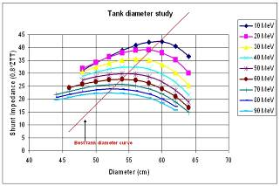
Fig. 4.2.1: Shunt impedance as a function of the tank diameter for different energy values.

4.2.1.2 DTL general design (WBS 2.1.1 to 2.1.4)

The DTL Task Force met again at CERN in April and June 2005. The beam dynamics design of the first tank was finalized, in particular with the definition of an error budget for alignment, mechanical, magnetic and RF errors, supported by a set of beam dynamics simulations. Moreover, the validity of some essential beam dynamics choices like the synchronous phase was confirmed by a consistent set of simulations.
A visit of a CERN team to VNIIEF Sarov, in charge of the mechanical construction of a DTL Tank1 prototype has been extremely useful to define the technologies that can be used to build a state-of-the-art DTL tank. In particular, has been retained the principle of separated alignment of the drift tubes with respect to a supporting girder, and the option of laser welding of drift tubes containing permanent quadrupoles, allowing the magnets to be outside of the vacuum.

4.2.1.2 DTL and coupling port design at CEA Saclay and LPSC (part of WBS 2.1.3)

After discussions (WP2 meeting at CERN, meeting at LPSC by the end of June), the thermal requirements for the coupling port have been refined and the thermal calculations finalized.
A solution is now proposed and is presented on figures 2, 3 and 4.

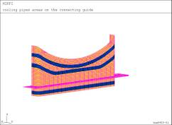

Fig. 4.2.2: Cooling structure. The pink part of the picture represents the flange. The upper part is the connecting guide to the DTL tank. The lower part is connected to the wave guide.

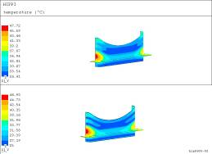

Fig. 4.2.3: The maximum temperature increase is 23 degrees Celsius. The cooling pipes have to be as close as possible to the DTL tank. The upper part of the figure represents the inner face of the connecting guide, the lower the outer.

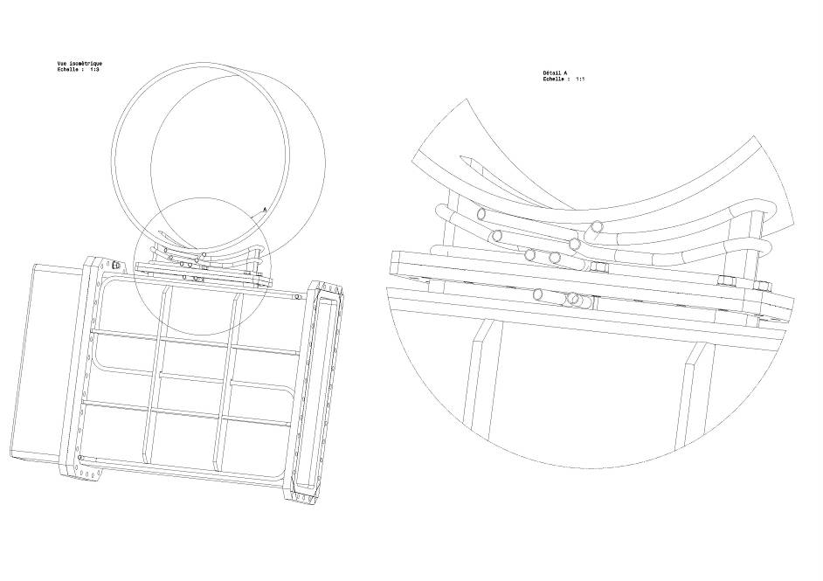
Fig. 4.2.4: General overview of the coupling port.

The power exchange is 44 W from the connecting guide to the DTL. Constraints studies have been finalized, showing no difficulty.
The next future steps will be:
- to summarize the studies and to present the solution to VNIIEF Sarov, who will be in charge of the tank, for the beginning of September.
- to design the coupling guide in details and to build it in Grenoble

    - H-mode DTL (IAP Frankfurt)

4.2.2.1 Beam dynamics design (WBS 2.2.4)

The beam dynamics design for the 70 mA, 70 MeV, 352 MHz proton linac for the GSI FAIR project has been completed. A design report on the linac front-end (including the MEBT between RFQ and CH-DTL and the CH cavity) is in preparation and will be published soon (HIPPI deliverable).
Recently, RFQ output distribution data from beam dynamics simulations at 70 mA (which is the GSI FAIR facility Proton Linac nominal current) were available.
Tracking of the RFQ distribution (all particles, including “halo” particles) without any change in parameter settings compared to the initial 90 mA CH-DTL design (for instance no correction of the quadrupole lens strengths for improved transverse beam matching) is already promising: the transmission through the 3 – 70 MeV CH-DTL section is 100% and the GSI FAIR Project output beam parameter reference values are mainly fulfilled.

Preliminary results are shown in Figure 5.
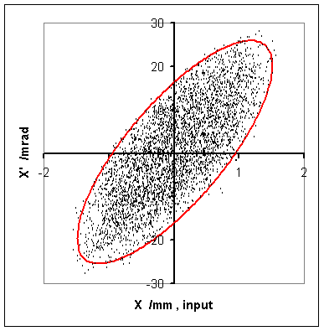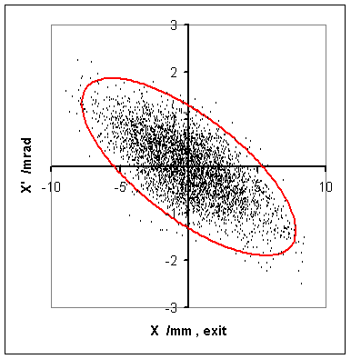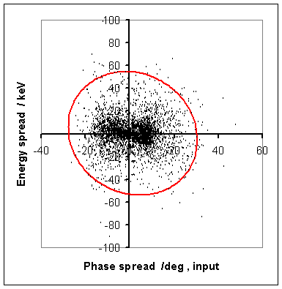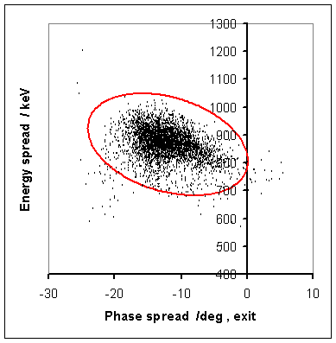

Fig. 4.2.5: Transverse beam envelopes, as well as transverse and longitudinal particle distribution at the entrance and at the exit of the 3- 70 MeV CH-DTL lattice.

Further beam dynamics optimization steps will be necessary, according to the updates of the available RFQ output distribution data. However, these optimization details will lead to minor changes and have no influence on the basic CH-DTL lattice design parameters (number of tanks, overall length and so on).

4.2.2.2 RF cold model design & construction (WBS 2.2.2)

The fabrication and assembly model is now under construction in the IAP workshop. It will be used in order to test the fabrication steps for the prototype cavity to be built. It consists of 8 identical cells for β = 0.09 (β λ /2 = 45 mm) which would correspond to the length of the last gap in the first CH cavity for the planned GSI Proton Injector.

As an intermediate result of the detailed design works within the HIPPI Project activities, it is proposed the following construction concept: the stems will be welded to the outer wall, while the massive copper half drift tubes will be press-fit into the stainless steel stems.

The model components are all fabricated. Figure 6 shows one stem together with the inner (water cooled) rings, to which the half drift tubes will be mounted.

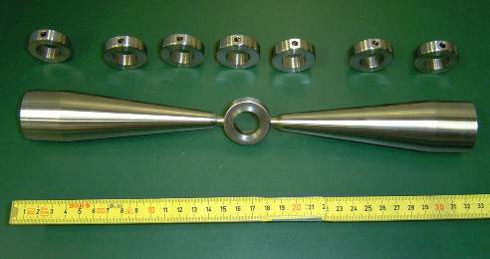

Fig. 4.2.6: Components of the fabrication and assembly model cavity: One stem with already welded inner ring, as well as the other water cooled rings for the 8 cell cavity.

As soon as possible, both mechanical and RF tests will be performed on the manufactured cavity: in particular, the effectiveness of the press-fitting technique will be tested, with several options regarding the shape of the tubes. Concerning the cavity tuning (resonance frequency and field flatness), the results on the cold model RF measurements should confirm the latest Microwave Studio design with the big end cells.
According to this new concept, the larger drift space at the cavity module ends, which is needed in order to enlarge the magnetic inductance at the cavity ends and thus to get the flatness of the electric field distribution, can be used to host one part of the quadruple lens or a diagnostics device.

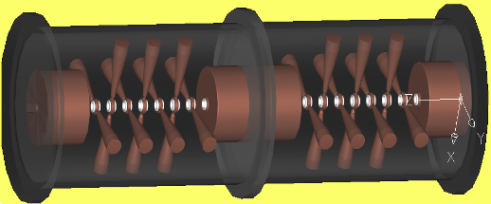

Fig. 4.2.7: Overview of the proposed design for the CH-DTL: the large end cells will host the quadrupole lenses and the beam diagnostics, while the massive copper drift tubes (shown here in white) will be press-fit into the stainless steel stems.

According to the HIPPI WP2 scheduling time all the measurements will be concluded within 2005 and the gained experience will be used for the construction of the Prototype Cavity foreseen in 2006.
    - Side Coupled Linac (LPSC) (WBS 2.3.1 and 2.3.2)

The error studies have been finalized. Even with a large coupling factor (and hence a low quality factor), the mechanical tolerances are too strong to avoid a mechanical tuning after construction. So, the conclusions are that a tuning ring is mandatory, and the best coupling factor has to be 3%.
The coupling slot has now to be studied carefully (its shape for example) to minimize the spread of the coupling factor k from one coupling cell to the other one, which would lead to variations in the accelerating field.
Several thermal studies and cooling scenarios have been investigated. An example is given below. The cooling philosophy is to control the accelerating frequency by water temperature tuning and to design the cooling system in order to keep the stop band (due to the change of the resonant frequency of the coupling cell) below 100 kHz. So, thermal but also displacement studies have been performed to fulfil these requirements and a solution is now proposed.
An important conclusion is that the current design is acceptable. In particular, there is no need to increase the copper thickness between to adjacent accelerating cells (leading to a lower Q value).
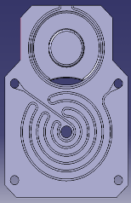
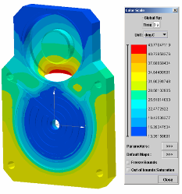

Fig. 4.2.8: Cooling system for the SCL cavities (left) and temperature chart (right).

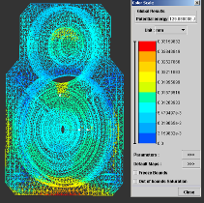

Fig. 4.2.9: Displacements inside the cavity

The next steps will be
- To investigate the real feasibility of the solution, in terms of brazing
- To propose this solution to the Russian team from ISTC, in charge of the technological model
- To launch the construction of the cold model at LPSC. The goal of the model will be to check RF calculations, to investigate the tuning procedures, and to finalize the cavity design
- To study, in parallel, the optimization of the coupling slot

All these steps will start in September.

    - Cell Coupled DTL (CERN) (WBS 2.4.1 to 2.4.3)

The CCDTL pre-prototype has been assembled in a test stand at CERN, in order to go through a series of low-level RF measurements preliminary to the copper plating of the input coupler and to the high-power tests.
The first step of the assembling procedure was the alignment of the drift tubes inside the half-tanks. An alignment bar was inserted in the beam hole (Fig. 10), and then the supporting stem was welded on the outside, blocking the tube in the aligned position. After the alignment, the tanks were equipped with covers, with dummy tuners to be used for the low-level RF measurements and finally with the waveguide coupler. On one side of the coupler was installed a movable short-circuit, required to match the coupler, while on the other side a coaxial-waveguide transition allows entering the coupler with a Network Analyzer. The assembled prototype is shown in Fig. 11.
After some simple rounds of tuning the 3 coupled resonators composing the prototype (2 half tanks and 1 coupling cell) could be tuned within 642 kHz, resulting in a stop band of 679 kHz. These values are considered satisfactory for the first round of measurements, and the tuning will be further improved in a second stage, using the final tuners. A bead-pull measurement (Fig. 3) of electric field along the prototype shows the correct field distribution, the total field error being 5%, in good agreement with the measured values of the cell frequencies and already close to the final goal of 4%.
The measured coupling between tanks and coupling cell is 0.86 %, very close to the value predicted by 3D simulations, 0.83%. The Q-value is 21’000, still only 65% of the 2D (Superfish) calculated value, 75% being a reasonable goal for this prototype. However, it is expected to improve when the final tuners will be installed. The coupling between waveguide and cavity is large enough to allow a perfect (-35 dB) matching even for the low Q-value. The measured β-coupling is in excellent agreement with the simulated value.
In July-August the coupler will be copper-plated, and then the final assembly will take place. After a second round of low-level RF measurements in September, the pre-prototype will be ready for high-power tests.
A visit to VNIEEF Snezinsk, in charge of the construction of the next CCDTL prototype has taken place in April. The design is basically terminated; the open points being under discussion are the copper plating details (surface roughness) and the design of the supporting frame.

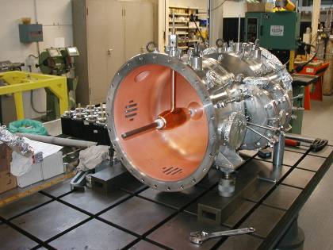

Fig. 4.2.10: Alignment of the drift tube inside the CCDTL pre-prototype

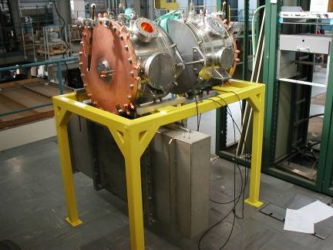

Fig. 4.2.11: The assembled CCDTL pre-prototype. On the bottom can be seen the waveguide coupling port.
Fig. 4.2.12: Bead-pull measurement of longitudinal electric field on axis along the pre-prototype. The field in the 4 accelerating gaps is clearly visible.

Table 4.2a : Status of the Sub tasks in WP5 which are supposed to have started according to the MS project breakdown in Annex 1

WBS # | Title | Original begin date (Annex 3) | Original end date (Annex 3) | Estimated Status | Revised end date
2.1 | Drift Tube linac
2.1.1 | DTL Design | July 2004 | June 2007 | On time
2.1.2 | Decision on prototyping | April 26, 2004 | April 26, 2004 | 100% | September 2004
2.1.3 | DTL coupler prototype design | May 2004 | June 2005 | 100%
2.1.5 | DTL coupler prot. constr., testing | July 2005 | June 2006 | 10%
2.1.4 | DTL beam dynamics design | January 2004 | June 2008 | On time
2.2 | H mode DTL
2.2.1 | RF model CH tank 1, RF design | January 2004 | August 2004 | see note | see note
2.2.2 | RF cold model design & construction | January 2004 | January 2005 | 85 % | October 2005
2.2.3 | RF model construction | December 2004 | June 2005 | 40% | June 2006
2.2.4 | Beam dynamics design CH tank 1 | January 2004 | June 2004 | 100 % | June 2005
2.2.5 | CH model cavity tests | January 2005 | December 2005 | 65%
2.2.6 | CH prototype design | January 2005 | October 2005 | 75%
2.2.8 | CH DTL beam, dynamics study | January 2005 | June 2005 | 100 %
2.3 | Side Coupled Linac
2.3.1 | RF model, RF design | January 2004 | July 2004 | 40 % | Mid 2005
2.3.2 | RF model mechanical design | July 2004 | December 2004 | 30 % | End 2005
2.4 | Cell Coupled DTL
2.4.1 | Pre-prototype construction | January 2004 | June 2004 | 100%
2.4.2 | Pre-prototype high power RF tests | July 2004 | March 2005 | Delayed | October 2005
2.4.3 | Prototype mechanical design | January 2005 | June 2005 | 90 % | On time

Note: for 2.2.1, RF measurements will be done directly on the prototype cavity
Table 4.2b: Status with respect to the interim reports and deliverables due in 2005 according to the MS project breakdown

WBS # | Title | Due date in Annex 1 | Status | Revised delivery date
2.2.5 | Test of CH model cavity: intermediate report | December 2005 | On time
2.2.8 | Design report on beam dynamics in the CH-DTL | June 2005 | Delayed | September 2005
2.4.1 | Construction of CCDTL pre-prototype: intermediate report | June 2005 | Delayed | December 2005

  - Work Package 3: Superconducting Accelerating Structures

INFN-Milano

Subtask 3.1.2 (Mechanical design of tuner) and 3.1.3 (Integration of piezo design).
The main mechanical aspects of the cavity have been fully characterized, in terms of their effect on the RF frequency, in order to define the design boundaries for the tuner. The calculations for the static Lorentz Force Detuning (LFD) have been extended to the entire multicell cavity geometry and for arbitrary mechanical boundary conditions.
The following table resumes the main cavity parameters.

Table 4.3.1. Cavity A mechanical/RF characterization
Spring Constant and tuning sensitivity
K_{cav} | 1.248 kN/mm
∂f/∂z | 353.4 kHz/mm
Vacuum load behaviour (constrained)
Frequency vacuum coefficient (constrained), K_{V}∞ | 84.72 Hz/mbar
Longitudinal reaction force coefficient at boundary, R∞ | 3.7 N/mbar
LFD Characterization (constrained)
Static K_{L}∞, with constrained boundary | -3.71 Hz/(MV/m)²
Longitudinal reaction force coefficient at boundary, F∞ | -0.177 N/(MV/m)²

The two load cases described in the table above can be accurately generalized to the case of an arbitrary boundary condition, characterized by its longitudinal stiffness K_{ext}, via the following relations:
$$\begin{matrix}K_{L}(K_{\text{ext}})=K_{L}^{∞}+\frac{∂f}{∂z}\frac{F^{∞}}{K_{\text{ext}}+K_{\text{cav}}} & {\text{Hz}}/({\text{MV}}/m)^{2} \\ K_{V}(K_{\text{ext}})=K_{V}^{∞}+\frac{∂f}{∂z}\frac{R^{∞}}{K_{\text{ext}}+K_{\text{cav}}} & {\text{Hz}}/{\text{mbar}}\end{matrix}$$

This generalization allowed to correctly interpreting the experimentally determined LFD of the Saclay/JLAB measurements, mainly determined by the low stiffness of the cavity supports.
Two different cavities of the shape of Cavity A (INFN cavities Z501 and Z502) have been measured several times in the last years, demonstrating the possibility to reach the design gradients with a sufficient margin. However, the RF measurements indicated a rather big value for the static LFD coefficient, with a rather large spread in the data. The data is for the six tests (three at Saclay on the Z502 and three at Jlab for the Z501) are shown in the following figure, with the corresponding K_{L} values from the curve fits. The evaluation of K_{L} ranges from -3.7 Hz/(MV/m)² in the fully constrained condition to -54 Hz/(MV/m)² in the free cavity case, according to the analyses described before.
The stiffness of the test environments in the two experimental conditions at Saclay and Jlab has been extensively model, in order to verify the simulation schemes with the measurements. The two support structures, shown in the Figure below, are very different: the Jlab titanium cage constraints the cavity at the He tank dishes positions, whereas the stainless steel Saclay support imposes a constraint at the cavity flanges.
Figure 4.3.1. Static LFD coefficients for the Z501/Z502 cavities.

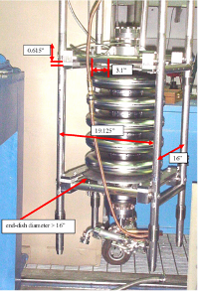
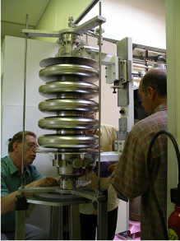
Figure 4.3.2. The test environment in Jlab (left) and at Saclay (right)
Structural calculations of the two support structures yield a stiffness of 0.93 kN/mm for the Jlab case and 2.39 kN/mm for the Saclay case. The following figure compares the experimental LFD from the measurement with the estimations discussed before.
In both cases the external stiffening system has roughly the same stiffness of the cavity itself, thus providing a very weak constraint to the change of its length due to the action of the electromagnetic fields. The measured LFD coefficient is thus nearly that of a “free” (unconstrained) cavity, with a rather big spread due to the uncertainty of the mechanical fixtures.
Figure 4.3.3. Comparison of the measured LFD coefficient with estimations, as a function of external stiffness.

The mechanical characterization of the cavity thus obtained is being used to finalize the tuner design and set the choice of subcomponents, in terms of required performances (motor, leverage and piezo excursions). It is foreseen to start the procurement through the industry of the main mechanical tuner components before the end of the year, in order to obtain them by mid 2006. The final tuner design will be presented in the intermediate report foreseen by the end of 2005.

CEA-Saclay

Post-analysis of cavity A vertical tests performed in 2004 (LFD studies).
During INFN cavity A tests in vertical cryostat at Saclay, the measured Lorentz detuning coefficients K_{L} were higher than expected from numerical simulations. In a first step, we re-performed calculations of K_{L} coefficients on cavity A with two different set of numerical codes at CEA-Saclay and INFN-Milano and found a very good agreement. Since mechanical boundary conditions are extremely important for K_{L} evaluation, we have investigated the stiffness of the existing cavity holding frame used at Saclay using CASTEM FEM code. The computed stiffness is 2.4 kN/mm which is very weak, and still over evaluated due to model simplifications.
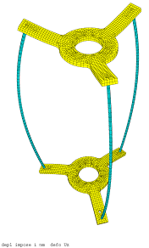

Figure 4.3.4: Deformation of the cavity holding frame

Another approach was used in order to evaluate this stiffness from the experiments. Using the data on the detuning versus He pressure when cooling down to 1.7 K one gets df/dP = -426 Hz/mbar. The coupled structural/RF calculations of the detuning when varying the external stiffness and applying He pressure on the cavity allows to determine the k_{ext} that corresponds to the measured df/dP. For k_{ext} =1kN/mm, one gets df/dP = -400 Hz/mbar which is very close to the measured value. In conclusion, the frame stiffness was found to be very low, and the high values of measured Lorentz detuning coefficient, which were close to the “free ends” case, are now fully understood. The study of a new frame is started in order to be able to perform the future measurements with “fixed ends” boundary conditions.

Design of cavity B (subtask 3.1.5)
Design of the cavity B is now finished. A set of full 3D-model and detailed drawings is available. We still have to perform some mechanical calculations to study in details the interface between the Helium tank of the cavity and the tuning system. A first model is however ready (see fig. 5). The drawings of the cavity with its helium tank should be finalized for October 2005.
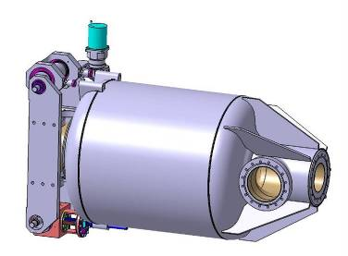

Figure 4.3.5: First model of the helium tank with the tuning system

Construction of cavity B (subtask 3.1.6)
With the drawings of the cavity B, we are preparing the order for the niobium material (sheets, disks and tubes) necessary for the cavity fabrication. The call for offers for the realization of the cavity including the helium tank will be done in parallel. We should be ready to place the order of the cavity and Helium tank in November 2005 and should receive the niobium material at the same time.

Power coupler design and engineering (subtask 3.1.7)
The RF design of the power coupler is almost finished. Next step is to begin the mechanical drawings, since a lot of interfaces (with the cavity, the thermal shield, the vacuum tank, …) have to be considered and correctly designed before going on in the thermal and mechanical calculations. A preliminary drawing should be available for December 2005.

RF source order and preparation (subtask 3.1.8)
The construction of the klystron should begin next September.
The order for the circulator is ready to be placed.

Modulator preparation for the 700 MHz test stand (subtask 3.1.10)
The modulator HV tank has been disassembled, carefully checked, cleaned and re-filled with fresh oil. This gives us a better view of what has to be modified apart from the electronic components. We are now ready to begin the modifications of the drawings of the HV modulator (water cooling, HV connectors, frame,…) which should be available next November. Since the characteristics of the klystron are now frozen, we are ready to launch the call for offers for the 110kV power supply.

FZJ
Test stand preparation (subtask 3.2.1)
The test stand is prepared. It was tested successfully with measurements on superconducting HWR structures. The goal of this activity has been reached and the activity is now closed.

Evaluation of 700 MHz resonator (subtask 3.2.2)
The weldings for this resonator were successfully completed and Helium leak test was successfully passed. Chemical treatment was performed at CEA Saclay. 104 µm of Nb were removed. After final rinsing the cavity was closed with clean coupler and antenna and transferred back to Jülich. Cool-down at FZJ test stand took place on March, 7th 2005, RF measurements started in March 2005.

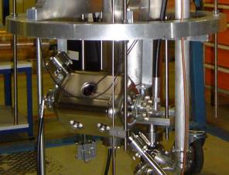
Fig. 4.3.6: Niobium cavity mounted on the cryostat girder.

The result of this first measurement is displayed in the figure below. The measurement was limited by a cable failure, so the data shown are NOT limited by the cavity.
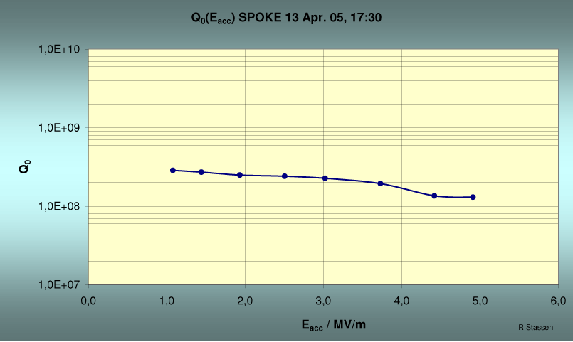
Fig. 4.3.7: Q vs Eacc curve at 4 K ( The accelerating field was limited by RF power)

Presently, the cavity is prepared for another cool-down after changing the coupler length.
Meanwhile the interim report on the cavity performance has been delivered as CARE/HIPPI Document-2005-004. Further measurements are planned for autumn 2005 to gain more knowledge on the cavity performance. Thus, it is suggested to extend this activity until 12/05.

RF design of 352 MHz multigaps resonator (subtask 3.2.6)
The RF design of the 352 MHz resonator was frozen. It was decided to build the resonator without He cover for use in a bath cryostat. Calculations aiming at supplying sufficient rigidity to the structure and at the same time limiting the mechanical stress on the niobium to practical values are completed. The results have been summarized in a report. It is being delivered in August 2005.

Final mechanical design of resonator (subtask 3.2.7)
This task is completed. Design drawings of the resonator are finished.

Integration of coupler. Tuning options (subtask 3.2.8)
Coupler is contributed by IPN-Orsay. Options for tuning under the existing boundary conditions will be evaluated. Integration of coupler and possibly tuning is in progress.

Preparations for electron beam welding (subtask 3.2.9 – new sub task)
The forming process for relevant parts of the cavity (e.g. end caps) has started using copper sheets. Ordered RRR Nb sheets arrived in the lab. Detailed mechanical design of the resonator started.

In parallel, FZJ is preparing with IPNO the test of the 352 MHz resonator. Planning for cryostat and power amplifier to be available for resonator test is progressing well. Power test will be limited by the available pulsed amplifier.

IPN-Orsay

Evaluation of 352 MHz 2-gap prototypes (subtask 3.2.3)
The first cold test of the 352 MHz, beta 0.15, 2-gap spoke cavity (Fig. 8) was performed in April 2005. The preparation of the cavity was: BCP chemistry (etching of ~140µm) followed by 2-hour HPR processing through all ports.
The test at 4K: after 2 hours of conditioning a maximum gradient of Eacc= 9.6 MV/m was reached (Eacc defined by an iris-to-iris length). The maximum gradient was limited by a quench. Two multipacting barriers were observed at 1.5 MV/m and 7-8 MV/m. These barriers were processed in a few minutes. X-rays emission started from 4 MV/m during the first run. After conditioning, no more X-rays emission was observed during the 2nd and 3rd runs.
A test at 2K was performed, this time the quench was measured at Eacc= 10.5 MV/m. One multipacting barrier was observed around 8 MV/m, and no X-rays emission.
For both tests, the quenches occurred at the same Bpk field level ~70mT (Fig. 9)

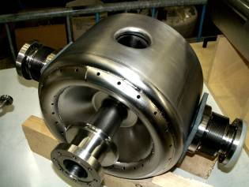

Fig. 4.3.8 : 2-gap spoke cavity (β 0.15)

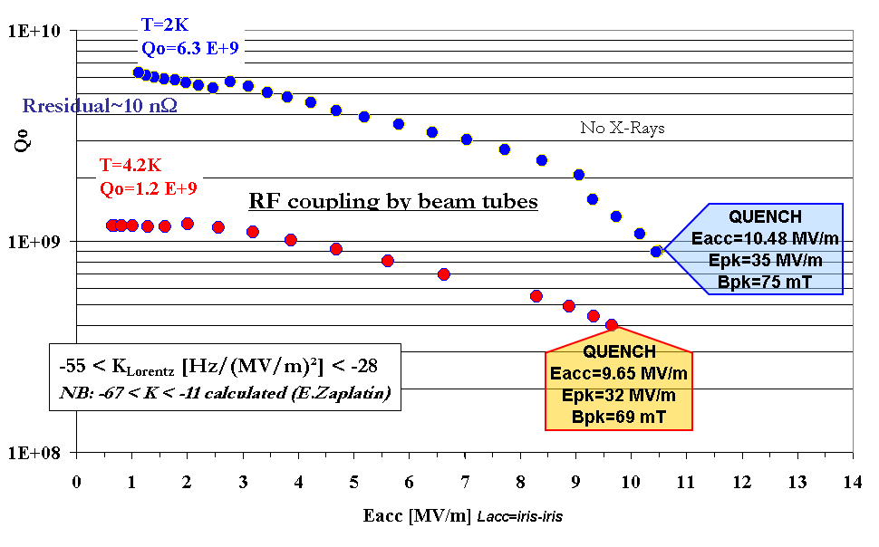
P_{cav}=8W
P_{cav}=15W
Lorentz forces detuning
Experiment (cav “free”): -55< K_{Lorentz}<-28
Calculation: -67 (cav free) < K_{Lorentz}<-11 (cav fixed)

Fig. 4.3.9 : First cold tests results (2K and 4K) of the 2-gap spoke cavity (β=0.15)

During these tests the Lorentz forces detuning coefficient was measured: a wide spread in coefficient measurements was observed: from -55 to -28 Hz/(MV/m)². The cavity was only maintained in position inside the vertical cryostat, but no mechanical fixture was installed to keep the beam tubes fixed.

FZJ has performed calculations on the Lorentz force detuning (using ANSYS software) for both boundaries conditions (beam tubes fixed and free) and for 3 different wall thicknesses of the cavity (2 mm, 2.5 mm and 3 mm, see Fig. 10).

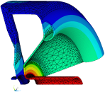
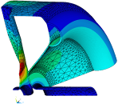
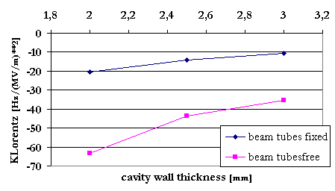
Beam tubes free
Beam tubes fixed

Fig. 4.3.10 : Lorentz forces calculations for several wall thickness of the cavity

A good correlation with the experimental data is obtained. We measured the K_{L} factor with a “like-free” cavity inside the cryostat. The wide spread of measurements -55, -51, -47 and -28 Hz/(MV/m)² fits quite well the calculated values: K_{L} range from -67 to -35 Hz/(MV/m)² (see graph on Fig. 10). We have expected these experimental results (more or less around -50) instead of a value closer to -35 with the homogeneous 3-mm nominal thickness. Indeed, ultra-sonic measurements, performed before cold tests on 16 cavity profiles, showed up a local reduction of the thickness down to less than 2-mm on some end-cup areas! This fact must certainly explain the strong increase of the static Lorentz forces detuning coefficient.
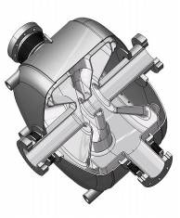
Beam axis axis
2.70
2.76
2.70
1.92
2.13
2.36
2.57
2.57
2.56
2.61
Fig. 4.3.11 : Average thickness in mm on end-cup (after 140 µm of BCP removal)

New tests are foreseen after summer period: new chemical polishing and installation of a helium tank preparing the installation of the cavity and coupler in a horizontal cryostat.

Design of Coupler Prototype (SubTask 3.2.4)
The study of the coupler prototype has progressed during the last months. Following a RF preliminary design study, detailed drawings of the mechanical components and the horizontal test cryostat installation have started in March 2005. First detailed study was completed in May 2005 (Fig. 12). A ceramic disk window assembly was designed with a simple impedance compensation scheme obtained by reducing the diameter of the inner conductor in the window area. Some cross-checks and fits with the cryomodule setup will allow very rapidly the procurement of this assembly.

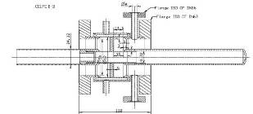
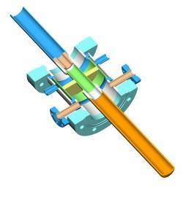
Fig. 4.3.12 : Power Coupler Prototype for 350 MHz spoke cavities.

Presently the main goal is to install the spoke cavity (β=0.15) and the coupler in a horizontal test cryostat. The horizontal cryomodule CM0 (old capture cryomodule designed and constructed by IPNO for the CEA MACSE superconducting electron accelerator project in the 1990’s) will be a quick and convenient set up for the tests (Integration of the β=0.15 spoke cavity and the prototype coupler in order to test them at levels of power up to 20 kW in CW regime (Fig. 13).
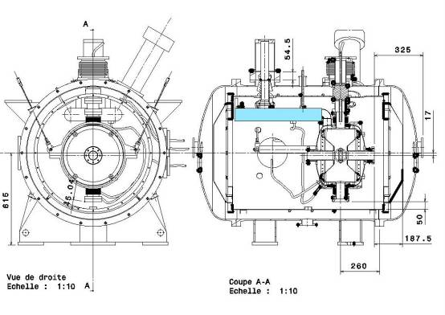

Fig. 4.3.13 : CM0 cryomodule assembly (spoke and coupler)

A rough schedule is presently considered:
- Modifications of the cryomodule structure to fit the cavity and coupler dimensions: between September and December 2005.
- First tests at 4K and low power (i.e. 600W) with the cavity only: beginning of 2006
- Test with the cavity and the coupler: foreseen in June 2006
- Test at higher power level (i.e. at least 5 kW): end of 2006

RF design of 352 MHz multigap-resonator (subtask 3.2.6)
In the frame of the design study concerning the multigap spoke cavity proposed by the Jülich group, some cross-check calculations have been performed at IPN Orsay using CATIA and CASTEM codes. An interface was developed to analyse and rearrange the CATIA meshing, and translate it into a specific CAST3M meshing (Fig. 14).
Different mechanical structure characteristics were evaluated:
- Static analysis: cavity deformation under vacuum conditions. Several fixing schemes of the cavity inside the helium tank were studied, along with the influence of the cavity wall thickness. The maximum stress peak was calculated: 15.3 MPa, and the maximum displacement of 0.072 mm, both results are very close to those obtained using ANSYS code.
- Dynamic analysis: The first eigen-modes were analyzed (138 …460 Hz). The frequency of these modes is considerably raised by using the half-torus stiffeners located on both cavity end-plates. Here again the results were very close to those obtained with ANSYS.

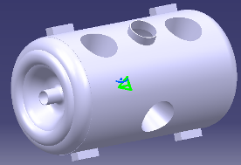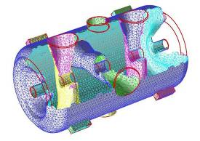

Fig. 4.3.14 : Multi-gaps spoke meshing for mechanical studies

IAP-FU

CH resonators (subtask 3.3)
Mechanical property of the superconducting CH-prototype:
The analysis of the superconducting CH-cavity has been performed to test the model predictions for peak stresses, deflections and flange reaction forces under vacuum loads in room temperature as well as cryo-temperature conditions. An important part of simulations is devoted to the determination of resonant structural frequencies. The simulation results should help to evaluate the required cavity layout in the cryostat environments. The whole CH-cavity, including the stiffening rings, has been produced from 2 mm thick niobium (RRR=250) sheets. The supporting frame (stabilization endplates and cross connections) is out of stainless steel and Aluminum. All simulations have been made with ANSYS 9.0 multi-physics code. To reduce the CPU time we used 1/4 symmetric boundary condition. The maximum displacement arises at cross connection from stainless steel with 2.72 mm. The maximum stress of Mises with a value of 273 MPa are only at the junction of cross connections and Aluminum end plates (Fig. 15), which are both uncritical. The higher values at the endplate of the resonator are artificial due to the chosen ANSYS fixpoints.
Fig. 4.3.15: Total deformation of the sc CH-cavity (left) and maximum stress von Mises (right) under 2 atm. pressure and 4.2 K cryostat temperature.

The modal analysis simulations have the purpose to find the best way to fix the cavity in the cryostat. The mechanical modes in the area of f < 100 Hz should be avoided (background noise and power supply frequency area). Table 2 summarize the first 5 eigenmode frequencies of the sc CH-cavity under 2 times vacuum pressure and cool down, which are all above the critical frequency range. Finally Fig. 16 shows the most critical first and second mode in a scaled 3D view.

Table 4.3.2: First 5 mechanical eigenmodes of the s.c. CH-prototype resonator at 2 atm. pressure and 4.2 K cryostat temperature in Hz.
1 | 2 | 3 | 4 | 5 | Mode
144.7 | 228.7 | 345.1 | 384.9 | 414.7 | Hz

Fig. 4.3.16: First and second mechanical eigenmode frequency of the sc CH prototype cavity at 2 atm. pressure and 4.2 K temperature.

Study of tuning system (subtask 3.3.1)
For our purposes we favour the mechanic-tuner design efforts of the TTF cryo-modules at DESY for mainly one reason: due to the slim frame around the helium vessel and the position of the stepping motor over or under the cavity, the needed longitudinal space between two resonators is very small. This allows having a chain of s.c. resonators with a narrow space between them and increases the real estate gradient of a s.c. linac, with no additional focusing element in the intertank sections required. Figure 17 shows the actual TTF-blade tuner design, first in a detailed 3D graphic of the complete tuner frame. First ANSYS® calculations of the maximum allowable slow-tuner force under 2 atm. pressure at 4.2 K and a mechanic rigidity of 2 mm thin bulk niobium sheets of the s.c.CH-prototype without an additional supporting frame showed, that not more than 400 kg traction power is needed to guarantee a 2 mm tuner stroke in both directions. Figures 18 and 19 showed the simulated ANSYS® safety-factor-distribution of maximum stress of Mises of the sc. CH-cavity with ± 2mm end drift tube displacement exited by an external force driven at the tank end drift-tube. In addition with the MWS® calculated tuner sensitivity of 0.194 kHz/μm leads to the following proposed slow-tuner parameters:

Table 4.3.3: Estimated slow-tuner parameters for the s.c. CH-prototype
Tuner stroke: | ± 2 mm
material: | stainless steel
maximum traction power: | 400 kg
maximum reaction time: | 1 sec
minimal tuning range: | 0.388 MHz

Fig. 4.3.17: Detailed 3D-drawing of a blade tuner frame with piezo-assisted tuner of a TTF- module at DESY (Courtesy of DESY TTF-facility).

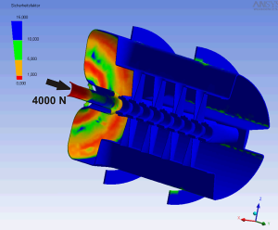 | 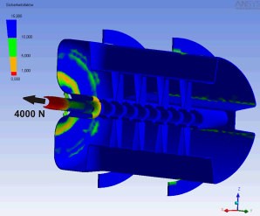
Fig. 4.3.18a: ANSYS® calculated safety-factor-distribution of maximum stress of Mises of the sc. CH-prototype under 2 atm. at 4.2 K and an external tuner squeezing force of + 400 kg. | Fig. 4.3.18b: ANSYS® calculated safety-factor-distribution of maximum stress of Mises of the sc. CH-prototype under 2 atm. at 4.2 K and an external tuner squeezing force of + 400 kg.

The first planned application of the new s.c CH-resonators is in CW mode, to overcome the microphonics problem. Therefore in a first technical design study a fast-tuner is not foreseen. But to have a wider spectrum of possible future applications, e.g. for HIPPI, in the next design level a piezo fast-tuner will be included.

Test of the superconducting CH-cavity
The superconducting CH-cavity has been assembled in the cryostat together with the new temperature measurement system (see fig. 20). The cavity has been pre-cooled with liquid nitrogen and then cooled with liquid helium. The cavity reached the superconducting state on Friday, July 15th. No problems with cold leaks or rf contacts have occurred. The Q-value at low fields was 5e8 (Fig. 21). At field levels of 0.04 MV (total effective cavity voltage) a multipacting barrier has been reached which could be conditioned without problems. A total effective cavity voltage U_{acc} of 3.6 MV has been reached so far. This corresponds to a gradient of 3.4 MV/m with respect to the total cavity length (L=1.04 m) and of 4.45 MV/m with respect to a length of 19*βλ. The next test is foreseen in September.

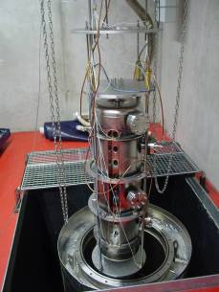
Fig.4.3.19: Assembled CH-cavity in the new cryogenic laboratory in Frankfurt.

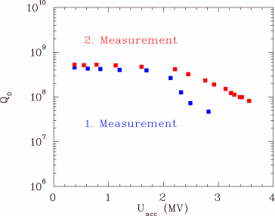
Fig. 4.3.20: Measured Q-value as function of the cavity voltage.
Table 4.3a : Status of the Sub tasks in WP5 which are supposed to have started according to the MS project breakdown in Annex 1
WBS # | Title | Participants | Original begin date | Original end date | Estimated Status | Revised end date
3.1 | Elliptical cavities
3.1.1 | Cavity A vertical tests | INFN, CEA | 01 / 2004 | 12 / 2004 | Done
3.1.2 | Tuner design | INFN | 07 / 2004 | 12 / 2005 | 40%
3.1.3 | Integration of piezo design | INFN | 07 / 2004 | 12 / 2005 | 40%
3.1.4 | Tuner construction and testing | INFN | 01 / 2006 | 06/2006
3.1.5 | Design cavity B | CEA | 07 / 2004 | 10 / 2005 | 90%
3.1.6 | Construction cavity B | CEA | 11 / 2005 | 06/2006
3.1.7 | Power coupler design & engineering | CEA-LPSC | 01 / 2005 | 04/2006 | 25%
3.1.9 | RF coupler construction | CEA-LPSC | 01 / 2006 | 10/2006
3.1.8 | RF source order and preparation | CEA | 07 / 2004 | 09/2006 | 40%
3.1.10 | Modulator preparation for test stand | CEA | 01 / 2005 | 05/2006 | 30%
3.2 | Spoke cavities
3.2.1 | Test stand preparation at FZJ | FZJ | 04 / 2004 | 08 / 2004 | Done
3.2.2 | Evaluation of 700 MHz prototype | FZJ | 09 / 2004 | 09 / 2005 | 90 %
3.2.3 | Evaluation of 352 MHz 2 gaps-proto | IPNO | 06 / 2004 | 06 / 2005 | Done
3.2.4 | Design of coupler prototype | IPNO | 01 / 2004 | 12 / 2005 | 60 % | 06 / 2006
3.2.5 | Realization and test of coupler proto. | IPNO | 01 / 2006 | 12 / 2006
3.2.6 | RF design of 352 MHz multigaps-res. | FZJ-IPNO | 01 / 2004 | 04 / 2005 | Done
3.2.7 | Final mechanical design of resonator | FZJ-IPNO | 05 / 2005 | 06 / 2005 | Done
3.2.8 | Integration of coupler. Tuning options | FZJ-IPNO | 07 / 2005 | 06 / 2006 | 30 %
3.2.9 | Preparations for electron beam welding | FZJ-IPNO | 07 / 2005 | 03 / 2006 | 5 %
3.3 | CH resonators
3.3.1 | Design of tuning system | IAP-FU | 01 / 2004 | 06 / 2006 | 65 %

Table 4.3b: Status with respect to the interim reports and deliverables due in 2005 according to the MS project breakdown

WBS # | Title | Due date in Annex 1 | Status | Revised delivery date
3.1.4 | Cavity A tuner: intermediate report | December 2005 | On time
3.2.2 | Report on evaluation of 760 MHz prototype | March 2005 | Delivered
3.2.3 | Report on evaluation of 352 MHz 2gaps-proto | October 2005 | On time
3.2.6 | Design report on 352 MHz n-gaps resonator | May 2005 | Results available | August 2005
3.3.1 | Report on CH tuners | June 2005 | Delayed | September 2005

  - Work Package 4: Beam Chopping

Web-site: http://lombarda.home.cern.ch/lombarda/WP4/WP4main.htm

Also during this second quarter of the year 2005 the work of WP4 is progressing steadily. In particular the prototype chopper structure A is almost fully assembled and will be ready for tests soon.

CERN:

The advancement of the CERN chopper structure A has followed a somewhat different track than the one foreseen in the planning originally proposed, in order to cope with the delays generated by the overload of the CERN mechanical workshop. In particular, it has been decided, in agreement with the HIPPI Coordinators, to pass over the phases of pre-prototyping (tasks 4.1.1 and 4.1.2) and to go directly to the assembly of the full scale prototype. This change does not jeopardize the validation of chopper A, as the difference between pre-prototyping and prototyping was only in the mechanical configuration of the chopper and not in its core constituents. As a consequence, the milestones 4.1.1 and 4.1.2 apply now to task 4.1.3 and are therefore delayed by one year.
- Chopper structure (subtask 4.1.4): All the components are in the CERN workshop ready to be assembled. They have been cleaned according to the CERN ultra high vacuum cleaning procedure. The quadrupole into which the chopper will be assembled has been refurbished and has been electrically tested. The next steps are a vacuum test and electrical tests. Should the vacuum test not be successful for the expected vacuum of 10⁻⁸ torr, a bake-out at 150 degrees will be performed before the electrical tests.
- Chopper driver (subtask 4.1.3): The new system based on solid-state MOSFET keeps on giving promising results and this solution is now the mainline for chopper A. The ripple has been reduced to few percent peak-to-peak. By the autumn a base module giving 500 V should be fully tested and decision will be taken whether to continue the construction of three more identical modules, needed to meet voltage, rise-time and repetition rate performances. A complete report on the chopper driver for chopper A has been published as CARE/HIPPI Document-05-003. This document constitutes an intermediate activity report.
- Dump (subtask 4.2.1): the special copper alloy for the dump core has arrived in the CERN workshop. Machining will start as soon as the brazing team will give the ok to the drawings.
- Beam dynamics studies, including matching to the subsequent possible accelerator have continued and the interface between the chopper line and the Drift Tube Linac is defined.

RAL:

Chopper line redesign

The original scheme for the RAL Front End Test Stand chopper line, initially modelled on the ESS design, has been recently revisited with the addition of dedicated beam dump(s), designed to take the full beam power, and a general relaxation of the parameters for all elements (apertures, distances, voltages etc). As a consequence, it has been possible to raise the MEBT energy from 2.5 to 3 MeV.
Work has been progressing on beam-dynamics simulations using a combination of the IMPACT, MaryLie/IMPACT and PATH codes. The line design is also being optimised using a generic algorithm running IMPACT on a Linux cluster.
Nominal beam tracking losses are compared for different beam distributions, giving statistical differences of the order of a few % and thus making variable dump and plate apertures strongly recommended in the real setup. Deflection occurs in the horizontal plane and beam survival is being studied as a function of the plate voltage in an attempt to minimise any partial chopping.
Two design options are currently being explored and optimised: a fast chopper/dump/slow chopper/dump scheme and a fast chopper/slow chopper/dump scheme. The first option would present a symmetrical layout where the two choppers would work independently of each other, while the second scheme would require a closer synergy of the two in kicking the beam to the dump. Performances are being compared in terms of nominal beam transmission through the line and chopping efficiency, in order to find the best compromise between reducing the voltage requirements on the chopper plates (ideally below 2kV) for easier and less costly engineering while at the same time limiting the amount of partially chopped beam surviving in the pipe to within a few tenths of a percent.
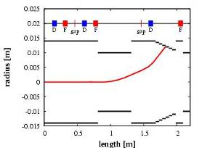
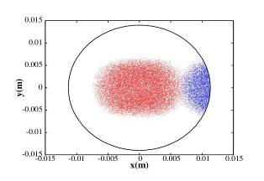
Figure 4.4.1: Deflection of the beam centroid (option 1)
Fig 4.4.2: Beam separation at the centre of the dump (red=nominal beam, blue=deflected beam)

Pulse generator development

Testing, of the ‘slow’ pulse generator system has been delayed. The module designs are based on a standard ‘euro-cassette’ rack mounting format, and were designed at RAL in a 3D CAD environment. Over 100 2D detail drawings, based on the 3D designs, were produced by a contractor, and checked at RAL. During the period March – May 2005, the module components were manufactured by a contractor, and were received at RAL during the first week of June. The proposed ‘slow’ chopper structure will consist of eight electrode pairs, close coupled to a ‘phased array’ of eight SPG pairs as shown in Figure 1.

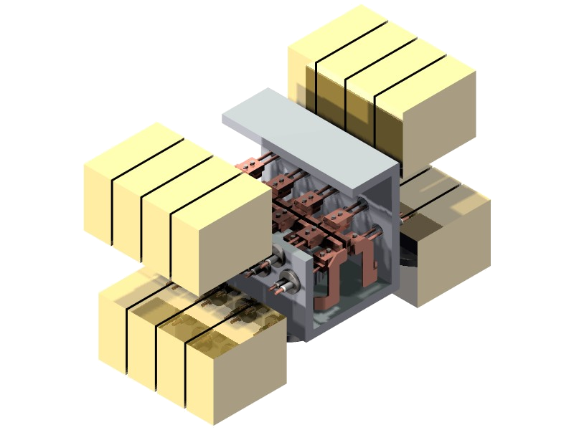
16 close coupled ‘slow’ pulse generator modules
Slow chopper
electrodes
Beam

Figure 4.4.3: “ESS” slow chopper structure with SPG’s.

Pre-prototype testing is planned on a representative configuration of two adjacent SPG pairs.
The four channel pre-prototype SPG system will initially be fitted with the ‘off the shelf’ switch modules, and tested at the maximum PRF of 0.1 MHz with a burst duration of 10 ms at a 50 Hz burst PRF. These high duty cycle tests should provide valuable information on switch reliability, cooling efficiency, and most importantly, on the effect of switch to switch coupling capacitance.
The intermediate report, representing a milestone, has been delivered in July 05.

Table 4.4a: Status of the Sub tasks in WP5 which are supposed to have started according to the MS project breakdown in Annex 1

WBS # | Title | Original begin date (Annex 1) | Original end date (annex1) | Estimated Status | Revised end date
4.1 | Chopper structure A (CERN)
4.1.1 | Pre-prototype construction | January 2004 | June 2004 | Finished | June2005
4.1.2 | Pre-prototype testing | July 2004 | November 2004 | Combined with task 4.1.5 | December 2005
4.1.3 | Driver construction & testing | January 2004 | December 2005 | 80 %
4.1.4 | Full scale prototype design | January 2005 | June 2005 | Finished
4.1.5 | Full scale prototype construction | January 2005 | December 2005 | 90%
4.2 | Chopper line (CERN)
4.2.1 | Dump design | January 2004 | June 2004 | Finished
4.2.2 | Dump construction | January 2005 | June 2005 | 20% | December 2005
4.3 | Chopper structure B (RAL)
4.3.1 | Pre-prototype design and test | January 2004 | June 2005 | Finished
4.3.2 | Prototype design | January 2005 | December 2005 | 40 %

Table 4.4b: Status with respect to the interim reports and deliverables due in 2005 according to the MS project breakdown

WBS # | Title | Due date in Annex 1 | Status | Revised delivery date
4.1.1 | Chopper A design report | June 2005 | delayed | December 2005
4.1.2 | Intermediate test report | March 2005 | Waiting for task 4.1.5 | March 2006
4.2.2 | Dump design report | June 2005 | pending | October 2005
4.3.1 | Chopper B intermediate report | June 2005 | Delivered July2005

  - Work Package 5: Beam Dynamics
Work at IAP, Frankfurt, Germany

Code development (subtask 5.1.2):
A new version of the LORASR beam dynamics code was released. It includes a new space charge routine based on a 3D FFT. Presently an algorithm using closed boundary conditions (Dirichlet cond. for the potential at the surface of a rectangular pipe, up to 128 x 128 x 128 grid points, up to 1 million macro particles) is implemented.
A code extension for open boundary conditions is in preparation.

Code comparison and benchmarking (subtask 5.1.7):
The LORASR code was included to the benchmark testing already in progress: LORASR-results on the static comparison of Poisson solvers (electric field comparison and depressed single particle tune comparison) are available or in preparation.
Simulations related to the tracking comparison for the Alvarez section of the GSI UNILAC are as well in preparation. The results will be presented at the HIPPI Annual Meeting.

Beam dynamics studies and simulations at LPSC Grenoble

In the framework of the HIPPI DTL task force, which meets regularly at CERN, LPSC took charge of studying the impact of errors on the accelerating field, quadrupole alignment and gradient, as well as defining acceptable tolerances for the DTL design. As reported previously, estimations were done with the CEA simulation code TRACEWIN and LPSC proposed a first set of geometrical and RF tolerances. Since then, taking into account both RF and beam dynamics considerations, this proposal was amended by the task force collaboration to reach a final error budget. The sensitivity of the DTL to each individual error was determined within this newly defined range of tolerances. An error on the quadrupole orientation around the longitudinal direction (roll angle) was found to be most detrimental to the beam quality. Global runs were performed where all types of errors were simulated simultaneously to estimate the overall impact of the error budget on the beam properties for two possible DTL designs. This was done with two extreme types of theoretical input particle distributions to evaluate the lower and upper bounds on the degradation of a physical beam. Results were confirmed by high statistics simulations (250 to 400 CPU hours) where were increased both the amount of particles per bunch (10⁶) and the number of runs (5000). In 98% of the simulations, the emittance of the beam along the 3 directions increases by no more than 5% relative to the transport through a DTL without errors (see table 1).

 | Proba. (%) for  Δε_{x} / ε_{x}  to be < 1 or 5 % | Proba. (%) for  Δε_{y} / ε_{y}  to be < 1 or 5 % | Proba. (%) for  Δε_{z} / ε_{z}  to be < 1 or 5 % | Losses
DTL Design 2005 | < 1% : 20.4  < 5% : 98.5 | < 1% : 20.3  < 5% : 98.1 | < 1% : 20.1  < 5% : 99.1 | < 10⁻⁶

Table 4.51: Probability (%) for the emittance growth to be less than 1% or 5% along each direction. The emittance growth is the increase of emittance of a 40 mA Gaussian beam transported through the DTL with all RF and quadrupole alignment errors relative to the emittance of same beam transported through the DTL without errors.

In parallel, was continued the work towards a better understanding of the code limitations as it was noticed that TRACEWIN results depend strongly on the type of space charge routine chosen for the simulation. For that matter, collaboration was extended to new partners and cross-comparison with independent particle transport codes is now underway.

This work (test of the codes, code comparison) corresponds to the forecasts of the HIPPI WP5 programme, and there is no deviation in terms of manpower or milestones.

Work at CERN

1) Simulation codes: work on the codes for the preparation of the 3 MeV test stand is steadily progressing. Code comparison is in progress.

2) Halo measurement device: the prototype is ready, a report has been issued. (K. Hanke, M. Hori, "Design and Construction of a Beam Shape and Halo Monitor for the CERN SPL" CARE/HIPPI Document-05-005). This is an official milestones and the report is the deliverable. The assembled prototype is shown in Figure 4.5.1.

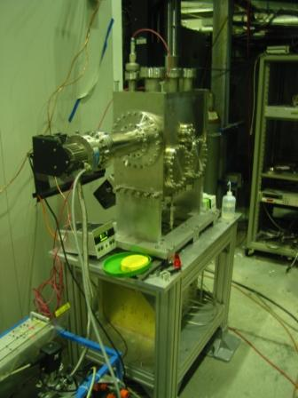

Fig. 4.5.1: Halo measurement device prototype.

3) Test of the halo measurement device: discussion over the possibility of testing the halo detector at GSI is ongoing.

Work at GSI

1) Diagnostics: The development of non-destructive diagnostics by the “beam induced fluorescence method” is in the status of proceed to prototype testing.
2) Beam Dynamics: In preparation of the UNILAC experiments, studies to explore various focusing options using PARMILA have progressed. A special rms-matching routine was developed that includes bunchers, transverse defocusing effect of bunchers, and space charge effects.
3) Code Benchmarking: Code comparison with tracking in the UNILAC Alvarez has progressed well. Since April 2005 code improvements where carried out and the agreement between codes is now visibly improved.
(Results see http://www-linux.gsi.de/~franchi/HIPPI/code_benchmarking_tracking.html)

Work at FZJ, Jülich

Two new sc resonators referred to as ‘slot’ and ‘slot+finger’ were developed. The electrodynamics including the fundamental mode distribution, the maximum field behaviour, the optimum geometry, the neighbouring modes etc. were investigated. The fabrication of slots might be simpler than that of spokes. Additionally the RF focussing due to slots simplifies the accelerator design.

Linear accelerators covering the energy range between 3 and 50 MeV proton energy were analyzed which use different kind of cavities and cavity grouping into cryomodules. Necessary quadrupole magnets are assumed to be normal conducting in a room temperature environment (requiring cold-warm transitions). In the energy range from 50 to 200 MeV no severe differences were observed.

Cavity types analysed cover half wave, triple spoke, slot and slot+finger. For half wave and spoke type cavities was observed a parametric resonance in the longitudinal plane due to the acceleration free “drift space” between cavities in the range 5-20 MeV. This resonance does not show up using the slot+finger structure. Above 20 MeV the slot structure is used.

The high intensity behaviour of the accelerators was investigated using the Jülich 3D space charge code. Currents up to 50 mA did not show losses in our calculations.

More details can be found in http://prst-ab.aps.org/pdf/PRSTAB/v8/i7/e070101.
A detailed report including the full electrodynamics and mechanical investigation is expected to be finished in one year.
Table 4.5a : Status of the Sub tasks in WP5 which are supposed to have started according to the MS project breakdown in Annex 1

WBS # | Title | Original begin date (Annex 3) | Original end date (Annex 3) | Estimated Status | Revised end date
5.1 | Code development
5.1.1 | Preparation, Dev. of 3D space charge routines, Testing | January 2004 | June 2006 | 60 %
5.1.2 | LORASR development | January 2004 | December 2005 | 80 %
5.1.3 | Transport in 3D map implementation | January 2004 | December 2005 | 80 %
5.1.4 | Improvement, modeling high current | January 2004 | June 2006 | 60 %
5.1.5 | Codes preparation for 3 MeV test stand | January 2004 | December 2006 | 50 %
5.1.6 | Codes preparation for SC linacs | January 2004 | December 2006 | 50 %
5.1.7 | Code comparison and benchmarking | January 2005 |  | On time
5.2 | Experiment at UNILAC: preparation & simulations | January 2004 | June 2006 | 50 % | December 2006
5.3 | Diagnostics and collimation
5.3.1 | Profile measurement prototype design and construction (GSI) | July 2004 | February 2005 | Done
5.3.2 | Profile measurement testing (GSI) | March 2005 | June 2006 | 20 %
5.3.3 | Non-interceptive bunch measurement design (GSI) | October 2004 | June 2005 | 100%
5.3.4 | Non-interceptive b. meas. construction | January 2005 | June 2006 | 80% | October 2005
5.3.5 | Halo measurement device design & construction (CERN) | January 2004 | June 2005 | 100 %
5.3.6 | On-line transmission control (GSI) | October 2005 |  | Not yet started
5.3.7 | Beam profile monitor design (FZJ) | January 2005 | June 07 | 20 %
5.3.8 | Collimators design (CERN) | January 2005 | December 2006 | Replaced by dump

Table 4.5b: Status with respect to the interim reports and deliverables due in 2005 according to the MS project breakdown

WBS # | Title | Due date in Annex 1 | Status | Revised delivery date
5.1.2 | LORASR development: intermediate report | December 2005 | On time
5.3.1 | Profile measurement by fluorescence prototype | March 2005 | Ready
5.3.3 | Non-interceptive meas. preparation | June 2005 | 80% Ready | October 2005
5.3.5 | Halo measurement device prototype ready | June 2005 | Ready
5.3.5 | Final report on Halo measurement device | June 2005 | Done (CARE/HIPPI Document-05-005)

Appendix 1: Gantt chart at end of August 2005

