 | 

CARE/JRA3: Second Quarterly Report 2006
31/08/2006

Title: High Intensity Pulsed Proton Injectors (HIPPI)
Coordinator: M. Vretenar (CERN), Deputy: A. Lombardi

Participating Laboratories and Institutes:

Institute  (participant number) | Acronym | Country | Coordinator | Scientific Contact | Associated to
CCLRC Rutherford Appleton Laboratory (20) | CCLRC | UK | P. Norton | C. Prior
Commissariat à l’Energie Atomique (1) | CEA | F | R. Aleksan | A. Mosnier
CERN (17) | CERN | CH | G. Guignard | M. Vretenar
Forschungszentrum Jülich (7) | FZJ | D | R. Tölle | R. Tölle
Gesellschaft für Schwerionenforschung, Darmstadt (4) | GSI | D | N. Angert | L. Groening
Institut für Angewandte Physik - Frankfurt University (5) | IAP-FU | D | U. Ratzinger | U. Ratzinger
INFN-Milano (10) | INFN-Mi | I | S. Guiducci | C. Pagani | INFN
CNRS Institut de Physique Nucléaire d’Orsay (3) | CNRS-IN2P3-Orsay | F | T. Garvey | T. Junquera | CNRS
CNRS Laboratoire de Physique Subatomique et de Cosmologie (3) | CNRS-LPSC | F | T. Garvey | J.M. De Conto | CNRS
INFN-Naples | INFN-Na | I | S. Guiducci | V.G. Vaccaro | INFN

Main Objectives: Research and Development of the technology for high intensity pulsed proton linear accelerators up to an energy of 200 MeV.

Cost:
Total Expected Budget | EU Funding
12 M€ (FC) + 2.7 M€ (AC)  Total 14.7 M€ | 3.6 M€

1 Management Activity 3
1.1 Meetings 3
1.2 External Scientific Advisory Committee 4
2 Dissemination Activity 7
2.1 List of talks 7
2.2 List of papers 7
3 Additional staff hiring 10
4 Status of the Work 11
4.1 Work Package 1 : Management and Communication 11
4.2 Work Package 2: Normal Conducting Accelerating Structures…………………….12
4.3 Work Package 3: Superconducting Accelerating Structures 23
4.4 Work Package 4: Beam Chopping 29
4.5 Work Package 5: Beam Dynamics 34
Appendix 1: Gantt chart at end of August 2006………………………………………..38

- Management Activity

  - Meetings
    - List of meetings
All meetings organized by HIPPI in the year 2006 have been planned (Work Package meetings, general meeting) and all HIPPI Work Package meetings have been held between April and May as foreseen. Important International Conferences (High Intensity Beams 2006 at Tsukuba, Japan, European Particle Accelerator Conference at Edinburgh, UK and finally Linear Accelerator Conference at Knoxville, USA) have taken place between May and August 2006, all with an important presence from HIPPI, in terms of participation, presentation of papers and posters and finally in terms of invited talks. The events concerning HIPPI during the year 2006 are shown in Table 1.1.1a. Details of the Work Package meetings are given in Table 1.1.1b, with the address of the workshop web-sites.
    - General meeting
The HIPPI general meeting for 2006 will be hosted by FZJ at the Jülich Laboratory, from September 27th to 29th.
We foresee this year some minor changes to the structure of the meeting. In addition to the usual Work-Package half day sessions, the programme will include some general presentations on the status of the linac projects in HIPPI and some presentations focused on the HIPPI objectives. The ESAC members will have more time (two sessions) to prepare their preliminary assessment. The presentation by the ESAC will be as usual on the last day, and the meeting will end Friday September 29 at noon. The definition of the detailed content of the WP sessions will be as usual the responsibility of the WP coordinators. The detailed programme with the list of talks will be available at mid-September. The preliminary programme is given here:

HIPPI 2006 Annual Meeting – Preliminary Programme – 7.8.06

Wednesday 27, September, morning
9h00-9h30  9h30-12h00  12h00-12h30 | Welcoming address and Introduction  WORK PACKAGE 4 (Chopper)  General: Review of HIPPI Prototypes and alternative designs | R. Tölle, M. Vretenar  A. Lombardi (conv.)
Wednesday 27, September, afternoon
14h00-14h30  14h30-15h00  15h00-18h00 | General: Status of GSI linac design  Status of CERN linac design  WORK PACKAGE 2 (NC Structures) | J.M. De Conto (conv.)
Thursday 28, September, morning
8h30-12h00  12h00-12h30 | WORK PACKAGE 3 (SC RF structures)  General: Comparison NC/SC designs (>90 MeV) | S. Chel (conv.)
Thursday 28, September, afternoon
14h00-17h00  17h00-19h00  17h00-19h00 | WORK PACKAGE 5 (Beam Dynamics)  First meeting of the ESAC  Visit of FZJ accelerator laboratory (in parallel) | I. Hofmann (conv.)
Thursday 28, September, evening: Social event (t.b.c.)
Friday 29, September, morning
9h00-11h00  9h00-11h00  11h00-12h00 | HIPPI administrative meeting (deliverables, planning, budget)  Second meeting of the ESAC (in parallel)  Plenary meeting, ESAC preliminary assessment

  - External Scientific Advisory Committee

Contacts by e-mail with the members of the ESAC have continued and all the three members of the ESAC have assured their participation to the Annual Meeting in Jülich. More activity has been devoted to applying the ESAC recommendations, in particular:
  - Work packages 3 and 5 have had in common their workshops at Jülich on April 27-28, with a joint presentation session and many fruitful discussions.
  - Detailed designs of accelerating structures based on superconducting cavities have been worked out, and thy will be presented, compared with the standard normal conducting layout, at Annual Meeting in Jülich.
Table 1.1.1a: Overview of meeting, workshop and event (co)organized by the Activity or with Activity contributions
 | Jan | Feb | March | Apr | May | Jun | Jul | Aug | Sep | Oct | Nov | Dec
CARE & HIPPI
CSC Meeting |  |  |  | 11 Paris |  |  |  |  | 13-14 CERN
WP2 Meeting |  |  |  |  | 18-19 Grenoble
WP3 Meeting |  |  |  | 27-28 Juelich
WP4 Meeting |  |  |  |  | 4-5 CERN
WP5 Meeting |  |  |  | 27-28 Juelich
HIPPI Annual Meeting |  |  |  |  |  |  |  |  | 27-29 Juelich
CARE Meeting |  |  |  |  |  |  |  |  |  |  | ??  Frascati
Collaboration meetings
IPHI-SPL meetings |  |  |  |  |  | 15-16 Saclay
ISTC meetings |  |  | 27-30 Novossib. | 5-7 CERN |  |  |  |  |  |  |  | 1st week Sarov
Conferences, workshops
HB 2006 Workshop |  |  |  |  |  | 29.5-2.6 Tsukuba
EPAC 2006 |  |  |  |  |  | 26-30 Edinbourgh
LINAC 2006 |  |  |  |  |  |  |  | 20-25 Knoxville
RuPAC 2006 |  |  |  |  |  |  |  |  | 10-14 Novosib.

Table 1.1.1b: List of meeting, workshop and event (co)organized by the Activity
Date | Title/subject | Location | Main organizer | Number of participants | Comments and Web site
May 4-5 | Meeting HIPPI Work Package 4 | Geneva | CERN | 15 | http://lombarda.home.cern.ch/lombarda/WP4/WP4main.htm
May 18-19 | Meeting HIPPI Work Package 2 | Grenoble | LPSC | 10

- DISSEMINATION ACTIVITY
  - List of talks

Some talks relevant to HIPPI were presented during the second quarter of 2006. The list is given in Table 2.1.
Table 2.1: List of talks presented by the JRA

R. Duperrier  (CEA) | Space charge neutralization and its dynamic effects | HB2006 Workshop, Tsukuba, Japan | http://hb2006.kek.jp/program.html WEAX03
- Lombardi  (CERN) | End to end beam dynamics for CERN Linac4 | HB2006 Workshop, Tsukuba, Japan | http://hb2006.kek.jp/program.html TUAY02
M. Baylac  (LPSC) | Error study of Linac4 | HB2006 Workshop, Tsukuba, Japan | http://hb2006.kek.jp/program.html TUBY03
U. Ratzinger  (IAP-FU) | A 70 MeV proton linac for the FAIR facility based on CH-cavities | Linac2006 Conference, Knoxville, USA | http://www.sns.gov/linac06/ TH104
M. Vretenar  (CERN) | Front End development for High-power proton accelerators in Europe | Linac2006 Conference, Knoxville, USA | http://www.sns.gov/linac06/ FR103

  - List of papers
Two CARE notes have been issued during the second quarter of 2006; they are listed in Table 2.2. Nine HIPPI related papers have been presented at EPAC06 (June06, Edinburgh): three concern WP3, two concern WP4 and four concern WP5. They have all been filed as HIPPI publications and the numbers can be found in Table 2.2.

Table 2.2: List of document issued by the NA or JRA

# | CARE document type and number | Title | Authors and Labs | Date
1 | CARE-Note-2006-008-HIPPI | A 90 - 160/180 Mev Spoke Liinac As An Optiion For The Cern Liinac4 / Spl | Jean-Luc Biarrotte, Guillaume Olry, CNRS / IPN Orsay | 06/2006
2 | CARE-Note-2006-009-HIPPI | Superconducting Spoke Linac Design As An Alternative Option For The Cern Linac4 High Energy Part | E. Sargsyan, A. Lombardi, CERN, | 06/2006
3 | CARE-Note-2006-011-HIPPI | Linac Code Benchmarking in Preparation of the UNILAC experiment | A. Franchi, W. Bayer, G. Franchetti, L. Groening, I. Hofmann, A. Orzhekhovskaya, S. Yaramyschev, X. Yin GSI, Darmstadt, Germany; A. Sauer, R. Tiede, C. Clemente IAP, Frankfurt am Main, Germany; R. Duperrier, D. Uriot CEA, Saclay, France; G. Bellodi, F. Gerigk, A. Lombardi, T. Muetze CERN, Geneva, Swizerland | 07/2006
4 | CARE-Note-2006-012-HIPPI | Field Stabilisation with Post Couplers for DTL tank1 of Linac4 | N. Alharbi, F. Gerigk, M. Vretenar, CERN. | 07/2006
5 | CARE-Conf-06-003-HIPPI | Re-bunching RF cavities and hybrid quadrupoles for the RAL Front-End Test Stand (FETS) | D. C. Plostinar, M. A. Clarke-Gayther (CCLRC/RAL/ASTeC) | 06/2006
6 | CARE-Conf-06-004-HIPPI | First Cryogenic Tests of the Superconducting CH-Cavity | H. Podlech,U. Ratzinger,H. Klein,H. Liebermann,A. Sauer(IAP, Frankfurt-am-Main) | 06/2006
7 | CARE-Conf-06-006-HIPPI | LORASR Code Development | R. Tiede, G. Clemente, H. Podlech, U. Ratzinger, A. C. Sauer (IAP, Frankfurt), S. Minaev (ITEP, Moscow): | 06/2006
8 | CARE-Conf-06-007-HIPPI | Error study of LINAC 4 | E. Froidefond, M. Baylac, JM de Conto (LPSC-Grenoble, France) Edgar Sargsyan (CERN) | 06/2006
9 | CARE-Conf-06-008-HIPPI | Status of linac code benchmarking within the HIPPI project | Andrea Franchi, GSI | 06/2006
10 | CARE-Conf-06-009-HIPPI | HIPPI Triple-Spoke Cavity Design | E. Zaplatin, M. Pap, R. Toelle,FZJ Juelich : | 06/2006
11 | CARE-Conf-06-0011-HIPPI | The 3D beam dynamics with the space charge in the low and middle energy super-conducting option of HIPPI | N. Vasyukhin, R. Maier, R. Tölle and Yu.Senichev, FZJ Juelich : | 06/2006
12 | CARE-Conf-06-0012-HIPPI | Status of the CH-Proton Injector for FAIR | G.Clemente, H.Podlech, R.Tiede, U.Ratzinger (IAP, Frankfurt-am-Main), L.Groening (GSI), S.Minaev(ITEP Moscow) : | 06/2006
13 | CARE-Conf-06-005-HIPPI | A Fast Beam Chopper For The Ral Front End Test Stand | M. A. Clarke-Gayther, (CCLRC/RAL/ASTeC)  G. Bellodi, F. Gerigk, (CERN) | 06/2006
14 | CARE-Conf-06-018-HIPPI | Linac4, A New Injector For The Cern Ps Booster | R. Garoby, G. Bellodi, F. Gerigk, K. Hanke, A.M. Lombardi, M. Pasini, C.Rossi, E.Z. Sargsyan,M. Vretenar CERN, Geneva, Switzerland | 06/2006

  - Web site
The HIPPI web site (http://mgt-hippi.web.cern.ch/mgt-hippi/) contains the most recent information on the JRA activity.

3 ADDITIONAL STAFF HIRING
There weren’t any new hire during the second quarter of 2006.

Table 3: Temporary staff hiring
# | Lab | Job Type | Duration | Work subject | Status
1

- STATUS OF THE WORK
  - Work Package 1 : Management and Communication
The main Management activity in the 2nd Quarter 2006 has been the preparation of the Annual Meeting, which has required many contacts with the Work Package Coordinators and with other members of the collaboration. The new structure of the meeting as well as the preliminary agenda is given in Section 1.1.
An important technical analysis closely followed and supported by the HIPPI management, concerned the definition of the chopper test location. The important delay in the construction of the IPHI RFQ puts at risk now the execution of the HIPPI chopper tests, foreseen at CERN in 2008 after the RFQ CW tests at CEA Saclay. The solution jointly elaborated by CERN and CEA now foresees that the CERN chopper will be tested at Saclay at end 2007. A temporary support with chopper, dump, 2 bunchers and the magnetic elements will be assembled at CERN and then transported at Saclay at mid-2007. After the RFQ CW tests, the CERN assembly will be mounted on the RFQ support and chopper tests will go on at reduced duty cycle for few months during the second half of 2007.
The follow-up of the publications for HIPPI has required more effort than usual in this Quarter, which has seen three important worldwide events (International Workshops and Conferences) with a remarkable number of papers related to the HIPPI work. On top of the papers, three invited talks were directly related to HIPPI activities.
On the other hand, now that HIPPI has passed half of its duration, recruitment is apparently stopped, and the participating laboratories do not foreseen additional HIPPI posts.
From the scientific point of view, the HIPPI Coordinators have checked that the recommendations of the ESAC are correctly implemented by the different laboratories. Work Package 3 and 5 had a common meeting, and we came to the definition of optimised layouts for spoke and elliptical cavity based layouts for the 90-180 MeV linac range. The study of post-coupler stabilisation has been started at CERN by a PhD student, following another ESAC recommendation, and first results have been presented at the Linac2006 Conference.
  - Work Package 2: Normal Conducting Accelerating Structures

    - Drift Tube Linac

4.2.1.1 Activities at Rutherford Laboratory (RAL) (WBS 2.1.4)

An important part of the activity at RAL was made on the chopper line, and it’s described on the WP4 section.
A second part of the work done at RAL is in conjunction with the RAL Front End Test Stand (FETS).

Bunching cavities

Two design options have been considered: the space efficient DTL-type cavity derived from the Drift Tube Linac (Figure 4.2.1) and the power efficient CCL-type cavity derived from a Coupled Cavity Linac cell (Figure 4.2.2).

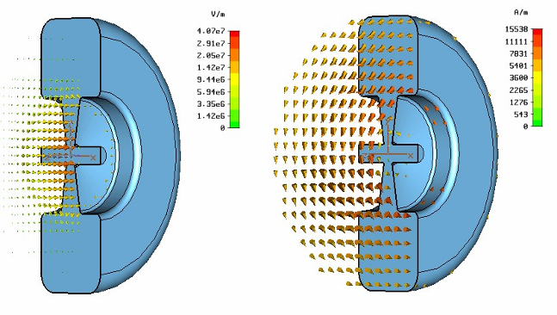
a)
b)

Figure 4.2.1: Microwave Studio 3D model of a DTL type cavity: a) Electric Field Vector, b) Magnetic Field Vector.

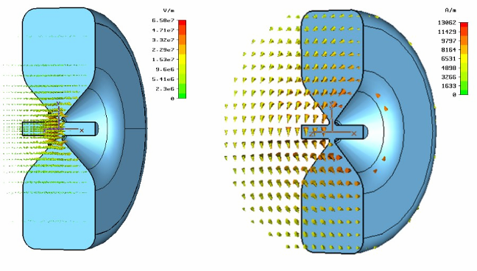
a)
b)

Figure 4.2.2: Microwave Studio 3D model of a CCL type cavity: a) Electric Field Vector, b) Magnetic Field Vector.

The preliminary RF design of the two cavity types has been performed using 2D (Poisson SuperFish) and 3D (Microwave Studio) codes. The 3D simulation is appropriate for designs that lack cylindrical symmetry, and can include the effects of tuning elements and vacuum pumping ports. A comparison of the preliminary 2D and 3D simulations shows good agreement between codes. Representations of the 3D electric and magnetic field vectors can be seen in Figures 1 and 2, respectively for both cavity types.
Figure 4.2.1: Microwave Studio 3D model of a DTL type cavity: a) Electric Field Vector, b) Magnetic Field Vector.

Figure 4.2.2: Microwave Studio 3D model of a CCL type cavity: a) Electric Field Vector, b) Magnetic Field Vector.

Considering the space restrictions in the MEBT line, the DTL-type cavity is desirable, because it allows EMQs to be integrated inside the drift tube, whereas the CCL structure is larger and due to its geometry, the nose cone cannot easily accommodate bulky EMQs. To overcome this limitation, a special combination of quadrupoles is proposed, that will be discussed in the next section. The main advantage of the CCL buncher cavity is its power efficiency, as shown in Figure 4.2.3, where the effective shunt impedance for both structures is plotted for different combinations of cavity lengths and gaps. The Kilpatrick factor variation with gap length for an effective cavity gap voltage of 160 kV is also shown. A region of high shunt impedance is highlighted, allowing an optimal choice for cavity geometrical parameters to be made.

Considering the arguments given above regarding the CCL cavity’s power efficiency (about 3 times more efficient than the DTL-type) and also practical considerations concerning ease of manufacture, we can conclude that this cavity type is a good candidate for a buncher cavity for the FETS project.

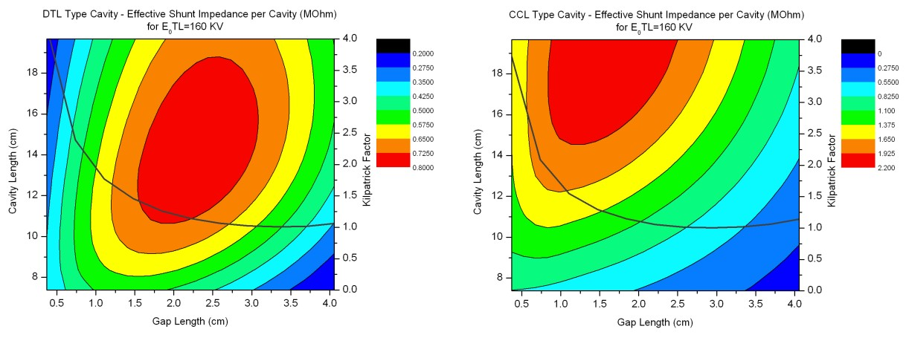
a)
b)

Figure 4.2.3: Effective shunt impedance (MΩ) and the Kilpatrick curve for a DTL-type cavity (a) and a CCL-type cavity (b).

Hybrid quadrupoles

The two hybrid quadrupole designs address the requirement for a compact design, able to efficiently utilise the space inside a DTL drift tube or a CCL nose cone, combined with a (limited) ability to adjust the field gradient. The proposed “tandem” combination of PMQ and EMQ where the smaller PMQ fits inside the nose of the cavity, makes good use of the previously ‘wasted space’. As a consequence of the more efficient utilisation of space, the MEBT line length can be reduced by ~ 11% when using the tandem design, and the reduction in beam-line length is expected to provide a corresponding reduction in MEBT emittance growth.
The second hybrid quadrupole design for the MEBT is a combination of PMQ with integrated cylindrical laminar conductor EMQ (Lambertson quadrupole), utilising flexible printed circuit techniques, and capable of producing modest field gradients. Integration of this structure in the bore of a PMQ should result in the summation of magnetic fields from both elements. As a consequence, the effective field gradient of the PMQ can be adjusted over a limited range, by varying the current in the laminar winding element. Preliminary magnetic field simulations using 2D codes (Pandira SuperFish and Opera 2D – Vector Fields) have been made. A 3D finite element analysis model is in preparation as well as arrangements to measure the achievable range of field adjustment, and field homogeneity of an existing PMQ – laminar quadrupole, combination.
For the laminar EMQ alone, a maximum current density of 10 Amm⁻² allows a maximum field gradient of 0.45 Tm⁻¹. This is approximately 1% of the FETS MEBT quadrupole gradient of 40 Tm⁻¹, and provides only 10% of the required range of adjustment. To achieve the required ±10% range of adjustment, multiple circuit board layers or conductors capable of carrying larger current densities must be utilised.

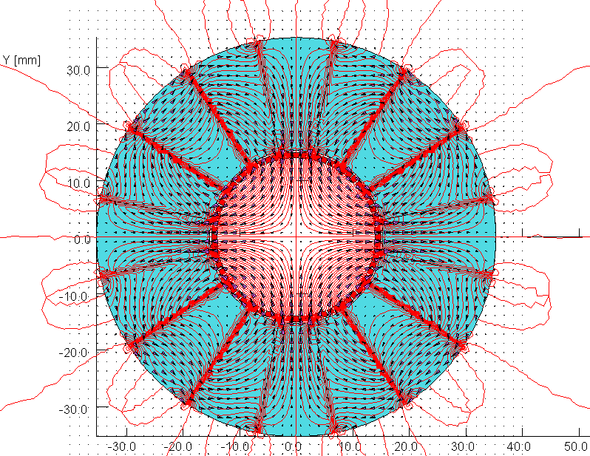

Figure 4.2.4: OPERA 2D plot of a PMQ with 16 wedges of material, and an integrated printed-circuit quadrupole.

Figure 4.2.5: OPERA 2D plot of a PMQ with 16 wedges of material, and an integrated printed-circuit quadrupole.

4.2.1.2 DTL general design at CERN (WBS 2.1.1 to 2.1.4)

The 3D simulations of post-coupler stabilization of the DTL Tank1 are going on. In parallel, a study has been launched to see if an old (1990) scaled DTL-like aluminum model could be modified for the geometry of Tank1, with the goal of studying post-coupler stabilization on a real model.

4.2.1.2 DTL and coupling port design at CEA Saclay and LPSC (part of WBS 2.1.3)

The 1 MW coupling port is still under construction and is foreseen, as initially, by the end of September 2006. Due to some machining impossibilities related to the size of the elements, a part of the manufacturing has been subcontracted. This has no incidence on the planning. The copper plating will be done at CERN and the goal remains to have the coupling port ready for the tank reception, during the first quarter of 2007.

    - H-mode DTL (IAP Frankfurt)

4.2.2.1 Beam dynamics design (WBS 2.2.4)

The beam dynamics design for the GSI Proton Injector has been completed and a detailed report can be found in the HIPPI Note 2005-016-HIPPI.

4.2.2.2 RF cold model design & construction (WBS 2.2.2)

The cold model has been completed and copper plated at the GSI Galvanic Workshop. After this operation several test were performed on the cavity in order to test the goodness of vacuum and cooling system. The measured frequency of 340.2 MhZ was in good agreement with the simulated one of 338.7 and the Unloaded Q-Value is 9400, value that confirms the potential of such a new cavity. In the next future a high power test will be performed with a 2 kW CW amplifier available at IAP.

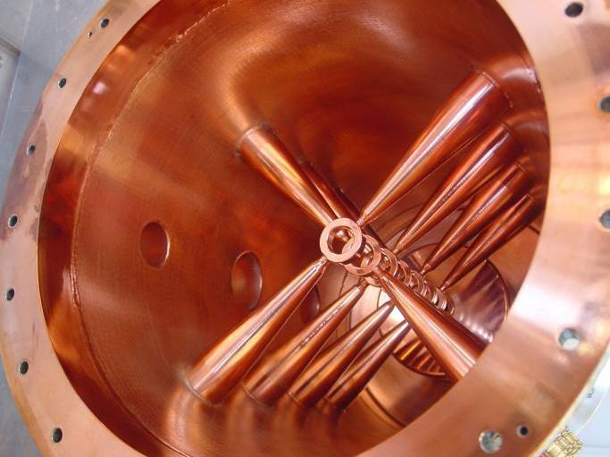

Figure 4.2.6: The Copper Plated CH

Concerning the real prototype a complete new scheme was proposed in order to couple 2 tanks and feed them with only 1 power supply: the basic idea is to couple the H211 resonator by an intertank section which hosts the magnetic lens needed by KONUS and which oscillates in E110 Mode. An example of this solution is presented in Fig. 4.2.7 where two CH tanks are coupled with this solution. MWS Simulations (see Figs. 4.2.8 and 4.2.9) have confirmed the validity of such a new concept that will be adopted for the new GSI Proton Injector.

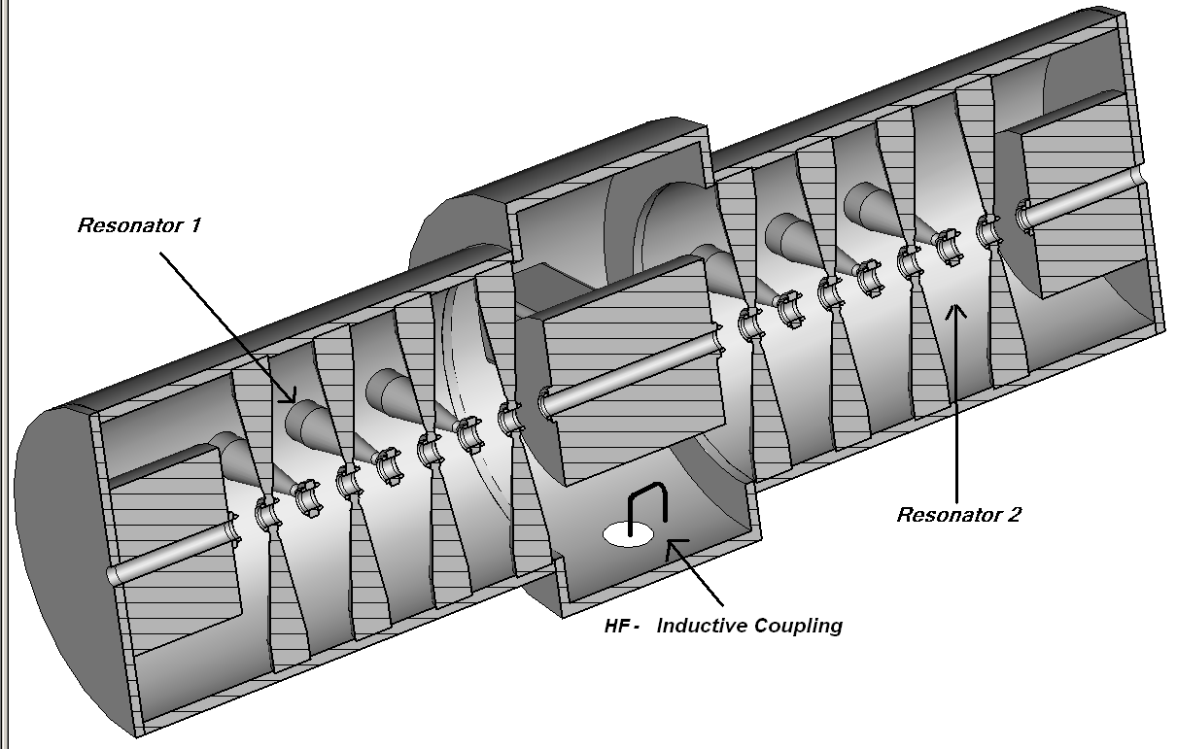

Figure 4.2.7

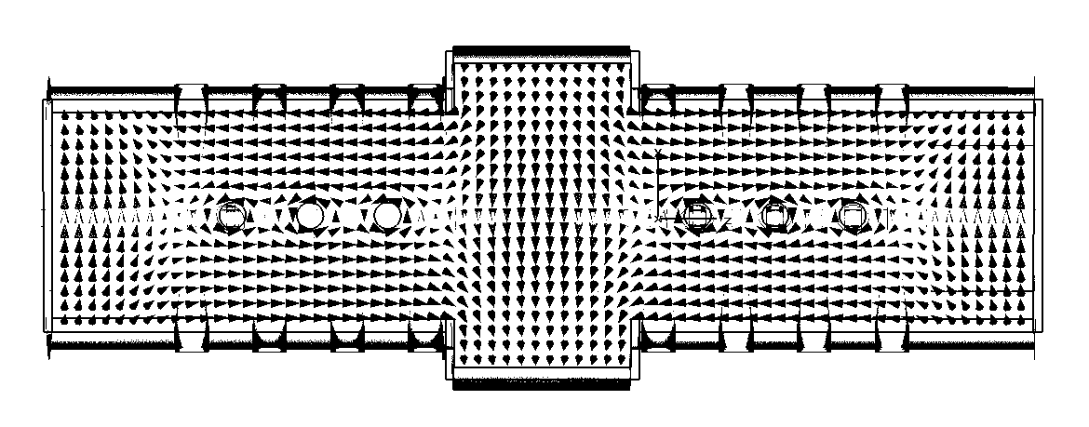

Fig.4.2.8: Magnetic Field line at half radius 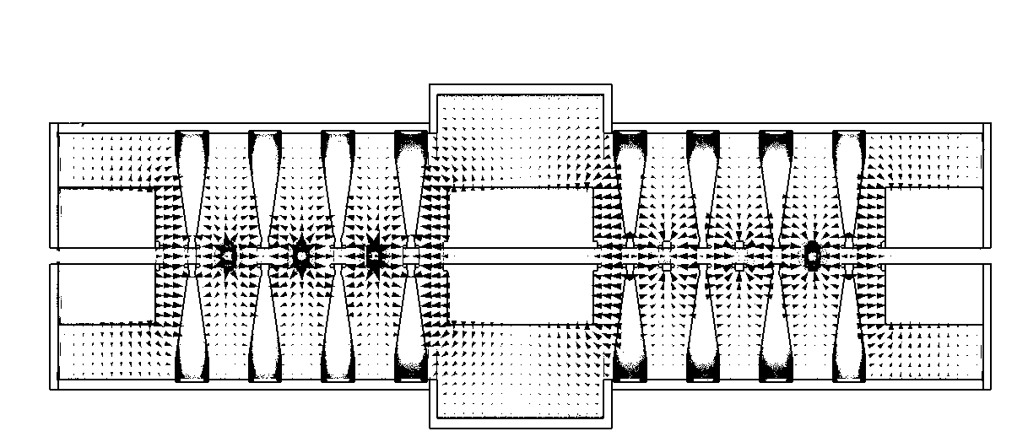

Fig.4.2.9: Electric Field along the cavity axis.

GSI has already funded the construction of a half scale model of tank 3 and 4 of the new Proton Injector and, at the moment, MWS simulations are performed in order to tune the field distribution. Technical drawing will be realised within the summer and it is foreseen to complete its construction within 2006. The construction of the real tanks is foreseen to be completed within the next two years.

    - Side Coupled Linac (LPSC and CERN) (WBS 2.3.1 and 2.3.2)

We have compared SCL layouts with and without water cooling for SPL and Linac4 duty cycle. The result is that removing the cooling channels for a structure operating only for Linac4 the shunt impedance could be improved by 14%, a value considered too low to justify the construction of an SCL for Linac4 only. The position of coupling cells has been re-optimized with the 3D program GdfidL to have smaller coupling slots. The overlapping length is now 17mm and the additional losses due to the coupling slots are 4.6%. It is considered that the slots will be remachined at 45º angle in order to equalize the slots dimensions. The peak loss density at the slots is about 300W/cm^2 when 40kW are dissipated in each accelerating cell. Figure 3 shows the new cell layout, with arrows representing the electric field.
The 2nd nearest neighbor coupling coefficients have been investigated. For 3% coupling between accelerating and coupling cells, the 2nd nearest neighbor coupling between accelerating cells is about 0.3% and between coupling cells about 0.03%.
Furthermore, the power flow droop has been studied. The relative voltage difference is 1.3% from the feeding point to the longer end of the SCL structure. This effect might be compensated by detuning the bridge coupler central cells by 100 to 400 kHz. Further simulations have been performed for tuning the SCL structure with tuners in the bridge couplers. A 5 degrees temperature change will lead to a frequency decrease of about 60 kHz and could be compensated by increasing the central bridge coupler cell frequencies by 900 kHz, which can easily be archived.
Voltage and phase data exchanges have been prepared for beam dynamic simulations to find strategies for compensating the power flow phase shift of 4 degrees - if needed.

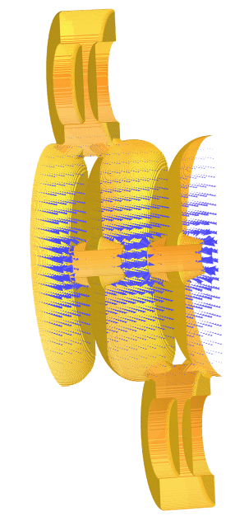

Figure 4.2.10: New SCL cell and slot design (with electric field arrows)

The cold model prototype (aluminium) is under construction at LPSC, at the 0.7 scale (resonant frequency around 1 GHz). Like the coupling port, it will be built in-house and made of 11 accelerating cells i.e. 22 elementary slices.

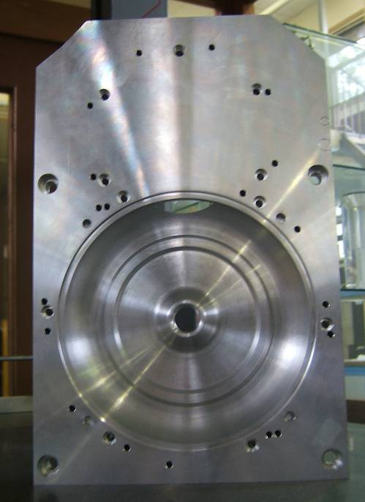

Figure 4.2.11: View of the prototype half accelerating cell

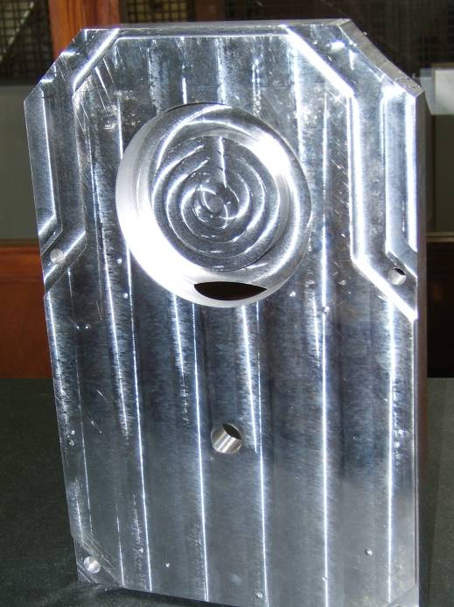
Figure 4.2.12: View of the prototype coupling cell (back side of picture 4.2.11)

The coupling and accelerating cell will now be tested, to check the main RF parameters, before the construction of the 20 remaining modules.

    - Cell Coupled DTL (CERN) (WBS 2.4.1 to 2.4.3)

After the low-level measurements on the pre-prototype, some effort has been devoted to understanding the reason for the low Q-value (65% of the theoretical one) measured. Finally, computer simulations indicated that the decision not to copper plate the surface of the vacuum (and RF) joints was at the origin of the low Q-value. From the vacuum point of view, it is considered easier to seal if the joint sits on stainless steel. However, in many systems at CERN the joints are placed on copper-plated surfaces, without particular problems. Now the simulations have indicated that the very small path that the RF current makes into the stainless steel is sufficient to reduce the Q-value by a substantial amount, and for this reason in the continuation of the project the joint surfaces will be copper plated.
After measurements, the pre-prototype went to vacuum testing. After some delays due to the CERN machine shut-down occupying all the vacuum experts, the testing started in earnest only in April. An important leak was found at the level of one of the pick-up ports. Finally, the origin of the leak was traced to a too weak external reinforcement, with the consequence that a stress during transportation or handling could have affected the internal vacuum welding. Repairing of the leak took a long time, because of the difficult access to the weld region, but was finally successful. Another smaller leak was detected on the rectangular flange for the waveguide connection. Some repair attempts failed, and the reason was finally attributed to the bad surface finishing of the rectangular flange. However, the leak level is low and the vacuum could reach the 10⁻⁷ mbar range. For this reason it was decided to continue the test of the prototype even in presence of this small leak, the vacuum being more than sufficient for starting the RF conditioning, but preparing at the same time a small test model of the rectangular flange, in order to vacuum test different surface finishing. The pre-prototype was finally transported at the high-power test area at the beginning of July, and connected to the klystron and to the cooling circuit. In Figure 1, are visible the cooling circuitry and the coupling cell, while Figure 2 shows the other side, with the waveguide coupler on the bottom. High power tests are due to start in August.

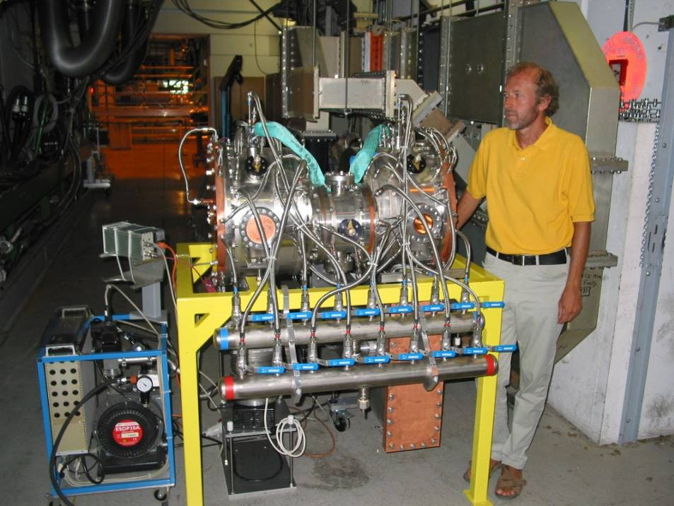

Figure 4.2.13: CCDTL pre-prototype at the high power test stand (cooling side).

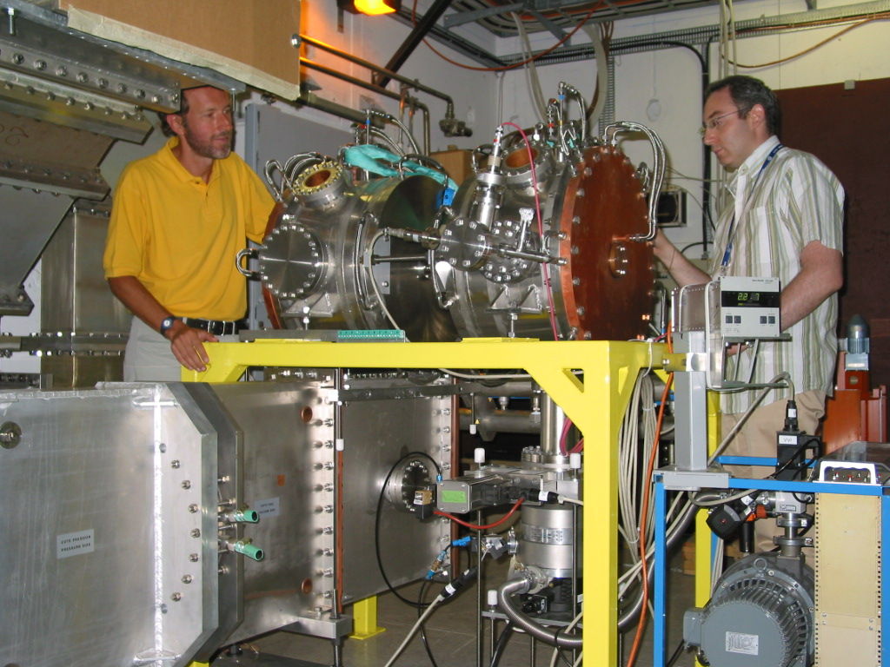

Figure 4.2.14: CCDTL pre-prototype at the high power test stand (waveguide side).

Table 4.2a : Status of the Sub tasks in WP2 which are supposed to have started according to the MS project breakdown in Annex 1
WBS # | Title | Original begin date (Annex 3) | Original end date (Annex 3) | Estimated Status | Revised end date
2.1 | Drift Tube linac
2.1.1 | DTL Design | July 2004 | June 2007 | On time
2.1.5 | DTL Coupler prototype construction | July 2005 | June 2007 | On time
2.1.4 | DTL beam dynamics design | January 2004 | June 2008 | On time
2.2 | H mode DTL
2.2.2 | RF cold model design & construction | January 2004 | January 2005 | 100% | April 2006
2.2.3 | RF model construction | December 2004 | June 2005 | 50% | December 2006
2.3 | Side Coupled Linac
2.3.2 | RF model mechanical design | July 2004 | December 2004 | 100% | June 2006
2.3.3 | RF model construction | January 2005 | December 2005 | 10% | October 2006
2.3.4 | RF model testing | January 2006 | June 2006 |  | End 2006
2.3.5 | SCL module design | January 2006 | June 2007 | On time
2.4 | Cell Coupled DTL
2.4.2 | Pre-prototype high power RF tests | July 2004 | March 2005 | 10% | July 2006
2.4.3 | Prototype mechanical design | January 2005 | December 2005 | 100%
2.4.4 | Revision of design | October 2005 | October 2006 | 30% | December 2006
2.4.5 | Prototype high-power RF tests | August 2006 | June 2007 | Delayed | December 2006

Table 4.2b: Status with respect to the interim reports and deliverables due in 2006 according to the MS project breakdown

WBS # | Title | Due date in Annex 1 | Status | Revised delivery date
2.4.3 | CCDTL Prototype ready | June 2006 | On time | December 2006
2.2.7 | CH-DTL Prototype ready | December 2006 | On time
2.4.4 | CCDTL Design report | December 2006 | On time
Milestones delayed from 2005
2.4.1 | CCDTL Pre-prototype intermediate report | June 2005 | In preparation | October 2006
2.2.5 | CH model cavity construction test Intermediate report | Dec 2005

  - Work Package 3: Superconducting Accelerating Structures
INFN-Milano
Mechanical design of tuner (subtask 3.1.2) and Integration of piezo design (subtask 3.1.3)
Tuner construction (subtask 3.1.4)
The work has progressed as foreseen.

CEA-Saclay
Construction of cavity B (subtask 3.1.6)
Fabrication drawings have been reviewed. In order to insure that an EB weld does not degrade quality of a nearby brazing, a test is being performed. Forming of Nb pieces is in progress.

In parallel, we launched the fabrication of the mechanical set-up for cavity field flatness adjustment. This set-up should be ready next October.

Power coupler design and engineering (subtask 3.1.7)
Detailed drawings are quite ready. Complementary studies were necessary, in order to insure the right mounting of the doorknob part, without stressing the brazed alumina/copper assembly. We already have contacts with industries for the fabrication of these couplers, but serious commercial work will begin in September.

RF source order and preparation (subtask 3.1.8)
The 1MW klystron (VKP-7952C) has been ordered to CPI (Communications & Power Industries) in August 2005 and should be delivered at the end of 2006. Qualification tests should be performed in CPI installations in September.
Low power measurements of the circulator have been performed and are in accordance with the specifications. The bad point is the system compensating the temperature fluctuation, based on the adjustment of the magnetic polarization in order to stabilize the center frequency of the circulator bandwidth. This system can not insure the correct compensation for all the RF phases and is still under work.

Modulator preparation for the 700 MHz test stand (subtask 3.1.10)
Modifications of the existing HV pulsed generator are continuing and study of the cooling system is completed. The assembly will be performed by CEA team in October.

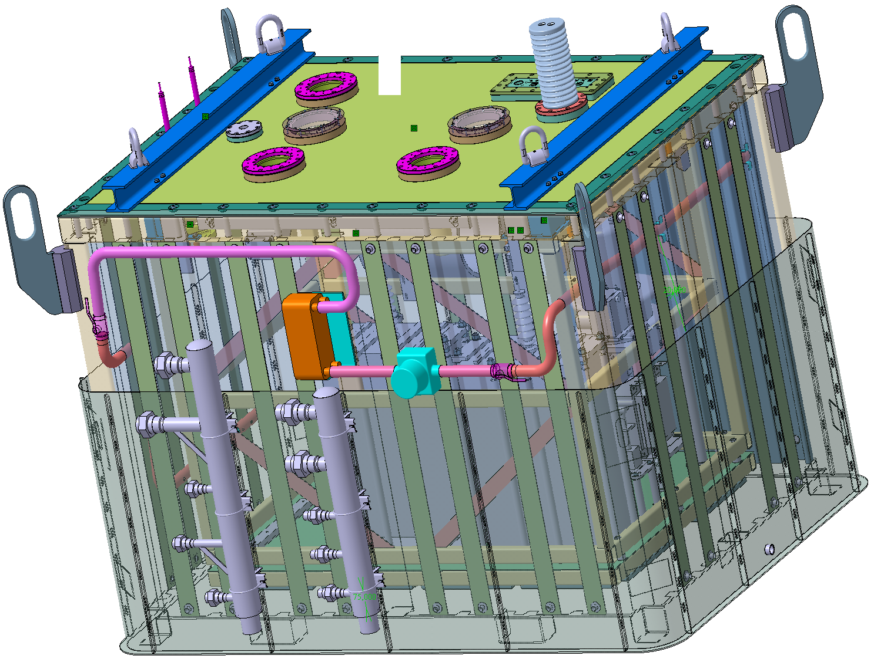

Figure 4.2.1: 3D model of the HV pulsed generator

The fabrication of the 110kV power supply is going on. Tank is ready, HV electronic components are supplied and assembly is in progress. This part should be delivered end of September, with the control rack.

In summary, the main components of the power test stand are on time, except an uncertainty about the circulator. However, if this piece is not ready on time, we will prepare a test of the klystron with its RF output directly connected to a 100 kW load. We then should be able to qualify the 100kV power supply, the HV pulsed modulator and the klystron with all the control racks. Addition of the circulator is then a minor step.

FZJ
All activities were focused on manufacturing the 352 MHz Triple Spoke Resonator.

3.2.9 Preparations for electron beam welding
All parts of the full scale copper 1-spoke-cavity model where manufactured and now electron beam welded (EBW): complete spoke, coupler ports into body half shells, complete body, beam ports into end caps. EBW of both end caps onto body remains to be done, no surprises expected. All supports and fixations for the EBW tasks showed a very good suitability and functionality, especially concerning to the now following niobium welding tasks.
Development of the 4 mm electron beam welding parameters of niobium is still ongoing showing already good optical results. To investigate the superconducting properties of these seams we just installed own equipment for these measurements. We are now able to measure the RRR values of the seams and of the heat affected zone.

3.2.10 "Manufacturing of 352 MHz Multigap Resonator”
The niobium sheets delivered by Wha Chang were sent to an external company for SQUID scanning due to the bad appearance and many scratches on the surfaces. 4 of 12 spokes sheets had some structural inhomogeneities and were therefore not qualified for superconducting requirements. The rest of the sheets were without any mistakes and could be used for the hydromechanical forming of the spoke bodies which was done successfully. The bigger sheets (750 x 1450 mm) for the cavity body and the end caps could not be scanned due to severe problems of the sensor control of the SQUID machine. We had to cancel the contract with this company in order to avoid any further time loss in the project. We are working hard to return to the original schedule, but presently a delay of some months seems probable. Quality control has now been shifted to eddy current scans. Call for bids have been sent out.

IPN-Orsay
Evaluation of 352 MHz 2-gap prototypes (subtask 3.2.3)
A new test of the beta 0.15 spoke cavity has been done in June 2006. This test was performed in our vertical cryostat at 4.2K. The preparation of the cavity has been made in the clean room at the CEA/Saclay:
- BCP chemistry : 120 µm removed
- 2 hours of High Pressure Rinsing through the 4 ports

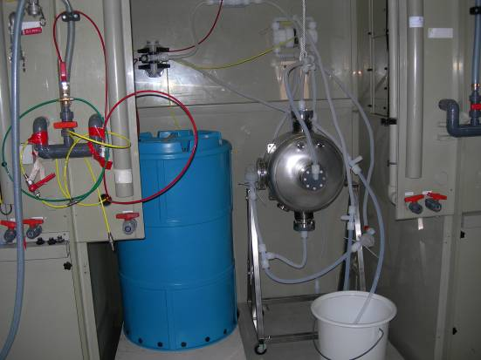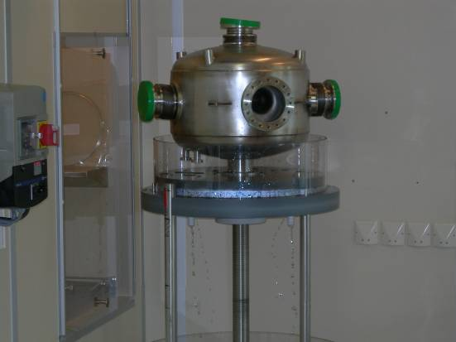
RF port
Beam tube

Fig. 4.2.2: Chemical polishing of the spoke cavity and Spoke cavity on the HPR set-up

The main goal was to test the “cavity + Helium vessel” as a whole and the coupling by the dedicated RF port. No leak was observed and, as expected, no extra-losses on the antenna while coupling by the ∅56 mm RF port. Thus, we are able to use the beta 0.15 spoke cavity inside our horizontal cryostat CM0, which is going to be assembled before the end of this year.
Erreur ! Liaison incorrecte.
Figure 4.2.3: Cavity performance in vertical cryostat (Eacc is normalized with respect to βλ=0.17 m).

We also tried to get a better maximum gradient, as compared with the one achieved in May 2005, by doing a new “heavy” chemistry, in order to remove the suspected “big” defect(s) on the surface. The accelerating gradient was limited to 4.7 MV/m (⬄Bpk=70 mT) during the first test. As shown on the above graph, we did not see any improvement (Eacc max=4.5 MV/m). The cavity performances were again limited by a thermal quench at, more or less, the same peak surface magnetic field level.

Design of Coupler Prototype (Subtask 3.2.4)
At the beginning of May, two windows were ordered to the French company SCT. The delivery is foreseen in November 2006. In parallel, we are designing the RF test bench for these couplers. Couplers are intended to be tested at 10 kW at the end of 2007.

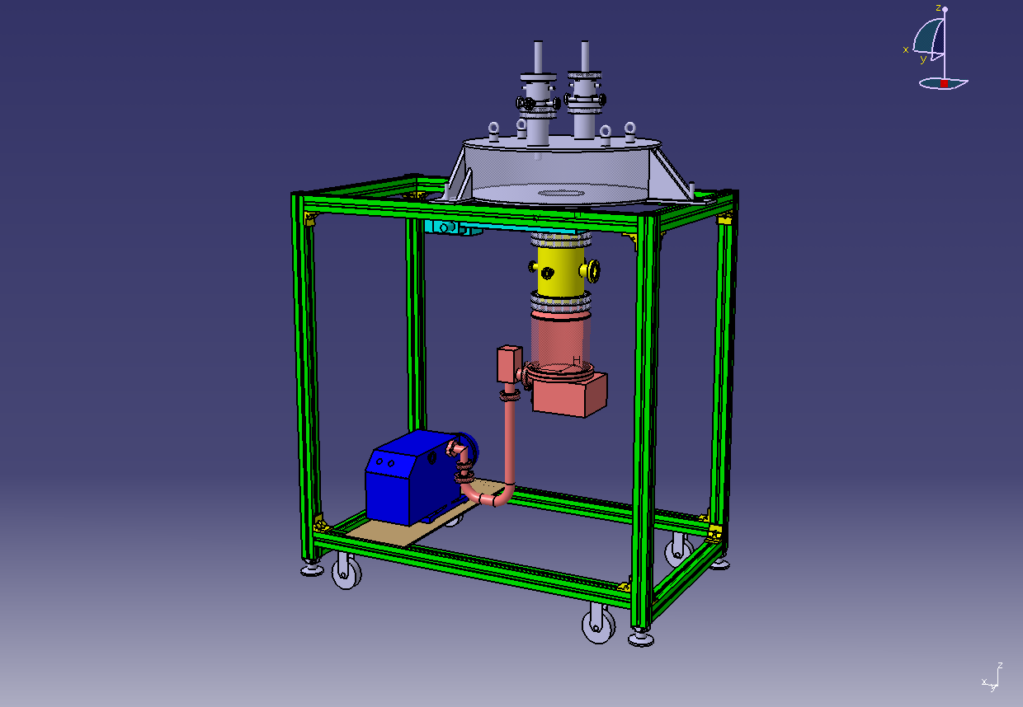
Vacuum pumping system
RF coupler
Cavity

Figure 4.2.4: Sketch of the 10 kW RF coupler test bench

RF design of 352 MHz multi-gap resonator (subtask 3.2.6)

Following the results on Lorentz forces detuning factor performed with SOPRANO, CAST3M and CATIA, new calculations has been done on multi-gap spoke sensitivities.
About the cavity’s tuning: the resonance frequency sensibility versus an imposed longitudinal displacement has been evaluated. The value of 136 kHz/mm is obtained by the simulations.
The frequency shift due to the fluctuation of the bath’s pressure has been also calculated. The results show 5 Hz derivation of the frequency for 1 mbar variation of the bath’s pressure. FJZ Jülich has obtained 2-10 Hz/mbar for this factor.

IAP-FU

Conceptual studies of a tuning system (subtask 3.3.1)

Progressing as foreseen.
WBS | Title | Participants | Original begin date | Original end date | Estimated Status | Revised end date
3.1 | Elliptical cavities
3.1.2 | Tuner design | INFN | 07 / 2004 | 12 / 2005 | 100%
3.1.3 | Integration of piezo design | INFN | 07 / 2004 | 12 / 2005 | 100%
3.1.4 | Tuner construction | INFN | 01 / 2006 | 06/2006 | 10% | 12/2006
3.1.6 | Construction cavity B | CEA | 11 / 2005 | 06/2006 | 20% | 11/06
3.1.7 | Power coupler design & engineering | CEA-LPSC | 01 / 2005 | 04/2006 | 95%
3.1.9 | RF coupler construction | CEA-LPSC | 05 / 2006 | 05/2007 | 0%
3.1.8 | RF source order and preparation | CEA | 07 / 2004 | 12/2006 | 80%
3.1.10 | Modulator preparation for test stand | CEA | 01 / 2005 | 12/2006 | 75%
3.1.11 | RF source testing | CEA | 01 / 2007 | 04 / 2007
3.1.12 | High power pulsed tests | CEA | 05/2007 | 06/2007
3.1.13 | Cavity A assembly with tuner | INFN | 06/2006 | 03/2007
3.1.14 | Vert. test & final welding of cavity B | CEA | 07/2006 | 03/2007
3.2 | Spoke cavities
3.2.2 | Evaluation of 700 MHz prototype | FZJ | 09 / 2004 | 09 / 2005 | 100 %
3.2.4 | Design of coupler prototype | IPNO | 01 / 2004 | 12 / 2005 | 100%
3.2.5 | Construction of coupler prototype | IPNO | 01 / 2006 | 06 / 2006 | 15% | 11/2006
3.2.8 | Final design of 352 MHz multigap res. | FZJ-IPNO | 07 / 2005 | 06 / 2006 | 100 %
3.2.9 | Test of coupler prototype | FZJ-IPNO | 07/2006 | 07/2007
3.2.10 | Manufacturing of 352 MHz multigap res | FZJ-IPNO | 04/2006 | 09/2007 | 40%
3.3 | CH resonators
3.3.1 | Design of tuning system | IAP-FU | 01 / 2004 | 06 / 2006 | 70 %
3.3.2 | Construction of tuning system | IAP-FU | 01/2006 | 12/2006
3.3.1 | Measurements of tuning system | IAP-FU | 01/2007 | 06/2007
Table 4.3a : Status of the Sub tasks in WP3 which are supposed to have started according to the MS project breakdown in Annex 1

Table 4.3b: Status with respect to the interim reports and deliverables due in 2006 according to the MS project breakdown
WBS # | Title | Due date in Annex 1 | Status | Revised delivery date
3.1.6 | Cavity B ready (deliverable) | June 2006 | Delayed | Dec. 2006
3.3.1 | Report on CH tuners (milestone) | June 2005 | Delayed | March 2006

  - Work Package 4: Beam Chopping

Web-site: http://lombarda.home.cern.ch/lombarda/WP4/WP4main.htm

The working package annual meeting took place on the 4-5 May at CERN. 10 participants are expected. The topics for this workshop were the calculations and measurements of the field coverage factor as well as the status of the key components and the possibility to test the chopper elsewhere than CERN. All the talks can be downloaded from the WP4 website.

Animated discussion has revolved around the theme of the field coverage factor. This factor, which represents the loss of field due the fact that the meander structure does not provide 100% coverage of metal, depends on the geometry of the meander, on the thickness of the dielectric and it has a mild dependence on the distance from the axis. All the factors were debated and trade-off between coverage factor and dispersion were highlighted. Simulations have been done both at RAL and CERN. At CERN also measurements, confirming the simulations, have been recently done. The field coverage factor measured on axis at CERN is around 80%. It is estimated to decrease radially down to about 75%.Unfortunately there is not enough manpower to investigate whether a higher field coverage factors can be achieved with the meander line geometry. At RAL simulation of the CERN and RAL chopper predict 75% and 82% respectively. The simulation has been done with an approximate geometry which describes the edge of the meander structure. More refined simulations have been done after the workshop and are reported below. With respect to the more general theme of the effective deflecting voltage it has been accepted by everybody that there are other sources of loss of effective field (e.g. scatter in the delay between the top and bottom plates ...) and therefore a conservative factor of 70% should be taken from now on between the amplifier voltage and the voltage used in the beam dynamics simulations.

Another important topic of discussions has been the measurement set-up and strategy. At the last annual meeting the possibility of testing the RAL chopper in the CERN 3 MeV test stand was mentioned. This is important in view of the completion of the HIPPI program in 2008 as the RAL test stand (FETS) will not be operational before 2009. This year it was agreed that the RAL driver will be shipped to Saclay for testing in the HIPPI@SAclay test stand. Possibly a RAL chopper could be tested in the 3MeV line by taking out the CERN chopper and replacing it with a quadrupole and one chopper units. Details for this option are still under discussion because an extra quadrupole from CERN is not presently available and the RAL chopper is not ready as well. The possibility of using the chopper electrodes as longitudinal pick-up to measure the beam phase spread has been mentioned. This feature, together with the measurement of the current lost on the chopper plates, could be a very helpful diagnostic mean for the setting up phase. This scope is outside the HIPPI commitments.

The workshop was very useful, especially as in this phase of hardware production and measurement planning the live discussion amongst experts helped to clarify and rectify some measurement strategy needs.

CERN:

In general the woks advanced steadily and first low power measurement have been started on the chopper plates. Measurement of the prototype with high power will be possible after the completion of all the vacuum tests which have been the bottleneck for the chopper prototype testing in the last two quarter.
- Chopper structure (subtask 4.1.4): The chopper is fully assembled since December 05. The preliminary results of the out-gassing test on the chopper deflecting structure were successful without in situ bake-out. In particular this test cleared any doubts related to vacuum out-gassing pockets (the space between the ceramic plate and the alumina plate). The second vacuum test, related to the cooling needed to cope with electrical heating and beam losses, is in preparation and an infrared (10 micron) vacuum window has been ordered for this purpose. New meander lines, ordered from the firm Kyocera arrived at CERN. They present some manufacturing errors and new one will arrive before the end of the summer.
- Chopper driver (subtask 4.1.3): Preliminary measurements on the new amplifier from FID Technology in Russia arrived during the WP4 annual meeting: they are very promising also if more work is needed to meet the full specifications. The first of four modules, scheduled to arrive at CERN in June06, is delayed.
- Dump (subtask 4.2.1): The delivery is on schedule
- The chopper will be modified as to be used as a pure high impedance DC voltage device in the very first measurement phase. This is a very simple modification and should ease the measurement of the effective voltage on the beam.
- A tuning of structure for the characteristic impedance and phase velocity could be done by making a groove on the chopper plate’s dielectric substrate. This idea will be tested experimentally.
RAL:

Important aspects of the RAL HIPPI activity for this quarter are as follows:
- RAL MEBT Optical designs: A high priority has been placed on the identification and development of three candidate optical schemes for a MEBT chopper line that will be a key part of a proposed 'Front-End Test Stand' (FETS) project, to be sited at RAL. Schemes A and B address three weaknesses in the original ESS MEBT optical design (now similar to scheme C), these being, the high chopper field requirement, the absence of a dedicated chopper beam dump, and an overly compact component layout. The schemes have been refined in the GPT code, where a filtered version of the IPHI RFQ output distribution, was used as an input distribution to the RAL MEBT. The CERN MEBT design was used as a bench-mark, to verify the accuracy of the GPT code, and the results obtained were found to be in good agreement with those obtained from the 'PATH' code. Schemes A and B make use of the 'optical amplification' of beam deflection in a downstream quadrupole (a key feature of the proposed Linac 4 MEBT design at CERN), to significantly lower the chopper field requirement, and to enable an increase in beam aperture.
- Simulation of CERN meander structure coverage factor : RAL simulations of E-field 'coverage factor' for the CERN meander structure have been refined in the CST EM studio code. This work was prompted by discussions at the WP4 meeting at CERN, and by subsequent e-mail contact. The results are now in good agreement with measurement, in that they predict an on axis value of ~78.4%,falling to ~74.3% at the beam edge. The geometry implemented is shown in Figure 4.4.1.

- RAL meander structure: work on the RAL meander structure has been delayed, as a higher priority has been given to the development of new optical schemes for the FETS MEBT line. Suitable replacements for two RAL HIPPI personnel previously working on the MEBT optical designs have not yet been found, and effort that would have been available for the meander design has been re-directed to the optical design task. However, good progress has now been made with the optical work, and so it is likely that effort can be directed back to the meander design task. Discussions have started on the possibility of testing the RAL choppers in the CERN MEBT using a modified optical set-up, with a 'plug-in' modular configuration.
- Plans for the RAL fast pulse generator (FPG): The RAL FPG is now available for testing meander structures (Z0=50 Ohm). The range of available pulse amplitudes, and durations are +/- 200 to +/- 1400 V, and 8 to 15 ns, respectively. RAL has offered to conduct a series of low and high voltage tests on the new CERN meander structures, when they become available. In addition, RAL is considering the possibility of shipping the RAL FPG to Saclay for preliminary tests of the CERN chopper system, and will try to make sure that space is pre-allocated at Saclay for the RAL FPG.
- Progress with the RAL slow pulse generator (SPG): Work on the RAL SPG has been delayed, as a higher priority has been given to the development of new optical schemes for the FETS MEBT line. Suitable replacements for two RAL HIPPI personnel previously working on the MEBT optical designs have not yet been found, and effort that would have been available for the SPG task has been re-directed to the optical design task. However, good progress has now been made with the optical work, and so it is likely that effort can be directed back to the SPG design task. In addition, preliminary testing of the 'off the shelf' 8kV SPG MOSFET switch has shown that pulse transition times increase, and durations decrease, during the first 20 us of the burst. However, the new RAL MEBT optical designs (schemes A & B) appear to halve the ESS SPG voltage requirement, and so the direction for the new SPG development will be revised towards a lower voltage (< 4 kV), custom designed switch, that should significantly reduce the above- mentioned initial shift in observed pulse transition time and duration.
- Re-buncher cavity and hybrid quadrupole design: work on a FETS MEBT re-buncher cavity design and on novel hybrid quadrupole configurations for compact structures is continuing. Construction and field mapping of prototype PM / EM hybrid quad designs are planned. Aster Enterprises Inc. (USA) has offered to provide a ‘surplus to requirements' SNS linac type PM quad for this work, at reduced cost.

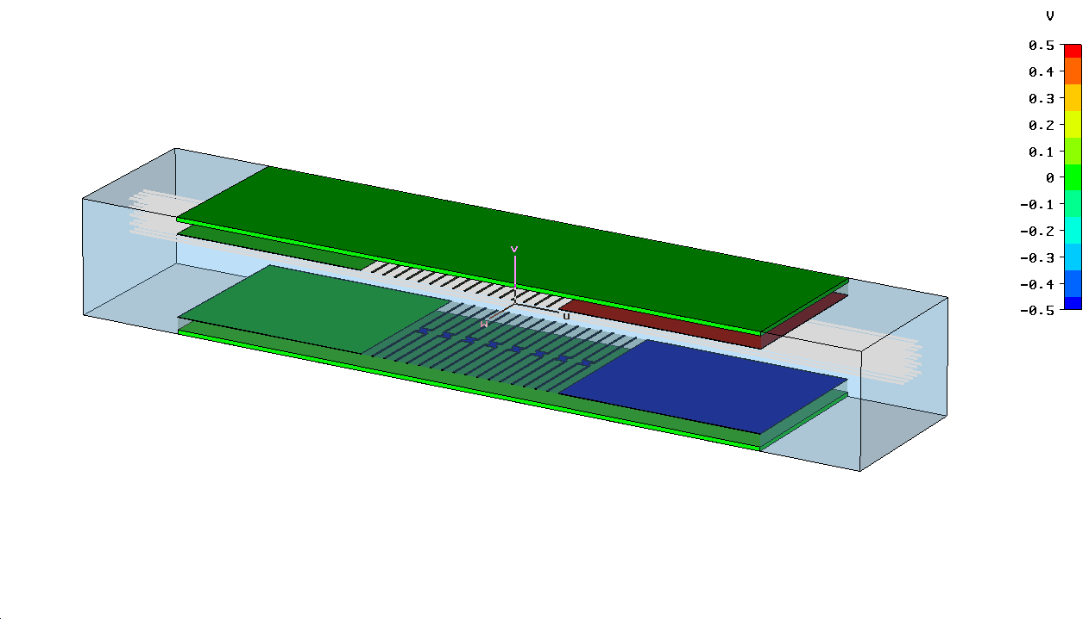

Figure 4.4.1: CERN meander line geometry implemented in EM Studio

Table 4.4a: Status of the Sub tasks in WP5 which are supposed to have started according to the MS project breakdown in Annex 1

WBS # | Title | Original begin date (Annex 1) | Original end date (annex1) | Estimated Status | Revised end date
4.1 | Chopper structure A (CERN)
4.1.1 | Pre-prototype construction | January 2004 | June 2004 | Finished | June2005
4.1.2 | Pre-prototype testing | July 2004 | November 2004 | Combined with task 4.1.5 | December 2005
4.1.3 | Driver construction & testing | January 2004 | December 2005 | Finished
4.1.4 | Full scale prototype design | January 2005 | June 2005 | Finished
4.1.5 | Full scale prototype construction | January 2005 | December 2005 | Finished
4.1.6 | Prototype testing w/o beam | January 2006 |  | 20%
4.2 | Chopper line (CERN)
4.2.1 | Dump design | January 2004 | June 2004 | Finished
4.2.2 | Dump construction | January 2005 | June 2005 | Finished | June06
4.3 | Chopper structure B (RAL)
4.3.1 | Pre-prototype design and test | January 2004 | June 2005 | Finished
4.3.2 | Prototype design | January 2005 | December 2005 | Finished

Table 4.4b: Status with respect to the interim reports and deliverables due in 2006 according to the MS project breakdown

WBS # | Title | Due date in Annex 1 | Status | Revised delivery date
4.1.1 | Chopper A design report | June 2005 | delayed | December 2005
4.1.2 | Intermediate test report | March 2005 | Waiting for task 4.1.5 | August 2006
4.2.2 | Dump design report | June 2005 | Delivered | April 06
4.3.1 | Chopper B design report | June 2006 |  | Decembre 2006
4.1.2 | Chopper A prototype ready | August 2006 | finished

  - Work Package 5: Beam Dynamics
Activities at IAP, Frankfurt, Germany

Code development (subtask 5.1.2):

The LORASR routines for error study and loss profile calculations have been further improved. Error studies on the GSI Proton Linac beam dynamics design will be started next.

Code comparison and benchmarking (subtask 5.1.7):

The LORASR code was included to the UNILAC Alvarez section tracking benchmark. The results are well fitting to those achieved by the other benchmarked codes. Further information can be gathered from the HIPPI Code Comparison Web page, as well as from the Note 'CARE-Note-2006-011-HIPPI', which is in preparation.

Beam dynamics studies and simulations at LPSC Grenoble

Activities are progressing as foreseen. There are no major news to report.

Activities at CERN

- The PATH code was extended to include possibility of doing statistical error studies. A comparison with TRACEWIN on LINAC4 DTL was successful.
- End-to-end simulation starting with an input beam distribution from the source was performed. Re-matching for the new conditions all along the linac4 is still in progress.
- Detailed beam dynamics simulations of the LEBT are in progress.

Activities at GSI

- Experiments: The first bloc of the UNILAC beam dynamics experiment planned for HIPPI was successfully conducted end of May. During the experiments it was verified that for a low intensity beam energy parasites lead to significant transmission losses and emittance growth. By optimizing RF parameters especially of the HSI RFQ and the second HSI IH structure, the phase correlation between HSI and Alvarez DTL, the settings of the gas stripper, and the matching of the beam to the first Alvarez tank a transmission of 99% and a minimum transverse emittance growth of about 1.2 was achieved. Further multi-particle simulations are needed to understand the results of these experiments in more detail.
- Simulation: The experimental data are in the process of being compared with different simulation codes (Parmila, Dynamion and Path).

Activities at FZJ, Juelich

- Beam Dynamics: The calculation of beam dynamics with space charge has been completed for the energy range from 3 to 180 MeV using slot-finger resonators and slot resonators. Stable particle motion could be verified for peak currents of up to 40 mA due to combination of accelerating field and focussing fields in the resonators of the low energy part.
- Beam Diagnostics: According to our schedule the beam profile monitor based on fluorescence is upgraded now to read each of the 32 PMT channels individually, leading to a higher resolution. This change also results in a new data analysis, the development of which has started. System enhancements for tailoring this beam profile monitor for use in circular accelerators cover three issues: (i) Measurements showed that the photocathode of the PMT must have optimum sensitivity for hydrogen photons. (ii) Measurements showed that the vacuum chamber of the beam profile monitor has to be covered with a black surface. (iii) For low intensity applications (e.g. time resolved measurements) a local enhancement of residual gas pressure will be considered.

Activities at CEA

- To implement the collisions processes into the code for ECR sources and neutralized LEBTs, several Monte Carlo method have been developed and checked. First hard sphere approximation have been used for modeling elastic and inelastic collisions (charged-neutral particle collisions), second, a partial differential cross section approach have been studied to more accurately simulate charged particles collisions. The routines have been checked with a simulation of a DC glow discharge.
- The benchmarks for acquiring a cluster have started and several manufacturers are contacted.

Table 4.5a : Status of the Sub tasks in WP5 which are supposed to have started according to the MS project breakdown in Annex 1

WBS # | Title | Original begin date (Annex 3) | Original end date (Annex 3) | Estimated Status | Revised end date
5.1 | Code development
5.1.1 | Preparation, Dev. of 3D space charge routines, Testing | January 2004 | June 2007 | On time
5.1.2 | LORASR development | January 2004 | December 2005 | Report delivered
5.1.3 | Neutralization and ECR source model. | January 2004 | December 2005 | On time | June 2007
5.1.4 | Improvement, modeling high current | January 2004 | June 2006 | Finished
5.1.5 | Codes preparation for 3 MeV test stand | January 2004 | December 2006 | On time
5.1.6 | Codes preparation for SC linacs | January 2004 | December 2006 | On time
5.1.7 | Code comparison and benchmarking | January 2005 | September 2008 | 90%
5.2.1 | Experiment at UNILAC: preparation & simulations | January 2004 | June 2006 | 90 % | December 2006
5.2.2,3 | Measurement campaigns | June and Oct. 2006 |  | 1st camp. done
5.3 | Diagnostics and collimation
5.3.1 | Profile measurement prototype design and construction (GSI) | July 2004 | February 2005 | Done
5.3.2 | Profile measurement testing (GSI) | March 2005 | June 2006 | 90 %
5.3.3 |  | October 2004 | June 2005 | Done
5.3.4 | Non-interceptive bunch measurement construction (GSI) | January 2005 | December 2006 | 80%
5.3.9 | Halo monitor tests and improvement (CERN) | January 2004 | June 2005 | 50 % | March 2007
5.3.7 | Beam profile monitor design (FZJ) | January 2005 | June 07 | 80%
5.3.6 | On-line transmission control (GSI) | October 2005 | September 2007 | 50%
5.3.6 | Collimators design (CERN) | January 2005 | December 2006 | Replaced by dump

Table 4.5b: Status with respect to the interim reports and deliverables due in 2005 according to the MS project breakdown

WBS # | Title | Due date in Annex 1 | Status | Revised delivery date
5.1.5 | Code preparation for 3 MeV test stand Intermediate report | June 2006 | In preparation
5.3.2 | Profile measurement by fluorescence final report | July 2006
5.2 | Simulations and experiment at UNILAC final report | December 2006 | delayed | July 2007
5.3.4 | Non-interceptive bunch measurement final report | December 2006
5.3.8 | Collimators design prototype ready | December 2006 | Replaced by dump  Task cancelled
5.3.8 | Collimators design final report | December 2006 | Replaced by dump  Task cancelled

Appendix 1: Gantt chart at end of August 2006

