D.Proch, T Garvey DESY, 30 April 2004

JRASRF Quarter report 1/2004

WP1 Management and Communication (M&C)

1. Administrative issues

  - A financial accounting system is established at DESY to trace all EU contributions to DESY. It is based on SAP (standard accounting system at DESY) and allows to trace all financial activities down to the level of tasks.
  - The EU payment for the first reporting period (75% of requested 18 month support) arrived at the DESY account just before the end of April.
  - Several financial activities have been started before arrival of EU support by “lending” regular DESY budged money.

2. Meetings
  - A briefing meeting was held in December 2003 at DESY to inform DESY JRASRF participants about the start of the project.
  - JRASRF kick of meeting was held during the TESLA meeting at Zeuten at January 2004
  - JRASRF sub meetings were held at Saclay/Orsay, INFN Legnaro and DESY (WP8) in order to activate the cooperation between the partners at different laboratories

- JRASRF Web-page
  - A JRASRF web-page is established ( Http://JRA-SRF.desy.de). It contains all JRASRF relevant information as well has a data bank for any report/publication of this JRA. CARE relevant information is linked to the appropriate server.
  - A telephone conference address is installed for meetings with work package leaders. The first meeting was held in March 2004.

  - Financial issues
  - Table WP1,1 shows the situation of money spending in JRASRF. All positions are in obligo, i.e. all orders mentioned for consumables or prototypes are placed to companies, delivery is soon. Two non permanent persons are hired at DESY, two more positions are opened.

WP2 (Improved Standard Cavity Fabrication, ISCF)

Task 2.1: reliability analysis

For what concern the reliability task (2.1), the analysis of the data coming from the experience of the TTF modules has been started and data relative to modules 1, 2, 3, 1*, and partially for 4 and 5, have been reviewed and correlations between cavity performances and assembly procedure have been analyzed. Preliminary results indicates that the reduction of the number of “troubles” and problems during the assembly is correlated with the reduction at the same time of the difference between the cavity performances during the vertical test and the behavior in the string.
Moreover the data review have highlighted some critical points as quality controls of components before the assembly, not well defined procedures and personnel training.
The next step, during the next quarter, will be dedicated to the reviewing of the data relative to new modules: 2*, 3*, and to complete the reviewing of cavity performances for module 4 and 5.
The main milestone is foreseen for end of September and we have to work hard in order to succeed to find and establish real correlations between cavity final performances and some critical steps in the cavity fabrication and handling.

Financial reporting

No money has been spent so far

Task 2.2: improved component design.

The improved component design activity is just started and has been devoted to the recording and the analysis of the experience on components design relative to SC cavities of the different laboratories. We started with collecting information from the other labs about cold connections (SC cavity flanges or cold bellow flanges) in order to setting up a table of parameters comprising for instance the flange and gasket materials, the number of bolts, the torque, the elasticity of components, the applied force to the seal, etc.
At the same time we are preparing a small facility for cold leak test (up to 2 K).

Financial and man power considerations
INFN has acknowledged formally the fund flow for the CARE contract during its “Consiglio Direttivo” only at the end of March. Therefore, up to then, no job on the CARE budget has been issued. We are currently in the process of setting up the INFN procedures for the selection of a mechanical engineer (only partially covered by SFR funds) and two young researchers for reliability analysis and for the retrieving of data on components and on welding techniques.

Task 2.3: EB welding

Design of tools for prototype welding is under preparation.
No money has been spent until now.

WP3 Seamless cavity production (SCP)

3.1 Seamless cavity production by spinning

We have finished to design the spinning machine for producing seamless multi-cell resonators starting from a tube. The spinning is done in an external firm that already owns a lathe currently used for spinning resonators. The existing machine however is not enough powerful and not properly suitable for the spinning operation. The main problem indeed is the following: the revolving turret supporting rollers can move back and forward along a direction that is approximately 45 degrees from the cavity axis. It moves forward in order to have rollers applying a radial force to the tube that must be plastically deformed. It moves backward in order to retract the roller after the deformation in order to shift to one another point to deform. During this latter operation, the pressure is released and there is no any possibility to apply any plastic deformation. Due to the peculiar shape of the cavity in each dumbbell, the actual machine can spin only the half cell that is encountered along the roller rectilinear path. In order to spin the other half-cell, the cavity must be dismounted from the lathe together with the internal mandrel. The whole stuff is turned of 180 degrees, the half-cell that was previously untouched by the roller becomes the part that must be plastically deformed. This operation is at the moment iterated several times up to the moment when the full dumbbell is finished. This operation is rather heavy to do, is time consuming, and it is rather risky. Not only for the piece that can be damaged during the operations of dismount from lathe headstock, piece tournament and remount, but also because the collapsible mandrel can move from the correct position. Further the late is not long enough for the nine-cell spinning and the pressure between headstock and tailstock is not sufficient.
Therefore we have decided to adapt the already existing machine designing some modified parts to add to the existing machine. All the work done is reported in the following:
- As reported above, the a new turret has been designed. The turret will work in opposite direction and on the other side of the already existing one.
- The hydraulic plant will be implemented and valves will be added, in order to achieve a pressure of 120 bar.
- Since the increase in pressure will be too large for the existing headstock configuration, and since the max rotation speed will be of 2000 rpm, the bearings supporting the headstock will be changed adopting forced lubrication bearings with the related pump and ancillaries
- The headstock will also be consequently elongated of 100 mm and it has been designed of more robust construction.
- The lathe base and carriage appear more solid in the new design. The base will be elongated of 200 mm.
- The lathe tailstock has been enforced too in order to support the higher pressure we need to apply between headstock and tailstock when spinning the part.
- A new motor has been taken into account. It will have a 18 KW power, with an output speed of 8000/min and a speed reducer of 1:4

For this point the milestones have been fully respected.

3.2 Seamless cavity production by hydroforming

The main idea is fabricate the actual cavity (excluding the end groups with auxiliary components like input coupler ports, higher order mode dampers…) by a method that avoids welding. Fabrication of seamless cavities from bulk Nb has potentially advantage over the standard cavity fabrication technique of deep drawing and electron beam welding. The weld-less cavity does not have risk of foreign material and gases diffusing into equator welds to reduce purity at place of magnetic field maximum, where it is needed the most. Lower cost of fabrication and better rf-performance can be expected.

In the length of time 1.02.04-30.04.04 following work was done:
- Work on design of the hydroforming machine is started. Concept of the machine hydraulic is developed. Drawings of the matrices and of the support system are in the work.
- Construction of the hydroforming machine is started. Most of hydraulic parts are ordered. Some of them delivered, some will be delivered in coming weeks. Concept for the software is developed and is in the implementation. Software will be based on the LabVIEW principles (company National Instruments).
- Construction of the tube necking machine is started. Concept for the support system and turning mechanism is developed. Drawings of necking mechanism are in the work.
- Specification for fabrication of the seam less bimetallic NbCu tubes is developed.

Money spent in the time 1.02.04-30.04.04
- ordered parts 14225 EUR
- pay for personal: physicist (Honorarwissenschaftler)

WP4 – Thin film cavity production

The work package WP4 concerns the elaboration of new technological methods for coating of internal surfaces of RF cavities with thin layers of a superconductor (pure niobium or another HTC material). As the first step, the applicability of ultra-high vacuum (UHV) arc discharges will be investigated in two different configurations: with a linear cathode (at IPJ in Swierk) and with a planar cathode (at INFN in Rome). Two prototype devices with planar-cathodes were constructed at INFN-Roma2 in previous years, and a prototype facility with a cylindrical (linear) cathode has just been constructed at IPJ-Swierk. Modifications of these devices have been planned for the first semester of 2004.
The modification of the linear-arc facility in Swierk (task 4.1.1) should involve an exchange of the old pumping system, installation of a metal UHV-valve and a gas analyzer, changes of the baking system and an improvement of the control unit. Since no funds for the CARE Contract have been transferred so far, there is a delay in buying and installation of the necessary equipment. However, an exchange of the baking system and the modification of the control unit have been performed. The optimization of the triggering and pulsed supply system has been initiated, and a prototype of a high-current pulse generator has just been commissioned.
The modification of the planar-arc device in Rome (task 4.2.1), which has just been finished, included the replacement of the whole baking system and the installation of a new computerized temperature control and data acquisition unit. A new arc power supply unit has also been bought and tested. Work towards the design and construction of an optimized laser triggering system (with a modified laser-beam input) has been started. Requests for tenders on optical components are under way and preliminary tests have been carried out with a laser on loan from the University Department.
As regards the budget, we have to remark that the power supply unit mentioned above, for which 10K€ were reserved in the budget, was bought in December 2003 in order to proceed more rapidly. The money has been borrowed by INFN, but because of VAT problems (still to be solved) the corresponding sum can not be reimbursed using ESGARD funds WHY NOT Therefore, we have to ask for the permission to use this sum eventually for other durable equipment, e.g. for an oscilloscope needed to study the arc behavior on a short time scale.
A call for a graduated engineer (with an experience in physics and technology of the film deposition) is ready and it has to be advertised in the next few days. A contract has also been signed for a graduate student from the University to work (part time, for one year) on the project.

WP5 Material Analysis (MA)

5.1 EP on single cells
Experiments on samples have started to study electropolishing parameters. A student has been hired to support this work. Preparation of the report is underway. A one-cell electropolishing system is bought from CERN. Currently it is being modified to fit the installations at CEA. A contract with a company has been made for mixing of the diverse acid mixtures.

5.2 EP on multicells
Improvement for the gas cleaning system is underway. It has been found that the cleaning system for the acid supply area is insufficient. An improved filter system has been ordered and will be installed in the immediate future (2500,-EUR). Sample measurements on the quality control of the EP process are planned. Preparation of the chemical lab has started (2500,-EUR).

5.3 Automated EP

The EP installation has been designed and the construction has already started. At the moment we are
- assembling the equipment and parts needed for the high pressure rinsing. In particular we are taking care of building an adequate cover of the electric plant from the water ejected during the processing. It still remains to understand which motor to apply for the linear motion of the high pressure rod. The actual motor indeed seems to move up and down with a too low velocity.
- testing with water the sequence of operations for the EP procedure in order to establish a protocol
- Electropolishing Niobium samples in order to investigate alternative electrolytes to the standard Hydrofluoric/Sulphuric one
- Investigating the possibility to solve the problem of instabilities in the automatic process. At the moment the operation of locking the EP parameters to the minimum of the differential Conductance of the polarization curve, gives rise to some instability problems. A solution to this problem is under study.
- The electropolishing of Copper electrodes in different geometrical configurations (planar and cylindrical) is also under study in order to investigate how the polarization curve changes as a function of electrode area and distance. All that is needed for a better comprehension of the algorithms to choose for making working the automatic EP. Copper is chosen as the material to study in first approximation, because its EP Copper is a much simpler and safer than processing Niobium

For this point the milestones have been fully respected.

5.4 Dry ice cleaning
A prototype system for the dry-ice-cleaning has been operated. One of the tests has shown a performance improvement. The design of a production system for cavities up to three-cells is finished. First parts have been ordered. A gas supply system for the cleanroom is nearly completely installed. Total expenditure is about 20000 EUR.
WP 6 Material Analysis (MA)

6.2 Flux gate magnetometry

Referring to this point we are:

- designing a cavity shaped electrolytic cell having the possibility to test different cathode shapes. The goal is a tomography of the electrolytic cell, in order to configure the effect of cathode geometry on Electropolishing.
- Designing the experiment to monitor two different kind of defected samples:
  - Physical defects like surface scratches and foreign particle embedded onto Niobium
  - Samples with degraded RRR to distinguish from samples with RRR 300.

For this point the milestones have been fully respected

Planning of expenses

Unfortunately the money were available only from middle of April. We plane to spend immediately around 45 K€ for Spinning, about 2-3 K€ for an Electropolishing supply, and to engage three persons that will work to the a.m subjects

WP7 Couplers (COUP)

7.1 The development of new proto-type power couplers

New proto-type coupler developments are of interest as they may lead to improved performance and /or reduced cost with respect to existing designs. Two alternative designs are currently under study i.e. the TTF-V and TW60 couplers. Both designs are based on a 60 mm outside diameter co-axial line (see Fig’s 1 and 2).

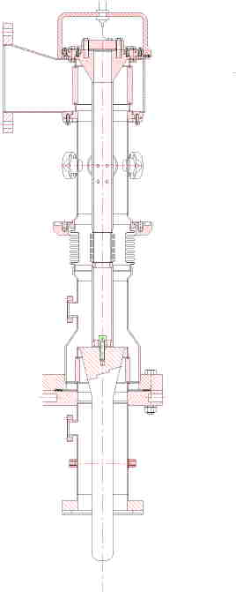  Fig 1 : Layout of the TTF 5 coupler | 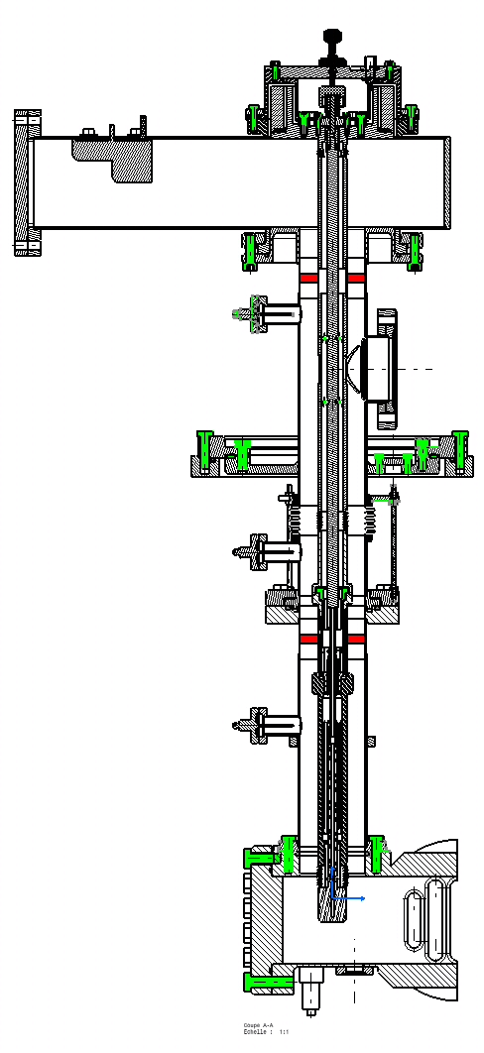  Fig 2 : layout of the TW60 coupler
The TTF-V coupler is a derivative of the TTF-III coupler presently used on the TESLA Test Facility. As is the case for the TTF-III coupler, the TTF-V coupler employs two cylindrical ceramic windows. The “warm” part of this coupler is essentially identical with the TTF-III version. The “cold” part has been scaled to a outer diameter of 60 mm (c.f. 40 mm for TTF-III) and has an impedance of 50 Ohms. The increased diameter is employed for two reasons; (i) the multipactor thresholds are pushed to higher power levels with increased diameter, (ii) the larger diameter would support higher travelling wave power flow, which could be of interest if ever a variant of the ‘superstructure’ cavity was adopted for TESLA. Note however, that the increased diameter would necessitate a change to the present TTF cavity flange. The present TTF-V design does not include a moveable antenna for coupling adjustment
The TW60 (Travelling Wave 60 mm φ) coupler employs two identical ceramic Al₂O₃ windows of 8 mm thickness (shown in red in Fig. 2). RF matching of the warm window is obtained using two reduced height wave-guides (WG) parts at the input to WG to co-axial transition. A DC bias can be applied to the inner conductor, the electrical insulation is made by an insulating ring located in the warm transition. The bias system is screened from RF power by the use of a RF choke. The antenna length can be adjusted by acting on the bellow near the antenna end (a simplified version of the TW60 without the tuning of the antenna will be built first as a proof of principle).

Simulations of these couplers were made using the HFSS code commercialised by Ansoft. The matching at the frequency of 1300 MHz was of course an important part of the optimisation. Fig. 3, for example shows the return loss calculated for the TTF-V coupler. The electrical fields inside of the structures were also optimised in order to reduce the losses. Fig. 4 shows the electric field distribution (as a false colour image) within the TW60 coupler.

Figure 3 : Reflection coefficient of the TTF-V coupler.

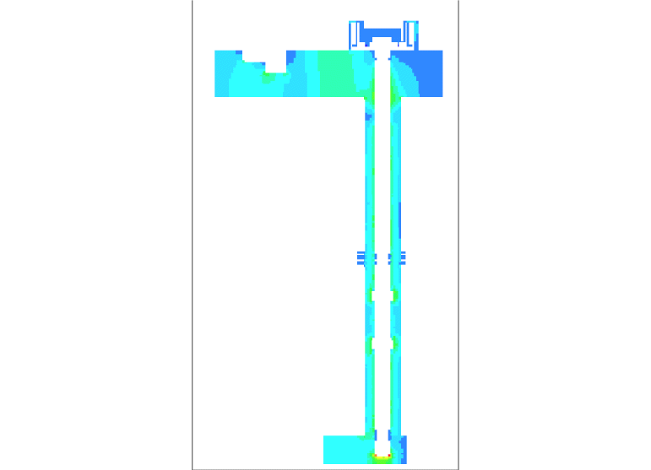
Figure 4 : Electric field within the TW 60 coupler.
It is important to keep the dielectric losses inside of the cold window as low as possible because of the proximity of the 2K environment. Losses of the TTF-V and TW60 cold windows are compared with the TTF-III case in the table below

Window type | TTF 5 | TW 60
Losses normalised to TTF3 (%) | 73 | 115
Comparison of calculated cold window losses between different coupler designs.

Following the RF simulations the calculated fields are used to estimated the thermal losses in the coupler.
At the time of writing the mechanical drawings for the TTF-V and TW60 couplers are at an advanced stage. Some modifications remain to be done on the TTF-V coupler drawing;
- Adjustment of the penetration distance of the antenna into the WG test box (to be compatible with the TW60 case as the test bench for these two couplers will be the same).
- review with the RF engineers certain details of the ceramic (metallisation, ceramic grooves).
After these modifications, a call for tenders will be made before ordering some examples of the TTF-V coupler.
The general conception of the TW60 coupler is completed. A review was held between RF, mechanical and vacuum experts to fix the design. The detailed fabrication drawings of TW60 coupler should be complete by the end of June of this year. More detailed thermal simulations of the coupler in the environment of a cryostat (taking into account the variations of thermal and electrical properties of materials in regard of temperature) are planned for the future.
After completion of the fabrication drawings, a call for bids will be established to produce some examples of TW 60 couplers. The initial fabrication will be made without the adjustable antenna. If the high power trials are successful, further proto-types will be made with variable coupling.

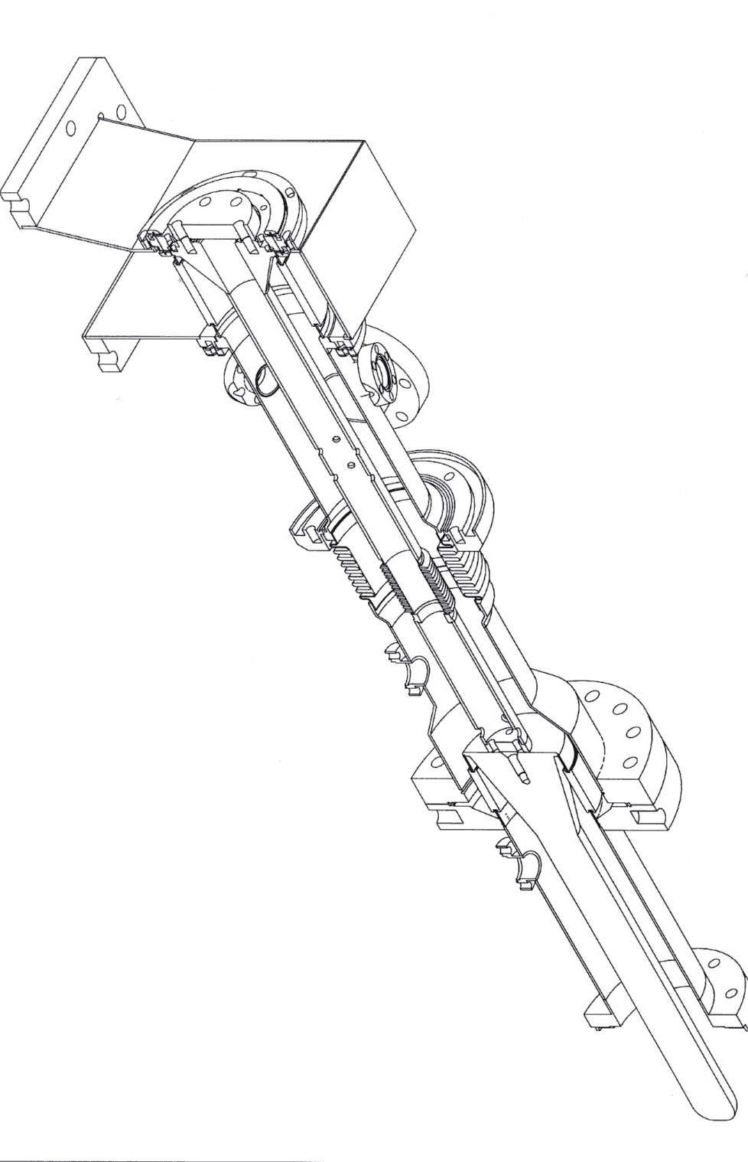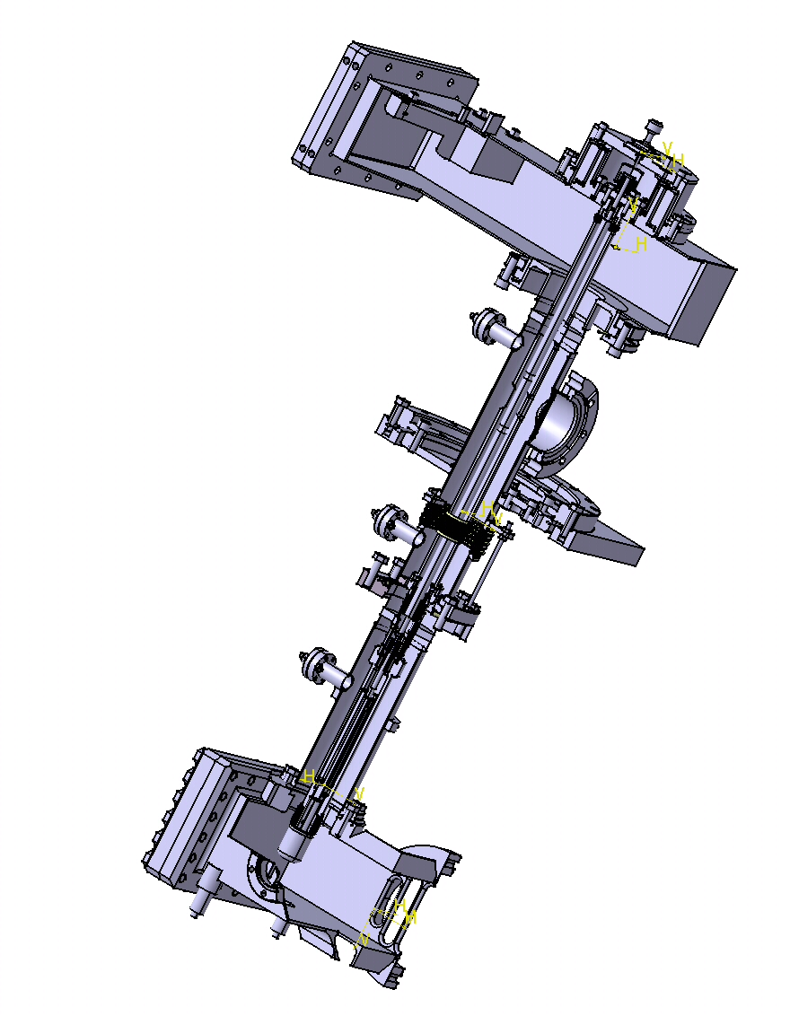
Figure 5. CAD views of the TTF-V (left) and TW60 (right) couplers.

WP 8 Tuner (TUN)

The objectives of the work package WP8 ‘TUNERS’ is to develop new active cold tuner system for SRF cavities. Several types of solutions can be proposed. Concerning the tuner mounting positions there are two possibilities – in first one the tuner can be attached to the cavity end (CEA tuner); in the second one the tuner can be assembled around the cavity (coaxial one). Concerning the type of active elements there are also two possibilities: piezoelectric element and magnetostrictive one.
Below the current research status of each task is presented

8.1 ‘UMI Tuner’

A facility to test piezo actuators and ancillaries (load cells and other sensors)
in liquid helium environment and under operation has been realized. We are routinely using the facility to qualify sensors and actuators to be employed in active tuner systems.
Active tuners are provided with piezo actuators. A proper pre-load force must be applied to the piezo actuators to maximize their lifetimes. So an apparatus to measure these preloads in cryogenic environment must be used or designed. Standard load cells have been evaluated, and after the failure of these devices in LHe a custom device
is under design in collaboration with industry. The testing of standard devices was precious to understand the critical parameters for a successful design of a cryogenic force detector.
At the same time piezo actuators evaluation in LHe is under way. In particular the piezo impedance at different loads is measured, showing that the actuator natural resonant frequency is a function of the applied force. This permits the piezo to be calibrated as a force sensor, to be employed in pre load force detection in LHe environment, and constitutes a valid alternative to the use of load cells.
For what concern the control electronics, a VME based system is under construction. A SPARK CPU is already in operation into the network. We are going to acquire from DESY a DSP board (together with DAC and ADC boards) for the design and realization of a microphonics stabilization system, based on piezo actuators, for the Tesla SC cavities.
A prototype compensation loop, based on a DSP evaluation board, has worked successfully on the reduction of microphonics noise on a copper cavity, though with poor performances due to low computation speed of the DSP evaluation board.

Manpower
INFN has acknowledged formally the fund flow for the CARE contract during its “Consiglio Direttivo” at the end of March. Therefore, up to then, no job on the CARE budget has been issued. We are currently in the process of setting up the INFN procedures for the selection of a mechanical engineer (partially covered by SRF funds and partially by HIPPI funds) for the tuner activities, and a PhD grant for R&D activity on control electronics for active tuners systems.
The estimate of permanent staff dedicated to SRF activities in the 1st quarter is
one persons/month. During the 2nd quarter, approximate two persons/months will be necessary for the active tuners activity.

Financial reporting
Concerning the financial reporting and the consistency with the contract planning, we note that the control electronics and the (UMI = coaxial) tuner definition, fall in the early period of the project. Our first priority in the near term future is to use the manpower funds for a PHD student activity and to hire a mechanical engineer, in order to complete the control electronics design and to start the coaxial tuner activities in due time (07/04). In the first financial reporting period (M1-M12) we will have mainly manpower and travel (DESY) expenses, with a limited amount of consumables related to in-house activities.

8.2 ‘Magnetostrictive Tuner’

The main objective of this task is to develop to a magnetostrictive tuner, which will be able to compensate the Lorentz Force and effects of microphonics. The principle of operation is similar to the piezoelectric tuner, however the active element uses the magnetostrictive phenomena instead of piezoelectric one. The main goal is to develop a system that allows to compare the features of both solutions. The final decision which type of tuner will be used should take into account several issues like i.e. reliability, efficiency, MTBF, influence to the other systems and price. Since the price of magnetostrictive tuner is several times higher than piezoelectric one the application of this type of tuner should be justified by the very good technical performance. We estimate technical parameters of the tuner. In order to obtain several micrometers of cavity movement there is a need to generate strong magnetic field in the coil core. We assume the several Amps of current will be needed. The coil is expected to have an inductance of order of some mH therefore to reload the current of several Amps in less than 1ms (dynamic requirements on tuner system) the more than 200V need to be provided.
Concerning the thermal issues the coil need to be a superconducting. In other case the Joule heat will cause temperature rise inside the cryomodule. However, there is need to take under consideration that the magnetic field created in the coil can destroy the superconductivity in cavity.
We have started design the electronic driver for magnetostrictive tuner. The technical data for it will be maximum output voltage 250V, maximum output current 5A together with bandwidth 1kHz. The output of driver must be short-circuit protected. The development is in the early stage. The prototype of such a driver is going to be build and tested during next 3 months.
Our institute received the financial support for the research just a few days ago, however our research is currently almost on schedule.

8.3 ‘CEA Tuner’

A mechanical analysis of the system cavity-tuner-helium tank has been made, in order to determine the strength applied by the cavity on the tuner at cold. This mechanical analysis, which is the key for a new piezo tuner design, was longer than expected. It is still not yet finished. Tuner studies could not begin before having determined the forces that are applied by the cavity on the tuner, i.e. on the piezo actuator, at the operating temperature 2K.
The final strength applied by the cavity on the tuner at cold is determined by the cavity preparation, which is performed between the cavity is receipt from supplier to the cooling down in the cryomodule. The main step of this procedure is the first cavity tuning at frequency f₀ (before chemical treatment pumping and cool down for RF measurements). This operation entirely determines the final force that the cavity applies on the tuner at cold. The other steps of the cavity preparation, like the chemical treatment, pumping and cooling down, add frequency shifts that are known with some uncertainty. All these effects have to be taken into account in order to determine the initial frequency f₀ that lead to the desired frequency at cold (f_{final} = 1.300GHz), with the desired force applied on the tuner.
The goal is to obtain a strength value within the range of typical piezo pre-load forces: 300 to 600 N. A first analysis of the present cavity preparation procedure was done, that is being made at DESY on TTF cavities. By modifying some of the parameters it seems possible to obtain strength comprised between 300 N and 2000 N. This is a first estimation, and more precise values have to be determined. Meeting with DESY people is foreseen at the beginning of May for a discussion about the details of a new cavity preparation that will be needed for a new tuner, and about our estimation of the cavity strength at cold. The possibility to reduce the range and to obtain a more precise value of the strength at cold will be analyzed.
Nevertheless, we decided to begin the design of the new piezo tuner before this discussion. The pre-study design is based on the following main criteria:
- The piezo will see half of the cavity strength.
- The piezo will be: NOLIAC PZT pz27
- The cavity will always be stretched at cold by the tuner, and not compressed as it is on the present design.
- SOLEIL tuner design
Using drawing files of the cavities and cryomodule the mechanical study of the tuner will be done.
The time spent for the mechanical analysis was longer that expected, and the design pre study that should have begun at the end of March began with one-month delay week 17 of April.

8.4 ‘IN2P3 Activity’

The task of CNRS-IN2P3-Orsay institute is the characterization of piezoelectric actuators at low temperature, perform radiation hardness tests of these components with fast neutrons at low temperature (liquid helium temperature = 4.2 K), contribute to the study of their integration in a piezo-tuner and participate to the tests of the final device inside horizontal cryostat in collaboration with CEA/DSM/DAPNIA institute. Our institute didn’t yet receive the financial support for these operations but the CARE coordinator Roy ALEKSAN informed us last week that the cash will flow to laboratories by the end of April 2004. The lack of the financial support results in a delay of at least three and half months in placing orders for the components needed for experiments. We have already placed an order for piezoelectric actuators: the delivery time for these components is 8 weeks and we expect to receive them by mid of June 2004. A dedicated chamber was designed for testing piezoelectric actuators under vacuum at low temperature (Fig. 1).
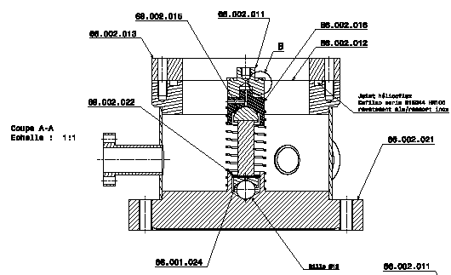
Fig. 1- Test chamber for piezoelectric actuators characterization at low temperature

The drawings were sent to three companies for the fabrication of all the components of test chambers and the estimate is expected by end of April 2004. The corresponding order will be placed immediately. Moreover drawings and fabrication of different elements for other experiments such as the tests of piezoelectric actuators as sensors and study of preload effect on the piezoelectric actuator behavior are in progress. The irradiations tests will be performed using CERI facility at Orléans. We have already the agreement of CERI laboratory for irradiations tests with fast neutrons and we will visit this institute soon for the discussion of the experiments to be prepared. The cryostat for irradiations tests is available: it was successfully used for irradiations studies on cryogenic thermometers for the LHC project. This cryostat with its insert needs some modifications for experiments with piezoelectric actuators, which should be operated under vacuum conditions. A special test-cell will be designed for irradiations experiments at liquid helium temperature. We have already the estimate for the main electronics device and sensors needed for the irradiations tests. We will place an order as soon as we receive the financial support. The corresponding tests are not scheduled before September 2004. We have an open position (Fellowship/Associateship) for a candidate, which will work on piezoelectric actuators experimental program at IPN Orsay.

WP 9 (LLRF)

General remarks:
- Hired P.h.D. student (PSI contribution) for robust rf gun control and exception handling.
- Prepared posting for position for rf engineer for design optimization.
- No procurements from CARE monies.

- Single bunch transient detection

  - Developed concept for single bunch transient detection based nulling of delayed probe signal with original probe signal

  - Studied sensitivity on nulling and system limitations for the single bunch transient measurement
  - Procured components for the single bunch detection experimental set-up

- Design optimization with respect to performance and cost

  - Developed concepts for cost reduction

  - Discussion of technical and operational performance requirements

- Highly stable frequency distribution

  - Measured temperature stability of phase detectors for fiber optic monitoring system

  - Developed microcontroller based portable data acquisition for the measurement of the temperaure stability of the fiber optic monitor system

- 3rd generation rf control (FPGA)

  - Demonstrated Virtex II based cavity simulator and controller in real time mode

  - Connected FPGA based controller to superconducting cavity and measured cavity field signals.
  - Prepared set-up for demonstration of feedback with superconducting cavity.

- Performance optimization for different gradients

  - Simulation studies of operation of ACC1 at the UV-FEL with the first 4 cavities operated at 12 MV/m and last 4 cavities at 20 MV/m. Used simulation tool to optimize the rf power distribution loaded Q for full and zero beam loading.

  - Operated cavities in ACC1 at different gradients (30 MV/m and 12 MV/m)

- Multichannel down- (up)converter

  - Discussed choice of IF frequency based on technology options and performance trade-offs

  - Developed undersampling scheme for field detection at a high intermediate frequency at 81 MHz.
  - Developed scheme to replace vector-modulator with digital upconversion scheme based on single mixer.
  - Designed test stand for multichannel downconverter performance evaluation and calibration (linearity, crosstalk, temperature dependence etc.)

- Fast magnetostrictive tuner

  - Received prototype of magnetostrictive tuner

  - Prepared plan to measure length change as function of mechanical preload at cryogenic temperatures at INFN Milano.

- Radiation effect on electronics

  - Studied different schemes to obtain calibrated measurements of neutron and gamma dose and dose rates

  - Measured effect of neutrons (at positron converter in LINAC II) on CCD and CMOS cameras, SRAM and FPGA
  - Developed concept for genetic algorithms that can be used to develop single event effect immune code for FPGAs.

- Finite state machine

  - Worked out overall state machine control for the klystrons and modulators

  - Prepared subset of procedures for klystron operation

- Data management for DOOCS

  - Discussed requirements for the data management in DOOCS

- Exception handling

  - No progress

- Robust RF gun contro

  - Controlled RF gun with feedback with new DSP system and field detectors.
  - Measured cavity detuning with resolution of 1 kHz
  - Developed scheme for frequency tracking of cavity to support rf based initial heating.
  - Controlled RF gun with feedback with new DSP system and field detectors.
  - Measured cavity detuning with resolution of 1 kHz
  - Developed scheme for frequency tracking of cavity to support rf based initial heating

WP 10 Cryostat integration test

The horizontal cryostat Cry-Ho-Lab, located in Saclay, is in full operation with its own cryogenic generator since February 2003 and until now mainly devoted to test a 5-cell proton cavity prototype [1-2] and cold tuning systems.
These cryogenic facilities have been suggested to test components developed within the Joint Research Activity “Superconducting RF”. In parallel, tests will be also carried out within the JRA “High Intensity Pulsed Proton Injector” with low beta 700 MHz cavities.
The different components for JRA-SRF (high power coupler, cavity tuners and low level RF system) will be previously designed in work packages WP7, WP8 and WP9. These tests are planned at full RF power (1.5 MW pulsed – 1 ms – 10 Hz) on a full equipped 9-cell cavity (1300 MHz). Thirty weeks, with helium production, are foreseen for these tests and scheduled according to each work package agreement (see CARE proposal - annexe 1).
As example, a typical two-week test is described below (figure 1): it is spread over 23 days for the cavity use with helium production during 12 days and 9 days for the RF test [3]. According to this scheme 15 tests can be considered from mid 2005 to 2008. The manpower required is 3.8 person.year and the estimated cost for the helium is 650 k€, based on 5 €/litre as operating cost for the cryogenic generator.

Figure 1: Gantt chart for a typical test with liquid helium supply during two weeks.

Work Package 10 itself needs at first a test for checking [4]:

- the infra-structure modifications for the 9-cell cavity handling (High Pressure Rinsing stand, transport and clean-room trucks),
- the mechanical support for the cavity and the coupler inside the horizontal cryostat,
- the cryogenic system (tank filling, thermal sensors, insulating…) during a one-week test with helium and low RF power.

These tests will occur in autumn 2004, before the CryHoLab displace planned for a period of 6 months from November 2004.

Now mechanical parts are under design to adapt the cavity (2D and 3D drawings provided by DESY) to CryHoLab infrastructure. The manufacturing cost of these parts (rails, supports, flanges…) is estimated at 15 k€.

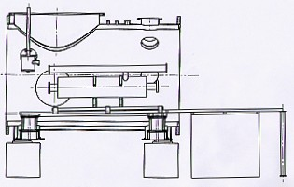

Figure 2: General drawing for the cavity-CryHoLab adaptation.

References:

[1] Particle Accelerator Conference Proceedings (Portland – May 2003)
( http://accelconf.web.cern.ch/accelconf/p03/PAPERS/TPAB047.PDF )
[2] Linear Accelerator Conference (Lübeck – August 2004)
( http://www.linac2004.de )
[3] JRA1 Start up meeting (Zeuten - January 2004)
( http://www-zeuthen.desy.de/tesla2004/agenda_wg1.html )
[4] ELAN Workshop (Frascati - May 2004)
( http://www.lnf.infn.it/conference/elan/ )

WP11 Beam diagnostics (BD)

11.1 RF Beam Position Monitor

The aime is to produce a RF cavity based beam position monitor (BPM), with a resolution five times better than existing device while maintaining high temporal resolution.
A first BPM is presently installed in module ACC1 of TTF. Tests with beam are planned in May 2004.
A design of a new cavity is in progress, with special focus on issues linked to the cryogenic and dust-free environment:
- The cleaning proved difficult → rinsing holes added
- Feedthroughs are optimized for instrumentation (reflections under 3% have been measured), but several of them broke during thermal cycles.
- The cavity is fixed to the adjacent new superconducting quadrupole developed by CIEMAT/DFFPE, Madrid. The alignment tolerance is 100 µm. New flanges. New gaskets.
Some important rf improvements are still to be done:
- Adjustment of the shape/position of the antennae to optimize the coupling (simulations and measurements).
- Possible sophistication of the cavity shape to achieve a geometric filtering of the common mode: We are too short for this before the beam tests in year 05, this is only envisaged as an alternative solution for a second unit that would be built later. For the moment we rely on the development of a hybrid coupler to improve the isolation.

In conclusion, the activity is started according to the planning.

There may be a change to the future schedule concerning the beam tests.

Money:
In the next days will come the following orders:
feedthroughs about 15 kEuros
cavity mechanics about 10 kEuros )

11.2 – Emittance monitor

The proposed monitor is based on the measurement of the angular distribution of the Diffraction Radiation (DR) emitted by an electron beam going through a slit cut in a metallic foil. It is only slightly perturbative to the beam and avoid the problems of material damage due to high density beam power.
Contrary to Transition Radiation from a continuous foil, DR, in its angular distribution, shows pronounced interference oscillation, depending on the observed wavelength, the slit dimension and the beam energy.
The visibility of the interference fringes is smoothed by two different mechanism: the beam dimension, with particles off-center emitting more intensity from one side than from the other, and the beam angular distribution, that simply “mixes” up the fringes.
Being the two effects different, by principle they can be valuated separately, so that, if the beam is in a waist on the screen, its transverse emittance could be measured through a single measurement.
We started simulations to find the best set of parameters to allow the separation of the two effects, introducing also some realistic effects as resolution and noise.
The first answer to be found is the dimension of the slit, in order to start its production, and the observation wavelength, to define the optics and the detector.
In the following, few simulation examples are shown.

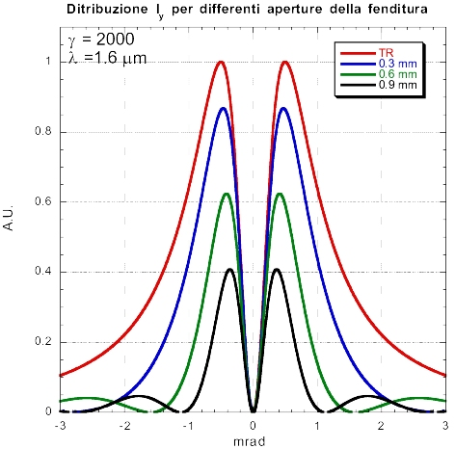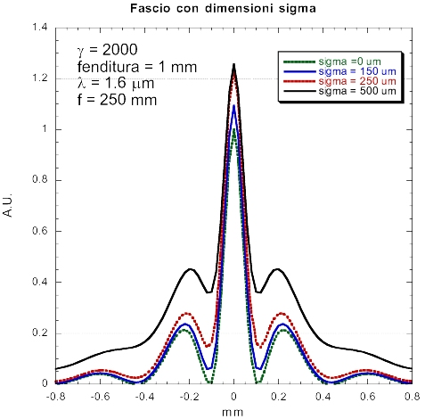
Fig. 1 – Effects of different slit width for a point-like beam (left) and effects of different transverse size beams

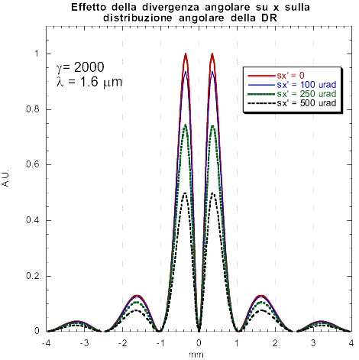
Fig. 2 – Effects of different angular spreads for a point-like beam

At the moment, no money has been spent, but we are now ready to offer a dedicated temporary contract to a post doc people. The relative advertising will be published on the CARE web site.

