 | SRF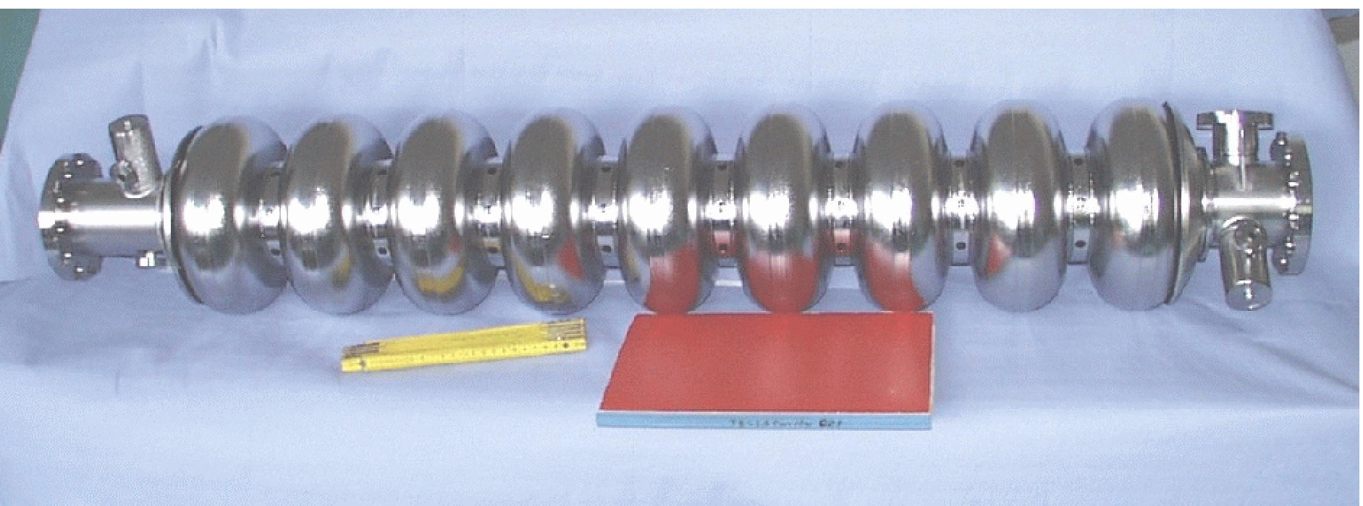

CARE/JRA1 Quarter report 2/2006

Research and Development on Superconducting Radio-Frequency Technology for Accelerator Application

Acronym: SRF
Co-Coordinators: D. Proch, DESY, T. Garvey, CNRS-Orsay
Participating Laboratoires and Institutes:
Institute  (Participating number) | Acronym | Country | Coordinator | SRF Scientific Contact | Associated to
DESY (6) | DESY | D | D. Proch | D. Proch
CEA/DSM/DAPNIA (1) | CEA | F | R. Aleksan | O. Napoly
CNRS-IN2P3-Orsay (3) | CNRS-Orsay | F | T.Garvey | T.Garvey | CNRS
INFN Legnaro (10) | INFN-LNL | I | S. Guiducci | E. Palmieri | INFN
INFN Milano (10) | INFN-Mi | I | S. Guiducci | C. Pagani | INFN
INFN Roma2 (10) | INFN-Ro2 | I | S. Guiducci | S. Tazzari | INFN
INFN Frascati (10) | INFN-LNF | I | S. Guiducci | M. Castellano | INFN
Paul Scherrer Institute (19) | PSI | CH | V. Schlott | V. Schlott
Technical University of Lodz (12) | TUL | PL | A.Napieralski | M. Grecki
Warsaw University of Technology (14) | WUT-ISE | PL | R.Romaniuk | R. Romaniuk
IPJ Swierk (13) | IPJ | PL | M. Sadowski | M. Sadowski

Industrial Involvement:
Company Name | Country | Contact Person
ACCEL Instruments GmbH | D | M. Peiniger
WSK Mess- und Datentechnik GmbH | D | F. Schölz
E. ZANON SPA | I | G. Corniani
Henkel Lohnpoliertechnik GmbH | D | B. Henkel

Work supported by the European Community-Research Infrastructure Activity under the FP6 “Structuring the European Research Area” programme (CARE, contract number RII3-CT-2003-506395).

Table of content:

1. Deliverables of the reporting period 3

2. Milestones of the reporting period 4

3. Tables of publications 5

4. JRA-SRF Activities January – September 2006 10

5. JRA-SRF Talks 11

6. Update 0f MS-Project 12

7. Status of activities 31

WP 2: Improved Standard Cavity Fabrication 31

WP 3: Seamless Cavity Production 36

WP 4: Thin Film Cavity Production 39

WP 5: Surface Preparation 44

WP 6: Material Analysis 53

WP 7: Couplers 57

WP 8: Tuners 59

WP 9: Low-Level RF (LLRF) 65

WP10: Integrated RF tests in a horizontal Cryostat 83

WP11: Beam diagnostics 84

1.) Deliverables of the reporting periode

3rd | 18m |  | 2nd midterm report
 | Task | Deliverables | Title | planned | expected | Reference | task | contractor
 |  |  |  | end | end |  | leader
1 | 2.1.7 | Final Report (D) | Final Report on reliability issue | 30.12.05 | 29.09.06 | EPAC06 | L..Lilje | DESY
2 | 3.1.3.5 | Final Report (D) | Spinning parameters defined | 18.05.06 | 29.09.06 | publication in progress | E.Palmieri | INFN-Lnl
3 | 5.1.1.4 | Final Report (D) | Best EP parameters | 15.01.06 | 15.01.06 | CARE-Report-06-010-SRF | C.Antoine | CEA
4 | 5.2.1.3.5 | Final Report (D) | Process parameters fixed | 31.03.06 | 31.08.06 | Intermediate Act. Rep. 2/06 | A.Matheisen | DESY
5 | 5.3.3.5 | Final Report (D) | Automated EP is defined | 13.02.06 | 01.10.06 | publication in progress | E.Palmieri | INFN-Lnl
6 | 5.4.2.4 | Final Report (D) | Cleaning parameters fixed | 30.06.06 | shifted |  | D.Reschke | DESY
7 | 8.4.8 | Final Report (D) | Report on IN2P3 tuner activities | 07.08.06 |  |  | M.Fouaidy | CNRS
8 | 9.3.3.8 | Final Report (D) | Report on new LLRF hardware comp. | 01.03.06 |  |  | R.Romaniuk | WUT-ISE
9 | 11.1.10 | BPM Protot. (D) | New BPM ready for Installation | 01.01.06 |  |  | C.Simon | CEA

2.) Milestones of the reporting period

3rd | 18m |  | 2nd midterm report
 | Task | Milestones | Title | planned | expected | Reference | task | contractor
 |  |  |  | end | end |  | leader
1 | 2.2.1.14 | Report | Final Report for new components | 17.03.06 | 01.03.06 | CARE-Note-2006-002-SRF | P.Michelato | INFN-Mi
2 | 2.2.2.5 | Report | Report about welding parameters | 11.08.06 | 31.12.06 | delayed | P.Michelato | INFN-Mi
3 | 4.1.1.7.3 | Hardware ready | Droplet filter ready | 30.06.06 | achieved | publication in progress | P.Strzyzewski | IPJ
4 | 5.1.3.4 | Commissioning | First operation of EP set-up | 01.02.06 | 29.09.06 | achieved ; Publ. in progress | C.Antoine | CEA
5 | 5.1.4.2 | Design Report | Define working parameters for single cells | 02.06.06 | 30.06.07 | shifted | C.Antoine | CEA
6 | 5.2.1.1.3 | Status Report | Proof-of-Principle experiment hot water rinsing | 31.01.06 | 24.06.06 | done ; no CARE number | A.Matheisen | DESY
7 | 5.2.1.2.3 | Design report | Electrode design fixed | 31.03.06 | 29.03.07 | shifted | A.Matheisen | DESY
8 | 5.2.2.4 | Equipment ready | Roughness measurement finished | 20.01.06 | 30.06.06 | Physica C441(2006) p83-84 | A.Matheisen | DESY
9 | 5.2.3.4 | Status Report | Proof-of-Principle experiment Oxipolishing | 31.01.07 |  |  | A.Matheisen | DESY
10 | 5.3.4.2 | Report | Proposal for alternative electrolytes | 31.05.06 | 29.09.06 | Interm. Act. R. 2/06+WP5.1 | E.Palmieri | INFN-LNL
11 | 5.4.1.5 | Commissioning | Installation finished | 28.02.06 | finished | EPAC06 | D.Reschke | DESY
12 | 5.4.3.5 | Commissioning | VT Cleaning Installation finished | 07.03.06 | shifted |  | D.Reschke | DESY
13 | 7.1.8 | Coupler Protot. | Ready for High Power Tests | 15.07.06 |  |  | A.Variola | CNRS
14 | 8.2.6 | Status report | Report on magnetostrictive Tuner | 31.01.06 |  |  | Grecki | TUL
15 | 9.1.2.7 | Status Report | Report on LLRF automation design | 23.06.06 | finished | not yet CARE numbered | S.Simrock | DESY
16 | 11.2.11 | Status Report | Evaluate first beam test result | 02.06.06 |  |  | C.Magne | CEA

3.) CARE publications, papers and conference contributions

CARE- Pub | Title | Authors | Journal/Conf.
 | Magnetic Filters in UHV Arc-Discharges: Constructions, Field Modelling and Tests of Efficiency | P. Strzyżewski, J. Langner, R. Mirowski, M.J. Sadowski, S. Tazzari and J. Witkowski | Physica Scripta T123 (2006) 135-139
 | Behaviour Of Gas Conditions During Vacuum Arc Discharges Used For Deposition Of Thin Films | P. Strzyzewski, L. Catani, A. Cianchi, J. Langner, J. Lorkiewicz, R. Mirowski, R. Russo, M. Sadowski, S. Tazzari and J. Witkowski | AIP CP 812 (2006) 485-488
 | RRR of copper coating and low temperature electrical resistivity of materials for TTF couplers | M. Fouaidy, N. Hammoudi, IPNOrsay, France | PHYSICA C
 | Seamless/Bonded Niobium Cavities | W. Singer | Physica C 441 (2006) 89-94
 | Deposition of Superconducting Niobium Films for RF Cavities by Means of UHV Cathodic Arc | J. Langner, R. Mirowski, M.J.Sadowski,P.Strzyżewski, J. J. Witkowski, S.Tazzari, L. L.Catani, A.Cianchi, J.Lorkiewicz and R. Russo | Vacuum 80 (2006) 1288-1293.
 | Cathodic Arc Grown Niobium Films for RF Superconducting Cavity Applications | L.Catani, A. Cianchi, J.Lorkiewicz, S.Tazzari, J.Langner, P.Strzyzewski, M.Sadowski, A.Andreone, G.Cifariello, E.Di Gennari, G.Lamura and R.Russo | Physica C441 (2006) 130-133
 | Progress in Use of Ultra-High Vacuum Cathodic Arcs for Deposition of Thin Superconducting Layers | J.Langner, M.J. Sadowski, P.Strzyzewski, J.Witkowski, S.Tazzari, L.Catani, A.Cianchi, J.Lorkiewicz, R.Russo , J.Sekutowicz, T.Paryjczak and J. Rogowski | IEEE Trans. Plasma Sci. (2006) – in print.
 | DC field emission scanning measurements on electropolished Nb sampels | A.Dangwal, D. Reschke, G.Müller | Physica C 441 (2006) p. 83-88
 | A distributed system for radiation monitoring at linear accelerators | D. Makowski, M. Grecki, A. Napieralski, S. Simrock, and B. Mukherjee | IEEE Transactions on Nuclear Science (TNS), Vol. 53, Issue 4, Part 1, pp. 2008â€„2015, 2006, ISSN: 0018-9499

CARE-Conf
 | Smart materials based system operated at 2K used at superconducting cavity tuner for VUV-FEL purpose | P. Sekalski, A. Napieralski, S. Simrock, C. Albrecht, L. Lilje, P. Bosland, M. Fouaidy, N. Hammoudi, A. Bosotti, R. Paparella | ACTUATORS 2006
 | Low temperature properties of piezoelectric actuators used in SRF cavities cold tuning systems | G. Martinet, M. Fouaidy, N. Hammoudi, A. Olivier, F. Chatelet, S. Blivet, H. Saugnac IPNOrsay, France | EPAC 2006
 | Electromechanical characterization of piezoelectric actuators subjected to a variable preloading force at cryogenic temperature | M. Fouaidy, M. Saki, N. Hammoudi, L. Simonet, IPN Orsay, France | EPAC2006
 | Low temperature electromechanical and dynamic properties of piezostacks for superconducting RF cavities fast tuners | Fouaidy M., Martinet G., Hammoudi N., IPNOrsay, France | CRYOPRAGUE 2006
 | Electromechanical System for Lorentz Force Compensation | P. Sekalski, A.Napieralski, S. Simrock | NSTI Nanotech 2006 (paper submitted)
 | Automatic, resonant excitation based, system for Lorentz Force compensation for VUV-FEL | P. Sekalski, A.Napieralski, S. Simrock | EPAC 2006 (abstract submitted)
 | Experimental and theoretical analysis of the TESLA-like SRF cavity flanges | L. Monaco, P. Michelato, C. Pagani, N. Panzeri | EPAC’06
 | Performance limitations of TESLA cavities in the FLASH accelerator and their relation to the assembly process | L. Lilje | EPAC’06
 | UHV Arc for High Quality Film Deposition | R. Russo, A. Cianchi, Y.H.Akhmadeev, L. Catani, J. Langner, J. Lorkiewicz, R. Polini, B. Ruggiero, M.J.Sadowski, S.Tazzari and N.N. Koval | Proc. ICMCTF06, San Diego, USA, Session B2-1-8, P.132.
 | Novel Development on Superconducting Niobium Film Deposition for RF Applications | A. Cianchi, L. Catani, D.DiGiovenale, J.Lorkiewicz B. Ruggiero, R. Russo, J. Langner, M. Sadowski, P.Strzyzewski, V. Merlo, M.Salvato and S.Tazzari | Proc. EPAC2006, Edinburgh, UK, Paper MOPCH168
 | Deposition of Lead Thin Films Used as Photo-cathodes by Means of Cathodic Arc under UHV Conditions | P.Strzyzewski, J.Langner, M.J.Sadowski, J.Witkowski, S.Tazzari, R.Russo, J.Sekutowicz, J. Smedley J.Sekutowicz, J. Smedley | Proc. EPAC2006, Edinburgh, UK, Paper THPCH176.
 | Metal Film Photo-Cathodes For High Brightness Electron Injectors | L.Cultrera, G.Gatti, F.Tazzioli, C. Vicario, A. Perrone, C. Ristoscu, J. Langner, M. Sadowski, P. Strzyzewski, S.Orlanducci and A.Fiori | Proc. EPAC2006, Edinburg, UK, Paper MOPCH02.
 | Status of Research on Deposition of Thin Superconducting Films for RF Accelerating Cavities | J. Langner, R. Mirowski, M.J.Sadowski,P.Strzyzewski, J. Witkowski, S. Tazzari, L. Catani, A. Cianchi, J. Lorkiewicz and R. Russo | Proc. 2nd Intern. Congress, Tomsk, Russia, 2006 – to be published
 | Ultra High Vacuum Cathodic Arc for Deposition of Superconducting Pb Photocathodes | P. Strzyzewski, J. Langner, R. Mirowski, M.J. Sadowski, J. Witkowski | Proc. 11th Int. Conf. PP&CF, Alushta, Ukraine, 2006 – to be published.
 | Progress in Use of Ultra-High Vacuum Cathodic Arcs for Deposition of Thin Superconducting Layers | J. Langner, M.J. Sadowski, P. Strzyzewski, R. Mirowski, J. Witkowski, S. Tazzari, L. Catani, A. Cianchi, J. Lorkiewicz, R. Russo, T. Paryjczak, J. Rogowski and J. Sekutowicz | Proc. 22nd ISDEIV, Matsue, Japan, 2006 – to be published.
 | Active compensation of Lorentz force detuning of a TTF 9-cell cavity in CRYHOLAB | G. Devanz#, P. Bosland, M. Desmons , E. Jacques, M. Luong, B. Visentin, CEA-Saclay, France M. Fouaidy, IPN-Orsay, France | LINAC2006
 | ILC Coaxial Blade Tuner (MOPCH171) | C. Pagani, A. Bosotti, P. Michelato, N. Panzeri, R. Paparella, P. Pierini | EPAC'06, 10th European Particle Accelerator Conference Edinburgh, UK 26-30 June 2006
 | Low temperature properties of piezoelectric actuators used in SRF cavities cold tuning systems | G. Martinet, M. Fouaidy, N. Hammoudi, A. Olivier, F. Chatelet, S. Blivet, | EPAC'06, 10th European Particle Accelerator Conference Edinburgh, UK 26-30
 | Compensation of Lorentz Force Detuning of a TTF 9-cell Cavity with a New Integrated Piezo Tuner | G. Devanz et al | EPAC 2006
 | Status of the Electron Beam Transverse Diagnostics with Optical Diffraction Radiation at FLASH | E Chiadroni et al. | Channelling 2006
 | High Power Couplers for linear accelerators | A.Variola | LINAC06 Knoxville, USA, 2006
 | FPGA-based Neutron Radiation Tolerant Microcontroller | D. Makowski, G. JabĹ‚oĹ„ski, J. Mielczarek, A. Napieralski, and M. Grecki | NSTI Nanotechnology Conference and Trade Show Nanotech 2006 May 2006, ISBN 0-9767985-8-1
 | New Method for RF Field Amplitude and Phase Calibration in FLASH Accelerator | P. Pawlik, M. Grecki, S. Simrock | 2006 Gdynia, Poland, 13 th International Conference MIXDES 2006
 | Research of fault-tolerant computing using COTS elements | B. Swiercz, D. Makowski, A. Napieralski | NSTI Nanotechnology Conference and Trade Show Nanotech 2006 May 2006, ISBN 0-9767985-8-1
 | The Radiation Tolerant Readout System for SRAM-based Neutron Detector | D. Makowski, M. Grecki, B.Mukherjee, B. Swiercz, S. Simrock, A. Napieralski | 13th Mixed Design of Integrated Circuits and Systems, MIXDES, pp. 95-100, 2006, ISBN 83-922632-1-9
 | Novel Approach for Operating Systems Protection Against Single Event Upset | B. Swiercz, D. Makowski, A. Napieralski | 13th Mixed Design of Integrated Circuits and Systems, MIXDES,pp. 61-64, 2006, ISBN 83-922632-1-9
 | TIMING BASED PROCESS EXECUTION IN LINUX ENVIRONMENT | M. Borzecki, B. Swiercz, A. Napieralski | 13th Mixed Design of Integrated Circuits and Systems, MIXDES,pp. 101-104, 2006, ISBN 83-922632-1-9
 | High Speed Synchronization Module Implemented in ALTERA Stratix II FPGA | M. Grecki, K. Przygoda | 13th Mixed Design of Integrated Circuits and Systems, MIXDES,pp. 69-73, 2006, ISBN 83-922632-1-9

CARE-Note
 | Reports about new design for components: Cold Flanges | P. Michelato, L. Monaco, N. Panzeri | CARE-Note-2006-002-SRF
 | Integration of piezoelectric actuators in the piezo tuner developed at Saclay | M. Fouaidy, N. Hammoudi, G. Martinet, IPNOrsay, France, G. Devanz, P. Bosland, E. Jacques, Sylvie Regnaud, CEA Saclay, France | CARE-Note-2006-006-SRF
 | Electromechanical characterization of piezoelectric actuators subjected to a variable preloading force at cryogenic temperature | M. Fouaidy, M. Saki, N. Hammoudi, L. Simonet. | CARE-Note-2006-007-SRF

4.) SRF meetings

Date | Title/Subject | Location | Number of attendees | Web-site address
20-21 Jan 2006 | IEEE-SPIE ELHEP-ISE XVII SYMPOSIUM 2006 | Warsaw, Poland | 40 | http://wilga.ise.pw.edu.pl/20061/downloads/program/program.htm
March 28-31, 2006 | CARE-JRA1-WP4 (Thin film production) Collaboration Meeting | INFN, Tor Vergata University, Rome | 8 | None
May 11, 2006 | Parameters of electropolishing / coordination of work task 5.1/5.2 | DESY | 4 | None
May 12, 2006 | WP6.3: DC field emission scanning | University of Wuppertal | 4 | None
May 22-24, 2006 | MIXDES | Gdynia, Poland | 300 | www.mixdes.org
June | EPAC | Edinburgh |  | http://epac06.org/
July 2, 2006 | Status of the Project and Future Steps | Frascati | 6
August | LINAC | Knoxville |  | http://www.sns.gov/linac06/
Sept 5, 2006 | Evaluation of Previous Shift Results; WP 11 | DESY | 5

5.) SRF talks

Subject | Speaker/Lab | Event | Date | Web site
Development of adaptive feed forward algorithm for Lorentz force compensation for VUV-FEL ACC1 cav5 purpose | P. Sekalski, DMCS-TUL | IEEE-SPIE Symposium | 20. Jan 06
Low temperature electromechanical and dynamic properties of piezostacks for superconducting RF cavities fast tuners | M. Fouaidy, IPN Orsay | CRYOPRAGUE 2006 | 17-21 July, 2006
High power couplers for linear accelerators | A. Variola | LINAC 06 | Aug 28, 2006 | http://www.sns.gov/linac06
Electromechanical System For Lorentz Force Compensation | A. Napieralski, DMCS-TUL | NSTI-Nanotech 2006 | May10, 2006 | http://www.nsti.org/ Nanotech2006/
Low temperature electromechanical and dynamic properties of piezostacks for superconducting RF cavities fast tuners | M. Fouaidy, IPN Orsay | CRYOPRAGUE2006 | July 17-21, 2006
Status of the Electron Beam Transverse Diagnostics with Optical Diffraction Radiation at FLASH | E. Chiadroni | Channelling 2006 Conference - Frascati | July 2, 2006 | http://www.lnf.infn.it/conference/channeling2006/
Status and First Results of Optical Diffraction Radiation Experiment at FLASH | E. Chiadroni | FLASH Seminar - Desy | Sept 5, 2006 | http://flash.desy.de/meetings/index_eng.html
Single bunch induced transient detection, Poland | P. Pawlik | 2006 Wilga Symposium | 29.05-04.06.2006 | wilga.ise.pw.edu.pl
SEU Tolerance in Microsystems by Application of Hardware and Software Redundancy | Adam Piotrowski | 2006 Wilga Symposium | 29.05-04.06.2006 | wilga.ise.pw.edu.pl
Application of RadFET for ionizing radiation dosimetry | D.Makowski | 2006 Wilga Symposium | 29.05-04.06.2006 | wilga.ise.pw.edu.pl
Fault-Tolerant VHDL Descriptions: A case-study for SEU-tolerant digital library | M. Tomczak | 2006 Wilga Symposium | 29.05-04.06.2006 | wilga.ise.pw.edu.pl

6.) Update of MS-Project

WP 2 IMPROVED STANDARD CAVITY FABRICATION

WP3 SEAMLESS CAVITY PRODUCTION

WP4 THIN FILM CAVITY PRODUCTION

WP5 SURFACE PREPARATION

WP6 MATERIAL ANALYSIS

WP7 COUPLERS

WP8 TUNERS

WP9 LOW LEVEL RF (LLRF)

WP10 CRYOSTAT INTEGRATION TESTS

WP 11 BEAM DIAGNOSTICS

7.) Status of activities

Work package 1: Management & Communication

Work package 2: Improved Standard Cavity Fabrication.

Task 2.1: Reliability analysis

The activity relative to the reliability analysis of the assembling procedures of the SC RF cavities at the TESLA Test Facility (TTF) has been summarized in a paper and a poster presented at the EPAC’06 [1]. The performances of these cavities are reviewed correlating them to the information relative to the assembly process.

Task 2.2: Improved component design

During this period, our research activity has been focalized on different items:
- completion of the cold flanges studies
- stiffening studies (end dish shape, etc.)
- e-beam welding

Cold flanges studies

The work relative to the cold connection flanges has been completed, both performing new experimental tests (at room and at liquid nitrogen temperature) and comparing our FE model results with the experimental measurements performed on the TESLA-like beam line connections [3].
Cryogenic temperature tests have been performed in order to study the seal behavior when subjected to several thermal cycles, and to identify possible long term and fatigue problems. The typical procedure consisted in 20 thermal cycles, between room and LN₂ temperature, applied to a joint closed with a tightening torque of 25 Nm. It was directly immersed in liquid nitrogen and let to cool for 10 minutes. The joint was leak checked every cycle, both at cryogenic and at room temperature. The connection performed well and the measured leak rate was always less than 1.10⁻¹⁰ mbar.l/s. In order to evaluate the criticality of the tightening procedure, a test was performed also on a joint closed with a lower torque, near to the one necessary for the leak-tight seal generation. In this case the joint tightened to 12 Nm, (about one half of the typical one used for the TTF beam line flanges), remained leak tight also after one thermal cycle in LN₂, demonstrating the reliability of this joint.
The availability of the mechanical characteristics of the Al5754 and Al6060 alloys (experimentally measured on specimens machined from the same alloy batch used for the gasket, Fig. 1) allowed to successfully finishing the comparison between the FE model results and the experimental measurements performed at room temperature (Fig. 2).

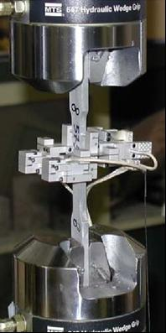 | 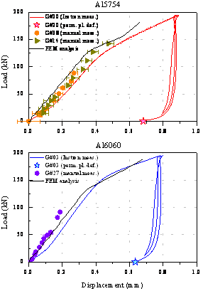
Fig. 1: Experimental tensile tests on an Al specimen alloy. | Fig. 2: Flange compression curves for the two Al alloys compared with the FEM analysis: the good accordance of the model with the measurements is clearly visible.

Stiffening studies

Minimal modifications have been realized on the existing cavity for the blade-tuner tests.
The coaxial tuner that will be used to accomplish with the cavity requirements for ILC, together with the shortening of the cavity total length and the cost reduction request for the mass production, forced the reviewing of the layout of the He-tank structure and of the end dishes.
The adopted strategy is based on the analysis of different solutions developed for SC cavities in several laboratories. In particular, we are critical analyzing the TESLA, SNS, KEK and TRASCO-ADS solutions. For each solution, we are evaluating performances, weaknesses, construction problems and costs.
As an example, Fig.3 and Fig. 4 show the FE analysis of the end dishes configuration used for the blade-tuner test. Fig. 5 shows the He-tank cavity assembly used for the coaxial blade tuner test. Fig. 6 and Fig. 7 show respectively the rings for the end dishes connection to He-tank and the Ti bellow.
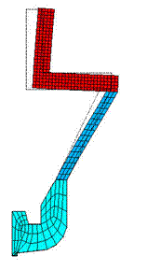 | 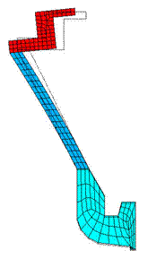
Fig. 3: deformed mesh of the end dish tuner side | Fig. 4: deformed mesh of the end dish coupler side

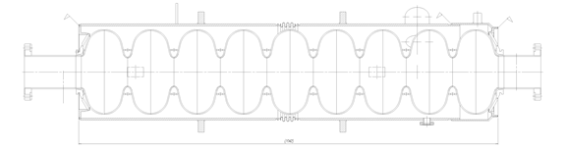

Fig. 5: cavity assembly for use with coaxial blade tuner

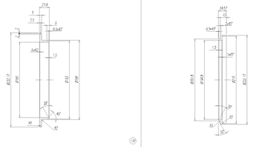  Fig. 6: rings for the end dishes connection to He-tank. | 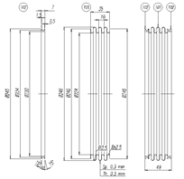  Fig. 7: He-tank bellow.

e-beam welding

The collection of the main parameters relative to the welding machine is on-going.
Papers relative to the welding mechanism such as the energy dissipation, electron scattering, etc., have been collected.
Moreover, we have analyzed the possibility to join dissimilar material as Nb and Stainless Steel [3, 4] through a thin Vanadium interlayer: this might imply a significant cost reduction in the SC cavities production. In Fig. 8 the phase diagram of some Vanadium alloys (Nb-V, Fe-V) is shown together with Nb-Ti phase diagram.

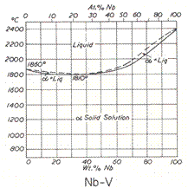 | 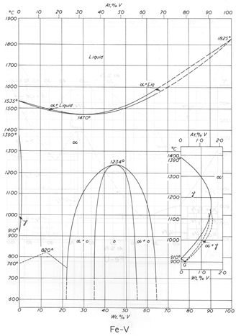
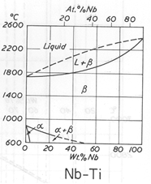
Fig. 8: Phase diagrams of some vanadium alloys and Nb-Ti.

References

[1] L. Lilje, “Performance limitations of TESLA cavities in the FLASH accelerator and their relation to the assembly process”, proceeding EPAC’06, Edinburgh, UK.

[2] L. Monaco, P. Michelato, C. Pagani, N. Panzeri, “Experimental and theoretical analysis of the TESLA-like SRF cavity flanges”, proceeding EPAC’06, Edinburgh, UK.

[3] N. P. Krutogolov, V. V. Diachenko, et al. “Defocused electron beam welding of Nb alloys and Stainless Steel”, Industrial Welding, 4, 1980, p. 14.

[4] V. A. Veinik, V. V. Diachenko, et al. “Electron beam welding of Nb alloys and Stainless Steel through a Vanadium layer”, Industrial Welding, 5, 1973, p. 16.
Task 2.3: EB welding

In order to manage new welding jobs like the neck of the nine-cell-cavity, we built a new universal support with wide rollers. A mandrel adjusts the axis-centre-distance of the rollers.
Therefore, we allowed welding work pieces with different diameters without constructing a new welding fixation.
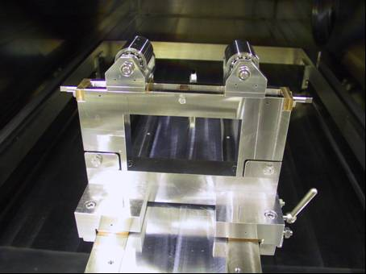
Figure 1: front side of a new universal welding support
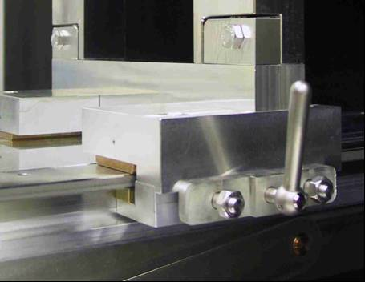
Figure 2: To change the working-position of the support, we use a quick release fastener

Work package 3: Seamless cavity production.

Task 3.1: Seamless cavity production by spinning

We produced by spinning one 3-cell cavity, starting from a blank that was previously flow-turned into a tube. The cavity has been then electro-polished and 100bar UHV rinsed.

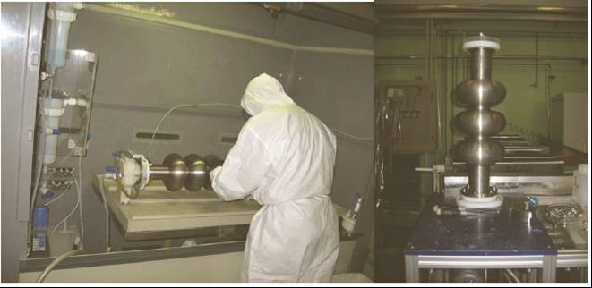
The 3-cell cavity was then titanified and it is ready for rf measurement.

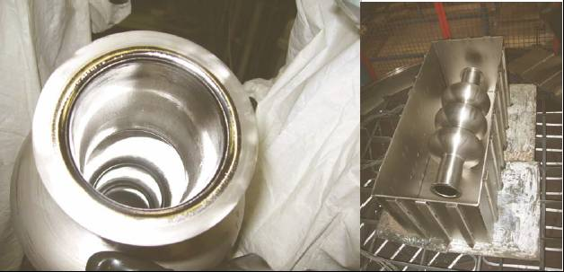
The first 3-cell prototype has an innovative flange design that has been fabricated seamless without the need of EB welding

Task 3.2: Seamless cavity production by hydroforming

Experiments on the tube necking at the iris

The necking experiments were progressed on the copper as well as on niobium tubes in order to optimize the necking parameters. Combination of radial and axial movements allows improving the uniformity of circumferential wall thickness at the iris area without remarkable reduction of the wall thickness. One example of the necking can be seen in Fig. 1

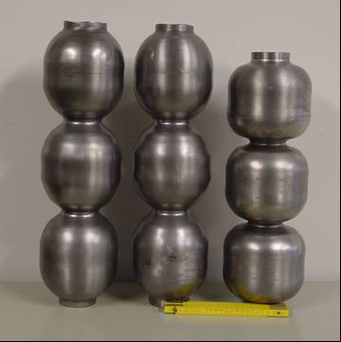

Fig. 1: Example of the Nb three cell unit necking

Hydroforming of three cell units and fabrication of a seamless cavity

After successful necking three 3-cell cell units from bulk Nb have been fabricated by hydroforming from earlier produced seamless tubes of dimensions: ID 150mm, wall thickness 3 mm (Fig. 2). The expansion of the tube diameter in the equator area (hydroforming) is done by applying of internal pressure and simultaneously of the axial displacement. Definite relation of applied internal pressure against axial displacement (path of the expansion) is fulfilled. The rough value of the pressure was derived from numerical simulations and further corrected on a base of hydroforming experiments. The hydroforming is done in two stages in order to achieve the correct shape, rather uniform wall thickness of the complete cavity and to suppress the instabilities in the tube expansion.

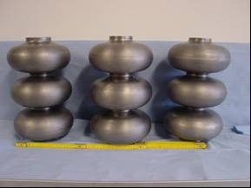

Fig. 2: Hydroformed three cell units

An order for fabrication of a 1.3 GHz nine cell seamless resonator (without equator welds) is placed to industry.
Fabrication includes following steps:
- Fabrication of the long and short end groups connected with three cell units
- Machining, preparation and welding of three units together in a 9 cell cavity (two iris welds done from outside)
- Machining, preparation and weld on of the stiffening rings
Delivering of the seamless resonator is expected for the end of the year.

Work package 4: Thin film cavity production

Task 4.1: Linear arc cathode
Task leader – Dr J. Langner*/ M.Sc. P. Strzyzewski (IPJ, Swierk, Poland)
* Dr J. Langner passed away on August 28, 2006, and he has been replaced by P. Strzyzewski

In the second quarter of 2006 milestones concerning the design and construction of a micro-droplet filter as well as the readiness of the micro-droplet filters have been achieved, as described below.

Design and construction of a micro-droplet filter
The first version of a magnetic filter was constructed in 2005. After preliminary tests it was decided to design and construct 2 new versions of the micro-droplet filter. The first version was based on a concentric set of water-cooled Cu-tubes carrying the magnetizing current, and the second one - constituted a Venetian-type blind system adapted to the
cylindrical configuration. The both versions were manufactured in the first half of 2006 and tested under vacuum conditions. Pictures of the both filters are shown in Fig. 1.

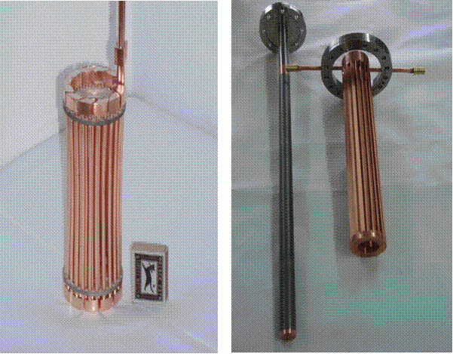

Fig. 1. Pictures of two different versions of a micro-droplet filter.

The both filters were also tested during UHV arc discharges. In two successive experiments they were installed within the Quasi-Tesla cavity and connected to the ground potential to facilitate the ignition of UHV arc discharges. It was observed that the Venetian-type filter withstands up to 2 minutes operation at a relatively intense arc (up to 55 A), but efficiency of the cooling (through the upper flange only) is too low. Nevertheless, a few sapphire samples, which were placed outside the investigated filter (near the cavity equator), have been exposed and coated with pure Nb films (see below).
The magnetic filter consisting of a set water-cooled and current carrying Cu-tubes, which was modified in a comparison with the prototype version (investigated in 2005), was delivered by an external manufacturer in June 2006. It has passed all preliminary electrical and thermal tests at a lower magnetizing current (< 100 A). These tests are now continued in order to increase the current value.

Coating of single cells
It was impossible to perform the coating of single-cells without and with the micro-droplet filtering (scheduled before June 30, 2006) because new TESLA-type copper cavities have not been delivered so far by the collaborating laboratories (INFN-Legnaro and DESY). This delay makes necessary to modify the time-schedule (as shown above).

Characterizations of non-filtered Nb layers
The previous report presented results of RRR and SIMS measurements of the non-filtered Nb layers, which were performed in other laboratories. After detailed analysis it appeared that these results must be revised:
- The RRR values, reported previously as very low (2-3), have been measured once again by our Italian partners. It has been found that correct RRR value for an unbiased sample is 25, while that for the biased (–70V) sample reaches 48.
- The SIMS measurements, as performed previously at the Lodz Technical University, were obtained with the bombardment of Nb surfaces by oxygen ions, and it was a reason why the results showed the large concentration of oxygen in the deposited Nb-film. In the second quarter of 2006 new SIMS measurements were performed with the use of non-reactive gas (Ar) ions. The recent SIMS results are presented in Fig.2.
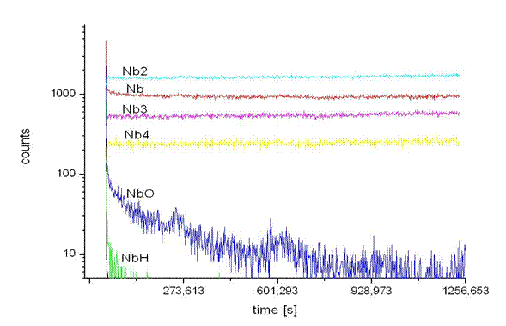

Fig. 2. Results of the recent SIMS measurement of the non-filtered Nb-layer.
It should be noted that the recent SIMS results are more reliable, since the introduction of oxygen was eliminated, and the NbO concentration was 2 orders of magnitude lower than that of pure Nb.

Characterizations of the filtered Nb-layers
Two sapphire substrates (biased and without bias), which were placed outside the Venetian-type filter (see above), have been coated during 25 minutes at the arc current equal to 55 A. The deposited Nb-film thickness was about 1.5 μm. The obtained Nb-layers were characterized by the surface distribution of micro-droplets and by measurements of superconducting properties. The recent results are shown in Fig.3.

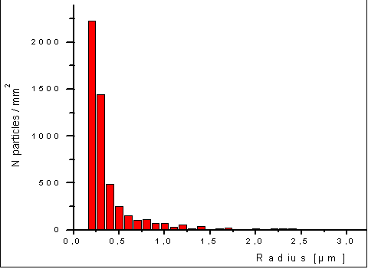

Fig. 3. Micro-droplets distribution upon the filtered Nb-layer.

It should be noted that the number of the deposited micro-droplets was strongly reduced, in a comparison to the layer deposited without filtering (see WP4 Quarter Report 1/2006), and about 90% of the micro-droplets has diameters lower than 0.5 μm. The RRR values of the considered samples are still under investigation at the Tor Vergata University.

UHV arc deposition of pure Pb-layers for photo-cathodes
In addition to the planned tasks, the IPJ team performed also several depositions of pure Pb-layers, which are investigated as potential photo-cathodes for new electron injectors. The preliminary results have already been presented at international conference EPAC-2006 in Edinburgh, and they are to be reported at another conference on plasma physics and technology to be held in Alushta (in September 2006).

Task4.2: Planar arc cathode

Characterization of non-filtered Nb-layers deposited at different bias voltages
Systematic measurements of thickness and superconducting parameters have been performed for the non-filtered Nb-layers deposited in different sample positions upon a substrate holder, which was placed inside the non-filtered UHV-arc facility at the Tor Vergata University & INFN-Roma 2. Six sapphire samples, which were placed on the horizontal copper holder, underwent the Nb-deposition process at an arc current of 110 A, different coating times and different values of the substrate bias. The obtained Nb-layers were analyzed, and the measured data are collected in Table 1.

Table 1. Investigated samples and the measured parameters.

Sample | Substrate | Bias | Nb-layer thickness | RRR value
1 | sapphire | - 23 V | 1.1 μm | low
2 | sapphire | - 24 V | 2.4 μm | 22
3 | sapphire | - 40 V | 2.1 μm | 50
4 | sapphire | - 60 V | 1.7 μm | 30
5 | sapphire | - 60 V | 3.5 μm | 26
6 | sapphire | - 80 V | 1.5 μm | 50

The obtained data show that the layer thickness spreads from about 1 μm to 3.5 μm,

The obtained data show that the layer thickness spreads from about 1 μm to 3.5 μm, whereas the RRR values are within a range from 26 to 50 for bias voltages (above 40 V), which guarantee saturation of the ion-current. At - 60V bias the measured RRR values are almost independent of the Nb-layer thickness. At a bias voltage corresponding to the plasma floating potential (about - 23 V) - the achieved layer quality is much reduced (RRR is below 22), irrespective of the layer thickness.
RRR measurements on the sapphire and copper samples coated at different angular orientations with respect to the plasma propagation direction, as well as SEM and X-ray measurements (on a substantial number of the deposited samples), are delayed due to measurement capacities and time assignment rules in the collaborating laboratories performing the tests. We expect to reduce these delays by extending the collaboration to include the Università Tor Vergata Roma-2, Università Federico II di Napoli, and Università di Napoli 2.

T-filter setup in operation, micro-droplets distribution and statistics
In the second quarter of 2006 the new planar-arc device with a T- type filter was put into operation and optimized. At typical operational parameters (i.e. at arc current equal to 110 A, bias voltage - 80 V) the ion current to a sample holder (of 71 cm² area) reached 0.5 A, and the averaged current density was about 7-8 mA/cm². It means that the ion current was twice higher than that obtained in the 90⁰-L-type filter system investigated previously. The surface density of micro-droplets deposited upon the Nb-layers has also been reduced at least by one order of magnitude, as shown in Fig. 1. It is of primary importance for quality of the deposited Nb-layers.
Taking into account the Nb-layer studies described above, the advancement of the 4.2.2.1 and 4.2.2.2 tasks is estimated to reach 97%.
Hardware for plasma diagnostics inside the cavity system
Three new current-collectors have been manufactured and used for testing the possibility of the Nb-deposition upon inner walls of the real TESLA RF-cavities. They simulate the shape of the internal surface of the TESLA-type cavity chamber. Contrary to the detection system used previously, the new system (because of the large collector areas ranging from 70 to 230 cm²) allows more accurate measurements of the ion-current distribution. It facilitates also appropriate corrections of the leading magnetic field in the system described. A general view of the upper part of the system is shown in Fig.2:

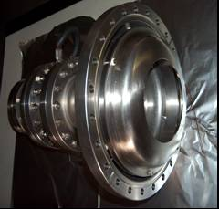

Fig.2. Picture of the new collector system, as taken before its assembling on the UHV stand.

Modified anode geometry for HTC superconducting coating system
A modified anode has been designed and manufactured. It is equipped with a copper diaphragm, which may facilitate the arc stabilization at nitrogen partial pressures above 10⁻² mbar. It seems necessary to create the conditions for the NbN formation and deposition. The new anode has been produced in cooperation with the Andrzej Soltan Institute for Nuclear Studies (IPJ) in Swierk, Poland. The advancement of task 4.2.3 is thus estimated to reach 35%.
Similar anodes (of the new type) will also be used in the UHV arc devices (equipped with an RF cavity-type chamber and T-filter) in order to enhance the arc plasma transmission.

Work package 5: Surface preparation

Task 5-2: EP on multicells

Since 2003 the DESY EP test set up is running. After a period of improvements and reconstruction the parameters for the two major EP preparation runs are fixed.
This fixation of parameters was done according to a stable run condition of the apparatus. Since the cavity performance depends on more parameters than the EP itself, this part of the preparation process was brought to a stable main infrastructure operation in order to be able to investigate the cavity results in respect to stable conditions in all preparation steps.
The stable operation of the EP facility (Pic 1; 2; 3) is defined as:

- Stable conditions at the Ultra Pure Water line quality defined by TOC; resistance of the UP water, particle contamination and Particle monitoring during the assembly process.
(Pic4; 5 ;6)
- Stable condition on secondary EP infrastructure.) The stable operation is defined by the stabilization of the gas scrubber systems which was one of the major impact parameters that lead to a shut down of the EP during the running process as well.
- For the EP set up the heat exchanger setting was chosen in a way, that the current over the processing time stays constant (Pic 4).
- Stable acid conditions
On a so called U/I measurement cell parameters like aging of acid and influence of HF concentration were studied. (Ref 1) It was found that these measurements are very sensitive against temperature changes and changes of the HF concentration of the EP acid mixture. Based on these experiments an online U/I cell was designed and installed into the apparatus (Pic.9). A software program is designed and integrated into the PLC control system of the EP facility as well. For reproducible results, which are not influenced by a temperature change during the EP run, the PLC starts the U/I cell automatically at defined temperatures and delivers a set of data online to the operator’s panel and in parallel to the data storage files of every EP run. (Pic.8)
For the DESY EP 3 different temperatures are chosen to cover a wide range of the standard operation temperature range.
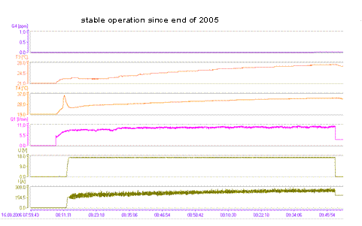

Pic 1 example parameter set for stable operation of the EP facility
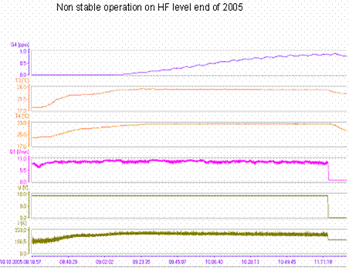

Pic 2 example for non stable operation due to HF load of the infrastructur

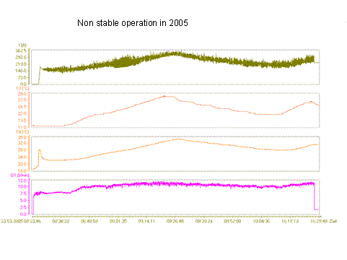

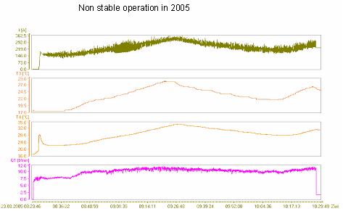

Pic. 3) Example on non stable operation due to problems on the heat exchanger

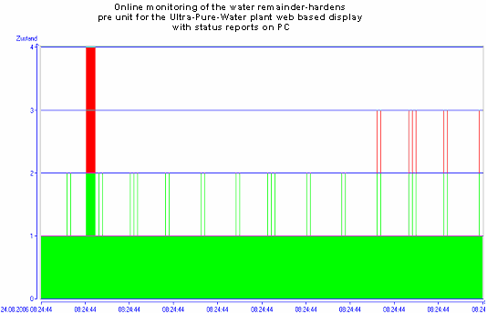

Pic 4 example for online monitoring of the remainder –hardness control

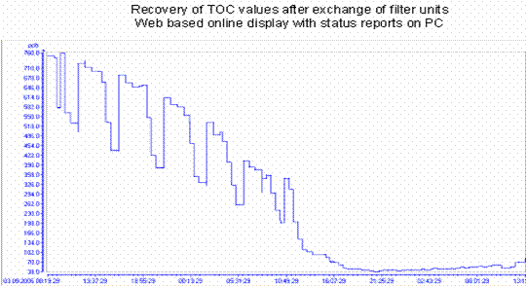

Pic 5 example for online monitoring of the TOC control unit

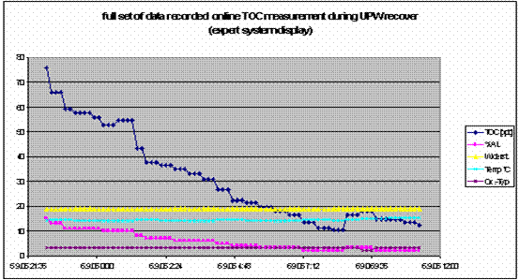

Pic 7) example of the readout of the expert system of the UPW control system

Improvements on the system since start up
- Continuous and online monitoring of the particle contamination in the UP water loop
- Quality control of the HPR by a facility control plan ( TOC; Bacteria; Particulates)
- Improved HF absorber ( Pic 9)
- Facility management plan for exchange of wearing parts. Improved algorithm for cooling of the acid during all runs of 120 to 360 Minutes length (Pic.)
- Installation and online monitoring of EP acid activity ( U/I cell integrated in the EP acid cycle ( bild )
- Improved rotating shaft seals at the rotational feed head
- Isolation of the electrode to improve removal ration Iris / Equator
- First crosscheck of EP simulation software by comparison of the software out put with evolutionary optimization results

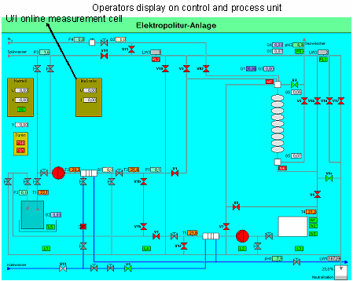

Pic 8) Online display of the EP operator panel

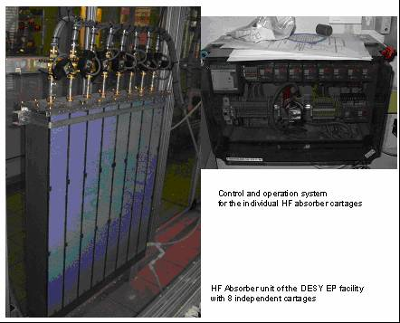

Pic 9 Picture of the new development of gas scrubber for HF exhausting gasses

EP Apparatus parameters for stable operation

Voltage 17 V
Rotation speed 1 turn/ min
Acid volume 10 l / min
electrode OD 40 mm
Electrode material Al 99.5
Active Al Surface 9* 10mm * OD 40 mm
Average temperature
Cavity inlet 24 C
Cavity outlet 29 C
Acid usage up to 12gr solved Niobium per litre acid
Main EP
Duration 2*360 Min
Removal 126 µm
Fine EP
Duration 1*120 min
Removal 42 µm
UPW
TOC
Standard 2 ppb
Max 100 ppb for 3h
Particles < 20 Counts / litre of 0,3 µm
Resistance < 18 M ohm cm
Temperature Tmin 18 C / Tmax 20 C
HF out gassing < 0,5 ppm HF gas concentration

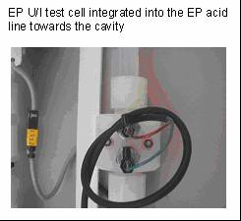

Pic 9 U/I parameter measurement cell installed into the EP acid line

Task 5.3: Automated EP

The search for hydrofluoric acid-free electrolytes for Niobium is fundamental for an eventual cavity mass production. Security rules must be absolutely strict and severe for handling even half litre of Hydrofluoric acid, it is easy to imagine what could be necessary if hundreds of tons of Hydrofluoric acid should be handled in order to process thousands of cavities.
Thanks to the automated electropolishing programme, we are able to actively contribute to the research activity on alternative electrolytes. The search for the minimum of the bath differential conductivity enables us to find always the best conditions for electropolishing.
In this context, we have developed several alternative recipes,

Recipe 1 for alternative EP: HF + OXALIC ACID + BORIC ACID + H3PO4
30% HF, 15% H3PO4, 30 gr/lt Oxalic acid, 10 gr/lt Boric acid

Recipe 2 for Alternative EP: Niobium electrodissolution in alkaline media
Solution of KOH 1 M; T ~ 70° ; mandatory Stirring; E = 1,38 V

Recipe 3 for Alternative EP: In addition to this we have found the possibility to perform the electropolishing of Niobium by adopting ionic liquids. In particular we have found that adapting the results obtained by researchers in the field of ionic liquids, a new electrolyte for electropolishing the Niobium can be found using the Ammonium Fluoride instead of the Hydrofluoric Acid. This electrolyte is produced, just by dissolving the Ammonium fluoride salt in the ionic liquid eutectic of the Urea and Choline Chloride (2-hydroxyethyl-trimethylammonium chloride), a well-known additive for animal feed. The Urea-Choline Chloride Deep Eutectic Solvent (DES) is a type of ionic solvent with a melting point much lower than either of the individual components. This opens the road to an other class of Niobium Electropolishing research: the so called electropolishing in room temperature fused salts. The ionic liquids have been only recently come to the research attention. The first generation eutectic solvents were based on mixtures of quaternary ammonium salts with hydrogen donors such as amines and carboxylic acids. The deep eutectic phenomenon was first described in 2003 for a 2 to 1 by mole mixture of choline chloride and urea. Choline chloride has a melting point of 302 °C and that of urea is 133 °C. The eutectic mixture however melts as low as 12 °C.
This DES is able to dissolve many metal salts. Compared to ordinary solvents, eutectic solvents also have a very low Volatile Organic Compounds and are non-flammable. Compared to the standard hydrofluoric recipes, deep eutectic solvents are easier to make, much less toxic and much more biodegradable.
In figure we see a Niobium sample after the new EP recipe, looking by SEM at the surface before (left) and after (right) EP:

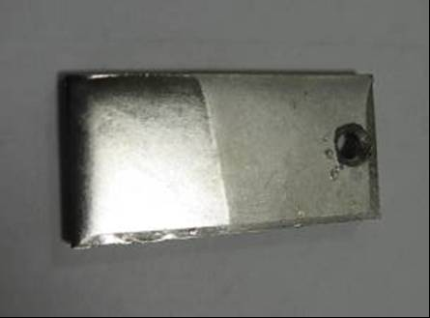
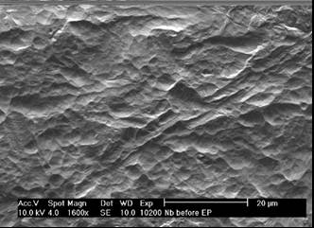
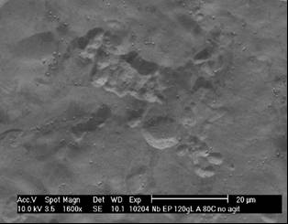
Fig 1: Niobium sample after the new EP recipe, looking by SEM at the surface before (left) and after (right) EP:

Task 5.4: Dry ice cleaning

Until end of September 2006 the new infra-red heater system (see QR 1/06) was successfully used for several cleaning procedures of single-cell cavities with achieved gradients up to 38 MV/m. The gas alarm system is installed and operable, but additional technical requirements of the DESY safety department need further installation effort.
With respect to the results there is a contradiction between excellent cleaning results on samples (WP6.3.) compared to most of the cavity tests still suffering on field emission loading. The reason can be either the cleaning parameters or a contamination of the cavity during the final assembly after the dry-ice cleaning. Together with the experts in dry-ice cleaning of the Fraunhofer Institute for Manufacturing Engineering and Automation (Fraunhofer IPA) the nozzle system and cleaning parameters are under re-investigation, which will take until the beginning of 2007. In addition further sample measurements are on the way.
Moreover the activity is significantly slowed down by the DESY test cavity program for the XFEL occupying most of the available resources of the test infrastructure and manpower.
The activity is delayed by app. additional 6 month.

Q(E)-performance of latest rf-tests after dry-ice cleaning

Work package 6: Material analysis

Task 6.1: Squid scanning

One niobium test sheet with artificially imbedded flaws (tantalum inclusions of size 0,1-0,05 mm close to surface) was produced and scanned with SQUID scanner. Holes of different diameter and depth were drilled and filled with tantalum. After that these location were heated by defocused electron beam up to melting. Finally the sheet surface was completely grinded, so that the defect positions were barely seen.
All artificially produced defects were identified with a SQUID scanner.
Fabrication of more systematic artificial defects is in work. A draft of the defect distribution can be seen in Fig.1. The following materials are foreseen to be imbedded; tantalum, cooper, iron, niobium, stainless steal.

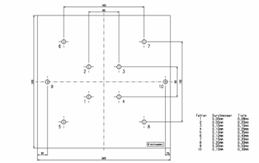

Fig. 1: Draft of niobium sheet with imbedded defects

Unfortunately this work has a delay. The contract for producing of holes for defects with very small diameter was placed to company Swiss-Laser, but it became insolvent. The company Rofin Sinar-Laser Micro took over the contract and the fabrication of the holes is foreseen for the week 39. After that the holes will be filled with implant material and closed by defocused electron beam at DESY. Scanning of the sheets with artificial defect is foreseen to be started in the week 44-45 after grinding at WSK.

Task 6.2: Flux gate magnetometry

The activity on flux gate magnetometry has proceeded comparing what can be obtained by a flux gate and what can be obtained by the same EP process by a GDR. We have applied the magnetometer to an Electropolishing cell section.
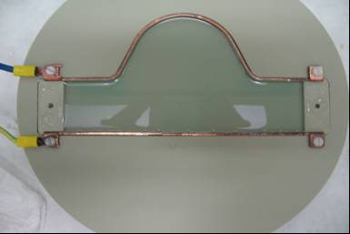

The left picture is the field distribution obtainable by a Flux gate 1st order gradiometer. The right picture is the current distribution GMR 2nd order gradiometer, showing that room temperature non destructive evaluation can easily make electrochemistry diagnostics.


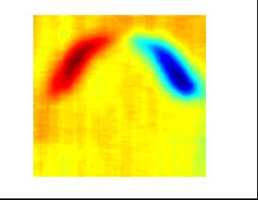

Task 6.3: DC field emission studies of Nb samples

Quality controled FE measurements were performed on first electro polished Nb sample prepared inside a nine cell structure at DESY. Moreover we also started to study the FE properties of two single crystalline Nb samples cut from ingot plates and chemically polished only. A series of systematic field emission scans on these circular Nb samples (28 mm diameter) at surface fields up to 200 MV/m was performed, followed by local measurements of the emitters found. The curvature and surface roughness of the electro polished Nb sample was measured by means of a new optical profilometer. The surface treatments and measurement details of the samples are listed in the table below.

Sample | Surface treatment/  Production method | Measurement, Analysis
NbQcEP*1 | EP + HPR(*) | FE scans up to 150 MV/m,  local I-V curves and FN analysis of 4 emitters  Profilometer scans with about µm resolution
SCNb*1 | BCP + HPR | FE scans up to 200 MV/m,  local I-V curves and FN analysis of 11 emitters
SCNb*2 | BCP + HPR

The main results of this work can be summarized as follows:
- Very good FE performances in terms of high onset fields E_{on} and low emitter number densities N were achieved after high pressure rinsing on both polycrystalline (NbQcEP*1) and single-crystal samples (SCNb*1, SCNb*2):
No field emission up to a surface field of 120 MV/m;
N = 9/cm² for (NbQcEP*1) and (4, 2)/cm² for (SCNb*1, SCNb*2) at 150 MV/m
- Some strong emitters were localized and showed nearly stable Fowler-Nordheim-like I-V curves with reduced local field enhancement factors between 20 to 113 for polycrystalline and 22 to 75 for single crystal Nb samples, which are typical for particulates and surface irregularities.
- The electro polished Nb sample showed a very smooth surface with height steps of µm due to the grain structure and a very small micro roughness of less than 0.2 µm, as measured with the profilometer. Single crystalline samples are mirror like suggesting even smaller surface roughness.

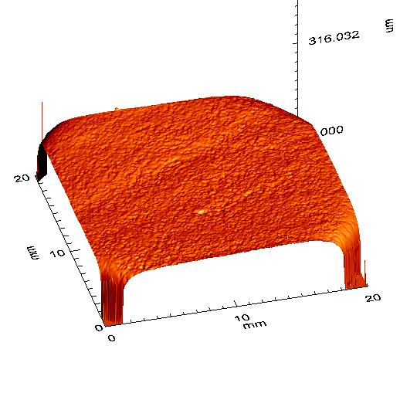 | 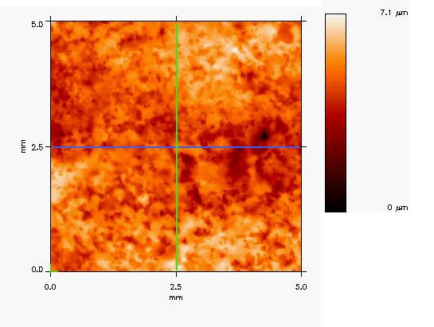
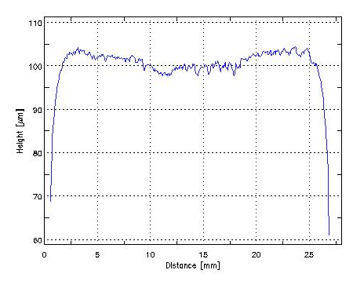 | 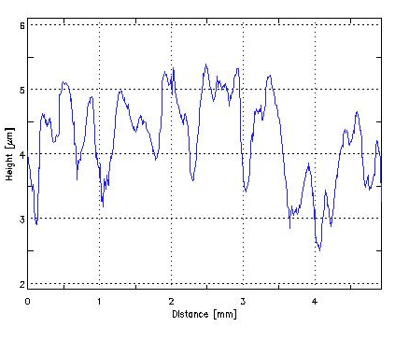
Profile:  Curvature: 6.7 µm over 20 mm | Horizontal profile:  Height steps: < 1.5 µm over 0.5 mm  Microroughness: < 0.2 µm

Fig.1. Profiles of electro polished quality control sample (NbQcEP*1)

As next steps, SEM and EDAX analysis as well as profiles of the localized emitters on the single crystal samples will put more light on the origin and nature of emission.
Some new crystalline samples with few grain-boundaries have been prepared for FE measurements to study the effect of grain boundaries on FE.
Dry-ice cleaning of all samples is planned to confirm the enhanced destruction of identified emitters as reported in QR1-06.

Work package 7: Couplers

Work-package 7 of JRA1 concerns the development of power couplers. This WP is broken down into three main tasks:
7.1 – New proto-type couplers.
7.2 – Fabrication of a titanium-nitride coating bench for the coupler ceramic windows.
7.3 – Conditioning studies of proto-type couplers.

Concerning task 7.1 we have designed two new-proto-types named TTF-V and TW60.
Both types of couplers have been produced in industry. A prototype TTFV pair has already been delivered before the summer holidays and has been tested at low power. The warm part of the second pair is already finished. A delay has been accumulated for the cold part of the second pair due to a coating problem. Recoating is scheduled for the two remaining parts from September 5th to September 18th. After that, they will be electron beam welded and shipped to LAL

TW60 was also expected before summer but it has a certain delay in production. We are continuously following the production and we hope to receive them in the month of September: all waveguides are finished. All manufacturing, welding and brazing on the inner conductors is finished and the parts are at copper plating All manufacturing, welding on the outer conductor is finished. The brazing of the warm ceramics is finished.
Some difficulties were encountered to apply the braze foils due to slight deformation of the inner tube during copper plating process. This will now be reworked and then the windows will be TiN coated. After return from TiN coating, there is one more week to do the electron beam welding operation on the cold and warm parts.

As far as the task 7.2 is concerned we have signed the contract with the supplier and completed all the administration. We still have a delay (5-6 months on the last milestone) on the time schedule already declared in the last report. The full prototype for TiN coating is expected for the beginning of the next summer.
The TiN coating will be performed by sputtering under vacuum using a magnetron.
The machine has been designed having a oil free pump system to adjust the pressure of the order of 1e-7 mbar. A Nitrogen (99.999% pure) entrance has been foreseen designed for vacuum breaking and nitrogen and argon bottles will be of 99.999% purity. All gas entrances have to be designed with filters filtering particles with a diameter bigger than 0.2 μm and the filters will be inserted as close as possible to the chamber. A vacuum measurement system will operate from atmospheric pressure to 1*10⁻⁷ mbar or from 10 mbar lower vacuum. All flanges with a low probability to be disassembled like pumps, instrumentation etc.. will be foreseen as CF flanges with metallic seals, while only the coupler entrance porthole, magnetrons and the UHV gate valve can use rubber seals. The device parts that constitute the internal part of the vacuum chamber have to be made of: 316L stainless steel (a part the magnetron AISI 304); Copper for UHV; Cu-be beryllium copper; pure titanium and titanium nitride and ceramics.
Fabrication drawings: A general drawing planning to face target planar magnetron has been made. The vacuum project is now ready, while the plasma chamber mechanical drawings have been just started.
Definition of vacuum needs: The sputtering system will be turbo pumped. The rough vacuum will be done by a scroll pump. Vacuum gauges will be of Pirani, capacitive and ionization gauges.
In the meanwhile we have performed some testes on different samples to validate the sputtering technique for TiN coating on Alumina. The results were extremely encouraging. A diffractometer analysis showed the deposition of a nearly stoichiometric layer of TiN. The same results were obtained in a 800 nm coated sample analysed by ESCA and SIMS techniques. In this last analysis contaminants were found, more precisely Oxygen and some contamination. Both can be fully explained by the low vacuum quality in the device used for the sputtering and in a minor accident that produced a limited quantity of carbonates.

Concerning the task 7.3 a lot of experience is been acquired working on the conditioning of the TTFIII couplers and a strong evidence of conditioning time reduction is the result. The conditioned pairs have also been installed and tested on a SC cavity giving excellent results. All the improvements on the conditioning procedure that have been studied in this activity will be applied to the new prototypes conditioning studies. We are waiting for the delivery of a pair of fully TiN coated TTFIII pair to be tested in September.
After its delivery we have cleaned, mounted and tested the TTFV first pair. Unfortunately we found an important shift on the working frequency for this pair already at the low power tests. A first attempt of high power conditioning has already been performed showing very slow conditioning time. We are actually working on a full review of the design to understand this problem and to identify solutions.

Work package 8: Tuners

Task 8.1: UMI tuner

A coaxial (blade) tuner solution has been developed for the compensation of the Lorentz force detuning of the superconducting cavities under the high gradient pulsed operation foreseen for ILC operation. The device is based on prototypes successfully tested at DESY in 2002 both on CHECHIA and on the superstructures inserted in the TTF string. In order to compensate the Lorentz forces detuning foreseen at 35 MV/m, fast elements, such as piezo ceramics, have been integrated in the tuning system. Each tuner can normally accommodate two piezos, but if necessary up to four piezo actuators can be installed. Two existing blade tuner assemblies have been equipped with a revised leverage system, and two modified Helium tank systems have been manufactured by Zanon in order to include the piezo active elements (see Figure 1, Figure 2 and Figure 3). Tests were initially foreseen at DESY and BESSY, after the final tuner integration with two existing TTF cavities, before this summer, but higher priorities for the Module 6 assembly operation at DESY lead to a delay in the testing program.

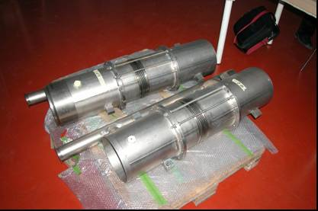

Figure 3: TTF cavities modified helium tanks

Meanwhile we have started to analyze design modifications to the coaxial blade tuner concept in order to reduce manufacturing costs and simplify the manufacturing process, in view of a possible industrialization for the ILC, having in mind the perspectives of the large scale production foreseen for the collider (> 16,000 components for the baseline 500 GeV design).
This consideration led us to begin exploring possible simplifications and cost reduction efforts for an industrial scale blade tuner. By lowering the requirements on the ring-blade stiffness, on the basis of the considerations that the overall combined tuner stiffness (as provided to the cavity) is essentially limited by the leverage mechanism, especially in terms of slacks and allowances, and by the helium tank conical end plates, a “lighter” version was devised, which reduces the needed

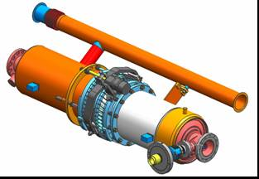
Figure 4: The cavity dressed with the modified helium tank and piezo blade tuner.
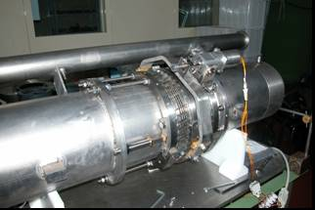
Figure 5: Complete assembly provided with leverage mechanism and stepping motor.

material and the number of machining and weld procedures. The width of the Ti rings has been reduced, as well as the number of blade elements. Now the system has a reduced number of blades, with a consequent reduction of the assembling time and number of EBW welds. This leads to a corresponding decrease of the nominal stiffness of the ring-blade mechanism that is anyway consistent with the overall stiffness requirement dominated by the other system components (see above). The blade length and width have also been adjusted to improve the tuning range in order to relax the pre-tuning requirements. The current tune 3D drawing is shown in Figure 4, while one can find in the aside picture 5 the revised “lighter” version.

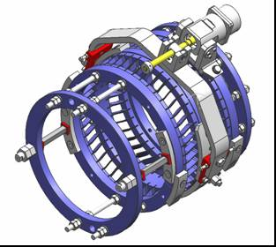
Figure 6: The piezo blade tuner (the cavity He tank is not shown for simplicity.
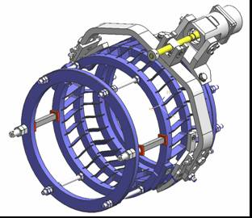
Figure 7: “Light” version of the piezo blade tuner, with an achieved 40% weight reduction and simplified manufacturing procedures.

Once installed the new coaxial blade tuner will be the core of a complex control system designed to ensure a stable resonant frequency of the superconducting cavity. The whole system must be able to implement an affordable and performing control, involving both feed-back and feed-forward architectures. For this purpose a complete electronic platform based on a SIMCON 3.1 FPGA board (recently achieved by our group by courtesy of the TESLA LLRF group) is now under development and will allow us to implement in short times a first prototype of the blade tuner control system. The block diagram of the tuner control system is shown in Figure 6

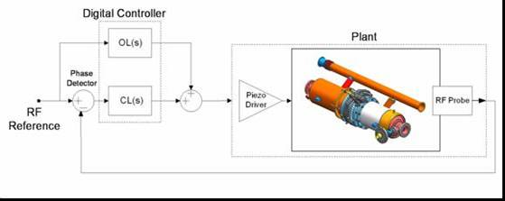

Figure 8: Tuner control system schematic view.

Last but not least, we finally got from Celmi a cryogenic (i.e. realized using strain gauges and glue suitable for cryogenic applications) load cell of reduced dimensions and tested it in LHe. This device has size comparable to the piezoceramic support and will allow us to measure forces exerted on (or by) piezo elements directly inside cryogenic environments. The new load cell (compared to the former an bigger one) can be seen in Figure 7.

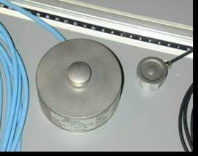
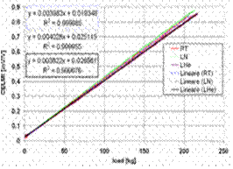

Figure 9: Cryogenic load cells from Celmi. Figure 10: Characteristics of the new cryogenic load cell for different working conditions.

The tests of the new load cell in liquid helium have been successful and the device characteristics taken at different temperatures show good linearity and repeatability. The characteristics of the new load cell with the insert placed in liquid helium bath, in liquid nitrogen and at room temperature are reported in Figure 8.

Task 8.2: Magnetostrictive tuner

The prototype of magnetostrictive tuner is ready for the test with the cavity. The control system as well as the driver is already prepared. Due to the movement of the CRYHOLAB stand test the proper experiment with magnetostrictive tuner is postponed. According to the recently updated schedule, the test will be performed before the end of the 2006.
The control algorithm was developed for both piezostack and magnetostrictive operation. The test with piezostack mounted in VUV-FEL shows that the Lorentz force was compensated in at least 4 steps by 90% for gradient of 20MV/m. Further developments are focused on implementation of used algorithms into the FPGA based board used for LLRF control. Currently, the online Lorentz force-detuning algorithm has been successfully implemented.

Task 8.3: CEA tuner

The fabrication of the new CEA tuner is finished. The tuner was mounted in CRYHOLAB and then tested. The detailed report of the investigation is in charge of WP 10.

Task 8.4: IN2P3 activities

After the integration of PICMA actuators into the new PTS developed at Saclay, we have characterized the tuning system and investigated the electro-acoustic behaviour of the TESLA cavity #C45. The following tests were performed in CRYHOLAB during April 2006:
- Measurements of the transfer functions,
- Study of the mechanical modes of the cavity including quality factors,
- Measurements of the actuators response to the applied preloading force,
- Study Lorentz detuning and detuning compensation with PTS (Pulsed RF tests).
The experimental data were reported at LINAC2006. The pulsed RF tests were started: the status of this activity is summarized in WP#10 quarter report (Cryostats integration tests). Finally, the sensitivity of PICMA piezostacks to a preloading axial force at cryogenic temperature are investigated and the corresponding results were reported and discussed thoroughly (CARE Note and EPAC06). The variations of the relative capacitance ΔCp= Cp-Cp₀ (Cp₀: capacitance at zero preload (F=0)) as function of the preloading force F at T= 2 K are shown in Fig. 9. Non linear effects are observed at low preloading force when F is increased from zero: they are due to friction, stick-slip among non linear phenomena in the preloading device mechanism (rotating arm, bellows …). Further, these data clearly show a large hysteresis for increasing and decreasing the preloading force. This behaviour could be attributed to the intrinsic irreversibilities in the piezoelectric material itself.
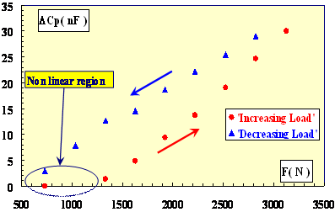

Fig. 9: Capacitance versus preload at T=2.05 K

At T= 2K, the measured sensitivity to preloading are 16nF/kN (respectively 10nF/kN) for F increasing (respectively decreasing).The behavior of the piezostacks as dynamic force sensor was also studied. The transient response of a PICMA type actuator to a steep preload variation ΔF at T=2K is presented in Fig. 10: 1) a steep voltage increase (capacitor charging) followed by an exponential decrease (capacitor discharging) is observed, 2) the peak actuator voltage ΔV_{p} (ΔV_{p}∝ ΔF) is reproducible (3 %). The actuator is a very sensitive dynamic force sensor with strong temperature dependence: ΔV_{p}/ΔF=4.7V/kN at T=2K and ΔV_{p}/ΔF=21.4V/kN at T=4.2K.

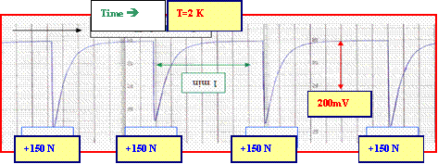
Fig. 10: Transient response of a PICMA type actuator to a steep preload variation ΔF=150 N at T= 2 K.
Status of milestones and deliverables for the task 8.4

The activities of IPN Orsay for the task 8.4 are nearly achieved. Our experimental program at Orsay is almost completed and most of subtasks are completed as illustrated in Table 1: four subtasks (items #8.4.3, #8.4.5, #8.4.6 and #8.4.7) are finished and two subtasks (item #8.4.2 and #8.4) are 80% achieved. Our main subtask now is to report on IN2P3 activities (item #8.4.8). This deliverable, initially scheduled for August 2006, is in progress. It is postponed to October 2006. The delay is mainly due to data processing and analysis which is now finished. The report on radiation hardness tests is nearly completed.

Nr. | Task | Begin of task | End of task | finished end 05 | finished April 06
8.4 | IN2P3 Activity | 01/01/04 | 07/08/06 | 52% | 85%
8.4.1 | Characterize actuators/piezo-sensors at low temperature | 01/01/04 | 21/03/05 | 95% | 95%
8.4.2 | Report on actuator/piezo sensor | 21/03/05 | 21/03/05 | 60% | 80%
8.4.3 | Test radiation hardness of piezo tuners | 01/07/04 | 15/08/05 | 100% | 100%
8.4.4 | Report on radiation hardness tests | 15/08/05 | 15/08/05 | 50% | 80%
8.4.5 | Integration of piezo and cold tuner | 03/01/05 | 06/12/05 | 20% | 100%
8.4.6 | Cryostat tests | 06/12/05 | 03/02/06 | 0% | 100%
8.4.7 | Tests with pulsed RF | 03/02/06 | 07/08/06 | 0% | 100%
8.4.8 | Report on IN2P3 tuner activities | 07/08/06 | 07/08/06 | 0% | 40%

Two CARE notes were edited: a) the note #2006-006-SRF untitled ‘Integration of piezoelectric actuators in the piezotuner developed at Saclay’ concerns the subtasks 8.4.5, b) the note #2006-007-SRF untitled ‘Electromechanical characterization of piezoelectric actuators subjected to a variable preloading force at cryogenic temperature’ concerns the use of piezostacks as force sensor. Three conference papers were published (two at EPAC06 and one at LINAC 2006). Notice that a master thesis ‘electromechanical characterization of prototype piezoelectric actuator subjected to variable preloading force at cryogenic temperatures’ by Mouad SAKI (in French) were presented in July 2005.

Work package 9: Low level rf

Task 9.1: Operability and technical performance

9.1.1 Transient detector

Progress: In line with schedule.
During the reporting period the activities were focused on improving the transient detection system. It was equipped with a fine-tuning circuitry for RF feed forward comb filter and it uses IQ modulator for precise filter adjustment. The system was moved from building 28F to the injection area in Hall 3. It was also connected to all cavities in module ACC1. Now it is possible to perform measurements and tests with any cavity in this module.
The block diagram of the new setup of the transient detection system is presented in Fig. 1.
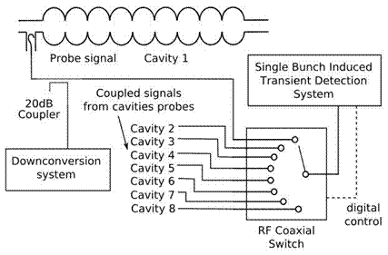
Figure 11 Transient detector connection in ACC1

Milestones and deliverables: None defined in contract for this period
Significant achievements and impact:
Filter for transient detection was improved with fine-tuning circuitry. This circuitry can constantly adjust the filter to keep the required filter attenuation. System can now work constantly without interruption.

Deviations from plan:
None

9.1.2 LLRF Automation
Progress: In line with schedule.

- Nonlinearities recognitions – FLASH high power station behaviour characterization (amplitude and phase characteristics)
The number of the tests for the amplitude and phase characteristics have been measured for the klystron 2 and klystron 5 HPC’s in the FLASH accelerator. The measurement for mentioned devices characterization had been performed for the test signal level (generated in the LLRF field controller), corresponding to driving signal used during the regular FLASH project work or slightly higher (approximately about 10 %).
Achieved characterization gave an opportunity for the statistical study of the HPC steady-state behaviour and allowed for extraction of the analytical model of nonlinear system. .

- High power chain model proposition. (Saleh and polynomial model comparison and evaluation)
During the statistical investigation two models have been considered:
- Saleh model – well known approach for representation of the high power standing wave tube preamplifiers. Model coefficients had been calculated with least square method. Model extraction had been based on sets of measurements of real klystron and preamplifiers characteristics. The achieved model accurately responds to the foreseen device behaviour especially beyond the areas that had been possible to measure - which is the main advantage of this approach. On the other hand the main drawback is the reduced accurate extraction of the model compared to the polynomial based model. Furthermore the complexity of this solution may cause some trouble in the possible implementation phase in the digital controllers.
- Polynomial model – the 5-th order polynomial model coefficients had been calculated using the least square method. It is easy for calculation in the FPGA or DSP based controller. On the other hand one has to be careful with the model extrapolation when badly conditioned coefficients may cause enormous deviation from the expected device characteristics.

- Linearization methods: predistorter approach evaluation with Matlab simulations
Among the different linearization methods used in the telecommunication power amplifiers the predistorter method can be recognized. Because of the existing common configuration of the power amplifiers used for linear accelerator superconducting module supplying this method seems to be the most flexible in operation and cost effective. It allows to adapt linearization performance due to specific behaviour of the linearised elements. Moreover it does not require significant changes in the hardware configuration as far as it can use standard diagnostics for coefficients calculation and can be implemented in the existing solution of the LLRF feedback loop controller.
During the early stage of the predistorter solution design there were some tools created in the Matlab environment. Created tools allow to:
- Perform the characterization of the HPC elements,
- Provide the model extraction from the collected data,
- Calculate necessary coefficients for the controller driving signal (that is HPC driving signal) correction so the amplitude and phase nonlinearities would be minimized.
Mentioned functionality gave an opportunity to the linearization algorithm implementation in LLRF FPGA and DSP based controller.

- Linearization method: predistorter first try of implementation in an existing LLRF control system for FLASH accelerator.

As far as the performance of the linearisation has to be checked the best opportunity for the method evaluation was in-situ tests performed in the FLASH accelerator.
The klystron No 5 high power amplifiers chain had been linearized using both Matlab tools and dedicated software platform (DOOCS servers) for communication and programming FPGA and DSP based LLRF control system feedback loop controller.
The comparison of this two implementations can be expressed in following way:
DSP realization:
➢ correction tables calculated in Matlab,
➢ controller signal correction performed in Matlab (control tables correction),
➢ correction possible from pulse to pulse (control signal tables can be read and written in gaps between pulses)
➢DOOCS server provided for control signal (like feed forward) tables modification and monitoring signals read-out’s.
FPGA Simcon realization:
➢ correction tables calculated in Matlab,
➢ controller signal correction performed in the FPGA (using: cordic algorithm for amplitude calculation for Ic and Qc tables addressing, and complex multiplication function),
➢ dedicated tables (2048 positions) for I and Q correction vector definition provided (possible slow feedback application)
➢ correction possible in-pulse to pulse (during the pulse amplitude of each sample generated in open/close loop operation, is corrected)
➢ DOOCS server provided for tables actualisation.
As it can be noticed from above comparison in the FPGA based (Simcon) LLRF controller the correction of the driving signal due to linearisation is an integral part of the device algorithms.
Still in both cases the Matlab participation cannot be neglected in linearisation coefficients adaptation. New designed controller (based in FOGA and DSP) will provide all required resources for placing the adaptation process also near to the control processes.

Some results in the amplitude to amplitude and phase to amplitude characteristics linearity improvements from the linearisation algorithm runs are presented below:

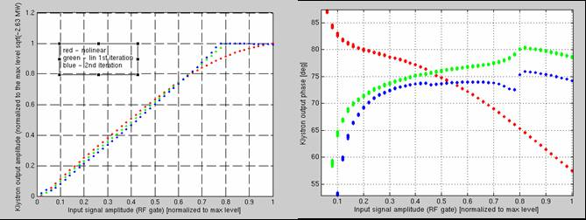

Figure 2. Linearisation of the high power amplifier chain of the klystron 5 in FLASH accelerator.

In the figure 2 there are two characteristics presented AM/AM (left side) and PM/AM (right side) of the klystron 5 HPC. With blue color the two step linearisation result had been marked. One can notice that using proposed predistorter method both amplitude and phase characteristic became more linear (blue trace) comparing to the situation without correction (red trace).
Further works on the method improvement for more accurate linearization and better implementation as well as algorithm extension with on-line adaptation feature is in progress now.

- Automation and decision support system for RF-power station and LLRF subsystem.

The new solution was being developed to facilitate automation of RF-power station and maybe other subsystems of VUV-FEL and forthcoming linear particle accelerators. The main effort is aimed at elaboration of general conceptual architecture and its preliminary implementation of the solution that can be easily adapted to automate all crucial subsystems of linear accelerator (e.g LLRF subsystem for regular accelerators module, LLRF subsystem for electron gun).
Major changes concern choosing different model of computation than Harels FSM and expansion of environment-driven aspect of the project. If it comes to implementation, currently all modules of the solution are implemented in Prolog. General conceptual scheme of the solution is presented in Figure 3.

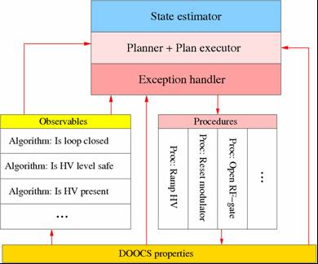

Figure 3 General conceptual scheme of automation module

Milestones and deliverables: None defined in contract for this period
Significant achievements and impact:
Implementation of the exception handler for RF station, design of prototype system for klystron linearization.
Deviations from plan: None
9.1.3 Control Optimization

Task 9.2: Cost and reliability
9.2.1 Cost and reliability study
9.2.2 Radiation damage study

The on-line radiation level monitoring was installed and operated in the tunnel. The radiation-tolerate readout circuit board is presented in Figure 4. The block diagram of the monitoring system is presented in Figure 5. It consists of several measurement units connected to the data collecting computer.
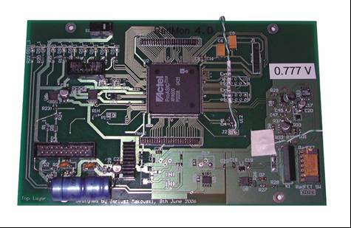
Figure 4. The photographs of radiation monitoring board

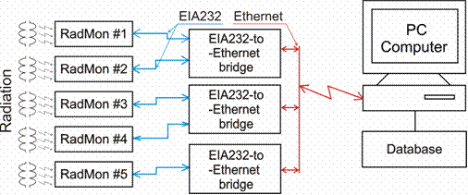

Figure 5. The distributed system RadMon installed in FLASH tunnel
(one spare portable RadMon is installed opposite ACC5)

The radiation monitoring system was also integrated with existing DOOCS control system. RSD (RadMON DOOCS System) is a visualization program for RadMON radiation measurement sensors located in the Flash accelerator tunnel. The main panel of this program is presented on Figure 6.

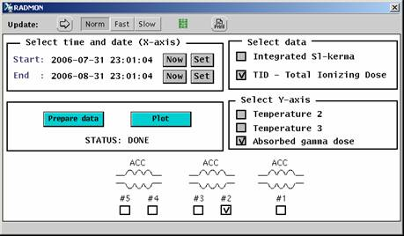

Figure 6: ddd client application - first example plot

Milestones and deliverables: None defined in contract for this period
Significant achievements and impact:
Development of a new version of SRAM based radiation on-line monitor RADMON, development of radiation tolerate operating system.
Deviations from plan: None

Task 9.3: Hardware technology
9.3.1 Multichannel downconverter

9.3.1.1 Prototyping and evalutaion in lab: passive frontend

To overcome the active frontend noise limitation of an active mixer, a single channel downconverter (DWC) prototype using a passive HMC483 double balanced mixer is used and characterized.

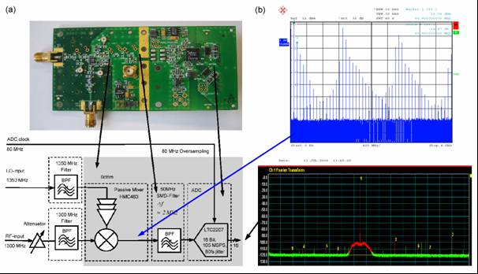

Figure 1: (a) Board and structure of a passive mixer prototype frontend using the HMC483.
(b) Intermediate frequency spectrum before and after the filtering.

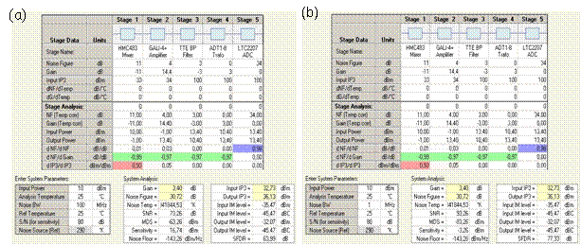

Figure 2: DWC system parameters before (a) with an SNR=73dB and after (b) digital filtering with an SNR=93dB.

As depicted in the power spectrum after the mixer of Figure 1b, higher harmonics from the LO-port and distortions from the non-linearity of the mixer must be filtered. Because the measured signal-to-noise ratio of 73dB is limited by the reference phase noise generation of the RF and LO signal, a test setup with sub-fs resolution is still under construction and described in section 9.3.1.4. A diplexer to reduce the reflections at the mixers output port didn’t reduced the distortions significantly. To improve the ADC’s spectral purity and to reduce its noise floor to get an SNR of >90dB by oversampling to the 1 MHz noise bandwidth digital filtering must be used for IQ detection, as depicted in Figure 2.

      - Multi-channel packaging and IO connection

Especially within a noisy accelerator environment a carefully design of the DWC, packaging and shielding is indispensable. According to the mechanical design in Figure 3, several items have to be taken into account.
- For a low channel crosstalk each channel is located within an rf-shielded subsection.
- To reduce distortions, the frontend and ADC must have a strong GND connection.
- To reduce spurious signals, separate the power supplies for analog and digital sections.
- To reduce the crosstalk RF, LO and digital interconnections must be filtered.
The rf-shielded multi-channel downconverter, as shown in Figure 3 can be plugged either onto an ATCA standard motherboard or an VME type motherboard having an FPGA for filtering, IQ detection and data preprocessing, which is currently manufactured.

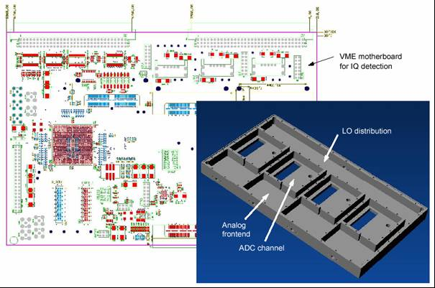
Figure 3: Multi-channel DWC digital motherboard and rf-shielded analog frontend including analog attenuators, mixer frontend, ADC channel and LO-distribution.

In addition, it is planned to test multi-channel boards having other mixer structures, e.g. high-level downconverters, where linearization methods and self-calibrating methods have to applied. These structures are more complex and are foreseen for the future.
The requirements of the phase and amplitude stability for the main linac is not so demanding compared to the DWCs located at the injector. To reduce the costs the number of DWC channels per main board should be maximized. One approach is to use an ATCA standard board with an FPGA and ADC’s. The DWC channels are located at the ATCA rear panel. This requires a different DWC board design compared to the injector multi-channel DWC, which is planned to designed in the near future.

      - Baseband IQ demodulator

As shown in section 9.3.1.1 the SNR of the DWC is limited by the resolution of the sampling ADC. Therefore it is planned to desgin a baseband multi-channel DWC using a passive IQ demodulator and a sampling ADC with an analog bandwidth of 1MHz having low latency and high resolution.

      - Testsetup for sub-fs characterization

To characterize a DWC with sub-fs resolution a measurement setup using cross-correlation techniques is required, as shown in Figure 4. To suppress the phase noise contribution of the RF-generators for the RF-signal itself and the sampling clock jitter, the intermediate frequencies of two DWCs under test are beated against each other. By using a second phase or amplitude detector and cross-correlation the uncorrelated noise floor of the phase measurement system can be effectively reduced.
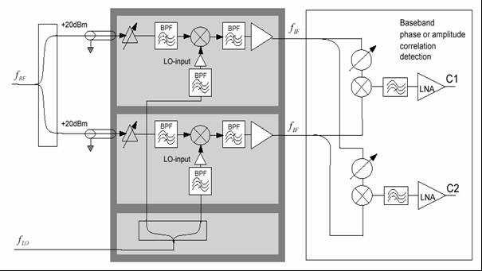

Figure 4: DWC frontend test setup with sub-fs resolution using cross-correlation.
9.3.2 Third generation rf control
9.3.2.1 Control software for superconductive modules

New control software was developed for superconductive modules. This software consists of VHDL project implemented in SIMCON 3.1 board which has FPGA chip from Xilinx – Virtex II Pro. The second part of software is DOOCS server written in C++.
New features implemented in software:
- MIMO (Multiple Input Multiple Output) – new version regulator which replaced proportional controller,
- Adaptive Feed Forward algorithm, algorithm which works in embedded PowerPC between pulses,
- Beam loading compensation – algorithm which samples signal from toroid and compensate effect of bunches going through the accelerating module. Toroid signal is proportional to charge of bunches.
- HV chain correction – special correction table, which is used to compensate nonlinearities of klystron, pre-amplifiers and vector modulator.
- new DAQ system which uses interrupts on VME. This system allows to collect data from 40 signals from each pulse.

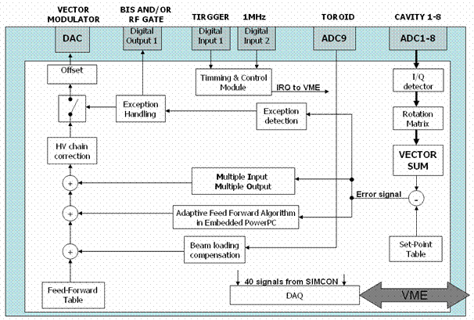
Fig. Block diagram of control software for superconductive modules

New control software was tested in module ACC1 at FLASH accelerator. Module ACC1 consists of 8 superconductive cavities. SIMCON 3.1 board with new software is used for permanent operation in ACC1 module of FLASH.

9.3.2.2 SIMCON 4 – concentrator board

During last period there was made design and production of new version of electronic board for LLRF control system. The board is called SIMCON 4 and it is continuation of SIMCON line controllers. Intention of building this board was to have one central electronic board for computation and data acquisition. The emphasis was placed on power computation and many communication links. This board has following features:
- FPGA chip Virtex II Pro - main element of concentrator board with 23616 slices, two PowerPC, 16 RocketIO tranceivers,
- 8 opto tranceivers with speed up to 2.125Gb/s each,
- 2 LVDS connector – fast connectors to DSP board,
- VME interface with Master capability for initiating transmission on VME,
- 1Gb of local memory for storage data from pulse,
- other communication links like Ethernet, RS-232

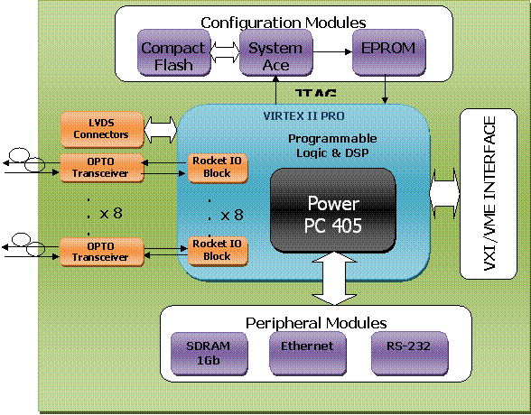
Fig. Block diagram of SIMCON 4 – Concentrator board

Two pieces of prototype board was produced. Basic functionalities of the board were tested.
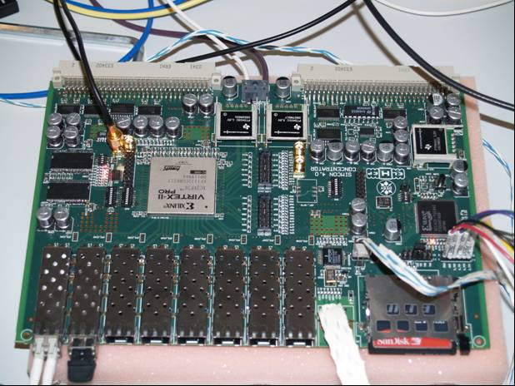
Fig. Photo of SIMCON 4 – Concentrator board

9.3.2.3 New version of SIMCON 3.1 with DSP

Success and reliability of last version of control board named SIMCON 3.1 initiated work on next version. There was made update of SIMCON 3.1 controller. Intention of update was to put DSP on it and bigger FPGA chip. This new version will allow to implement more sophisticated control algorithms which need floating point operations.
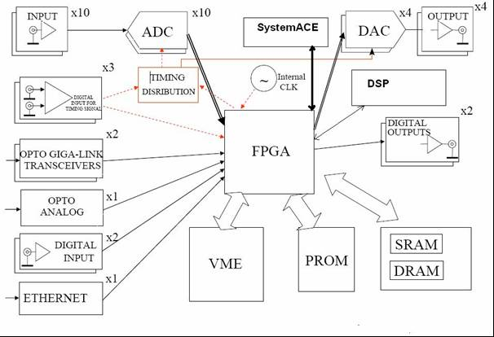

9.3.3 Stable frequency distribution

During the reporting period three low power parts (LPP) of the Master Oscillator (MO) crates, and two 1.3 GHz power amplifiers and the two crates for the 81 MHz power amplifiers were assembled. First tests were carried out, e.g. the 1.3 GHz PA. This PA has been driven by a pre-amplifier to reach the non-linear region of the power amplifier Appropriate attenuators were used to lower the power such that phase detector boards with AD8302 from Analog Devices were used in the middle of their dynamic range (-30 dBm). On these boards fixed 20 dB attenuators are already installed, resulting that an input power of -10 dBm at the board´s input connector gives -30 dBm at the input of the AD8302.
Output voltages and temperatures were recorded via a hp 34970A data logger every 10 seconds. The overall measuring time was chosen up to 12 hours.

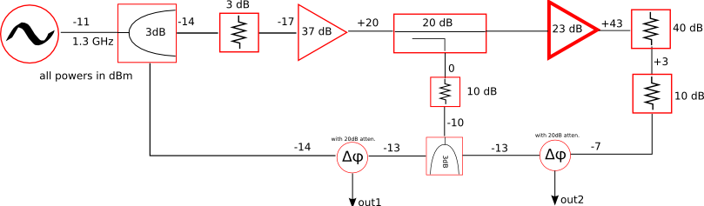
Figure 1
Block diagramm of the test setup

Figure 2
Drifts below the 1 dB compression point of thPA.
Above) Phase drifts and temperature of Power Amplifier.
below) Phase drifts and temperature of pre-amplifier. Drifts in [ps], temperature in [ºC]

Figure 3
Drifts at 1 dB compression point of PA.
Above) Phase drifts and temperature of the Power Amplifier.
Below) Phase drifts and temperature of the pre-amplifier. Drifts in [ps], temperature in [ºC].

The drifts of the power amplifier below the 1 dB compression point (Figure 2) vary in the range of +/- 2 ps and are strongly correlated with the ambient temperature. Sudden increase of drifts in 9th hour is the result of change in temperature (someone opened the door / window in the lab).

At the 1 dB compression point (Fig. 3) drifts and the correlation with temperature seem to increase slightly. On the drifts figure some spikes appeared but the cause is not known. Oscillation problems of the buffer opamp in the AD8302 detector box could be one reason. This measurement confirmed less than 1 ps drift of PA but correlation with temperature dropped from 98 to 61 percent.

Problems
Phase jumps of the 108 MHz reference frequency, 50 Hz and 150 Hz spurious lines on the output signals, high frequency dividers (HMC 394 LP4) are dying during operation and unknown reason. Through conversation with the German representative revealed that other customers reported similar problems. Defective dividers have been sent to the manufacturer for inspection.

Task 9.4: Software technology

9.4.1 Data management development

Progress: In line with schedule.
Task completed in 2005 and final report published. The database is currently under tests in DESY – Hamburg.
Milestones and deliverables: None defined in contract for this period
Significant achievements and impact:
Database and supporting programs installed and exercised.
Deviations from plan: None
9.4.2 RF Gun control Development

1.Installation and verification of control system for RF-Gun in PITZ experiment in DESY-Zeuthen
In April 2006 the last version of controller for RF-Gun implemented in board SIMCON 3.1 was installed in DESY-Zeuthen. New iq-detectors were used for field detection. It was first time when information about field inside cavity was used for control loop in SIMCON controller. This solution improved stability of the field in cavity.

2. EPAC06 Paper
Elmar Vogel, Waldemar Koprek, Piotr Pucyk “FPGA BASED RF FIELD CONTROL AT THE PHOTO CATHODE RF GUN OF THE DESY VACUUM ULTRAVIOLET FREE ELECTRON LASER”, DESY, Hamburg, Germany

3.Detector Development

In order to reduce EMI on the link between the iq-detector and the ADC, they should be laced as close as possible. For this, the iq-detector and ADC are placed on one PCB, which was designed and assembled in the last 3 month.

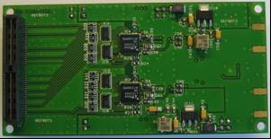
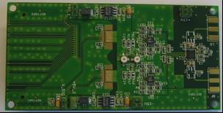
Fig. Top and bottom view of iq-detector

The iq-detecor (LT5516), the differential buffer amplifier (LT1994) and the 16-bit ADC (LT2203) are from Linear Technologies and designed for the telecommunication industry. The new detector (iq-detector and ADC) promises to provide a better noise and EMI performance than the currently installed iq-detector (AD8347) and 8-channel ADC board (based on 14-bit AD9240).

For the readout of the ADC data, a motherboard with FPGA, memory and components and connectors for communication was designed and assembled, too.

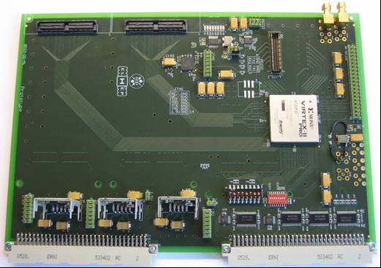
Fig. Top view of motherboard (bottom layer has 3 additional connectors)

For connection between detector and motherboard, a 80-pin QSE high-speed data connector from SAMTEC Inc. was choosen.

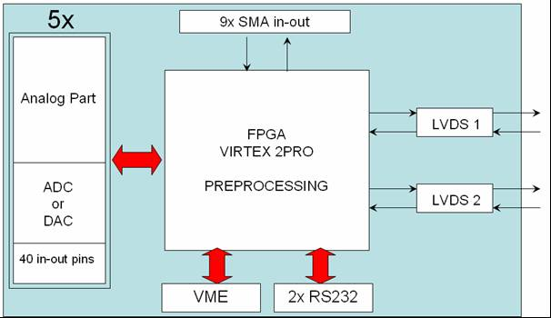
Fig. Block diagram of motherboard

Features:
- Xilinx Virtex II Pro – FPGA chip which is used to collect data from ADCs on analogue boards. This FPGA is also used for computation.
- VME is used as interface to control software,
- RS-232 optional control interface,
- LVDS connectors are used to send data from ADCs to another similar board,
- 5 QSE high speed data connector as an interface to analogue daughter boards.
It is planed to test this new system in the accelerator in parallel to the current scheme, to compare the results.

Work package 10: Cryostat integration tests

Superconducting RF infrastructures (klystron, vertical and horizontal cryostats, cryogenic plant) began to be moved in June from “l’Orme des Merisiers” site to the main Saclay Center. Reassembly of the facility is on the way, according to the schedule: seven months will be necessary to restart it.

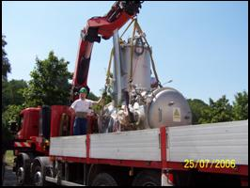
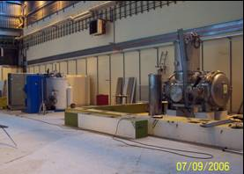

Fig.1 CryHoLab transfer to the new experimental area.

To prepare the next CARE SRF experiment on CryHoLab using the cold tuning system, we have changed the fast tuner part to adapt it to the magnetostrictive device. The mechanical component is still on the drawing board and it will be manufactured as soon as possible.
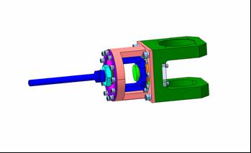

Fig.2 Adaptation for Magnetostrictive fast tuner.

http://accelconf.web.cern.ch/AccelConf/e06/Pre-Press/MOPCH140.pdf

Work package 11: Beam diagnostics

Task 11.1: Beam position monitor

The activity of the last months was dedicated to beam tests on the new BPM installed on the linac (Figure 1).

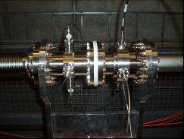
Figure 1: Reentrant BPM (right) and button BPM (left) installed on the linac downstream ACC7.
1- Reentrant BPM calibration:

First, the two electronics subsystem were calibrated:
- a subsystem with hybrid couplers, phase shifters and one combiner was installed in the tunnel during the maintenance day.
Tuning of the phase shifters gives a high common mode rejection (30 dB at 1.25 GHz).
- the second subsystem (Figure 2) was installed in AN-14 bench. Housing the synchronous and direct detectors, as well as amplifiers and limiters for protection were adjusted to have a linearity range around +/- 10 mm.
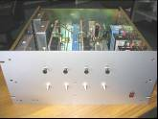
Figure 2: BPM subsystem located in the hall

The measurement of the "sum" signal peak power is around 36 dBm for 0.9 nC, it is of the same order of magnitude compared to simulations. The spectrum analysis of the "delta" signals from the 180° hybrid coupler output shows good common mode rejection. Phase tuning for the synchronous detection was refined while visualizing the delta/sigma signal on a scope

The video amplifier gain was adjusted to +/- 1V to avoid saturation from ADCs. Figure 3 shows the signals from video amplifier outputs of Δx and Δy channel.

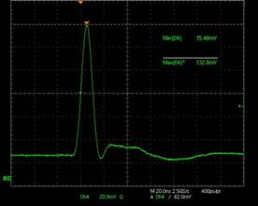
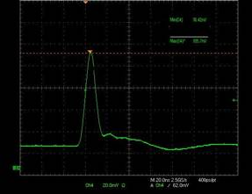
Figure 3: Signals at video amplifier outputs, Δx (left) and Δy (right).

Signal delays were adjusted with cables for simultaneous acquisition with the Doocs ADC board. The calibration for offset on the Doocs ADC board was made and the trigger delay adjusted to 102.5 on Doocs.
Afterward, a period of test followed. The H10ACC6 and V10ACC6 steerers were used to move the beam, and the magnets were switched off.

2- Method and results

We began with a horizontal steering then a vertical steering. Results are given in Figure 4.
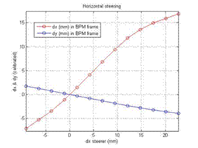
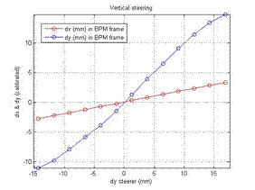
Figure 4: Calibration results in BPM frame from horizontal (left) and vertical (right) steering

The reentrant BPM has, on the X and Y channels, a good linearity in a range 15 mm but there is an asymmetry and the linearity is better for a positive deviation. This effect is not yet well understood; it may be related to the steering magnets (residual field or saturation).
The reentrant BPM is mounted with a tilt angle of 11.25° with respect to the horizontal direction. A frame rotation change is therefore necessary. Calibration results after this correction are displayed in Figure 5.
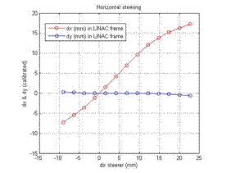
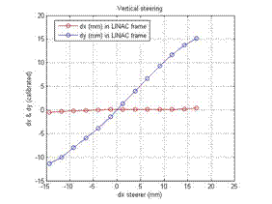
Figure 5: Calibration results in LINAC frame from horizontal (left) and vertical (right) steering

The standard deviation of the calibrated position measurement was plotted for the horizontal and vertical steering (Figure 6).
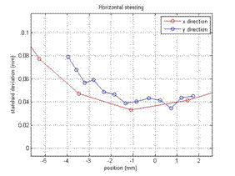
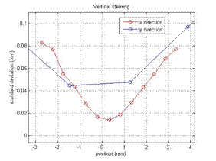
Figure 6: Standard deviation of the position measurement (calibrated)

The raw RMS resolution of the system directly measured by the standard deviation of the readings from the reentrant BPM (14ACC7) can reach 20 µm on the X channel and around 40 µm on the Y channel, at the BPM center. But those results depend on the beam jitter, too. With simulations, the resolution of this system was determined around 15µm.
A second test period was necessary to validate the first results: the same steerers were used, the deviation range was limited to ±4 mm for a more accurate calibration (Figure 7, 8, 9).
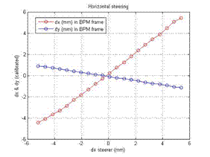
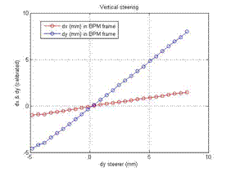
Figure 7: A more accurate calibration results in the BPM frame
from horizontal (left) and vertical (right) steering

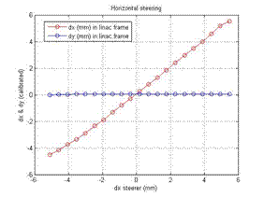
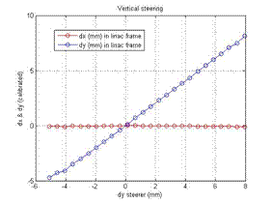
Figure 8: A more accurate calibration results in the LINAC frame
from horizontal (left) and vertical (right) steering

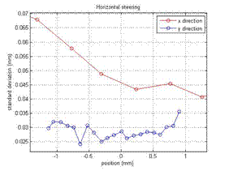
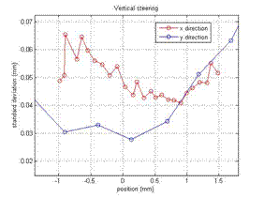
Figure 9: Standard deviation of the position measurement (calibrated)

This second measurement corroborates the first calibration. The linearity in this calibration range is very good for both channels. The minimum standard deviation of the measurements at the BPM center is around 40 µm for X channel and around 30 µm for Y channel.

Future work

We need to know the resolution of the BPM with this dynamics range to compare and validate the simulations. Some resolution measurements could be combined with the ‘DESY’ Button BPM which is close to the re-entrant BPM.
Then, the electronics system and in particular the gain on each channel will be modified to improve the resolution but the dynamics range will be reduced.

To improve the resolution of the BPM and keep a dynamics range around +/-5mm, the mixer which is used in the electronics installed in DESY could be replaced by a new one which accepts a high power RF input (around 16 dBm instead of 0 dBm).

Task 11.2: Beam size and emittance monitor

In this last period the main activity has been the analysis of the data taken in March, to understand if the procedure we were following was correct and with the final energy the expected result could be reached.

Background Subtraction Procedure
The main limitations during the measurements were given by the background and the large amount of hot spots which did not allow us to increase the CCD exposure time.
To separate the background from the beam, the beam has to be moved out of the screen by using steering magnets upstream of the target. However, since the steered beam hits the beam pipe, this procedure further increases the amount of emitted X-rays. In this regard, an off-line LabView tool which first eliminates X-rays by selecting a neighborhood with a 3x3 matrix, then subtracts the background image has been developed. In order to increase both signal and background intensity, the sum of N images, normalized to the number of images, is considered.

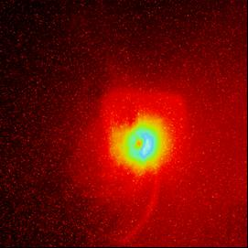
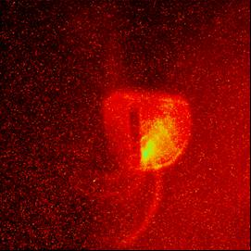
Figure 1: Signal plus background (left) and background image (right).

Figure 1 shows the OTR angular distribution and the background image on the focal plane. The beam was steered out of the target by a vertical steerer upstreams, and the background image was then isolated and recordered to allow its subtraction. Both images are the result of the sum of 20 images taken with 10 bunches per macropulse, 0.3 nC per bunch and 2 s exposure time.
Figure 2 shows the OTR angular distribution after removing X-rays and subtracting the background. The result is a clean image whose profile is the one we expect.

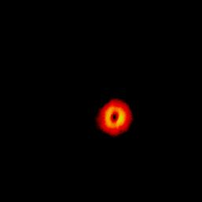
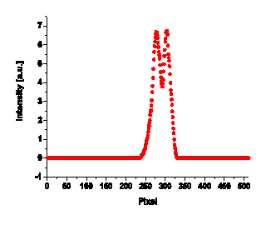

Figure 2: Subtracted OTR angular distribution (left) and its profile (right).

This tool becomes mandatory for the analysis of ODR signals which, being of the same order of magnitude and even weaker than the background, are covered by it.

From OTR to ODR
The aim of these first measurements was to demonstrate that we are able to detect a difference between OTR and ODR angular distributions.
To do so we used a vertical steerer to change the position of the beam on the screen in order to smoothly go from OTR to ODR emission. To detect ODR as well as to distinguish OTR and ODR, high quality electron beam in terms of small transverse emittance, high beam energy and good stability is required. Unfortunately, during the whole set of measurements, the transverse beam size was too large even for the 1 mm slit. To reduce the emittance, i.e. the beam size, the charge was reduced down to 0.3 nC per bunch, and to increase the signal intensity the number of bunches per macropulse was increased to 25. The signal was integrated over 1 s. The nominal beam energy was 620 MeV.
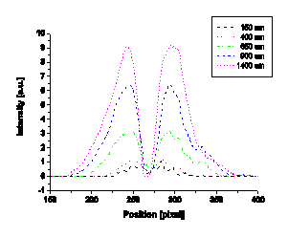
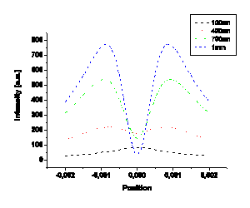
Figure 3: Angular distributions for different positions of the beam with respect to the center of the slit: experiment (left) and simulations (right).

The plot in Fig.3 (left) shows the angular distribution profiles for five steps. The short dash curve (magenta) corresponds to the beam at 1.4 mm from the center of the slit, a condition which gives rise to OTR emission. As the distance decreases the OTR contribution gets lower. The dash curve (black) corresponds to the beam at 150 μm from the center of the slit: ODR emission is now expected, showing a less pronounced minimum in the angular distribution. A simulation (Fig.3, right plot) reproducing the insertion of the slit shows a qualitative agreement with experimental data.

ODR Evidences
Only during one of our measurement shifts we succeeded to have the beam shown in Fig.4 with a FWHM of 360 μm, but even in this case, when the beam goes through the slit, the tail hits the edges.

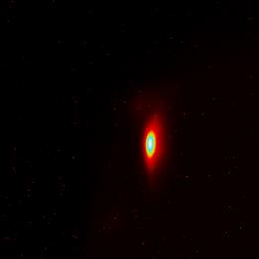
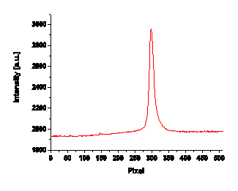

Figure 4: Image of the beam on the OTR screen (left) and its profile (right).
A measurement dedicated to the ODR detection has been performed with this beam transporting 10 bunches, 0.3 nC per bunch through the center of the 1 mm slit. Several images of both signal and background have been acquired to allow an easier subtraction procedure. The subtracted ODR angular distribution image is shown in Fig.5 (left), the corresponding profile is plotted in Fig.5 (right: red dots). A simulation which takes into account an rms beam size of 150 μm, compatible with the given beam, and a negligible angular divergence, shows a good qualitative agreement with the measured ODR profile (Fig.5, right: straight line).
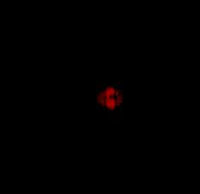
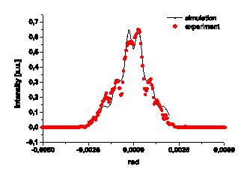

Figura 5: Subtracted ODR angular distribution (left) and its projection in comparison with a simulation (right).

Although these first preliminary measurements did not yet allow us to quantitatively retrieve beam parameters and showed that effort has still be put on improvement of the experimental set-up and background subtraction, they are encouraging and give us confidence to continue the measurements.

Plans for the next future
During FLASH maintenance period in October 2006, a second target, a replica of the first one, will be installed. The second target will be used during preliminary adjustment of the beam to avoid damages on the slit used for measurements. In order to reduce synchrotron light we plan to install in the OTR station before our experimental station a diaphragm to cut hopefully the background. The whole system will be than aligned. For the next set of measurements, planned in January 2007, we expect to reduce the contribution from X-rays with a better shielding of the camera. Also an update of the analysis software is planned.

