

Progress Report on ELAN

By F. Richard on behalf of the ELAN Steering Committee (November 2003-April 2004)

Introduction

Since the CARE kick off meeting held at CERN Nov 19-21 2003, the organisation of the
ELAN network has been closely monitored through regular phone conferences of the Steering Committee (7 such meetings with written minutes were held since then).

The following tasks were achieved:

- Creating a web page for ELAN and web pages for the various packages (LTENC,LTESC,ANAD are ready with addresses given in the appendix)
- Collecting names of participants (249 names with e-mail addresses and WP identification available from the web site)
- Preparing an for the ELAN workshop at Frascati

ELAN workshop at Frascati (May 4-6 2004)

This workshop, which is jointly organized by the 5 WP, represents the main priority of ELAN since we believe that it allows to set a coherent organisation of work and to establish the appropriate connections between these WP.
Details of the Agenda of this workshop can be found at:

http://www.lnf.infn.it/conference/elan/index.html

There are 82 participants registered. The main issues of this meeting are:

- To define the strategy of ELAN and review our main goals in the rapidly evolving situation of R&D for Linear Colliders
- To organize the work of the different WP and insure proper connections between them
- To define dissemination of knowledge
- To review our work on the first deliverables of the network
- To define the relation of ELAN with the two relevant JRA of CARE PHIN and SRF
- To promote the synergy between ELAN and the Design Study EUROTEV proposed
within the FP6 program

Samples of abstracts presented at this workshop are given in appendix.

EUROTEV and ELAN

While the activity of PHIN and SRF are entirely dedicated to R&D on existing facilities like TTF at DESY and CTF at CERN, the urgent need for an active participation of Europe to an international effort in view of a worldwide Linear Collider requires a new framework.
Within ESGARD this priority was clearly acknowledged and resulted in the Design Study EUROTEV submitted to FP6 at the beginning of the present year.

It soon became clear that ELAN was a natural forum for an active preparation to this DS and
it was recognized that ELAN should be associated to EUROTEV. In practice some representatives of ELAN were associated to the preparation of the documents of EUROTEV and participated to a public meeting held in Daresbury where the various work packages were presented. Also, as shown in appendix, the coordinator of ELAN is part of the management structure of EUROTeV.

During the Frascati Meeting, we intend to focus on the potential synergy between the two bodies with the following possibilities:
- Definition of common meetings
- Common documents

Financial aspects

The financial management of ELAN is rather complex since there are 16 contractors and, with the associates, a total of 53 Institutes.

It is felt that the sharing of resources should follow the actual participation of the contractors and associates rather than having a sharing of these resources fixed a priori. In some cases, like for DESY, a formal agreements took place between the contractor and his associates according to national rule. In general travel expenses will be reimbursed a posteriori by the contractors to their associates requiring justifications and following to the rule of the country.

The highest priority for using the ELAN financial resources are the Frascati meeting and the plenary ELAN/CARE meeting which will take place in DESY in November. Typically the cost for a participation to the Frascati meeting is of the order of 700 € which corresponds to a total cost of 50 k€ for 70 participants (not counting the local participants). One expects a higher cost for the participation to the DESY meeting but compatible with ELAN resources for this year. Additional resources for participations to collaboration meetings of CTF and TTF should come from the resources invested by the laboratories in ELAN.

APPENDIX

Abstracts of the presentations in LTECNC sessions of the ELAN Workshop.

R&D for CLIC technology feasibility study J.P.Delahaye CERN

CTF3: Status of INFN Collaboration A.Ghigo INFN
Overview about the JRA2:PHIN A.Ghigo INFN
Overview of the present status of the SRF gun design and construction J. Teichert FZR
An overview of CLIC accelerating and transfer structure development. A.Grudiev CERN
Development of a planar accelerating structure H.Henke TUBE
A short pulse two-beam accelerator with energy recuperation H. Henke TUBE
Status of the Linear Collider Alignment & Survey project A.Mitra UOXford

Design of a RF photo-injector for PHIN R.Roux LAL

Stabilization of Accelerator Magnets to the sub-mm level R.Assmann CERN

Stabilisation studies from LAPP/ESIA A.Jeremie LAPP

RF Deflectors for Combiner and Damping Rings F.Marcellini INFN

Abstracts of the presentations in LTECSC sessions of the ELAN Workshop.

Introduction to LTECSC (Schedule, Deliverables)

L.Lilje
A review of the deliverables of the LTECSC including deliverables will be given. The main topics for discussion will be introduced (dissemination of knowledge, workshops, interconnection JRA-ELAN, etc.).

JRA SRF (WP refers to the SRF Work Packages)

WP1 - Start up introduction, Management
D.Proch
A short description of the JRA will be given. The organisation and the overall work plan will be described.

WP2 - Planning for production reliability
P.Michelato
WP2 (Improved Standard Cavity Fabrication, ISCF) aims at improving the present cavity fabrication technology. It is based on the operating experience with superconducting cavities in the test linac TTF. There is despite recent successes a need to modify at least partially the cavity and cryostat design and the preparation procedures to improve the performance and reliability of the SRF accelerating system.

WP3 - Seamless Cavity Production
W.-D.Möller
This WP follows the idea to fabricate the actual cavity (excluding the end groups with auxiliary components like input coupler ports, higher order mode dampers…) by a method that avoids welding. This would eliminate possible performance degradation by a low quality weld. There are two methods of seamless production: spinning and hydro-forming. Very encouraging results are obtained with single cell cavities. This technology will be extended to multi-cell cavities.

WP4 - Thin Film Cavity Production
J.Langner
The WP works on a new method of thin film coating by vacuum arc technology. Instead of fabrication of a cavity from bulk Niobium, a Copper cavity will be coated at the inside by a thin (several mm thick) superconducting Niobium layer. As compared to the sputter coating method (as being developed by CERN) the novel method of vacuum arc coating promises superior superconducting film properties. First results on samples support this expectation. Two different methods using a planar or a linear source will be investigated.

WP5 - Surface Preparation
L.Lilje
The work package for surface preparation deals mainly with two different topics which will be described in detail: Firstly, electropolishing as it has shown very encouraging accelerating gradient results on single-cell and nine-cell cavities. The electropolishing process (e.g. different types of electrolytes, different process control ideas) will be investigated in much more detail on samples and single-cell cavities. As a next step, this technology will be adapted to the geometry of multi-cell cavities and should be transferred to industry. Secondly, dry ice (CO2) cleaning is expected to clean surfaces from dust or residual contaminations much more effectively than the presently used technique of high pressure water.

WP6 - Material Analysis
E.Palmieri
Further improvement of material analysis techniques will lead to an improved quality control. Possibilities are scanning of niobium sheets with SQUIDs and controlling the preparation of cavities by field emission scanning of niobium samples or the development of flux gate magntometry for the control of the electropolishing process.

WP7 - High power coupler
M.Omeich
The aims of this WP include new input coupler designs as well as construction of prototypes. Results from the tests of prototypes will also be delivered, the tests being carried out on a dedicated high power tests stand recently built at Orsay. Among the delivered hardware will be a titanium-nitride coating bench designed to allow coating of several coupler ceramic windows simultaneously. RF “conditioning” studies will also be provided.

WP8 - Active tuner development
P.Sekalski
The development of active tuner systems is imperative for operation of SC cavities at high gradient. Especially innovative will be the development of tuners based on piezo-electric and magneto-strictive effects. Tuners are required to counteract the so-called Lorentz de-tuning effect when the cavities are pulsed at high field so as to maintain the phase and amplitude constant during the RF pulse, whilst minimising additional RF power needed for field control. We aim to develop tuners capable of correcting 1 kHz of de-tune so allowing the cavities to operate stably at 35 MV/m. This should be compared with existing tuners on TTF which correct for fields of~ 15 –20 MV/m. Long life-time is also a major issue and we aim to develop tuners allowing for 20 years of operation.

WP9 - Low Level RF
S.Simrock
The WP deals with development of new hardware for single bunch transient detection and a multichannel downconverter, improvement of LLRF reliability, the development of a highly stable frequency distribution and the design optimal control algorithms for superconducting cavities.

WP10 - Cryostat Integration Tests
B.Visentin

The horizontal cryostat Cry-Ho-Lab and the RF power facility, located in Saclay, have been suggested to test components (coupler, cavity tuners, low level RF system) developed within the JRA-SRF by WP7, WP8 and WP9 work packages. In all, thirty weeks of helium production are foreseen for these tests scheduled according to each work package agreement. As example, a typical "two weeks" test will be described. The estimation of the manpower required and the helium cost will be made.
Before these tests the "Cryostat Integrated Tests - WP10" needs itself a cryogenic and RF test to check the well running of the 9-cell cavity in CryHoLab. A description of this preliminary task will be given.

WP11 - Beam diagnostics
C.Magne
Two different diagnostics will be designed and constructed. The first will be an RF cavity based beam position monitor (BPM).This device will have a resolution five times better than existing devices while maintaining high temporal resolution.
The second will be a non intercepting emittance monitor based on micrometer wave radiation emitted by diffraction effects as the beam traverses a slotted aperture. The simulations for the determination of the different parameter of the monitor have started, and some result will be shown. The most important aspect under investigation is the possibility to separate the beam angular spread effect from the beam size one, and define a set of parameters that maximize this difference, allowing a direct measure of the emittance.

JRA HIPPI

WP3 - SC structures
S.Chel/C.Pagani

Abstracts of the presentations in ANAD sessions of the ELAN Workshop.

Progress on the Advanced Laser Plasma High-energy Accelerator ALPHA-X project
D.A. Jaroszynski ¹, R. Bingham ^{1,2}, E. Brunetti ¹, K Burnett ³, R.A. Cairns ⁴, J. Clark ⁵ , A. E. Dangor ⁶ , M. Dykes ⁵, B. Ersfeld ¹, J. Gallacher ¹, W.A. Gillespie ⁷, T. Gonsalves ³, S. Hooker ³, H. Hutchinson ², R. Issac ¹, S. Jamison ^{1,7}, A. Johnson ¹, D. Jones ¹, S. Karsch ², K. Krushelnick ⁶, A. Lyachev ¹, A. MacLoud ⁷, S. Mangles ⁶, S. McDermott ⁶, C McKenna ³, C. Murphy ^{2,6}, Z. Najmudin ⁶, P. Norreys ², M.W. Poole ⁵, A. Reitsma ¹, Y. Saveliev ¹, D. Spence ³, G. Vieux ¹, R. Viskup ¹, I. Walmsley ³, J. Wark ³ , K. Wynne ¹
1. University of Strathclyde, Glasgow, G4 0NG, UK (d.a.jaroszynski@strath.ac.uk)
2. Rutherford Appleton Laboratory, Chilton, Didcot, Oxfordshire,OX11 0QX, UK
3. Oxford University, Clarendon Laboratory, Parks Road, Oxford OX1 3PU, UK
4. University of St Andrews, North Haugh, St Andrews, Fife KY16 9SS, UK
5. Accelerator Science and Technology Centre, CLRC Daresbury Laboratory, Warrington WA4 4AD, UK
6. Imperial College of Science,Technology,and Medicine, University of London, SW7 2BZ, UK
7. University of Abertay Dundee Bell St, Dundee DD1 1HG, UK

Electrostatic forces in plasma can be harnessed to create extremely compact accelerators, by creating a wake by an intense short-pulse electromagnetic field. To achieve the goal of developing a laser-driven accelerator and utilize it to drive a coherent radiation source a number of significant challenges need to be met. The project Advanced Laser Plasma High-energy Accelerators towards X-rays (ALPHA-X) aims to develop a laser driven wakefield (LWF) accelerator and apply it to the creation of a compact free-electron laser (FEL).
LWF accelerators based on table-top terawatt lasers have the potential of producing high brightness ultra-short electron bunches. A number of significant challenges remain to be met before they can be used as a driver for compact FELs. Wakefield accelerators are predicted to produce ultra-short electron bunches with energies as high as several GeV in several centimeters, using available lasers. The acceleration gradients are three orders of magnitude higher than available from conventional accelerators thus making possible extremely compact devices producing ultra-short electron bunches, a few ten's of femtoseconds in duration. Laser wakefield accelerators currently produce beams with excellent transverse emittance but very large energy spectra. As a potential driver for a FEL the fractional energy spread should be less than the universal FEL gain parameter. To improve the energy distribution from LWF accelerators electrons injected into the accelerator must occupy a small region of phase space and thus should be much shorter than the Langmuir wavelength. This is the main challenge of developing wakefield accelerators. To evaluate the technology it is necessary to investigating several techniques for injecting ultra-short electron bunches into a plasma channel.
We report on the ALPHA-X project to develop LWF accelerator technology for driving compact FELs. A consortium consisting of several UK universities and facilities, and collaborators from Europe and the US, has been set up to realize these goals. To achieve the stringent injection requirements, two different injection methods are being investigated. The first of these is a compact all optical method, which involves extracting electrons from plasma using an intense ultra-short laser pulse and injecting it into the LWF accelerator. In parallel to these investigations we are also developing a RF photoinjector to produce 10 MeV ultra-short electron bunches, with a duration a fraction of the plasma wake period. Measurements of the electron bunch duration using terahertz time domain techniques will be presented. The technique involves measuring the Coulomb field of the highly relativistic ultra-short electron bunches using chirped pulse electro-optic detection. These results demonstrate that single shot measurements are achievable and indicate that a resolution better than 100 fs is possible. A fully ionized hydrogen filled capillary, with plasma densities up to 10 19 cm -3 , has a dual purpose of acting as a waveguide for the driving pulse while providing the medium for the LWF accelerator. A table-top terawatt Ti:sapphire laser is being used to produce the plasma wake in the channel. Recent results of the development and characterization of a suitable plasma channel will be presented. To demonstrate the utility of the compact accelerator electron bunches from the LWF accelerator will be used to create coherent electromagnetic radiation in a FEL. An injected laser pulse or a signal arising from coherent spontaneous emission will be amplified to reach the non-linear superradiant regime.
Various forms of envelope equations have been used to study the propagation of a pulse in the wakefield problem. Generally these retain second order derivatives in order to have physically realistic properties. We will discuss a method, based on the standard ray-tracing equations, which yields a true first order envelope equation, which conserves wave action (or number of quanta) and also gives rise to an energy conservation law. It can be shown explicitly that the energy extracted from the electromagnetic pulse is exactly accounted for by the change in energy of the plasma and its associated electrostatic field. The usual equations describing wake field generation can be shown to be in agreement with this general formalism. Direct energy transfer from an electromagnetic pulse to a relativistic electron bunch is, in principle, possible without the intermediate step of wakefield generation and that the efficiency of energy transfer should be of the same order.

Single-shot longitudinal profile characterisation of 500fs electron bunches

S.P. Jamison, G. Berden, A.M. MacLeod, W.A. Gillespie, D.A. Jaroszynski, B. Redlich, A.F.G. van der Meer, S. Karsch, C.D. Murphy, P.A. Norreys, M. Kaluza, J. Schreiber, J. Stein, K. Witte

Using a new technique which combines the electro-optic detection of the Coulomb field of an electron bunch with the single-shot cross correlation of optical pulses, we have overcome the dominant time-resolution constraint of electro-optic single shot longitudinal profile beam monitoring. The technique has been used in single-shot temporal profile characterization of 500fs FWHM electron bunches at the FELIX free electron laser. We were also able to clearly observe the bunch timing jitter, which was comparable with the bunch duration. The bunch profile was able to be adjusted in real time through reference to the electro-optic profile monitor. Single shot electro-optic sampling of electron bunches ejected from self-modulated laser wakefields in gas jets has also been demonstrated at Max Planck fur Quanten Optik Garching. The low gamma of electrons from the gas jets dominates the time resolution of the measurements, but still allows sub-picosecond time resolution.

Carrier-envelope-phase-stabilized sub-10-fs lasers and their application to laser-based electron acceleration

L. Veisz, A. Baltuska, E. Goulielmakis, F. Krausz

The rapidly developing ultra short laser pulse technology made it possible to generate laser pulses with a pulse duration shorter than 10 fs (= 10⁻¹⁴ s). As the central wavelength is around 800 nm, i.e. The period time is 2.7 fs, it contains only a few (2 - 3) oscillation periods. The relative position of the carrier sinus wave and the envelope of the pulse becomes very important at these pulse durations. This so called carrier-envelope-phase has been stabilized the first time between the consecutive laser pulses with an accuracy of about 0.2 fs. The generation and applications of these pulses for among others electron acceleration will be discussed.

The Eindhoven High-brightness Electron Source Programme

G.J.H. Brussaard and M.J. van der Wiel

The status of our programme on ultra-high brightness photoguns will be reported. This involves developments both on an RF photogun and on a 'pulsed-DC' gun. With the latter, gradients of 1.3 GV/m on the photocathode have been achieved, and acceleration to energies of 4 MeV. The issue of synchronisation of the electron bunches with a laser wakefield will be addressed. Finally, parameters will be presented of a planned demonstration experiment on 'controlled' wakefield acceleration: injected 10 pC, 50 fs bunch accelerated in a capillary discharge channel to tens of MeV with 30-40% energy spread.

---------------------------------------------------------------------------------------------------------------

Electron acceleration in the Bubble regime: analytical theory and numerical simulations

S. Gordienko ^{1;2} , A. Pukhov ¹ , T. Baeva ¹

1 Institut fur Theoretische Physik I, Heinrich-Heine-University at Dusseldorf, D-40225, Germany
2 L. D. Landau Institute for Theoretical Physics, Moscow, Russia

We present analytical theory and numerical simulations of laser-plasma electron acceleration in the
Bubble regime that is able to generate a nearly monochromatic electron bunch [1]. This regime is
achieved in under dense plasma provided that the laser pulse has an ultra-relativistic amplitude and
its duration is shorter than the plasma period 1/ω_{p}.
We study equations of cold ultrarelativistic plasma hydrodynamics coupled with the Maxwell equations and we find 3D solutions of these equations. Surprisingly, the efficient electron acceleration works in an almost linear regime that is free of a chaotic behavior inherent in non-linear dynamic systems. Particularly, there exists a solution in the form of a spherical cavity with radius R almost free from plasma electrons. The resonance interaction between the wave and the particles expels background plasma electrons from the cavity and we can relate the cavity radius R with the relativistic factor γ_{p} of the cavity propagation: (2πR/λ_{p}) ² = 2.6 γ_{p} (ln 2γ_{p})^{1/2}. The cavity rear side is unstable due to the electron density perturbations leading to electron trapping and acceleration. We find that the electrons can be accelerated in the Bubble up to the γ-factor γ_{jet} = 11 γ_{p}³ (ln 2γ_{p})^{1/2}. The development of the jet and cavity formation have also been investigated by 3D PIC simulations.

[1] A. Pukhov, J. Meyer-ter-Vehn, Appl. Phys. B 74, 355 (2002).

The laser based electron beam approach : review and perspectives

V. Malka
Laboratoire d’Optique Appliquée, École Nationale Supérieure des Techniques Avancées, École Polytechnique, CNRS, UMR 7639, 91761 Palaiseau, France.

We report a review of electron beam generated by lasers. The efficiency of electron acceleration in the Forced Laser Wake Field regime demonstrates the benefit of such approach by the used of ultra short laser pulses as it been proved at LOA. Within this regime, TV/m electric field has been generated, producing high energy and very high quality electron beams. The most remarkable characteristic of these beams is their high spatial quality: the beam is nearly a perfect Gaussian very collimated with a divergence of only 10 mrad. Optical transition radiation measurements were performed confirming that the divergence of energetic electrons (> 15 MeV) is even smaller. In this regime, the electron beam pointing, as well as its stability, (a critical issue for applications) is also very good. Most importantly, we showed that smooth laser propagation is correlated to the generation of good quality beams. In fact, violent relativistic self-focusing has a tendency to disrupt laser propagation and it results in lower energy electrons, as well as unstable electron beams with very poor spatial quality.
Our strategy concerning the production in an uniform or channel plasmas of an electron beam with higher energies (GeV range) and with a quasi mono energetic spectra as proposed by A. Pukhov will be presented.
Such ultra short electrons bunches and low emittance electrons beams will permit new insight in science. Some example of potential applications will be presented and discussed.

--------------------------------------------------------------------------------------------------------------------------------------

Overview of Codes Simulating Plasma Acceleration
G. Maynard
---------------------------------------------------------------------------------------------------------------------------------------

A photon-in-cell code for laser wakefield accelerators

R.M.G.M. Trines [1], R.L. Bingham [1, 2], L.O. Silva [3], J.T. Mendonça [3], W.B. Mori [4], and P.K. Shukla [5]
[1] Rutherford Appleton Laboratory, Chilton, Didcot, Oxon
[2] Dept. of Physics, University of Strathclyde, Glasgow
[3] Grupo de Lasers e Plasmas, Instituto Superior Técnico, Lisboa
[4] Dept. of Physics and Astronomy, University of California, Los Angeles
[5] Fakultät für Physik und Astronomie, Ruhr-Universität Bochum, Bochum

A particle-in-cell type code has been developed to perform numerical simulations of the laser wakefield accelerator scheme using the quasi-particle approach. This code allows for a comparatively easy description of both random phase and coherent pump pulses coupling to electrostatic plasma waves, while providing an extended range of powerful diagnostics leading to a deeper physical insight into the dynamics of the fast waves. The propagation of short, intense laser pulses through a plasma has been simulated. The relativistic wakefield that develops strongly interacts with the photon bunch producing regions of photon acceleration and deceleration. This can be exploited to develop a photon beam diagnostic for wakefield studies. Additionally, other phenomena that can be studied include modulational instabilities, pulse compression, and soliton formation. The extensibility of the numerical implementation to other types of fast wave-slow wave interactions will be discussed.

----------------------------------------------------------------------------------------------------------------------------------------

Theory, simulations and experiments on second-generation plasma-based electron accelerators at GoLP-IST

N. Lopes

We present the theoretical, simulation and experimental research developed at GoLP-IST on second-generation plasma-based electron accelerators, along with a description of the team profile and the facilities at IST.
This work encompasses the development of plasma channels for high-intensity laser guiding, laser guiding experiments, and numerical experiments showing self-injection of ~ 10 pC electron bunches,
and the acceleration of background plasma electrons to the GeV level in 1 cm length channel

Participation to the Work Packages of the Contractors in Frascati: X gives the initial commitment, the numbers refer to the actual participation (in some cases the participants are fractional when they are split between WP). This table corresponds to 43 participants. The other 40 participants come from the associates.

Number | Participant | LTECNC | LTECSC | BDYN | INSTR | ANAD
1 | CEA | X | 1X | X | X
3 | CNRS | X | X | X | X | X
 | CNRS-Orsay | 1 | 2X | 2X
 | CNRS-CPHT |  |  |  |  | X
 | CNRS-LULI |  |  |  |  | X
 | CNRS-LAPP | 1X |  |  | X
 | CNRS-LOA | X |  |  | X | 1X
 | CNRS-LPGP |  |  |  |  | 2X
 | CNRS-LPCO | X
5 | DESY | X | 5X | 2X | 2X
7 | FZJ |  |  |  | 1X
8 | FZR | 1/2X | 1/2X |  | 1/2X | 1/2
10 | INFN | X | X |  | X
 | INFN-LNF | 3X |  | 1 | 2X
 | INFN-LNL |  | 3X
 | INFN-Mi |  | X
 | INFN-Na |  | X
 | INFN-Ro2 |  | X
11 | TEU | X |  |  | 1X
12 | TUL |  | 2X
13 | IPJ |  | 1X
14 | WUT-ISE |  | X
16 | CSIC |  | X | X
 | IFIC |  |  | 2X
 | CIEMAT |  | X
 | LEII |  | X
17 | CERN | 5+3/3X |  | 3/3X | 3/3X
19 | PSI | X |  |  | 1X
20 | CCLRC | X | X | 2+2/2X | 2/2X | X
21 | ICL | X |  | X | X | X
22 | UMA | X |  | X | X

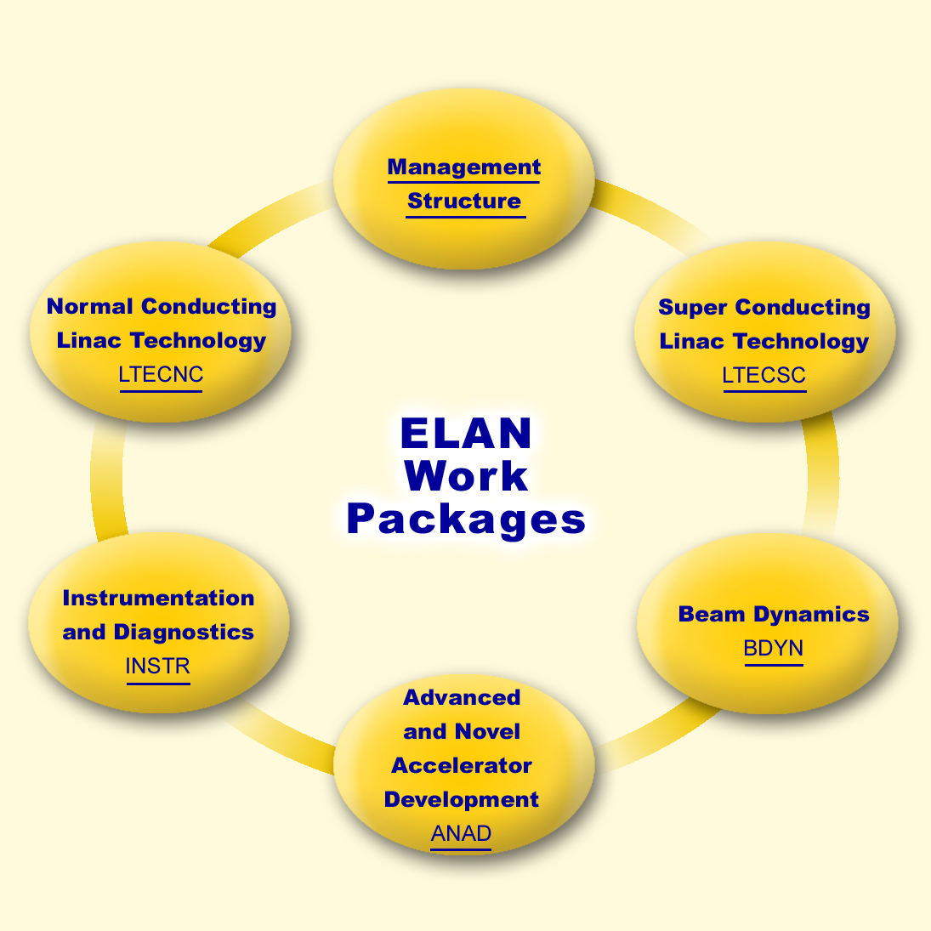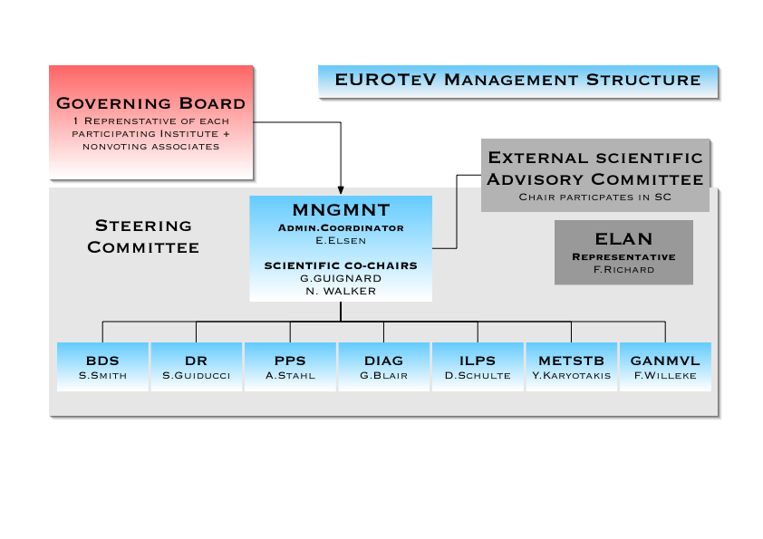

Structures of Management of

ELAN and EUROTEV

